CONTRA DANCE
CHOREOGRAPHY

A Reflection of Social Change

MARY McNAB DART

Copyright ©1995 Mary McNab Dart
All rights reserved
ISBN 0-8153-1984-3

Table of Contents
Preface 3
Acknowledgments 9
Illustrations 10
1. Introduction 12
2. The Contra Dance Event 25
3. The Contra Dance Tradition 48
4. The Composing of Contra Dances 58
5. An Aesthetic of Contra Dancing 79
6. Changes in Contra Dance Choreography 116
7. Choreography and Community 134
8. Conclusion 165
Appendix 172
A. CONTRA DANCE FORMATIONS 172
B. CONTRA DANCE FIGURES 179
C. DANCING STYLE 194
D. BIOGRAPHIES OF INFORMANTS 195
E. TWENTY CONTEMPORARY CONTRA DANCES 201
Selected Bibliography 208
Index 214

Preface

This book is an exploration of the way the choreography of the contra dance, a folk dance tradition brought to us from the British Isles, has been changing, particularly over the last twenty years. When I was first involved in contra dancing, in the early 1970s, the dances were made up of comparatively simple figures and transitions, simple enough that I could bring my three-year-old daughter onto the dance floor and guide her through a dance. Today, in the mid-1990s, the dances are more complex and faster-paced, largely because of the creativity of contra dance callers and composers who have been putting together new dances in the contra dance tradition.
This book is the story of these new dances—how they are composed, what aesthetic principles underlie their composition, and how the evolution of the choreography reflects changes in the preferences and priorities of the people who dance them.
The study is based on interviews with twenty-six people who have been involved in contra dancing as callers, dance composers, or musicians. I conducted these interviews in New England, the Washington-Baltimore area, North Carolina, and the Midwest. The first interviews were open, without much direction from me, because I wanted to know what the relevant issues were for those who had thought the most about contra dance choreography. In the later interviews I directed my questions to the issues that surfaced in the earlier ones. In the course of my travels, I visited many local dances, where I was able to talk with dancers about contra dancing and about current issues in the dance revival today. As a dancer of twenty years myself, I was also able to pay attention to my own feelings about dance aesthetics, noticing what I liked in a dance and examining the aspects of dance choreography that led me to prefer certain dances over others. I kept a journal of these thoughts and recorded specific dances as illustrations of these impressions.

THE FIELD OF DANCE STUDIES

My work focuses on a number of relatively neglected areas of scholarship—the anthropology of dance, the study of revival folklore, and the examination of social dance traditions. Dance as a focus of academic study has received comparatively little attention. Early anthropologists saw dance either as a Western art form, in the case of ballet, or as an emotional and primitive activity not worthy of serious scientific and scholarly study (Royce 1977:19). Puritan ethics, which discourage calling attention to the human body, and concepts of masculinity, which view dance primarily as the prerogative of women, have caused some to avoid the field. Dance scholarship has also been hampered by the problems of notating movement. This difficulty has made a scientific study of dance problematic, while a humanistic approach has been considered second rate. The availability of film and video cameras facilitates the recording of dance, but does not eliminate the problems of recording movement from only one perspective, nor the cultural bias inherent in the process of the recording of events from a single person's perspective. As a result of these various problems, dance scholarship has suffered from low status in the academic world:

As all academics, and especially anthropologists who work on dance and human movement in America, know, they cannot emphasize the movement part of their research if they want to be taken seriously as academics. The "status and scholarly position" of dance researchers in America is notoriously low. (Kaeppler 1991:3)

The study of revived folklore is also a relatively recent phenomenon. At the turn of the century the emphasis was on collecting traditional lore before it vanished, and little attention was paid to contemporary adaptations of traditional forms:

What emerged during the early decades of the 1900s as a vigorous folklore revival rooted both in recreation and social reform was so remote from the concerns of the burgeoning discipline as to generate virtually no interest at all for more than forty years. (Bealle 1988:7)

Now scholars recognize that traditions are continually evolving, and we are becoming increasingly interested in this evolutionary process. The contra dance choreography of which I write is a contemporary form expressing current social values, although it has its roots in tradition.
Most anthropological studies of dance have focused on cultures outside of Anglo America. This is in part because anthropologists, unlike folklorists, have traditionally worked outside their home culture. Most of the available literature on dance in the United States focuses on stage dance and performance rather than on participatory folk dance traditions. Contra dance in America today is not performed for an audience, but is primarily a social activity for its participants, and in this way it differs from the dance forms examined by most American dance scholars.
In the American anthropological tradition dance has been used to illuminate other aspects of culture and society. European dance scholars have concentrated their efforts more on the classification of dance, the comparison of regional styles, and the study of historical trends, while their American counterparts have focused their work on dance in context. One of the early pioneers of the anthropological study of dance in America was Gertrude Kurath, whose work with American Indian dance supplemented the ethnographic work of other anthropologists who relied on her expertise in the field of dance.
Adrienne Kaeppler, in her recent article, "American Approaches to the Study of Dance," separates American dance scholarship into two major approaches, the anthropological and the ethnological:

The aim of anthropological works is not simply to understand dance in its cultural context, but rather to understand society through analyzing movement systems. . . . In contrast . . . the focus of dance ethnology is often on the dance content, and the study of the cultural context of the dance aims to help illuminate the dance. (Kaeppler 1991:4)

Dance scholars working in the anthropological tradition include Kealiinohomoku (1976), Royce (1977), Hanna (1979), Williams (1981), and Kaeppler herself. One concern of these scholars has been to develop theoretical models and methods that situate the study of dance within an anthropological framework (Kealiinohomoku 1976; Royce 1977). Another direction of inquiry has been the use of structuralism and linguistic models to construct grammars of dance movements (e.g. Kaeppler 1972; Martin and Pesovar 1961; Hall 1985). Williams has concentrated her work on the semantics of body language using an approach called "semasiology" (Williams 1981). Hanna is primarily interested in a psychobiological approach to human movement, examining the emotional and communicative aspects of dance (Hanna 1979). Other scholars have used dance to illuminate specific social issues (e.g. Cowan 1990 on gender).
My study is a contribution to the expressed need for good descriptive studies in the field of dance (Royce 1977:217), and it embodies aspects of both the anthropological approach and the ethnological approach. I have tried to bring together the dance form and the dance event by examining both how the social context has influenced the form, and how the consequent changes in form have affected the dance event.
I look at contra dance as a tradition deriving its form in part from individual creativity, and in part from the existence of a system of group aesthetics, and have attempted to show how these points of view interact:

By observing how dancers and choreographers work within a dance style and at the same time introduce change, by seeing how they manipulate the limits of the culturally allowable, we see both what the rules for artistic judgments are, aesthetics, and how the rules are sometimes set aside, creativity. (Royce 1977:190-191)

My attempt to lay out the principles of contra dance aesthetics is similar to Kaeppler's work with the aesthetics of Tongan dance (Kaeppler 1971) in which she outlines the major principles of aesthetics in that dance tradition. My work differs from Kaeppler's in that I do not break contra dance movements down into minimal units, but look at the choreography at the levels of "morphokines" and "motifs" (Kaeppler's terms). My work also differs in that I am not examining aesthetics from the point of view of an audience watching a dance performance, but rather from the point of view of the dancers participating in the dance. Consequently the aesthetic principles that emerge from my discussion have an element of physical "feel" to them and a concern with both physical and narrative "flow" which would not be of concern to an audience except as they influenced the visual impact of the dance.
Other scholars have examined the way dance changes in response to social factors (e.g. Kaeppler 1967, 1970; Ranger 1975). Kaeppler and Ranger both look at how dance forms respond to political forces, and I look primarily at forces connected with social relationships. In my work I have given additional emphasis to the reverse direction of influence, the way changes in the dance choreography affect the social context of the dance. Form and context are in a dynamic relationship and it is often difficult to determine the direction of influence, but it is important to realize that the choreography can and does affect the social context as well as the other way around.
My work contributes to the literature on folklore revival. It is related to John Bealle's work (Bealle 1988) in that we both examine the contra dance event as a central focus of our theses. Bealle looks at revival at the community level, while I focus more on the form itself. We share an interest in the way in which community emerges from the dance in the social dance revival (Bealle 1988:106), and in the way the traditional and contemporary elements of the dance blend and interact:

Were revivalism strictly traditional, there would be no place for modern consciousness; were it strictly contemporary, there would be no way to ground it historically. (Bealle 1988:119)

The literature specifically on contra dance is very sparse. Some of it consists of collections of contra dances with instructions for dancing them or teaching them (Armstrong 1973; Hamilton 1969; Holden 1956; Knox 1990; Page 1976; Sharp 1975, 1976). Some of these collections include historical and contextual information in addition to dance notation (Nevell 1977; Page and Tolman 1976 [1937]). Others are collections of contemporary contra dances assembled over the last two decades in response to the increasing interest in these new dances. Some collections are the work of one choreographer and are published as a small pamphlet or book (e.g. Hubert 1986, 1990; Parkes 1988; Sannella 1982). Others contain commentary and advice relating to contemporary contra dance events (Jennings 1983).
Other available writings on contra dance come in the form of notes and instructions written for workshops on dance calling or dance composing offered at camps across the country (Diggle 1989; Kaynor 1990; Morningstar 1982; Olson 1988; Parkes 1989; Pearl 1987). Many of these notes are not so much published as copied and handed around to anyone interested in them.
Another source of information about contemporary contra dancing is the articles, reports, and letters in regional newsletters and in the Country Dance and Song Society Newsletter. The current concerns of contra dancers are discussed in these newsletters (Dalsemer 1988; Jamison 198889; Markham 1990; McKenzie 1989; Reed 1989; Sannella 1990), notably in the "Contra Connection" feature of the CDSS Newsletter written by Larry Jennings, Ted Sannella, and Dan Pearl.
Specific research projects on contra dance are few. Ronald Pitkin did some research in New England in 1952 on contra dance in connection with his degree requirements for Goddard College (Pitkin 1952), and John Bealle wrote his dissertation on the local Bloomington, Indiana, dance group (Bealle 1988). I know of no detailed study of contra dance choreography, either traditional or contemporary, and no work focusing on the relationship of this choreography to social change. In these areas my work stands alone.

LIMITATIONS OF THE STUDY

The scope of this study has been limited by a number of considerations. Most of the material used is from the contemporary contra dance scene. I have not attempted to write a history of contra dance choreography, but have used historical material solely to highlight current trends through a comparison with the past.
The reader should be aware that this study is delimited geographically. One quarter of the interviews were done in the greater Boston area. Another quarter were with dance leaders in other parts of New England. A third quarter took place in the Washington, D.C. and Philadelphia areas. The rest were scattered over the Midwest and the South. Western callers and choreographers are not represented in this study, and the South is only weakly represented. My geographical focus on New England was in part because New England has been in the forefront of changes in the contra dance scene. My neglect of the western areas was due to lack of the time and the means to travel that far.
Most of the people that I interviewed are callers and musicians who travel from one dance community to another and are paid for their work. These people probably have the best overview of the contra dance revival, and are, therefore, excellent informants for this study. However, there are many more callers, musicians, and choreographers who work at a local level and are not paid, and whose work is equally important to the evolution of the contra dance tradition. The latter group contains many women, who are not as well represented in the traveling leadership circuit. Because I focused on a particular group of dance leaders—mostly professional, and mostly from New England—I did not collect or study the dances that are being composed by less visible leaders in other locales. My conclusions represent general trends at best, and are not based on an exhaustive study of all the new dances available.
In setting down my ideas, I have relied heavily upon the knowledge and the thoughtful commentary given to me by the people I interviewed. Consequently I have tried whenever possible to let my interviewees tell the story through the use of quotations from their interviews, because the story really belongs to them.

Acknowledgments

I am greatly indebted to the dance callers, choreographers, musicians, and dancers who took the time from their busy schedules to let me interview them about contra dance: Peter Bixby, Fred Breunig, Bernard Chalk, Bob Dalsemer, Roger Diggle, Larry Edelman, Susan Elberger, Chip Hendrickson, Steve Hickman, Becky Hill, Tom Hinds, Gene Hubert, Larry Jennings, David Kaynor, Carol Kopp, John Krumm, Dudley Laufman, George Marshall, Al Olson, Fred Park, Tony Parkes, Beth Parkes, Dan Pearl, Ted Sannella, Pete Sutherland, Don Theyken, and Steve Zakon.
I am grateful also to those who fed me and gave me a place to sleep during my travels: Carol Henry, Fred Park, Busy Graham, Bob Dalsemer, Chip Poston and Catherine Peck, Bill Satterthwaite, Pete Sutherland and Karen Billings, Doug Feeney and Sally Kleinfeldt.
My work was supported by the Indiana University Graduate School through a Grant in Aid, by the Folklore Institute through the Richard Dorson Fellowship competition, and by the Special Projects office of the Folklore Institute through the loan of a video camera.
Those who have carefully read portions of my study and have given me the benefit of their criticism and wisdom deserve special thanks: My committee chair, Ruth Stone; committee members Henry Glassie, John McDowell, and Anya Royce; dance callers Ted Sannella and Bob Dalsemer; dance historian Michael McKernan; and my fellow graduate students Peter Bixby, Bridget Edwards, and Frank Hall. Special thanks to Larry Jennings for standardizing the dance notations in the appendix, to Susie Lorand and Ben Bolker for proofreading, and to Lenora Kandiner for help with the printing.
This project would have been a lonely journey indeed without the encouragement and support of my family: My parents, Martha and Leonard Dart, who have always lent their unconditional support to my life and work; and my daughter, Leah, who has cheerfully foregone the pleasures of an economically sound existence while her mother went through graduate school.

Illustrations
Figures
Figure 1. The Contra Dance Line 48
Figure 2. The Progression 49
Figure 3. The Proper Formation 50
Figure 4. Down the Outside and Back in "British Grenadier" 50
Figure 5. Cast Off in "British Grenadier" 51
Figure 6. The Star in "British Grenadier" 51
Figure 7. Right and Left Through in "British Grenadier" 52
Figure 8. The Improper Formation 53
Figure 9. Star Once and Three-Quarters in "The Ritz" 53
Figure 10. Allemande Left in "The Ritz" 54
Figure 11. Swing in "The Ritz" 54
Figure 12. Lines Forward and Back in "The Ritz" 55
Figure 13. Half Ladies Chain in "The Ritz" 55
Figure 14. Hey for Four in "The Ritz" 56
Figure 15. Swinging on the Sides and in the Center 117
Figure 16. Swing Frequency Over Time 120
Figure 17. Diagonal "Right and Left Through" 122
Figure 18. Transition Use through Time 125
Figure 19. Changing Popularity of Transitions 125
Figure 20. Paths of Men and Women Moving from a "Pass Through" to a "Circle Right" 153
Figure 21. The Duple and Triple Formations 172
Figure 22. Minor Sets in Duple and Triple Formations 173
Figure 23. Duple Formations 173
Figure 24. Triple Formations 174
Figure 25. Sicilian Circle Formation 174
Figure 26. Double Contra Formation 175
Figure 27. The Progression 176
Figure 28. Waiting Out in Becket Formation 176
Figure 29. The Allemande 179
Figure 30. The Balance 180
Figure 31. Box the Gnat 180
Figure 32. California Twirl 181
Figure 33. Cast Off and Cast Around 181
Figure 34. The Circle 182
Figure 35. Contra Corners 183
Figure 36. The Courtesy Turn 184
Figure 37. The Dosido 184
Figure 38. Down the Center and Back 185
Figure 39. Down the Outside and Back 185
Figure 40. Down the Hall Four in Line and Back 186
Figure 41. The Figure Eight 186
Figure 42. The Four-Leaf Clover 187
Figure 43. The Grand Right and Left 187
Figure 44. The Gypsy 188
Figure 45. The Hey for Four 188
Figure 46. The Ladies Chain 189
Figure 47. Long Lines Forward and Back 189
Figure 48. The Pass Through 190
Figure 49. The Promenade Across 190
Figure 50. The Pull By 191
Figure 51. The Right and Left Through 191
Figure 52. Two Kinds of Slides 192
Figure 53. The Star 192
Figure 54. The Buzz Step Swing 193
Figure 55. The Twirl 193

Tables
Table 1. Aesthetic Criteria for the Contemporary Contra Dance 105
Table 2. Changes in Contra Dance Choreography 132

Introduction

The contra dance event in Bloomington, Indiana, is held every Wednesday evening in the gym of a local school building. If we were to walk into the gym about eight o'clock, we would find a volunteer setting up the sound system, a group of musicians tuning their instruments and comparing tune lists, and the caller for the evening riffling through a card file and pulling out dances that look promising. Shortly after eight the dancers begin to gather, shedding jackets and backpacks in corners and under chairs, changing shoes, paying the small entrance fee, and greeting friends.
At some point around eight thirty, when there are enough dancers present for a contra dance line or a square, the caller asks the dancers to form up for a dance. The first dance is usually a contra dance, because late arrivals can easily join in at the ends of the sets. The caller walks the dancers through the dance figures once (twice if there are a number of beginning dancers), signals the band to start playing the first tune, and the dancing begins. This dance continues for ten minutes or so, after which the caller brings it to an end by signaling the band to stop the next time around and perhaps by inserting a "partner swing" in place of the last figure of the dance.
When the dance is finished, partners thank one another and go find new partners for the next dance. Pauses between dances are brief, a few minutes at most. As the dancers take their positions for another dance, there is usually the assumption implicit in the process of forming up that the next dance will be a contra dance, although the caller may specify another formation such as a square dance or a circle dance.
A typical evening in Bloomington consists of about eight or nine dances, followed by a last waltz. Each dance, with the exception of the waltz, is taught with a walk-through and then danced for ten minutes or so. The Bloomington dance lasts only two hours and consequently there is no break scheduled into the evening. Many dances in other localities run three hours and schedule a break of about fifteen minutes, during which the dancers get drinks of water, visit the bathroom, and socialize. In many places it is customary to play music for a couple dance at the end of this break, perhaps a hambo, a polka, or a waltz. In Bloomington the dance ends promptly at ten thirty with a waltz, and then the sound system is dismantled, the band and caller pack up their instruments and dance cards, and many of the participants reconvene at a local bar to drink beer and socialize (see Bealle 1988).
The weekly dance in Bloomington is typical of many local contra dance events. Local dances, however, do vary considerably, and each has its own character. Some dances are very small, and some have hundreds of participants. Some use primarily local talent, often amateur, and others hire professional talent and charge money at the door to cover expenses. Some local dances provide a great deal of support and teaching for beginning dancers, and others cater more to the experienced dancers and are intimidating for newcomers. Still the basic structure is the same: The leadership consists of a caller and a group of musicians, as well as someone who is willing to arrange for a hall and a sound system. The activity consists of a series of contra dances and/or dances in other formations, with a partner change normally expected from one dance to the next. There may or may not be a break, and there may or may not be refreshments of some sort. The evening usually ends with a waltz.
In New England the music used for contra dancing is of Irish, Scottish, English, or French Canadian origin. Jigs and reels are the standard accompaniment to the New England contra dance, although marches, hornpipes and polkas may also be used. As contra dancing has spread across the country, other kinds of music have also been used for the dance. In the South, Appalachian fiddle tunes are used, and in the Midwest one can find elements of New England music and elements of Southern music, often during the same evening. Live music is the rule at today's dances, and the presence of skilled musicians provides an additional draw for the dancers.
A clarification of terms will be helpful at this point. In reference to a dance event, the terms "square dance" and "contra dance" have historically been used interchangeably. A dancer may say, "I am going to the contra dance" or "I am going to the square dance" and in both cases be referring to an evening of dance that includes square dances, contra dances, and a few dances in other formations as well. To add to the confusion, these terms may also be used in opposition to one another, "contra dancing" sometimes implying that "we dance contras and we're not very fond of squares." The term "contra dance" also refers, of course, to a single dance within the contra dance tradition. The reader needs to be aware of the different uses of these terms in order to avoid confusion. When I am referring to an event, I will use the term "contra dance" to mean an evening of dances that includes contra dances and possibly a mixture of other formations as well. When I am referring to a particular choreographic sequence, I will use the term "contra dance" to mean a dance in a linear formation, danced in opposing lines.

HISTORICAL BACKGROUND

Country dances, of which the contra dance is one form, are primarily figure dances that make use of group movements and patterns for their expressiveness rather than complex stepping patterns or intricate body movements. Relying on group participation, they are social dances rather than performance dances. Country dances can be classified by the formations in which they are danced, formations which include the circle, the square, opposing lines, and other more specialized arrangements.
A country dance that is danced in long lines, with partners standing across from one another, is called a "contra dance." Many of us are familiar with this kind of formation from dancing the "Virginia Reel" in grammar school. The contra dance has also been referred to as a "long dance," "string dance," "line dance," and "longways for as many as will," this last phrase reflecting the fact that any number of couples may join a contra dance line, as long as there is space in the room. Square dances, on the other hand, are usually danced by exactly four couples arranged in a square formation. The term "square dance" is used to refer to the New England quadrille, the western club square dance, and the southern style of square dance (in which the dancers arrange themselves in a large circle of sets of two couples, rather than four). Although the contra dance and the square dance have similar and related histories and choreographic elements, this book will focus exclusively on the contra dance.
The origin of the term, "contra dance," is a source of speculation. There are at least two common theories about its derivation. Some references suggest that the term derives from the Latin word, "contra," meaning "against," and refers to two lines of dancers facing "contrary" to one another (Page and Tolman 1976:83). Another theory submits that the term derives from the French term, "contre-danse," used in France to refer to the English country dances and later translated back into English as "contra dance" or simply "contra" (Damon 1957:8). Others claim that this cannot be the case, because the dates of usage do not support this derivation (Sharp 1975:12). Whatever its origins, the term now refers to a country dance performed in opposing lines.
The American contra dance developed from the English "longways for as many as will," and was further influenced by the music and dance traditions of Scotland, Ireland, and France. The first source of English country dances that appeared in print was John Playford's The English Dancing Master: or Plaine and Easie Rules for the Dancing of Country Dances, with the Tune to each Dance, published in 1651. This collection contained 105 of the popular English country dances of that time, in a variety of formations (including circles, squares, and the longways dances that interest us here) and their accompanying tunes. Playford's book was so popular that he, and later his son, published a series of them, the last book in the series being issued in 1728. By examining these books, one can track the rising popularity of the longways dances during this nearly eighty year period. The first edition contains thirty-eight longways dances out of a total of 105 country dances, and in the last volume the ratio has increased to 904 longways dances out of a total of 918.
Through Playford's books and similar collections which followed, the country dances became increasingly familiar to the urban population of England as well as to the villagers. Dancing masters in the cities taught their young pupils these dances, adding their own touches of refinement and gentility to the dancing style and polishing the dance choreography as they saw fit. By the middle of the 18th century, the country dances had become popular throughout the British Isles and in France and were danced everywhere, from the village greens to the royal court, enjoyed by both the common people and the upper classes.
As the longways dance tradition developed, it took on characteristics of the regional dance traditions of Scotland, Ireland, and France, in addition to those of the English. From the Scottish reels and longways dances, our own contra dances inherited some of their steps and figures. From Ireland come many of the jigs and reels that are still used as musical accompaniment to the contra dance in this country. The French influence derives from the 17th century, when many of the English country dances were brought over to France. A century later some of the same dances found their way back over to England, having been edited and refined by the French dancing masters. The influence of the French continued with the settlement of French colonists in America, and later with the incorporation of French Canadian dance tunes into the New England contra dance music.
We see, then, that the longways dances that were the precursors of the New England contra dance were being molded and changed in their European forms prior to and during the colonizing of America. The early colonists naturally brought their dances with them, and the contra dance was at one time danced in all of the thirteen colonies. Because most of the early settlers in the New England area were from the British Isles, the longways formation dances became particularly strongly entrenched in that area, where they survived in small communities long after they had ceased to be danced in other parts of the country.
During the colonial period, country dancing was one of the principal forms of recreation for people of all social classes. Dancing masters were teaching in the colonies as early as 1670, imparting not only a knowledge of dance to their pupils, but a modicum of training in posture and the social graces. More isolated communities relied upon itinerant dancing masters who would come every week or two to teach a class and then to offer dancing to the public for an admission price. Music was provided either by local musicians, or by travelling fiddlers who would pass the hat in the course of the evening.
The political division between England and her colonies during the American Revolution did not result in a cultural division. New contra dances continued to be developed in the patterns of the older ones, although some of the original British dance names were changed to include the names of American places and people. As a result of the colonists' military alliance with France, an influx of French culture followed the war. Some of the French dancing masters remained in America, adding an element of sophistication to the teaching of the country dances.

Following the War of 1812, many people refused to dance the English dances, turning instead to the square dances that were brought over by the French. The anti-British sentiment was not as strong in New England, however, and there the English contra dances continued to be danced. It seems probable that the contra dance remained relatively unchanged in the small New England communities, where it escaped some of the influences of the dancing masters and the fashions of the day.
Most of the contra dances that we think of as the old traditional dances—"Chorus Jig," "Money Musk," "Hull's Victory," "Petronella," "Rory O'More," "Lady Walpole's Reel," and "Lady of the Lake"—came into being sometime in the first half of the 19th century. During the latter half of that century the buzz step swing, a swing in ballroom position, was introduced into the dancing in New England and replaced the two hand swing. No one really knows from whence it came, although there has been some speculation that it arrived with the dances of Eastern Europe that were brought to this country by immigrants in the late 19th century (Parkes 1990). Another influence at this time was from the French Canadians who came down into New England to work in the lumber camps and the textile mills. French Canadian fiddle tunes were incorporated into New England dancing, accompanying both contras and squares. Some dance historians suggest that the French Canadians also influenced the length of the swing, leading to the popularity of the sixteen count swing in addition to the shorter eight count swing (Wakefield 1966:24).
Before proceeding with historical considerations, let us pause long enough to look at the kind of community dances that were held a few generations back in the small villages of New England, where the contras were preserved for so long.
The New England "junket," also called "kitchen junket," "house dance," and "house party," was a dance event held in a community member's house. Sometimes the event was held to celebrate a particular occasion—to mark and add festivity to a wedding, a reunion, or a house warming, for example. Gatherings for communal work also provided opportunities for dancing. Neighbors would come together to help with such tasks as house or barn raisings, quilting, corn husking or the making of maple syrup, and after the work was done, there would be a communal supper followed by a dance. On other occasions junkets were simply spontaneous, the guests being notified by word of mouth shortly before the event. Spontaneous parties frequently occurred in the winter months when people had more leisure time and were in need of distraction.
Some farmhouses had dance rooms built onto them, but usually the kitchen was used for dancing, it being one of the largest and warmest rooms in the house. Tables and chairs were carried out, and even the stove was sometimes removed to make room for dancing. Music was usually provided by a fiddler, although any available musician could be pressed into service. Guitars, banjos, harmonicas, and organs might be found at a junket, in addition to the fiddle. The musicians would establish themselves in some out-of-the-way place (including, on occasion, the kitchen sink) to avoid getting trampled by the dancers. The fiddler often called the figures in addition to playing the tunes, although many of the dances were known to the community and did not require either teaching or calling. Both square and longways formation dances were popular, and the repertoire was small compared to the dance events of today. Dudley Laufman, a caller and musician who played a key role in the dance revival, recalls that at the dances in Nelson, New Hampshire

the [contras] they liked were "Hull's Victory" and "Lady of the Lake" and the "Virginia Reel" and possibly "Money Musk." And that was it. They didn't want to do any others. And then there was a couple of quadrilles that they wanted to do, "Darling Nellie Gray," "Hinkie Dinkie Parlez Vous," and "Golden Slippers" and "Duck for the Oyster" and a couple of others, and that's it. They really didn't want to do any more. (Laufman 1990)

Participants at a junket included people of all ages, from babies to grandparents. In addition to the social dancing, there might be solo jigging or clogging, singing and the telling of tales, gossip and courting, and of course eating and drinking. The hosts took primary responsibility for organizing a supper, but the guests also brought contributions to share for a potluck supper. The midnight meal provided a break and some sustenance for the dancers, after which the dancing might continue until dawn.
Not every community held regular dances. The degree to which country dancing became a part of the life of a community depended in part upon the availability of talented callers and musicians in the immediate area. Where there were families in which these skills were fostered and passed down from one generation to another, the dance traditions flourished.
In addition to the kitchen junkets, public dances were held in town halls, grange halls, or hotels where there was a room big enough to accommodate the dancers. These public events were more formal than the junkets, and admission was often charged at the door. The public dances were advertised in newspapers or by means of posters, and sometimes participants travelled a considerable distance in order to take part. While the kitchen dances included perhaps eight to sixteen couples, the larger rural halls had room for twenty-five to as many as eighty couples. A single fiddler could not play loudly enough for so many dancers, so dance bands were put together using a greater number of musicians and including a wider variety of instruments, including the flute, clarinet, cornet, and bass viol. At these early public balls, minuets, reels, hornpipes, and other kinds of dances were enjoyed as well as the country dances.
Special architectural features were added to dance halls to make them more functional and attractive to dancers. The spring dance floor, for example, was built in such a way that it provided a degree of spring under the dancer's feet, preventing the aching legs that can result from dancing on hard surfaces. Another such feature, the fiddler's throne, consisted of an alcove above the dance floor from which a musician could easily be heard while staying out of the way of the dancing.
By the end of the 19th century, the contra dance was in a decline almost everywhere. Dancing manuals declared it unfashionable. The influence of the dancing masters had led to a formality and gentility that was stifling to the once boisterous country dances, and the younger generation in the urban areas rebelled against the shell of decorum that had begun to develop around these dances. At the same time there was an upsurge of interest in the new couple dances from Europe—the waltz, polka, schottisch, and mazurka. In the small New England villages, a modest repertoire of contra dances continued to be danced, but almost everywhere else the contra dance became a thing of the past to be collected and preserved by historians. The influential New England caller, Ralph Page, attributed the survival of the contra dance in New England to "a combination of English resentment to change, Irish bull-headedness, and Scottish stubbornness" (Page 1976:9).
In the early 1900s, as better transportation and communication systems developed and the cities grew, students of traditional culture became increasingly interested in the preservation of elements of folk culture that were fast disappearing. Collectors combed the countryside searching for traditional songs and dances. Educators began to incorporate folk dance into the school curriculum and into the recreation programs in the cities. The dances that were used in the schools were initially European folk dances, but later American contras and squares were added to the curriculum as well. They were taught to children as required recreation and consequently lost some of their spontaneity and some of their appeal to the older generations.
Several noteworthy publications resulted from this interest in the revival of the traditional dances. Henry Ford, concerned about the evils of jazz, enlisted Benjamin Lovett to write the book, Good Morning: After a Sleep of Twenty-five Years, Old-fashioned Dancing is Being Revived by Mr. & Mrs. Henry Ford. Ford's book contained 19th century versions of stylized country dances, as well as pointers concerning the proper etiquette that should accompany the dancing.
In the 1930s Lloyd Shaw published his book, Cowboy Dances, in which he collected and explained the dancing of western square dances. As early as 1913 Shaw was teaching European folk dance at the Cheyenne Mountain High School in Colorado, and by the 1930s he had added American square dance to the curriculum and had organized a performing group of students that travelled across the country introducing western squares to their audiences.
Two years prior to the publication of Shaw's book, Beth Tolman and Ralph Page issued The Country Dance Book, which contains not only a large selection of squares and contras, but also descriptive anecdotes about traditional dance in New England, particularly in the southern New Hampshire area. This book brought the surviving contra dances to the attention of those who were interested in the revival of folk culture, and it remains an important source of information about the dance traditions of New England.
In 1955 Rickey Holden published The Contra Dance Book, in which he collected all of the contra dances that he could find in this country at that time. His book provides a clear picture of the American contra dance repertoire at mid-century, and it has been a valuable source of comparison for me as I have studied the contemporary dances.
The 20th century has seen a tremendous revival of country dancing. We have noted the growing interest in the collection and preservation of cultural traditions, the use of European folk dances in the schools and in recreation programs, and the efforts of Henry Ford, Lloyd Shaw, and others to nurture an interest in traditional dance. These early efforts helped to set the dance revival in motion.
With the folk music revival of the 1950s and 1960s, there was a growing interest in traditional music of all kinds. Young people used folk music as a vehicle for their concerns about civil rights and the war in Viet Nam, and they were drawn to elements of the traditional way of life in their efforts to better the world in which they found themselves. As Phil Jamison, a dance caller from North Carolina, wrote:

Old time music and other varieties of traditional music went hand-in-hand with homemade bread, food co-ops, and thoughts of log cabins and living off the land. (Jamison 1988:1)

Ralph Page had been calling dances in the Monadnock region of New Hampshire since the 1930s, and as the folk music revival got underway in the urban areas, enthusiasts from Boston discovered his dances. Summer visitors from Boston and skiers who travelled to New Hampshire in the winter participated in Page's dances while they were there, and then hired him and his orchestra to come down to Boston and teach the country dances. As contra and square dancing began to develop as an urban activity, there was some conflict between the younger generation discovering country dancing for the first time, and the experienced rural dancers who had their own ideas about what country dancing should be. Through the leadership of Ralph Page, Duke Miller, Dudley Laufman, Ted Sannella, and others, new urban dancers were successfully integrated into the country dancing, and, as Tolman and Page so succinctly wrote:

Country dancing has been responsible for a friendship of town and country, young and old, beginner and veteran, "high" and "low". . . . It's a workable democracy. (Tolman and Page 1976:23)

The contra dance made its way from New England to other areas of the country largely by means of dancers who relocated for one reason or another, and through the hiring of New England talent at festivals and camps in other regions. Bicentennial celebrations also focused attention on traditional dance and increased its visibility. By the mid 1970s contra dance had gained a strong foothold in dance communities centered in Boston, New York, Berea (Kentucky), Brasstown (North Carolina), Knoxville, and Atlanta. By the 1980s contra dancers were active as far away from New England as the west coast. Some idea of the current distribution of contra dancing in the United States may be gained by looking at the 1994 group directory of the Country Dance and Song Society, an organization to which many, but by no means all, country dance communities belong. This directory lists over 400 country dance groups in 45 states, four Canadian provinces, Belgium, Denmark, England, and Germany, most of which include contra dances in their repertoires.

CHOREOGRAPHY AND SOCIAL CHANGE

As late as 1952, a researcher lamented the passing of the contra dance:

The contra dance was left behind, much as wheat falling from a nail-torn hole in the grain sack riding on the back of a bouncing wagon. (Pitkin 1952:i)

Pitkin went on to plead the necessity of gathering the scattered contra dances, before the tradition had entirely disappeared from living memory.
From the vantage point of the 1990s, we can see that the American contra dance has survived after all and is not only alive and well, but has been enthusiastically embraced by social dance groups from New England to the Pacific coast and overseas as well. How can it be that the contra dance has achieved such a remarkable comeback, after coming so close to extinction? What is its appeal in our society today?
One answer is that the contra dances enjoyed by participants today are, for the most part, not the same dances as those enjoyed prior to the current revival. In the last two decades an interest in the composition of new contra dances has mushroomed, resulting in literally hundreds of new dance sequences. Many of these new dances are tried once or twice and then abandoned for one reason or another. Some are composed and never tried at all. But a large number of the new dances have caught the fancy of the contra dance communities and have been carried all over the country and abroad. In many areas, particularly in the urban contra dance communities, these new dances have largely supplanted the older ones. One can see in the contemporary choreography reflections of broader societal trends that have made their impact on many forms of recreation, including folk dance.
Prior to the current revival, social dancing was a leisure time activity within local communities of people whose relationships with one another went far beyond the dance. The group of people who danced together also worked together, worshipped together, educated their children together, and shared the celebrations and turning points of their lives with one another. The dance was only one of the threads that bound people to one another.
Although there still exist small community dances of this sort, in many urban areas the social dance event has been transformed from a community dance to a dance community, in which the dance provides the major focus for the participants' relationship with one another. The dance has become the strong thread in the binding of those people's lives, with spin-off activities of various kinds streaming off in little filaments. A century ago people's social contacts were more often occupation-centered, and in our society today many more of these contacts are recreation-centered, including such organizations as bike clubs, YMCA groups, sports teams, hiking clubs, and social dance groups. For many urban participants, contra dance is not a supplement to their social life, but rather the hub of it.
Life in the 1990s is typically faster paced and more complex than it was at the turn of the century. As technological advances have been applied to more and more sectors of our society, occupations have become increasingly specialized. More people work in offices, and fewer work on farms. With these changes in employment, the need for physical challenge and exercise has led people to join recreational groups in which they can keep fit through regularly scheduled activity. Contra dance offers physical exercise alongside pleasant social contacts, and the patterns and intricacies of the dance choreography appeal to people who enjoy pattern-centered and language-centered work.
As we study the evolution of the contra dance form, we will see that these elements of social change are visible at the contra dance event on several levels. The distinction between a community dance and a dance community is a useful one as we try to understand the changes that have come about on the dance floor. Probably the majority of today's contra dancers attend the latter kind of dance event, where communities are built around attendance at the dance, even though other activities may grow out of the resulting networking of participants. The dance community in the Cleveland area, for example, has developed strong communal feelings that grow out of the dance events themselves. In March of 1990, the Cleveland dance community put on a dance event advertised as "the First Homegrown Cleveland Community Contra Dance: Featuring Entirely Cleveland Written Dances and Tunes." This event was remarkable in that not only were Cleveland callers and musicians providing the leadership for the dancing, but the dances and tunes that were used were all composed by members of the Cleveland dance community. These tunes and dances were subsequently gathered into a small booklet entitled "Cleveland Dances! A Midwestern Expression of the New England Tradition."
Like Cleveland, other local groups of dancers have also developed this view of their dance gatherings as community centers. Participants create special celebrations and traditions connected with holidays, weddings, birthdays and deaths; they organize annual gatherings for dancing and related activities, to which dancers come from miles around; and from the hub of the contra dance, participants branch out to explore and create other common interests such as sacred harp singing or Morris dancing. The dance becomes the center of a community whose members grow to know, help, and celebrate one another.
Contra dancing is a catalyst for community not only at the local levels, but also at the national and even international levels. Annual and semi-annual dance camps are held regularly all across the country and in Europe, and dancers who attend these camps form ties with dancers from a large number of other communities. At these gatherings, participants share dances and tunes, discuss the problems and successes of local dance activities, and form personal bonds from many hours of pleasurable dancing in one another's company.
In many dance communities, the complications of modern life have led to some tensions as well as to constructive community building. The focus on dance as a physical outlet has brought about a shift in the balance of motivations for participation in the dance. Where once the main motivation was to socialize with friends, for some dancers the primary draw has now become a desire to develop and exercise physical skill. As a result of this changing focus, some experienced dancers tend to view beginners as a disturbance to their developing skill rather than as an asset to the continuation of the activity, and avoid choosing them as partners, just as the members of a soccer team that have developed their plays would hesitate to invite a novice to join them in a game. In some of the larger dance communities, then, the needs of individual dancers may take precedence over the needs of the group as a whole. Issues of this kind are being discussed in dance communities, particularly by leaders who have been dancing long enough to have an overview of some of these trends.
Other social issues, such as the movement toward gender equality, also find an expression at today's dance events. The encounter between traditional social dance etiquette and the movement toward more equal roles for men and women has led to new awareness and a healthy dialogue among the participants in contemporary contra dancing. The concern for gender equality shows itself in a number of ways at the dance event: Many more women have moved into leadership positions in dance communities, stepping into the roles of organizers, callers, and dance musicians. On the dance floor women invite men to dance almost as freely as men invite women; and it has become acceptable for women to dance with women and men to dance with men when there is an overabundance of one gender or the other.
The issues and problems of modern life are not only reflected in social relationships at the dance event, but they are also, remarkably, reflected in the choreography of the dance form itself. The dance sequences have become more complex, with a focus on faster, more energetic, and more challenging movements, just as our lives, too, have become ever faster paced, more complex, and focused on high performance in specialized areas. The new dances give equal activity to all the dancers, unlike the traditional dances in which every other couple waits out some of the dance movements. Today we do not like to wait—we use our microwaves for quick cooking, our fax machines for quick mailing, our bank machines for quick banking. Dancers prefer to maximize their dancing time, dancing without pause.
Gender enters the choreography through an awareness on the part of the choreographer of how the dance movements "work" for both men and women, and through an exploration of the social interactions within a given dance sequence. Experimental moves, such as men swinging with men, have been added to some dances, to point to and explore gender roles in dance.
The choreography also reflects the aforementioned interest in individual competence, sometimes at the expense of the social goals of the event, through its increased complexity and physical demands on the dancers.
With the new contra dance choreography has come an emphasis on learning contra dancing as opposed to contra dances. Instead of learning a fixed repertoire of a dozen or so dances and dancing them every week or every month, today's dancers learn the language of contra dancing and may dance several dances in an evening that they have never danced before. Does this perhaps reflect the trend in our schools toward greater manipulation of the ideas of a discipline in addition to memorizing facts? Or does it reflect the increasing emphasis on language itself, through intercultural studies and the use of computers? Or is it simply a more advanced level of learning that reflects a higher group competence in the dance? These questions are worthy of investigation.
Contra dance composition offers a fruitful arena in which to study a number of questions of interest to folklorists, ethnomusicologists, and others involved in cultural studies—questions relating to creativity, variation, community acceptance, dissemination, and aesthetics. In the course of the next seven chapters we will examine many of these areas of inquiry.

The Contra Dance Event

You can't really say there is any one creator of a dance. . . . Each time the dance is done is in some sense a new creation of that dance. And although you can often fix a name to the person who wrote the dance, . . . any particular time that dance is done it will be a creation of the caller, the band, and the dancers. (Bixby 1990)

Before we look in detail at the construction and form of the contemporary contra dance, the stage must be set through an examination of the players: the dancers, the caller, and the musicians at the contra dance event as we know it today. The choreography is only a skeleton of potential until it is actually performed at a particular place and a particular time. The most important players are, of course, the dancers, and we will begin by exploring some of the reasons they choose to participate in contra dancing.

THE DANCERS

The dancers are the heart of the contra dance event and its reason for being. The event is designed primarily to give them an enjoyable experience as they relate to the music and to one another. Surveying some of the reasons that dancers participate in contra dancing will give us insight into these events, since they are molded to a large extent around the dancers' needs and expectations.
According to my informants, one of the primary reasons that dancers participate in social dance is the need to belong to a community. Attending a local contra dance event regularly provides the dancer with a group of people with whom he or she can identify, and with whom a shared sense of community and belonging can develop. This community feeling begins within each dance set, as a dancer performs figures requiring the presence and cooperation of a small group of other people; and it occurs at the level of the local dance community as a whole, as participants spend regular time together dancing. David Kaynor, a caller and musician from Montague, Massachusetts, clarified for me several levels of community that he saw operating in contra dance groups:

There's the community of the couple. . . . You take hands four, you have the community . . . of four people. And then there's the whole set as a community. And then the whole dance crowd as a community. And then you have the larger dance community of a region. . . . And I think that a lot of people find that that's a very fulfilling thing, to have that sense of community. (Kaynor 1990b)

George Marshall, a caller and musician from Belchertown, Massachusetts, suggests the role of the dance community in establishing the identity of participants:

When you say . . . I'm a contra dancer, . . . it's like saying I'm a nurse, or I'm a ditch-digger. . . . It's sort of a way of identifying yourself, and ordering the world and universe. (Marshall 1990)

Those dancers who regularly attend dance workshops and dance camps will even experience this sense of community on a national level as they meet the same dance friends again and again. Don Theyken, a caller from Ann Arbor, Michigan, described to me his experience with these wider connections:

You have dance friends all over the country. You can go into a dance almost any place and you'll recognize somebody. Or if you don't recognize somebody, you'll be talking and you'll say well so-and-so, and you'll know some of the same people. And there's this connection that is there. And that's a good feeling. (Theyken 1990)

This sense of community frequently extends itself beyond the dancing, through contacts and exchanges among contra dancers outside of the dance event itself. Often these interactions are a direct result of the shared experience of the dance and the feelings of cooperation that result. A good example of this extension of community feeling was related to me by Becky Hill, a caller in the Cleveland dance community. Becky organized several dances for the blind, to which people with a variety of handicaps came, and she went to her community of dancers and asked for some experienced dancers to come and help out. At the first event about a dozen experienced dancers came. The second event attracted over twenty community members. When the local dance musicians heard that she had used records the first time (and a variable speed record player), they came and played live music, even though it meant playing the tunes at dirge speed. Carol Kopp, another caller from the Cleveland area, observed:

What is really neat about Becky's calling for this group . . . is that it kind of pulls the dance community together, because people feel that this is something they can share with other people. And they're very enthusiastic about helping out. And it's really great for the community to see this happening. (Kopp 1990)

Another motivating force for those who participate in contra dancing is the need for a safe place to meet and socialize with other people, especially members of the opposite sex. Ted Sannella, for decades a major force in Boston area dancing and now from Wiscasset, Maine, speaks for many when he says:

It's a great social activity, a way to meet people, to socialize and have a good time with a group of people. Not just one or two. . . . At a contra dance you meet lots of people in the course of the evening. You're interacting with lots of different people, and there's no commitment to any. (Sannella 1990a)

People need places to congregate with other people where they feel comfortable. The dance event provides such a place for contra dancers. It is a safe place to meet members of the opposite sex and to touch them, without feeling any obligation to pursue the relationship further. The following comments are typical:

One of the most obvious reasons is the whole singles experience, you know, going and finding a potential partner, . . . going and finding the sexual thrill. (Kaynor 1990b)

It's a low pressure place where you can interact with the opposite sex and not have to worry if they're going to be asking you to come back to their place after the dance. (Pearl 1990)

It's like the most laid back of all the dating services. It's a do-it-yourself dating service. (Park 1990)

Over the course of many weeks of dancing, the participants can learn a great deal about one another without involving themselves in any commitment whatsoever, and can then choose to pursue a friendship outside the dance event if they wish.
In addition to being safe for the dating game, the contra dance event is safe for dancers on a number of other levels. It provides a structure for social interaction which takes much of the responsibility off of the individual, making it a comfortable place to relate for someone who is shy or socially ill at ease:

It's a place where a shy person has built-in topics for conversation. You know that experience . . . where you go somewhere and you just don't feel like you have anything to talk about? You feel just sort of like a bump on a log? But at a contra dance you go and if all else fails, you can talk about the music and the band and the caller and the dance figures and other dancers you met. . . . There's a whole bunch of real structured codified movements and behaviors that [the dancers] don't have to initiate. . . . It gives them a whole backdrop of things that they can do, that somebody else thought of, that they can talk about and react to, without having to take responsibility for conceiving and initiating them. (Kaynor 1990b)

This safety extends to touching as well. Dancers can touch each other without any sense of discomfort or commitment, which is a rare thing to find in a social situation, and this is important to a lot of dancers. Bernard Chalk, a visiting caller from England, explained to me how this sense of safety begins on the dance floor:

You're telling them what to do. Just bring on a partner, join hands in a big ring. And you're immediately licensing people who've never perhaps danced before, or don't know anybody at that dance, to go and hold hands with somebody else in a circle. (Chalk 1990)

The feeling of safety extends to the dance hall itself, an environment which is a far cry from a bar or a singles scene in the city. This kind of safety was described to me by Steve Zakon, a caller from East Sullivan, New Hampshire:

There're so many, you know, more disgusting ways to meet people in our society these days. Especially in the city. I mean when you think about it, [contra dancing] really is a wonderful way to meet people. It's alcohol-free, smoke-free, you know. The lights are on bright. (Zakon 1990)

The safety inherent in the contra dance event is sufficiently great that the event often attracts people who are for one reason or another social misfits, and who find that at the contra dance they can be a part of a group that will not turn them away. Several of my informants commented on this phenomenon:

Many times the people that are involved in dancing are people who don't do well socially, for whom dance is their only ability to spend time with other people. . . . You can give yourself the illusion of, look at all these people that I know, without knowing them and having them know you. (Elberger 1990)

It seems to me like [a] critical mass of psychologists, at some point they all met at some national convention, and enough of them were dancers that somebody stood up and said, "hey, here's a community who will accept anybody, regardless. And we ought to tell our patients about the dance communities in our towns." . . . And bingo, just like out of nowhere they just started appearing. (Park 1990)

This has not become a major problem in dance communities as far as I know, but it appears to be a trend which has developed because the dance event provides safety on so many levels.
Many of my informants mentioned enjoyment of the music as an important motivation for participation in the contra dances. The music is live, it is often of high quality, and the event is cheap. David Kaynor elaborated upon this:

There may be just really fantastic music which you get to participate in for like four or five bucks. Whereas if you went to the Iron Horse Music Hall in Northampton, you'd have to probably pay at least nine or ten to sit there with your hands folded, you know, and obey a whole lot of house rules. Like you can't get up and boogie, and you're not supposed to talk loudly, and, you know, you have to spend a lot of money on drinks. (Kaynor 1990b)

Another motivating factor for dancing is the opportunity for exercise, after one has perhaps been at a desk job all day. Larry Edelman, a caller and musician from Baltimore, Maryland, shared with me his conversations about the importance of the contra dance as exercise:

I know lots of people who've told me, hey I work with computers all week long, I have a high pressure job, I have a lot of demands on me. . . . Those two nights a week I go to contra dance I want to go there, I want to dance fast, I want to dance hard, and I want to stay active. And that's my aerobic exercise, that's my cardiovascular fitness. (Edelman 1990)

Some people are attracted to dancing by the intellectual challenge. They enjoy memorizing patterns, and seeing how the intricacies of the choreography work themselves out, which adds a dimension of interest beyond the purely physical movement.
There are dancers who participate in contra dancing because it is an expression of values that are important to them, particularly the idea of home-made fun, as opposed to the passive enjoyment of the media:

A lot of us live here [in rural New Hampshire] with this idea of being more self-sufficient than you can be in a city. We try to grow our own food as much as we can, and we try to, you know, reduce our energy use, or provide our own, and things like that. And I look on [contra dancing] as self-sufficient entertainment. We're doing it for ourselves. It's a group of people providing the music, providing the calling, and doing the dancing, instead of plopping down in front of a TV and just having it be all passive entertainment. (Zakon 1990)

As dancers become really competent they begin to use the dance increasingly for artistic expression. Simply moving to music is a form of artistic expression for most people:

People dance, I dance, because it's great to move to music. . . . It seems to be hard-wired into our pleasure centers to move to music. (Marshall 1990)

When the basic dance movements become second nature, when the dancers comprehend how the music interacts with the movements, when the dancers have a sense of the geometry of the dance and the patterns that are being formed, then the dancers begin to see the dance form itself as art. Fred Park, a caller from Asheville, North Carolina, sums up this aspect of contra dancing:

It is like going to look at Picasso . . . and it's all a great big so-what, with eyes randomly put anywhere, and illogical form to . . . the twists and the turns of the body. . . . And then . . . coming to terms with the same kinds of things Picasso was coming to terms with when he created any given piece . . . To the uninitiated, Picasso is a piece of junk. To the initiated, to the student, to the life-long aficionado, it is everything. (Park 1990)

The reasons that people come dancing change over time for each individual. Beginning dancers may come because they are attracted to the dance community as a group of interesting people. As dancers become more experienced, they may come as much for reasons having to do with the dance itself. The people who come are also changing. It is less a counter-cultural activity than it was in the early 1970s, and a wider variety of people are participating. Dan Pearl, a caller from Ashland, Massachusetts, observed:

When I started dancing . . . it was like an alternative counter-culture activity. Nowadays [there are] more people involved with computers and technical vocations . . . contra dancing tends to attract that sort of people, and people in social work and health care. . . . It's just a matter of changing demographics, and changing needs of the dancers. (Pearl 1990)

There are more dance events available now, and they can be found in many more regions of the country. Transportation has improved and dancers will travel farther afield to attend a dance. As a result, today's dancers come from a wider cross section of society than they did twenty years ago.
We have examined in some detail a number of the most common reasons that people like to participate in contra dancing. The dance event is in many ways molded to the reasons that the dancers participate, and the caller needs to be aware of why the dancers are coming in order to plan a program that will fill their needs. If the dancers are seeking a sense of community, then the caller needs to help the dancers feel that they are a group, by using words that imply this and by providing dances that remind them that they are part of a larger entity. If the dancers are coming in order to socialize and to meet members of the opposite sex, then the caller needs to provide dances in which there are satisfying interactions with those people. If the dancers are coming because it is a safe place to be, then the caller needs to make it a safe place to be, by being supportive and friendly to the dancers, and by providing dances that match the skill level of the group. If good music is important to the dancers, then the caller needs to use the tunes that the band is most skilled at playing, to take advantage of their talents to the full. If the dancers are coming for exercise, or for intellectual stimulation, or for artistic expression, then the caller needs to provide dances that are vigorous, dances that are challenging, and dances that are beautiful.

THE CALLER

The caller at the modern contra dance event is the person in charge of the evening's program, and as such he or she plays a key role in the success of a dance event. Others may have dealt with the hall rental, the sound system, the publicity, and other aspects of the event, but during the event itself the caller serves as both the organizer of the activity and the master of ceremonies. He or she decides what kinds of dances will be done (e.g. contra dances, square dances, couple dances and/or other formations), specifies the particular dances that will be danced and in which order, and schedules breaks for rest or refreshment. The caller can influence the music too, by making requests concerning which tunes will be used and the tempo at which they will be played.
The dancers put their trust in the caller to provide them with a successful and entertaining evening of dance, and consequently this individual has both a great deal of power over the event, and a great deal of responsibility for the event. John Krumm, a caller from Audubon, Pennsylvania, sees his role this way:

The dancers give over a certain amount of their power to me, and then I tell them what to do all night. And the only way I can justify taking that power is if I give it back to them, if I make something happen that's bigger. (Krumm 1990)

The relationship between the caller and the dancers develops through a process of negotiation. The dancers give the caller a position of leadership and responsibility so that they can come and dance and have a good time, without having to worry about what dance will be done next or what tune should accompany it. A good caller will use this position of power to further the goals of the community. By effectively using the power given by the dancers, the caller can help build a community in which beginning dancers are welcomed, new leadership is encouraged, and dancers are open to a variety of dance forms and dancing styles.
A caller who is not able to gain the trust and respect of the dancers forfeits this power. Larry Jennings, a caller and dance organizer from Belmont, Massachusetts, describes how this can happen:

The dancers know what's going on, and they can tell whether the leader is trying to exert power just for the sake of ego. . . . If the leader is trying to be pedantic, or exert [power] satisfying his ego, or achieving things that are ill-advised, they won't respond at all. Such a leader will say, I can't control the dancers. They don't listen to a word I say. (Jennings 1990b)

The caller's role as the person in charge of a dance event involves a number of more specific roles. We have seen that the caller serves as the master of ceremonies, facilitating the evening's activities and announcing the order of events. The caller also serves in the role of teacher. It is customary at a dance event for each dance to be preceded by a walk-through, during which the caller will lead the dancers through the figures of the dance. This walk-through must be done quickly and efficiently, with the goal of maximizing the dancing time and minimizing the teaching time, and it must be done in a way that instructs the beginners without boring the experienced dancers. Effective callers are skillful teachers, and not simply callers of figures.
Another important role of the caller is to be the mediator between the music and the dance. Callers generally give the band an idea of what kind of tune is needed for a particular dance, and give cues for beginnings, endings, and tempo adjustments if they are needed. The caller is the facilitator of what Fred Park calls the "marriage between motion and music."
A skillful caller must help create the ambience for an event. If a caller is welcoming and respectful toward the beginning dancers, then the rest of the dance crowd will follow this lead; but if the caller expresses frustration with the new dancers, this negative attitude will spread throughout the dance hall. Fred Park offered me an example of such a situation:

When you go to a dance community and there is an attitude of disrespect generally on the floor for beginning dancers, it . . . is because some caller who was a very important character in the eyes of the community could not consistently deal with the idea of teaching rank beginners. . . . Their own personal disregard for beginning dancers caused the . . . group as a whole [to frown] on beginning dancers. (Park 1990)

The caller is in this way responsible for setting the tone for the evening, and for helping to create a satisfying experience for every participant.
A caller may use the power given over to him or her to be a creator of traditions. Ted Sannella related to me how he initiated traditions associated with his dance formation, the triplet, which is performed in sets of three couples:

As the creator of the form, I also created the tradition to go with it. The first thing they have to do when they get on the floor in formation is to touch everybody in their set. They have to shake hands and meet them, introduce themselves. . . . The other . . . tradition is one that has sort of evolved from the old joke about the numbers. . . . When I get up and I say, "OK, we're going to do Ted's Triplet number twenty four!" everybody cheers: Yaay! Twenty four! That's from the old joke with the numbers. (Sannella 1990a)

The caller thus serves in many roles, at least potentially: as the master of ceremonies, as a teacher, as the coordinator of the music, dance, and dancers, as a force in creating an ambience for the event, and as a creator of new traditions.

THE PROGRAM

The amount of pre-planning which goes into the program for a dance event varies with the individual caller. Some callers will plan an evening of dance in great detail beforehand, while others depend upon on-the-spot decision-making throughout the course of an evening. The problem, of course, is that there are always unknowns in the planning of an event, especially when a caller is leading a dance in a place where he or she has not been before, and a pre-planned program may have to be revised or thrown out altogether at the last minute. Even at a home dance one does not always know who will be there, or when what caller Dan Pearl refers to as the "bus load of beginners" will arrive at the back door. Most callers do some degree of pre-planning, and then deviate from their programs in response to the particular needs of the participants at the event in progress.
When caller Larry Edelman leads workshops, he tells prospective callers that they should ask themselves three questions in planning a program, and ask them in this particular order:

One is, what can the dancers do? . . . The second question is, what do they want to do? And the third question is, what do I want them to do? And if you vary from that order of questions, you're going to get stuck. You're going to get calleritis, which is a dreaded disease where you become more important than anyone else in the room. (Edelman 1990)

Using these questions as a basis, the caller can select dances that seem appropriate for a given group on a particular occasion, and use these selections as a basis for the program.
A common approach to programming is to choose a group of dances from which to work, perhaps twice as many as there will be time to call, and then to select specific dances from that pool to meet the particular needs of the evening in progress. Caller Fred Breunig from Putney, Vermont, takes this approach:

I like to sit down for a time sometime before the dance, . . . anywhere from half an hour to an hour, and just sort of focus on what is likely to happen, what sort of people are likely to come, and what level of dancing is likely to be there, and just jot down some ideas of things that I feel like doing. . . . I'll create an evening as the evening progresses, and see what feels right for the next thing. (Breunig 1990)

Ted Sannella is a good example of a caller who likes to plan his programs in as much detail as possible. He not only plans the dances he wants to use, but he tries to match a tune with each of these dances beforehand:

I carry things further than most people, because I'm a perfectionist. I don't leave any more to chance than necessary. I spend hours planning programs. . . . And quite frequently at dances I bring my tape recorder and I tape the actual program, the music that was played. . . . When I'm using a particular band, I go to find a tape of that band. . . . And when I'm making up my program, I play the tapes. . . . and I'm trying out the dances that I'm going to use, to see which tune seems to fit it . . . the best. But I tell the musicians if you have a problem with that tune, do something in that style. (Sannella 1990a)

Ted Sannella also keeps careful records of his programs, as do several other callers whom I interviewed, to avoid repeating programs with the same group of people and to keep a record of which dances were most successful:

I . . . make notes on the program as to how things went. . . . If something went real well I put three arrows. If it didn't go quite so well, I put two arrows. If it was a bomber I put one, or I even put a down arrow. (Sannella 1990a)

Other callers that I interviewed are proponents of the spontaneous approach and prefer to wait to see how the evening develops, choosing on the spot those dances that seem to fit the crowd. Dudley Laufman and Steve Zakon both prefer this approach:

I never have a program. . . . When I've gone down to different dance camps . . . I generally have sort of a plan. But I like to go with the flow, see what's going to happen . . . because once the crowd starts coming, in the very beginning you might have four really excellent dancers, and you're doing something. And then all of a sudden you're deluged with kids from a camp, and you have to change the whole thing. So I don't go in there with any preconceived idea of what it's going to be like. (Laufman 1990)

I think there's a lot of people that would be very uncomfortable with how, dare I say, relatively unprepared I am. . . . I'm at times during the night sitting up there with, you know, the band is playing and it's getting near the end of another dance, and I'm about to pick a new one, and I'm like, well uh, you know, . . . I'm really racing for a decision. (Zakon 1990)

Whether one is a proponent of detailed planning, or a risk taker in the spontaneous camp, there are some basic principles and guidelines that most callers use in their programming. Some of these principles have to do with the pattern of the whole evening, while others have to do with the selection of the specific dances used to fill that evening.
An evening dance should have both a unifying concept that ties it together into a whole, and a degree of variety and balance that makes it interesting and challenging for the dancers. David Kaynor gave me an example of a unifying concept through his description of a particular evening:

I did a dance over in G--- last Saturday night. And G--- has a higher percentage than anywhere else I go of terminal beginners, people that are beginners all their lives, you know. . . . So I deliberately stayed away from . . . dances that required a lot of individual decision-making. It was also quite warm that night . . . and I thought, why tire all these people out? . . . So my concept for the evening was that I wanted to keep everybody busy . . . but I didn't want them to be thinking too much. And I also didn't want to get them exhausted. So I did a lot of dances where the twos were really inactive . . . [where] the ones did a "swing" and the twos watched, or the twos did a "swing" and the ones watched . . . where there were a lot of opportunities for rest. (Kaynor 1990b)

As this example shows, the general concept behind a particular event is related to who will be there, their skill level, and the environment in which the dancing will take place. Within the boundaries created by these considerations, a dance event will exhibit balance and variety. Dan Pearl explained to me how this is accomplished:

[What makes a good evening?] Balance. That's the short answer. . . . I try to feature some old dances, some new dances, dances by a lot of composers, dances which feel kind of different, dances which start differently from one another. . . . Balance in the physical demands you put on the dancers, balance in the mental demands. (Pearl 1990)

Carol Kopp sees this variety as one way of assuring the community's continuing growth:

An issue for me is providing a certain amount of variety in the community. I think that's what keeps dancers in the community, is if they can continue to grow in some way. (Kopp 1990)

In planning an evening of dance, a caller will generally divide the evening into several parts, with breaks in between. The most common way to plan an evening is to break the evening into two halves and have a fairly long break in the middle. George Marshall does it this way:

The way to structure an evening is that we play two sets. We do about an hour and a half set, and take between a fifteen and twenty minute break, and then finish off the other hour and fifteen [minutes]. . . . We do a set of three contras, and a couple dance, and another set of three contras and a waltz in the first half. And in the second half usually it's two or three dances and a couple dance, and then two or three dances and a waltz again. And after the break we often put in a Scandinavian dance, which is usually, but not always, a hambo. (Marshall 1990)

Other callers think of an evening as consisting of three parts—an introductory phase, a period of more difficult dances, and a winding down phase. Fred Park put it this way:

An evening, just like a dance all by itself, just like a moment in the theater, just like a good piece of literature, it has a beginning, and a middle, and an end. (Park 1990)

In particular, it is deemed effective to begin the evening with easier dances, to put the most complex ones about two-thirds of the way through, and to end with easier ones again. This kind of energy curve is justified by social, physical, and mental considerations.
Socially, the pattern of an evening dance can be compared to the story line of an individual dance:

You can look at both an individual dance and an evening on a process level. Hi, how are ya? Let's do something together. And it's been nice meeting you. (Elberger 1990)

The evening's program should echo the story line of a single dance, in that in the beginning of the evening you're interacting with everybody in the room. . . . Toward the end of the evening . . . [the dancers have] settled on who they want to dance with. . . . The last few dances I'll make sure that they spend a lot of time with their partner. . . . You've got this kind of "V" kind of homing in on your partner through the evening. (T. Parkes 1990)

In terms of physical and mental effort, callers like to build to a peak somewhere in the middle of the evening, and then taper off, reducing particularly the number of dances that require mental effort. When the dancers are tired they are not able to concentrate successfully on a complex dance. Tony Parkes, a caller from Billerica, Massachusetts, explained to me this pattern:

I find that in the last third of the dance people tend to tune out mentally. You'll see this also in a single contra number, where people will spend the first few rounds of the number figuring out what's going on. Then for the bulk of the dance they'll be dancing up a storm and loving it. And then if the music goes on past a certain point, people will start blanking out and just forgetting where they're supposed to be, including experienced dancers. . . . So in terms of mental effort I like to start low, get higher, and come back down. (T. Parkes 1990)

The successful evening usually begins with easy dances that are not taxing either mentally or physically. This is true for a number of reasons. First, the caller needs to size up the crowd to get an idea of how experienced they are, and how vigorously they want to dance. By starting the evening with something easy, the caller can watch and discern the level of dancing on the floor. Steve Zakon described to me how he sizes up a dance crowd:

The best thing you can do is just get the pulse of the crowd, find out how experienced they are, what they like to do. And you can tell just by watching them, what they respond to. You know, do they clap a lot after that one? Or do they stop and go, "heh heh, no, God I'm tired!" (Zakon 1990)

A caller may come prepared to call for a relatively experienced crowd, and discover that the dance crowd that night is not up to the planned program. This happened to Tom Hinds, a caller from Silver Spring, Maryland:

At this festival I didn't expect a lot of beginners. I thought it would be all experienced dancers. And I came with some pretty heavy-duty dances. . . . But I did change my program. . . . If I were doing my homework I would have checked that out. It would have been good to ask other callers who've called here. But instead I just assumed that it was, you know, cream of the crop dance gypsies. (Hinds 1990)

One way to gauge the crowd is to start an evening with the same dance every time. David Kaynor uses this technique:

One of the things I picked up from Fred Park many years ago was that it's OK to always start with the same dance. He likes to do that if he goes into a situation where he doesn't know what the crowd's like, or where he's real tired, or just got out of a car, or never had his supper, or is wired on caffeine, or whatever, he knows he can always get through that dance with no problem. And I took that to heart. (Kaynor 1990b)

This approach gives the caller a means by which to compare the abilities of different groups, and it also gets the caller off to an easy start with a dance that he or she can call without much thought.
A second reason for starting the evening off easy is that it is important to integrate the beginners into the dance. Therefore it is wise to program developmentally, beginning the evening with easy dances that will give opportunities for teaching the most basic figures, and then adding other figures gradually, a few at a time. Two callers explain this method of developing the dancers' skills throughout the evening:

A caller who programs correctly doesn't need a beginners' workshop. . . . There's no reason why anybody who has even remotely average intellectual skills can't learn by adding a figure in each dance. (Kaynor 1990b)

When you're arranging dances in an evening you can really bring the dancers' skills along. You know, you can do a dance with four basic figures . . . and easy ones—"circles," "star," "go down the hall and back," "dosido," . . . stuff that takes seconds to teach. . . . And then maybe you throw in a "ladies chain" . . . and just keep building on what they already know. . . . And sometimes you can do a pretty tough dance and they'll get through it. But it's a matter of not giving them too much at once. (Diggle 1990)

The developmental technique is very useful when a caller has a particularly hard dance to teach later in the evening. The caller can teach the more difficult elements of that dance one by one earlier in the evening, so that when the hard dance comes along the dancers are already familiar with all of its parts:

Identify[ing] that hardest spot in the dance, I then try to find another dance that has that same figure, or that same transition, surrounded by desperately simple figures, so that there's only this one moment that they have to think about. (Park 1990)

The beginning phase of the event, then, is a getting acquainted phase for both the caller and the dancers, and it is also a learning phase in which the caller makes sure that the dancers have the basic skills that they need in order to enjoy the dancing.
The middle of the evening is the best time to use the most difficult and exciting material. The dancers are warmed up physically, yet not too tired to absorb something new:

Generally I tend to want to have a couple of real brain-teasers. . . . two or three dances that are really challenging. . . . And people who [succeed] say, yeh, I did it! I just had a great time with this dance! That was a really hard dance and I did it, and there was all this neat stuff, and we got to do all these things, and I found my partner and did the "swing" at the end! (Kaynor 1990b)

Fred Park recommends ascertaining which is the hottest tune in the band's repertoire and putting that tune in the middle of the evening at that most exciting point in the dance event:

If there's any specific piece that [the musicians] all get really excited about, I make careful note of it. Because that has got to be in the middle of the evening. It's got to be the high point. It's got to be a really great dance that's just right for that tune. (Park 1990)

In this way, the dances in the middle of the evening bring to a peak both the mental and the physical efforts demanded of the dancers.
As the evening draws to a close, it is appropriate to slow down the dancing. The dancers are tired and they don't want to be challenged. They want familiar dances that don't require a lot of thought:

At the end of a program people are less interested in learning new things, and they want to do something that they already know. They want to be comfortable. They want to be able to dance with their partner. (Sannella 1990a)

David Kaynor describes what happens when a caller does not heed this guideline and calls a complex dance at the end of the evening:

I just succumbed to this desire to call hot dances. And the last dance of the night was a real brain-teaser, one where you've really got to know rights, lefts, and who's up the set and who's down the set, . . . how far around is halfway, how far around is three-quarters, . . . all this spatial relationship stuff which is just unfair to try to get a crowd of tired people to [do]. . . . And it was a dance that required them to succeed, or else the set fell apart. . . . Here we were at the end of a long hot night, all these tired people, I had to call the dance all the way through with this really great band playing really hot music, and there was my voice blasting in over it all: Find your partner and swing! Hurry Up! Find your partner! Circle left! Left! Only half way! (Kaynor 1990b)

Sometimes callers like to end an evening with a slower, more elegant dance, to let people cool down gradually. Other times they like to end with a dance that requires a lot of physical energy but not much thinking, to leave the dancers on a high:

I'll either have the last dance of the evening be real high energy and leave them, you know, screaming for more, or bring them down, slow it down. (Elberger 1990)

Sometimes the last dance will be a kind of a let-them-down-easy dance, kind of an elegant dance to more quiet music. And sometimes we'll just leave them four feet off the floor. It depends on the mood. (T. Parkes 1990)

THE MUSIC

One of the primary supports for the choreography of the dances is, of course, the music. Live music is the rule at today's contra dances, and the musicians who provide this music play an essential role in the success of the dance event. Together with the caller, they choose tunes to accompany the dances in the program and set the tempo at which these tunes are played. But their creativity by no means ends there. The musicians interact in important ways with the dancers, and even with the choreography itself, and the music can make the difference in the success of a particular dance sequence. Fred Park emphasizes this point:

The music makes the dance. A really great dance with a really awkward tune is such a mismarriage that the dance can't be appreciated to its full. (Park 1990)

Bob Dalsemer, a caller and musician from Brasstown, North Carolina, relates an example that illustrates the importance of accompanying a dance with the right kind of tune, in discussing his dance, "Lovely Lane Chain." He wrote it for a wedding, and it did not work out particularly well on that occasion:

I figured it should be done to kind of marchy type jigs. . . . And it was such a different kind of a dance that people had a real hard time with it at first. So I sort of despaired. I thought, well, it's a good idea, but, you know, big deal. Better forget about it. So I did, until the following summer, when I was asked to call at Mendocino. . . . And I thought, let me try that "Lovely Lane Chain" again. Maybe I just didn't have the right music. . . . I'll do it to some kind of raggy type thing and see if that works. . . . So we did it to "Peacock Rag," and it just went over like gangbusters! People loved it! (Dalsemer 1990)

As the example above illustrates, the actual choice of tune can be significant in determining the success of a particular dance. The match of the musical phrasing and melody line with the phrasing and character of the dance figures can enhance or detract from the choreography of a particular dance, and the general mood and pace of the tune can also make a difference in how well the music fits the dance. One can, for example, echo the phrase lengths of the choreography through the choice of an appropriate tune. If the dance consists of short moves four to eight beats long, then the musicians can select a tune which is also structured in short phrases. Longer sixteen beat phrases might, on the other hand, be used to accompany a movement such as a "hey for four," which requires sixteen beats to accomplish in the dance. David Kaynor comments on this relationship:

When there's a lot of four-beat "forwards and backs" and real chopped up things, like when you circle left for eight beats and then change direction and circle to the right . . . the band should do things that chop up the musical phrases. (Kaynor 1990b)

The melodic line can also be chosen to fit well with the choreography by selecting a tune, for example, which has a high or a long note at the point where a "balance" occurs in the choreography. We will examine below some of the specific ways in which the music can underscore elements of the choreography.
Recall that the choosing of tunes is usually a collaboration between the caller's requests and the musicians' repertoire, a collaboration that may be planned ahead, or may occur spontaneously in the course of the evening. The more experienced the band, the more likely that the caller will let the band make the selections. Some musicians who have been playing for contra dances for many years have developed an intuitive ability to select a tune for a particular dance, simply by watching the figures as the dance is taught. Steve Hickman, a fiddler from King George, Virginia, describes this intuitive process:

I'll watch what they're teaching, and just hope that my brain throws out some tune, which is usually what happens. While I'm watching the dance my brain starts going duddle deedle deedle deedle duddle deedle dee doo. It just starts playing a tune along with what I'm watching. And that's the tune I pick. . . . Mostly I go on intuitive suggestion. . . . It's never wrong. . . . There really is this very compelling force that you feel like the bearer of, you know. Rather than being the instigator, you're just a vehicle. Rather than being some genius, you're really just a record player. (Hickman 1990)

Different kinds of tunes make the dancers dance differently, and the character of the tune can be selected to match the choreography. A driving, intense reel, for example, might be more appropriate for a very vigorous dance, while a gentle, pretty jig might fit better with a more graceful, elegant dance. Steve Hickman explained this concept to me:

You have kinds of tunes that are just intense, you know, like splitting firewood. Just something very masculine and very great about splitting firewood, or digging with a shovel. But then you have times when you have to darn socks, you know, so I mean there's tunes that to me feel like certain kind of times, you know. And if I want to split wood, I don't want to hear didely didely deedely doodely doo dee doodely doo. The same's true of these dances. Depending on what the activity is—and you can just watch—you just make a guess. (Hickman 1990)

Another aspect of the music that affects the dancing is its tempo. A very involved dance with a number of precisely timed sequences needs music that is not too fast. Rushing to keep up with the music is not fun. A tempo that is too slow, on the other hand, makes it hard to accomplish figures that require a degree of momentum, such as the "swing." Doing a buzz step "swing" at half speed doesn't work. A good dance tempo is one that is slow enough to allow the dancers to dance comfortably to the music, but that provides enough energy to give lift to their feet and support to their natural momentum. By regulating the tempo, the musicians (and the caller) can affect how well a dance is received by the dancers.
Once an appropriate tune has been chosen, the band can play it the same way throughout the dance, or they may change the music either by using an arrangement that has been worked out ahead of time, or by improvising variations on the spot. On some occasions a simple repetition of the tune can produce an effective background for a particular dance:

There's times when it's appropriate to have something become totally trance-like, played the same way fifteen times through. And you achieve transcendence through repetition. (Kaynor 1990b)

Other times it is fun for both the musicians and the dancers if the music is played with variations. Bands differ in the degree to which their playing is arranged or improvised. A band that plays together regularly can work out particular tune combinations with effective transitions, special beginnings and endings, and changing musical textures. Arrangements have the advantage that they can be honed to produce a certain effect every time, whereas an improvisation may not always work. But a band that can read the mood of the dance crowd can spontaneously achieve effects that an arrangement cannot. Fred Park describes such an effect:

Just look at these people, they're on the edge of screaming, you know. We can take the music and back off right now and let somebody just go absolutely wild, just take off and abandon the rhythm, abandon the melody line and just totally jam off on their own, and when the whole band comes back in it's going to hit the dancers like a rocket! (Park 1990)

David Kaynor stresses that an important part of the art of playing music for contra dancing is to know when to use these different techniques:

The good band and the good caller consists of being able to identify when to take off on a flight of fancy, when to do something really repetitive, when to do the bare minimalist playing, when to get extravagant, when to play just the absolute simplest version of a tune because the dancers are confused and they need everything orderly. And then say, the dancers have it. The dancers are in the groove. Let's go wild. (Kaynor 1990b)

In addition to the choice of tune, the tempo, and the degree of arranging and improvising used, the musicians may contribute to the dance by using their skills to underline the choreography itself. My musician informants described to me some of the techniques they use as they interact with the choreography of a particular dance. One common technique is the use of medleys—putting together two or three dance tunes to accompany a single dance, and using the tune changes to add variety and energy to the dance. Steve Hickman describes the process of creating a medley:

We'd sit around and . . . we'd plot and plan how these tunes would go together, . . . to feel the medleys. It's not something you can specifically sit down and say, well this tune's in G, this tune's in A minor, this tune's in C. How can we best arrange these so they'll make a good medley? It doesn't work like that. They feel like it. If you play this tune, . . . then the next tune just jumps out of your thoughts, right there, and so you just write that down. You go, wow! Let's try it! Yeh! (Hickman 1990)

Not everyone is comfortable with the use of medleys, although their use has certainly become the rule in many areas, notably New England. Fred Park, who lives in Asheville, North Carolina, points out regional differences in the use of medleys:

There are two schools of thought about changing tunes in midstream. It is a tradition in New England. It is a tradition in French Canada right next to New England. It is not a tradition in the South, although we are slowly inheriting that tradition. People have learned from these northerners this desire to play a medley of tunes. (Park 1990)

Even in New England, however, there are those who prefer to stay with the same tune throughout a particular dance. Dudley Laufman shared with me his feelings about medleys:

When I play with musicians who are medley crazy, I'll tell them, all right, you're going to be responsible for making the change. It's got to be a tune I know, so let's talk about it now. . . . I like a tune well enough to stay with it. If a tune's good enough to start a dance, it's good enough to finish it. (Laufman 1990)

Others see the use of medleys as a part of the changing tradition of contra dance music, and consequently as an appropriate technique to be used at today's dance events. Pete Sutherland, a fiddler from Monkton, Vermont, takes this point of view:

The medley is not a new development at all. It's one that has stood the test of time, and we're only kind of taking it another step further. And the idea of orchestration and arrangement is an old one as well. In fact I think it's a regression nowadays if you don't play medleys, or if you don't do some sort of arranging. To me it feels like, not only not as exciting, but it's letting the tradition lapse a little bit. (Sutherland 1990)

Another common technique employed by contra dance bands is playing to the dance figures—using the music to underscore specific elements of the choreography. One can use dynamics, for example, to emphasize movement down the hall and back. The figure "down the center and back" can be underscored by making the music get softer as the dancers dance down the set and louder as they return:

When there's "down the centers and backs" and people go away from the music and come back to it, I think there should be diminuendos and crescendos. (Kaynor 1990b)

The character of the movement of specific figures can be underscored through the use of musical techniques. One such figure is the "swing," which can be accented by a driving or pumping kind of rhythm, and by using tempos that match the pace of this figure:

If there's a lot of swinging or if there isn't a lot of swinging, makes a great deal of difference as to what would be desirable for tempo, briskness of tempo, and kind of what I call pace, which is whether the tune is really easy-going and flowing, or whether it's kind of rapid-fire reels or jigs with lots of notes. (Sutherland 1990)

Another figure that dance bands particularly like to accent is the "balance," which most commonly involves each dancer stepping on the left foot and kicking up the right (or vice versa), and then stepping on the right foot and kicking up the left (or vice versa). The musicians may choose a tune that has a strong rhythmic accent or a prolonged note at the point in the dance where the "balance" occurs, and accent the music at that point in their playing. Two musicians suggested to me the relationship of a melodic line to a balance:

There're some tunes that sort of cry for a "balance" to happen at the beginning of a phrase—or [on the other hand] if you try to balance there it really is awful. (Marshall 1990)

You want something incredibly rhythmic if you can get it. . . . A shift in tonality is good—if you were in major, doing something in a minor and with a rhythmic bounce to it on "balances," you can hardly beat that. (Sutherland 1990)

Turning and weaving figures can also be underscored through musical techniques. The "gypsy," a flirtatious, sinuous figure in which the dancers circle one another without touching, can be accentuated by the choice of a tune that uses the minor mode in the phrase where the gypsy occurs. Pete Sutherland describes this technique:

A "gypsy" is great—slinky, sexy sort of minor chord, riff, something like that. Just something to make the dancers get more into the mood that's already inherent in that particular dance step. (Sutherland 1990)

Similarly, the weaving "hey for four" figure may be effectively accompanied by using a tune that has a long smooth sixteen-beat phrase at that point, or something which suggests the changing form of this figure:

Something with a slight degree of chaos perhaps. I think something with a sort of a tumbling end-over-end figure anyway. (Sutherland 1990)

The goal of these techniques of playing to the figures is to take the feeling of a figure and accent it with both the choice of tune and with the style of playing, thus enhancing the choreography:

If it could be boiled down, I think you want to kind of underscore the mood that's already really suggested by the dance choreographer. (Sutherland 1990)

There are different opinions concerning how much a band should use these techniques. Some callers feel that because they are effective and fun, they should be used as much as possible, while others feel that they should be used judiciously, as more of a spice than a main course at a dance event. David Kaynor gave me his point of view:

I don't feel that the dance band has to play every figure in a way that exactly mimics what the dance is doing. Other people disagree. They feel that the band absolutely has to at all times have music reflect the characteristics of the figure. I think that . . . the band ought to at least break even in . . . tailoring the playing of phrases to suit what happens to the phrases of the dance. (Kaynor 1990b)

We have seen that changes in dynamics can be used to emphasize a particular figure, such as "down the center and back" described above. This technique can also be used more generally to give variety to the music. By playing the music very quietly and then coming into a new tune or phrase with a sudden change in dynamics, it is possible to get quite a rise out of the dancers, who will shout and cheer and dance with renewed vigor. Steve Hickman described to me how it is done:

You start out medium, medium mezzoforte. And then you quiet. Everybody on the dance floor can hear themselves better, and they quiet down. And then you switch tunes and just pkkk!—bludgeon the tune like a ball bat. So you've been using a straw and now you're using a ball bat, a good Louisville slugger. And that causes an excitement. So I mean it's in a way like going fishing. It's exciting to bait the hook and throw it out there. Then you're waiting and waiting, and all of a sudden you get a bite! (Hickman 1990)

The use of chord changes and key changes provides another arena for interacting with the dancers. In discussing the composing of dance tunes, Pete Sutherland commented on the power inherent in the use of chording to give the dancers a sense of release:

For contra dances I think staying on one chord forever doesn't work. . . . A balance of tension and release is what you're looking for. . . . I think dancers respond on that same gut level. They're aware if they're . . . becoming like coiled springs, where there's too much tension in them and the music doesn't let them really go. . . . If you hit the right sort of chord at the right time, where people really need it, you can just about feel people shoot off the ground. (Sutherland 1990)

Changes of key or mode can be used by the dance band to build the level of tension and excitement or to change the mood of the dancers. Steve Hickman gives examples of both:

One of my favorites is to go F G A. . . . Everything's going a step at a time, you're stepping up, you know, through three steps, boom boom boom. And it's very exciting, because the music always gets a little higher. (Hickman 1990)

[Changing from a major key to a minor key] you're getting a change from being say the virtuous and the good and the God-fearing to being the Devil and the pits and the pendulum. . . . Now you can do [the figures] and you can bend your knees and squint your eyes and point your fingers, because of how we've been conditioned to respond to music. We respond that way. The wicked neighbor came over and took Dorothy's dog, you know. . . . You cause people to go through a little bit of an emotional variety. (Hickman 1990)

Using medleys, playing to the figures, and providing variety in the dynamics, chording, modes, and keys chosen, all allow the band to interact with the dancers in very specific ways and to influence the way they dance. Fred Park points out that as the dancers improvise on the dance floor, the band can pay attention to how these dancers "jam" on the figures and can help them to do so by accenting whatever it is that they are doing:

When they see some one dancer doing something particularly innovative, if it gives them a musical idea and they run with it . . . then they can have the same effect on a larger percentage of the population, making them also capable of jamming. (Park 1990)

This band-dancer interaction is a two way thing, and the mood of the dancers on the floor will infect the band, just as the music of the band can infect the dancers. Pete Sutherland experiences this as a musician:

If there's improvisational dancers out there I feel like I'm on exactly the same wave as they are in terms of my improvising. If I look out and people are really not improvising with their own stylistic side, the stylistic element of the dance, in other words they swing exactly the same way all the time, . . . then it doesn't really move me to go overboard doing that either. (Sutherland 1990)

It can be very satisfying and a great deal of fun for a band to discover and use the power they have in determining the dancers' moods and responses to the music, and it makes their role as dance accompanists creative and exciting:

The band . . . [understands] how the music can affect the dancers, . . .[and is] capable of determining when the dancers are going to yell and scream, wild with frenzy, because the band made them do it. (Park 1990)

Many of the people I interviewed emphasized the importance of the communication between the musicians and the dancers and pointed out different ways in which this communication can be facilitated. Pete Sutherland told me that he prefers to stand when he is playing for a dance, because he is better able to interact with the energy level of the dancers from that position:

I like being on the same level, literally. . . . I feel like I can communicate better with dancers. They're providing their part of the energy flow on their feet, and if I sat down at a dance . . . literally some of it would be going over my head. So I have to stand up for it. (Sutherland 1990)

David Kaynor emphasizes the importance of communication between the musicians and the dancers at other levels than the dancing itself, that there should be eye contact, acknowledgment of each other, and personal interaction:

I feel the dancers want live musicians to interact with them personally. That's one of the reasons why you pay a live musician as much money in one night as you might pay for their cassette that you could listen to night after night. You want to have an experience with them, a personal experience. And if the dance band is all looking at each other, then the dancers don't get that. (Kaynor 1990b)

Clearly the band plays an essential role at the contra dance event. Not only do the musicians provide musical accompaniment for the dances, but through the choice of tunes and the way in which they choose to play these tunes, they are also able to help determine how a dance is received by the dancers. The band can use specific techniques to interact with the choreography of the dances: choosing medleys that build excitement, playing to the figures, and using changes in dynamics, key signatures, and modes to interact with the activity on the dance floor. The musicians receive inspiration from the dancers, and in turn inspire the dancers to explore the full range of the potentialities inherent in the dance choreography.

THE PHYSICAL ENVIRONMENT

As we have noted previously, the success of a dance can also be influenced by the physical environment in which it is danced. The size and shape of the dance floor may be more suitable for some dances than for others. Contra dances require spaces that can accommodate lengthwise sets. The number of people in the room makes a difference too; some dances work well on a crowded dance floor, and some do not. A figure such as "down the hall four in line" does not work well in a crowd because it spreads the sets out to the side where they collide with each other, and it calls for all the dancers to move toward one end of the hall where it becomes overly congested. Figures that are very expansive or figures which require the dancers to go down the outside of the set are also difficult to perform on a crowded dance floor. No matter how good the choreography of a dance may be, if there is not room to dance it, then it is not a "good" dance for that occasion.
The temperature, the time of year, and the ventilation in the dance hall affect the pleasure of the dance as well. A dance with a high level of activity is fun when it is a winter evening and the dance hall is cool. But it can be exhausting on a hot summer night toward the end of an evening of dancing. Even the geographical location can affect how a dance is received, since dance communities have their own preferences and habits within the wider aesthetics of the national dance scene.
When the caller is good, when the programming is right, when the musicians are hot, when good planning is spiced by spontaneity and creative inspiration, then the dance choreography is richly enhanced and the dance event can be an unforgettable high for its participants. Fred Park sums up these influences on the choreography:

What makes a good dance may not necessarily be a brand new hot-off-the-press flowing swinging dance, but it may be some old standard that was presented quickly, everybody understood it, and the music is just right. That is a good dance. (Park 1990)

The Contra Dance Tradition

The contra dance uses figures similar to those used in square dance, but it is danced in opposing lines rather than in a square formation. The "Virginia Reel" is perhaps the dance most familiar to the general public that uses the contra dance formation. Dancers stand opposite their partners in a long line, with the men forming a line on the caller's right, and the women forming an opposing line on the caller's left:

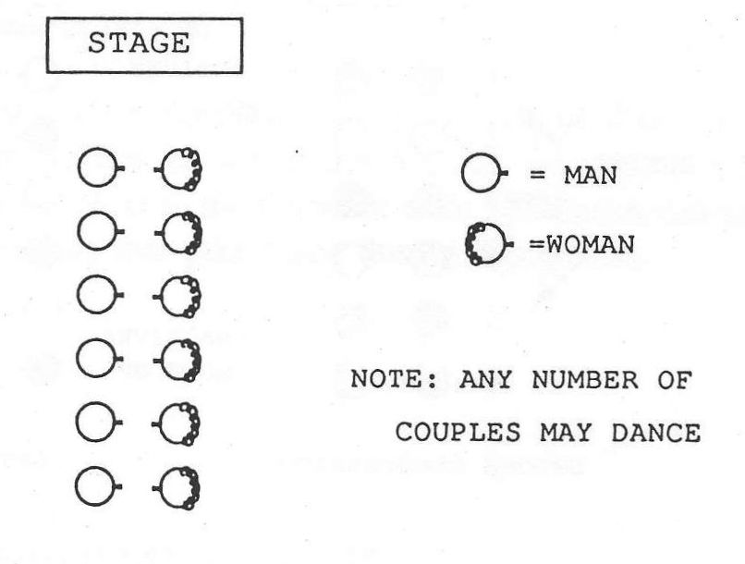
Figure 1. The Contra Dance Line

Essential to the concept of the contra dance is the idea of progression. In a typical contra dance, each couple dances with one other couple next to them in the line. Each time through the dance, in the course of executing the figures, the couples move either up the set or down the set one place. Most commonly the first, third, fifth, and other odd-numbered couples, or active couples (numbered from the head of the set, the end closest to the band) move down the set one place during a single repetition of the dance, and the even-numbered couples, or inactive couples, move up the set one place in the same time period. (Down the set means away from the music and up the set means toward the music.) If the dance continues long enough, a single couple may move all the way to the bottom of the set as an active couple, and then move all the way back to the top of the set as an inactive couple. This movement is what is meant by the progression. The progression allows every couple in a set to dance with every other couple in the set, which is one of the distinctive and delightful features of the contra dance formation.

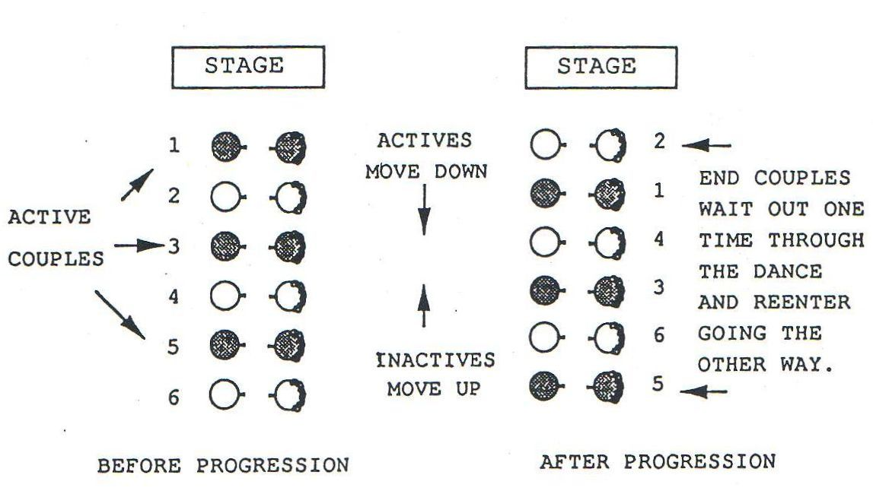
Figure 2. The Progression

The dance figures themselves resemble and in many cases are identical to the figures many of us associate with square dance, figures such as the "star," the "circle," and the "dosido." They are generally danced within a subset of four people (called a "minor set") consisting of one active couple and the inactive couple below them.
To make clear how the contra dance works, I will present two examples. The first is a dance called "British Grenadier," which is a traditional dance. The second is a dance called "The Ritz," and it is a recently composed dance.

BRITISH GRENADIER

This is the way the dance "British Grenadier" would look written on a typical dance caller's cue card:

A1 Actives down the outside and back to place.
A2 Actives down the center, turn individually, come back and cast off with the inactives.
B1 Star right, star left
B2 Right and left through across the set, and back again.

(Adapted from Jennings 1983:38)

The tunes used for contra dancing usually consist of four eight-bar phrases in the form AABB, to which the A1, A2, B1 and B2 refer in the dance notes above. Next to the letter for each phrase is a description of the dance movements that take place during that phrase.
"British Grenadier" is danced in the proper formation (see Appendix). This means that the men all stand in one line and the woman in the other:

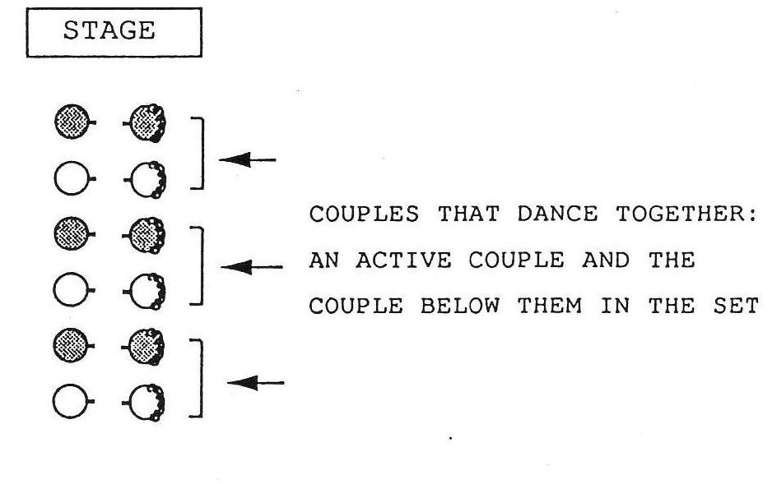
Figure 3. The Proper Formation

As the dancers line up, they figure out who is active and who is inactive by taking hands in their minor sets of four people all the way down the line. When the dancers are ready, the caller leads them in a walk-through of the dance.
During the first eight bars of music, the odd-numbered couples, or active couples, are instructed to separate from one another and go down the outside of the set, turn, and come back to place:

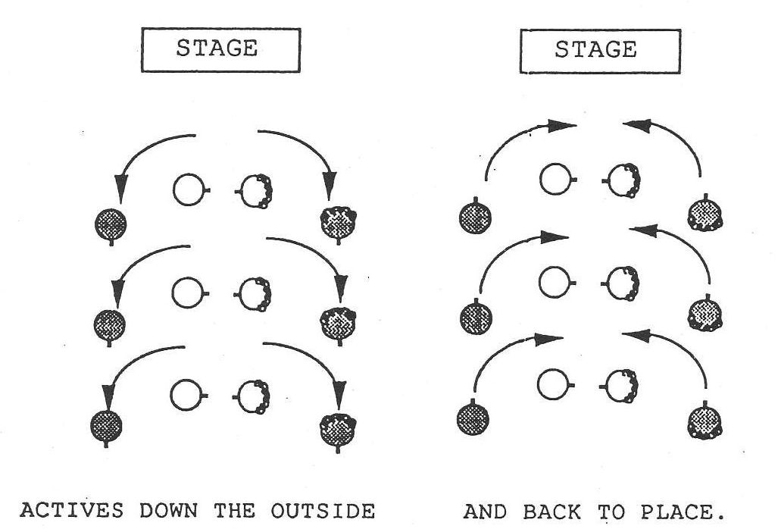
Figure 4. Down the Outside and Back in "British Grenadier"

During the second eight bars of music these same couples go down the center of the set together, turn individually, and come back almost to place. When they reach the inactive couple with whom they are dancing the active couples do a "cast off" around the inactive couple by holding them at the waist and turning around with them until they are back in line again. The result of this maneuver is that the active couples have progressed one place down the set, where they remain for the rest of the dance sequence. This establishes the progression (see Appendix).

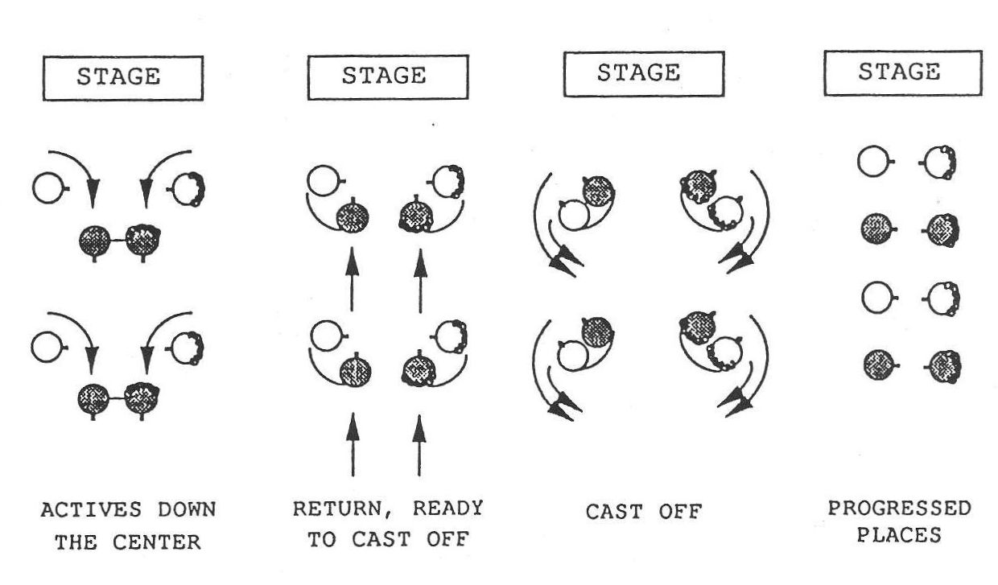
Figure 5. Cast Off in "British Grenadier"

During the third eight bars of the music the active couple and the inactive couple make a "right hand star" by placing all their right hands together and walking around in a little circle; they then turn to face the other way, place their left hands together, and walk back to place in a "left hand star."

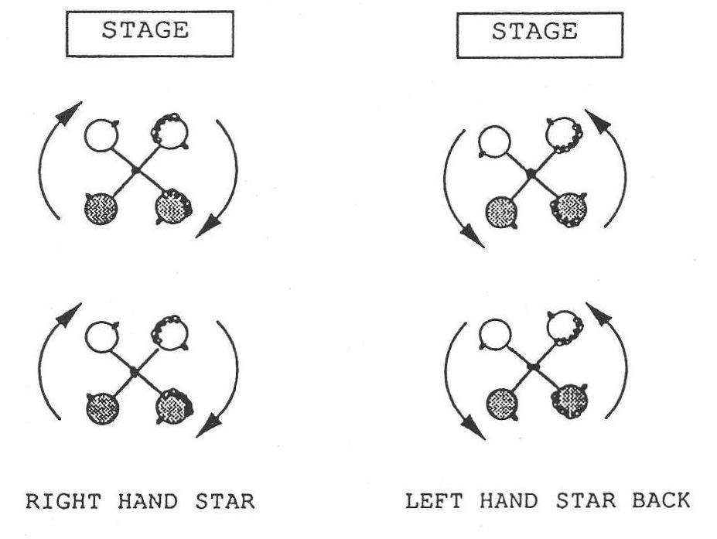
Figure 6. The Star in "British Grenadier"

During the last eight bars of the music the dancers in the subset of four walk across the set passing right shoulders with their partners, turn together with their neighbors, and in like manner cross the set again and turn back to place. This figure is called a "right and left through."

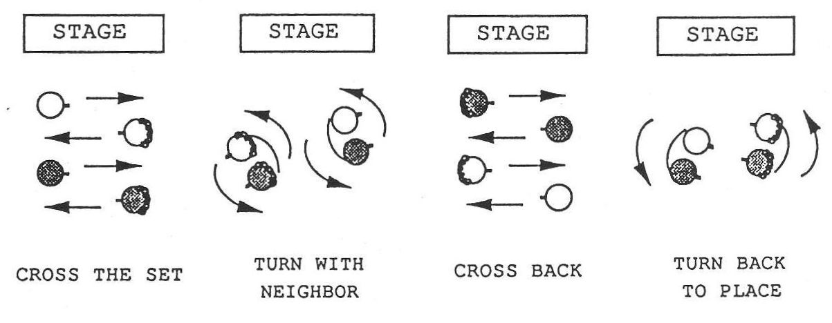
Figure 7. Right and Left Through in "British Grenadier"

This completes one round of the dance. To begin the next round, the active couples separate and go down the outside of the set again, passing first the new inactive couple with whom they will dance during this new round of the dance.
"British Grenadier" exhibits a number of features typical of the traditional contra dance. The dance uses the proper formation, which was most common in the dances collected by Holden in the 1950s and is now relatively rare. The "cast off" is used to accomplish the progression—a figure which does not fit in well with today's more symmetrical dances, because it gives the active couples most of the action. Both the "star" and the "right and left through" are made up of symmetrical halves, the "star" going right and then back to the left, and the "right and left through" going across the set and back again. In today's dances the figures that either revolve or cross the set are most often done in only one direction and the return is accomplished in some other way, if at all. Finally, "British Grenadier" has no swing, which is seldom the case in contemporary dances.

THE RITZ, BY GENE HUBERT

Here is what a dance card for "The Ritz" looks like:

A1 Right hand star once and a quarter around. Allemande left with the next person along the line.
A2 Balance and swing your partner.
B1 Lines go forward and back. Ladies chain across.
B2 Hey for four starting with the women passing right shoulders in the center.

(Hubert 1986:5)

This dance is an example of a modern composed contra dance. It begins in the improper formation. This means that after the dancers have lined up with the men on one side and the women on the other, the caller will ask the active couples to change places with their partners, which results in two lines of alternating gender like this:

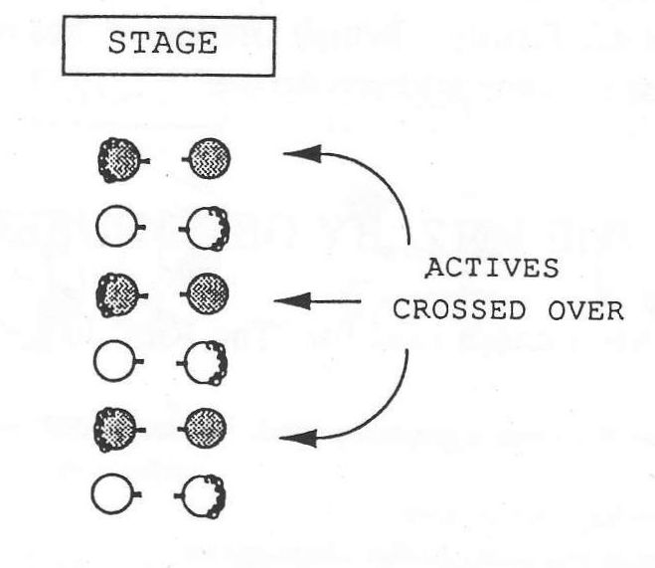
Figure 8. The Improper Formation

The dance begins with a "right hand star" within each set of four dancers. Dancers take right hands with one another in one of several possible holds, and they turn the "star" once and then a quarter more, so each dancer ends up one place farther around the little circle than he or she started. The use of fractional turns is very common in today's composed contra dances.

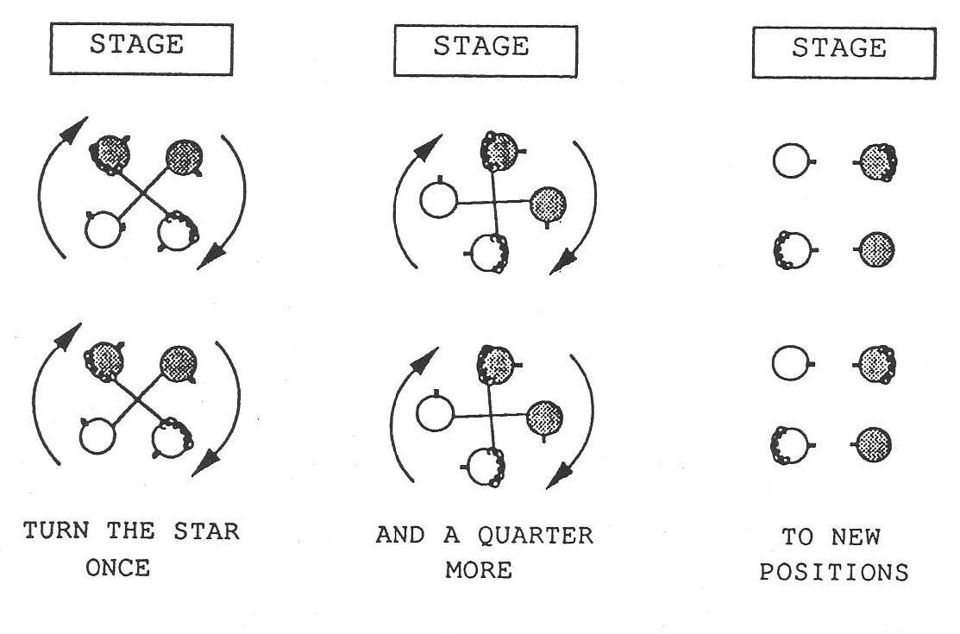
Figure 9. Star Once and Three-Quarters in "The Ritz"

The next move is an "allemande left" once around (a hand turn using the left hand) with the next person in line. This new person is not in the minor set with whom most of the dance is executed. This too is typical of many of the modern dances where the dance figures expand to include dancers from neighboring subgroups. The "star" and the "allemande" together make up the first A part of the music.

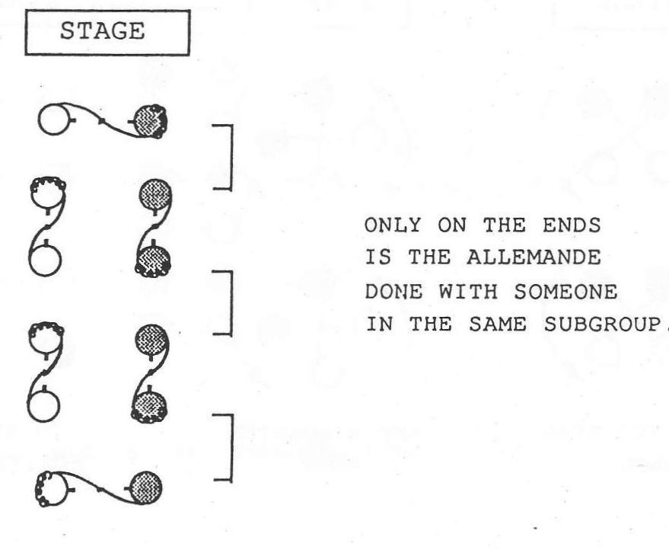
Figure 10. Allemande Left in "The Ritz"

Dancers are now standing on the same side of the set as their partners, and the next figure is a "balance and swing" with one's partner for everybody. In the traditional dances partner swings tend to be only for the active couples, and tend to occur in the center of the set. In the modern dances partner swings are generally for everyone, and occur on the sides of the sets so there will be room for everyone to swing at once. The standard "balance" involves each dancer stepping on the left foot and kicking up the right (or vice versa), and then stepping on the right foot and kicking up the left (or vice versa). The "swing" is in ballroom position and is done with a buzz step (see Appendix). The "balance and swing" fill the second A part of the music.

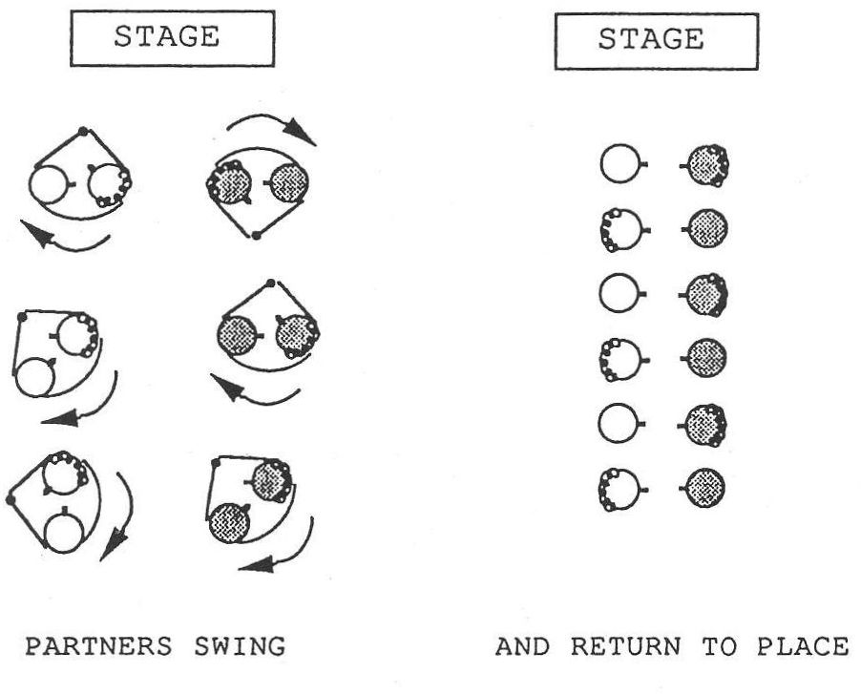
Figure 11. Swing in "The Ritz"

Next the dancers take hands in the long lines comprising the contra set and in these long lines they walk forward four steps toward the other line, and then back up four steps to place.

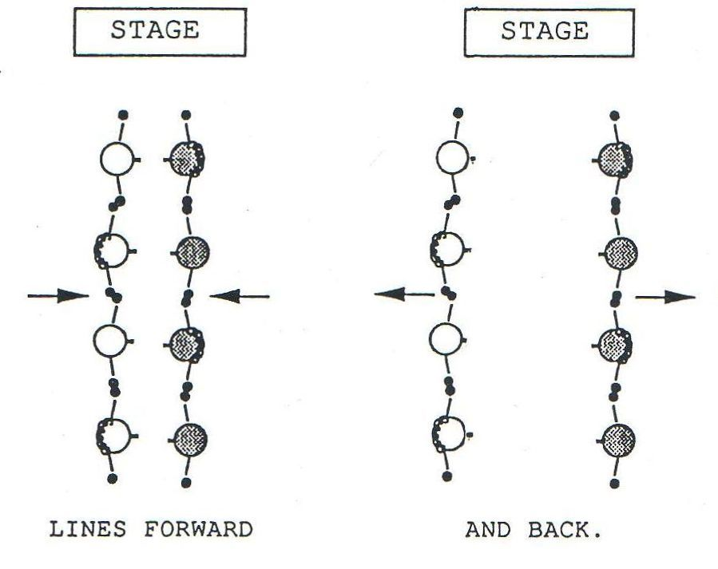
Figure 12. Lines Forward and Back in "The Ritz"

The "ladies chain" follows. In this figure the two women take right hands and walk past each other to the other side of the set, where they are turned by the man on that side. In this dance they do not chain back across the set. The half chain finishes the progression, since the women are turned to the right hand side of the opposite man, one place away from where they started the dance.

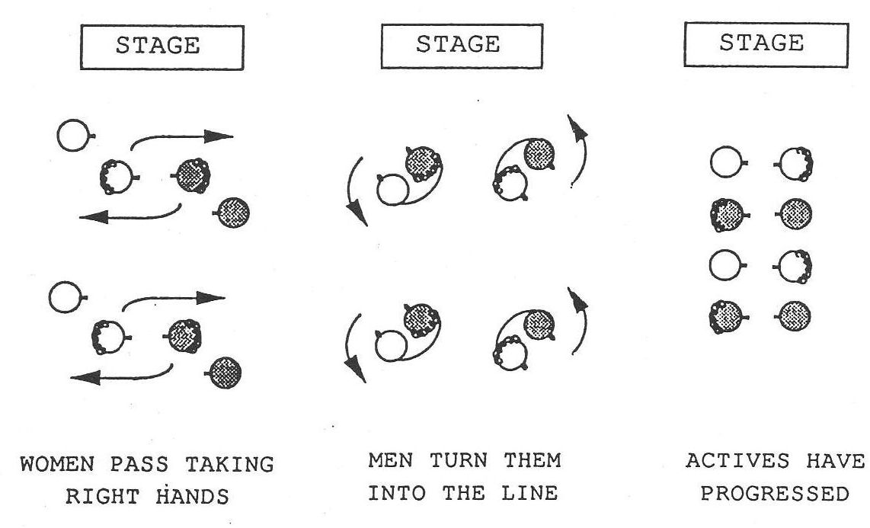
Figure 13. Half Ladies Chain in "The Ritz"

The final B part of the music accompanies a "hey for four" which begins with the ladies passing by the right shoulders and the men following in a weaving figure which eventually brings everyone back to their original position. The "hey" is a figure from English country dance that was incorporated into the American contra dance during the 1970s. Now an evening of contra dance rarely goes by in which there is not at least one dance with a "hey".

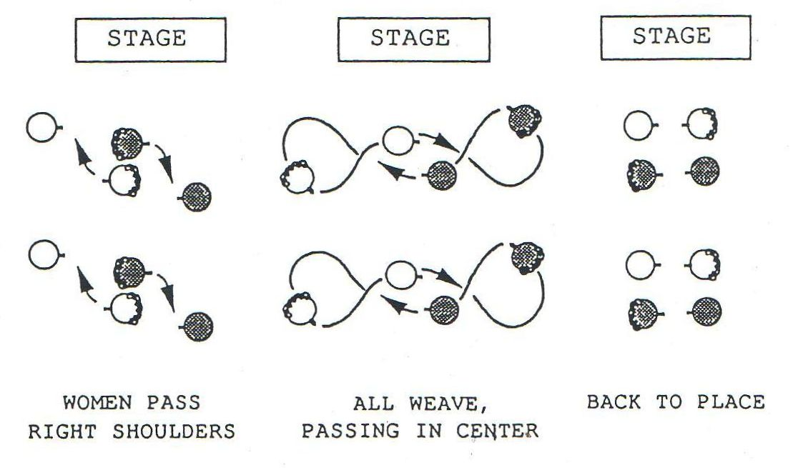
Figure 14. Hey for Four in "The Ritz"

The dancers begin the next round of the dance by weaving out of the "hey" and directly into a "right hand star" with the next couple below them in line.
This dance illustrates some of the ways the modern dances differ from the older traditional ones: The use of "fractional figures" (my term); the expansion of figures to include dancers outside the subgroup of four; the popularity of the "swing," especially the partner swing for everyone at once, done on the sides of the set; the use of half figures such as the half "ladies chain"; and the use of figures from other dance traditions such as the "hey" from English country dance. These and other basic figures are described and illustrated in the Appendix, and the reader is urged to familiarize himself or herself with these figures before proceeding.

THE MUSIC

As noted above, a contra dance tune is usually of the form AABB, each phrase being eight measures (or sixteen beats) long. One repetition of the typical contra dance is thus thirty-two measures long, or sixty-four beats long. (Exceptions do occur, including tunes of the form ABAB and tunes that are not thirty-two bars in length, but they are less common.) This format of four eight-measure sections is used by callers and choreographers in notating contra dances on paper, and in discussing the moves of a contra dance with one another. In conversation, a caller might refer to the circle "in the first A part" or the swing "in the second B part." The dancers may be less aware of the structure of the music and how it fits the structure of the dance, especially when they are beginners. However, it is essential for a caller to understand this relationship in order to call a dance.
Traditionally some dances such as "Hull's Victory," "Chorus Jig," "Rory O'More," and "Petronella" have always been danced to particular tunes by the same names. Contemporary contra dances are not generally matched to specific tunes, although occasionally a choreographer will be inspired by a particular tune to write a dance that works well with that tune. As a rule, however, a modern contra dance is danced to many different tunes, depending on the capabilities of the band and the preferences of the caller.
A contra dance band can consist of a single instrumentalist—a fiddle player or an accordionist, for example—but most typically there will be several musicians. Melody instruments, such as the fiddle, accordion, flute or tin whistle, banjo, or mandolin, provide the musical phrase that accompanies the dance. Bass instruments, such as the piano, guitar, or bass fiddle, provide the downbeat, which helps the dancers dance in time with the music. Rhythm instruments, such as the guitar, piano, or banjo, provide the upbeat or "lift," which gives the dancers support in moving to the music. Percussion instruments, such as spoons or wood blocks, accent the music and provide variety in the sound (Morningstar 1982). Musicians are also experimenting with drums (Sutherland 1990) and with brass instruments and woodwinds, such as the trombone, oboe, clarinet, and tuba, bringing back some of the instrumentation of the dance bands in the early part of this century.

The Composing of Contra Dances

The continuing development of a traditional form such as the contra dance is dependent upon the creativity of individuals who are inspired to bring their own innovations into the tradition. If a new contra dance stays within the current cultural bounds, but adds an element of something exciting and new, then it will be taken up by the dancers and become a part of the ongoing tradition. If a new dance does not meet the aesthetic criteria of the dancers, or falls too far outside the bounds of the tradition, then the dance will fall away from the repertoire in short order. The creative individual is both guided by the tradition, and also in a position to influence its development. This chapter examines the work of individuals, surveying the techniques they use in the composing process, and their motivations for composing dance.
The invention of new contra dances did not begin with the current revival in the 1970s. Individuals have been composing them ever since the form has been danced. What is noteworthy about the current revival is the sheer number of new dances, and the possibility through modern communications for these dances to be widely and rapidly disseminated. This wide dissemination means not only that more communities use the new dances, but that dance composers are more likely to come into contact with and be influenced by one another's work, resulting in a kind of group aesthetic affecting dance communities all over the country.

THE COMPOSERS

The twenty-six individuals whom I interviewed are for the most part representative of the "big names" in contra dance choreography in the eastern part of the country, composers whose dances are well known and widespread. Exceptions include some well-known callers and musicians who do not compose but who work with the new dances, and a couple of less experienced composers who were in the right place at the right time to be interviewed. A general profile of these individuals may be useful.
Five of my informants are old enough to have been involved in country dancing before the contra dance revival of the early 1970s, and they took part in the beginnings of the composed-dance upsurge. Most of the others are in a middle age range of between 30 and 50, and first became involved in the contra dance revival as dancers in the 1970s or early 1980s.
At the time of the interviews, my informants had dancing experience ranging from seven years to forty-seven, with an average of twenty; their calling experience ranged from five to forty-six years, with an average of fifteen; and their experience as choreographers ranged from four to thirty-nine years, averaging thirteen. Fourteen of them have played musical instruments for dancing.
The occupations of these individuals are varied. Seven of them reported working in dance leadership as their primary occupation. Another seven work in dance calling or music as a part-time occupation, but make a larger percentage of their income through other work. Occupations represented included education and human services (seven individuals); computers, science, and engineering (seven individuals); and the occupations of printer, proofreader, pharmacist, and chef.
Most of these dance composers are men, which I believe is related to the fact that most traveling callers are men, and it is these professionals whose choreography becomes most widely known. The women who are composing contra dance are more locally based. Only four women are represented in my study; I made some effort to seek out women dance composers, but my primary goal was to interview the composers of the better known dances, most of whom are, in fact, men. A follow-up study on composing activity at the local level would probably rectify this gender imbalance.
All of my informants are dedicated to the well being of the dance revival, and generously shared their knowledge, their feelings, and their concerns as dancers and as dance leaders in the revival today.

THE COMPOSITION PROCESS

One of the initial problems I encountered in my conversations with these individuals was the question of what to call this process of composing new contra dances. My informants used a number of terms, including: "write a dance," "compose a dance," "create a dance," "conceive a dance," "concoct a dance," "do choreography," "make up a dance," "put together a dance," and "throw together a dance." The first two terms, "write" and "compose," were by far the most frequent.
These terms reflect different ways of thinking about the composition process itself. The term "write" implies a literary model, the making of a story. This literary model is echoed in the frequent use of the term "story line" in discussing dance structure, as we shall see in Chapter 5. A contra dance may be seen as a story both in terms of the logic of its physical movements—how well they lead into one another—and in terms of its social interactions—the people who dance with one another at various points in the dance.
Other terms such as "compose," "create," "conceive," "concoct," and "make up," imply a process coming from the artistic imagination—the striking of the muse. "Compose" also brings to mind the musical framework behind the dance sequences, since it is a term commonly used for the creation of music. This view of dance composition as art is an important element in the composing process.
Terms such as "do choreography" and "put together a dance" imply a more technological approach to the process, while "throw together" emphasizes the spontaneous casual approach experienced by most dance composers at one time or another, when a dance must be composed in a hurry. There is indeed a technological aspect to the composition process that complements the artistic one. We will find that all of these ways of viewing the creative process—the making of a story, the creating of a work of art, and the use of a technical approach to dance composition—are important elements in the composing of contra dance.
I have chosen to use the term "compose" for the creation of new dances, because this term, along with the term "write," is used most frequently by the composers themselves. I choose to avoid the term "write," because I feel it may narrow the reader's interpretation of the process by focusing on the story aspect of the dance.
Reflected in these terms is also the issue of how much original work is actually involved in composing new contra dances, and to what extent it is possible to "compose" using a limited pool of common figures on which to draw. Some composers object to the terms that imply artistic creation on the grounds that there is nothing new under the contra dance sun and that anyone can place figures in a sequence. Fred Breunig and Fred Park offered me their opinions on this issue:

To talk about composing dances I think is sort of funny. . . . It's mostly just restructuring things and reordering things and pulling them from different traditions. And so I usually use the verb "to put together" a dance instead of "composing." (Breunig 1990)

I didn't invent "dosido," you know. So if I put "dosido" in a dance that I write, it's usually going to go right next to something else that I didn't write. "Swing your partner." I didn't write that. The "ladies chain." I didn't write that, you know. . . . The dance choreographer is really an assembler of old parts. (Park 1990)

We shall see that the composition of dances may be anything from a brief, practical, basically unpondered revision, to an artistic creation that has been worked and reworked to approach its creator's sense of aesthetic perfection.

TECHNIQUES OF COMPOSITION

Most contra dance composers get their start through the revising of existing dances, and through this process of revision they develop the skills to compose original dances. The techniques used by these composers follow some general patterns.
The most common approach to the writing of a new dance seems to be to build the dance around an interesting movement, idea, or transition that has caught the composer's fancy. This interesting element is most commonly referred to as the "gimmick." The composer becomes interested in a particular gimmick, and then the trick is to incorporate it into a dance that also flows nicely, includes a swing or two, and accomplishes the progression successfully, all within thirty-two bars of music.
Contra dance composers often become interested in a gimmick as a result of dancing a particular dance and especially enjoying one part of it. This leads to a desire on their part to incorporate this enjoyable fragment into a dance of their own. Choreographer Ted Sannella shared his experience:

I just get these little ideas, and I store them in my mind, and then when the time comes that I'm working on some dance, they come back, and I incorporate those things into dances. (Sannella 1990a)

Many gimmicks are in this way taken from pre-existing dances and given a new context by the composer. Here are two examples of the use of gimmicks from other dances in the creation of a new dance:

(Ted Sannella, discussing the dance, "Jan and Dan," written for his daughter's wedding) David Kaynor wrote a dance where you circle . . . with the opposite couple . . . left three-quarters, and then the active couple ducks through to the next and goes four in line down the hall with that next couple. And I just liked the idea of ducking through, and then just joining onto the next couple and going four in line. (Sannella 1990a)

(Steve Zakon, discussing the dance, "With Thanks to the Dean") I did a dance by Dan Pearl called "The Rendezvous," and it had this neat move where you circled and slid on to a new couple and circled. And that's how he ended the dance. And I thought, that's kind of a neat transition. . . . How else could I use it? And I picked it and put it into where it was not the end of the dance. It was in the middle of the dance, and I did something before it and something after it. (Zakon 1990)

Another way of developing a gimmick is to explore a new combination of existing figures, a combination which has not occurred in other dances, but which uses figures that occur in other dances. The transition between two figures is often the focal point of the use of a new combination, as Roger Diggle, a caller and musician from Madison, Wisconsin, describes here:

(Discussing the dance, "Roll in the Hey") If you're doing a "hey for four" and you can "star right" with a new couple after that, well you should be able to do a "hey for four" and "circle left" with . . . the same new couple after that just as easily, it seemed to me. . . . So one of my earliest dances actually was a dance to test that transition and see if it would work, because I couldn't find any dances where that happened. And not only did it work, but it's turned out to be probably one of the most widely distributed dances that I wrote. (Diggle 1990)

A gimmick may also take the form of an existing move from some other dance tradition which is imported into the contra dance tradition. Contra dance composers have taken moves from Appalachian dance, western square dance and English country dance, for example, and used them to compose a contra dance that is unusual and different, as illustrated by these examples from Fred Breunig and Ted Sannella:

(Discussing the dance, "Ya Gotta Wanna") "Symmetrical Force" that Fred Feild put together used a "four-leaf clover," which is a southern Appalachian square dance figure. . . . And what "Ya Gotta Wanna" uses, . . . you make and break a "four-leaf clover" all in one motion. It's called "roll the barrel." (Breunig 1990)

My dance, "Bonnie Jean," I think, was the first, probably the first of the revival contras that had a "hey for four". . . . My inspiration came from my enjoyment of doing heys in English country dancing. . . . And now you don't find an evening's program without a dance that has a "hey" in it. (Sannella 1990a)

New dances have emerged from the invention of an altered formation, or the use of a particular subset of the contra dance formation. The best known contemporary example is Ted Sannella's "triplets." The triplet is a dance which uses the longways formation, but limits each set to exactly three couples. Sannella explains how he got the idea to compose triplets:

I was dancing at Pinewoods and doing English country dancing, and I learned the dance, "Fandango," and I realized what a wonderful idea: a dance with three couples where one couple is active, and then another couple is active, and then the third couple is active, and the fourth time you do it, the first couple starts again. I said, why can't we do that in our American dances? . . . And so I decided I'd try writing some dances where you dance with three couples. That's how Ted's Triplets were born. (Sannella 1990a)

Ted's Triplets have spread across the country, and there are now other composers creating new dances in this form.
Another source of inspiration for dance composers, in addition to the gimmick and the form itself, is the music to which the dance is danced. Although most contra dances now can be danced to many different tunes, some composers are inspired to write a dance that goes nicely with a particular tune. In the composing process, they attempt to make the pacing of the dance movements fit the pacing of that dance tune. Becky Hill used this technique to compose a dance:

(The tune) "Druid's Reel" has these stops in it that are very, they're just wonderful. . . . The first dance I wrote to "Druid's Reel" . . . I'm trying to get the whole floor to come to a dead stop when the music stops, which is hard, because it's on the last two beats of an eight count phrase. (Hill 1990)

A drawback of this approach is that the musicians at hand may not know the tune in question, and the dance will in reality be accompanied by many other tunes in its travels—so the dance-tune match-up may be in vain.
In order to compose a dance with a particular gimmick in it, the composer must maneuver the dancers into the position required by the gimmick, and then maneuver them back to a progressed place from which the dance can start again. To do this, the composer may start at the end of the dance and work backwards, or start at both ends and work toward the middle, in an attempt to maneuver the dancers into the necessary positions to make the gimmick work. Tony Parkes uses this technique:

Sometimes I'll write a dance backwards. . . . I wanted a dance where I had that figure of "pass through and the ends turn in," and when you duck through there's your partner. . . . I wanted that to be the gimmick. So I put that down on paper saying, OK, that's the end of the dance. Now what do I have to do at the beginning of the dance to get people in such a position that that's the person that will be coming toward them? (T. Parkes 1990)

As a contra dance composer begins to put together a dance, he or she will find it necessary to visualize the dance in some way in order to see if it accomplishes the necessary movements that result in a progression. Some composers, such as Fred Park, are able to do this easily in their heads:

I have a great ease in picturing dance movement in my mind. I can drive down the road and keep my eye on the lines and look at the traffic in the mirrors and look at the traffic ahead, and conceptualize movement, and keep everybody clear where they are, which way they are facing, whose hand they've got. (Park 1990)

Other composers, especially when they are in the process of learning dance composition, like to have some sort of visual aid in picturing the movements of the dancers. In her early composing efforts, Becky Hill used spools as composing tools:

For the first couple of years . . . I always had to have little spools, you know, with blue and pink? I put little paper clips and little heads with smiley faces, so I knew which way their "ocean wave" would go, and little pipe cleaners for little arms, so I could remember which is left and right. And now I can do it in my head, unless it gets really complex. (Hill 1990)

Another method of visualization is to get up by oneself and dance the dance, trying out each of the parts in turn, both the man's part and the woman's part, and including the roles of both the active couple and the inactive couple.
The ultimate method of visualization is, of course, to get some dancers together to try the dance and see how it works. Many composers are callers for their own local dance, and they can use their home dancers to test new dance ideas. Steve Zakon uses the dance in Nelson, New Hampshire, as a place to try out his new dances:

Nelson [New Hampshire] is my testing ground. . . . I get up and say, OK, it's guinea pig time. This one's never been called before. Tell me what you think of it. And I'll try it. And that's fortunate, because I've had some real losers. . . . I wouldn't want to pull it out when I'm on the road and in a new place, and think I'm going to wow the crowd with this dance, and there's one glitch that I didn't think about. I'll even say, is that a keeper? And they'll say, yeh, but we felt rushed at this part. It should be once around instead of twice. Or there's too much of a pause here. (Zakon 1990)

If a particular dance does not work out very well, a composer will often keep it for future revision, since such a dance represents an unsolved puzzle waiting for a solution:

Fifty percent of the dances I write just end up collecting dust. . . . I screen them out. . . . What you thought was good last year, you can see a glitch in it when you relook at it and examine it again, and then maybe change it. (Hinds 1990)

As I talked to these dance composers, I wondered to what extent it was possible to put together a "good" contra dance through technique alone. I asked this question to Gene Hubert, a dance choreographer from Bethesda, Maryland, who works with computers as well as composing dances, and he replied:

There's always subtle little things that I don't think you could ever get [with technique alone]. . . . Things like, if you do a "half promenade" across the set, you don't end up exactly square from each other, directly across the set. You end up a little offset, because the guys just pass left shoulders and you're a little off to the side. So if you follow that by a "circle left," you're already a little bit in the circle left direction. . . . Maybe it saves you one step. It means that that "circle left" maybe could take one beat less. . . . In that context a circle all the way around would be relatively forgiving, where in another context, say at the end of a short swing, people will have all kinds of trouble in the world. . . . It just takes a lot of time and a lot of experience from doing a lot of dances before you get into some of the really subtle things like that, that really do make an important difference in how well the dance works. So it's kind of technology, but it'll always be an art. (Hubert 1990b)

A summary of the dance composition process might go something like this: A composer is inspired by an idea, either through dancing a dance or through pondering the possibilities, and builds a dance around this idea or gimmick. First, the gimmick must be set into the dance and other moves placed around it so the dancers can both enter and leave the gimmick smoothly. Then the dance must be filled out with other moves that do not detract from the gimmick, that make the dance fit within the cultural bounds of the tradition, that follow certain aesthetic principles (see Chapter 5), and that assure the accomplishment of the progression.
It will be helpful to illustrate dance composing techniques by following the composition of one dance. I have chosen Tony Parkes' dance, "Shadrack's Delight" (see Appendix), both because it is a classic among the contemporary composed dances, and because in our interview he gave a clear and detailed description of how he came to write it:

(The gimmick.) And "Shadrack's Delight," I can tell you exactly . . . how I came to write it. I've always liked the move called "balance four in line," where you're facing in alternate directions and your arms are acting as springs against each other. . . . And in the modern western square dance field they used that figure a lot. . . . But what they'd lost was the timing. They would say rock forward and rock back, but they wouldn't do it with the music. . . . And I wanted to take some of the things that they had invented, or reinvented, and incorporate them into a New England dance with good timing and phrasing, and see if we could make them more satisfying to do.

(Fitting in the gimmick.) The problem is that to do a "swing through" comfortably takes six steps, and music is written in fours and eights. . . . I could have tightened up the timing and had people kind of pull their way along the line instead of doing nice round half turns, and done the whole thing, both of the turns, in four steps rather than six. Or I could have stretched it out and made it very elegant, and had each turn take four steps so the whole thing took eight. . . . but I knew there was no way I was going to get people to turn right two three four, left two three four, unless I was imitating a dance from two hundred years ago. So the only way to force people to do both turns, to do each turn in four steps, was to put a "balance" in between the turns. So that's what I did.

(Placing moves around the gimmick.) I started with a "dosido," which is the way that modern square dancers get into an "ocean wave" formation. . . . And then I had a "balance" and a "right hand turn," "balance" and a "left hand turn," and I decided that was very good in terms of feel, and alternating the choppy with the smooth. . . . And I said, well where does that end you up? And I saw that you're coming right toward your partner so why not swing at that point? And I had eight counts of music where we needed to do something, and that was just about the right time for a nice medium-length swing. So I had my first half of the dance all set.

(Filling out the dance with non-detracting, traditional figures.) For the second half, I took what were basically standard contra dance figures. I was still thinking in very traditional terms. . . . In the second half there's always a "down the center and back," and there's always something at the end like "ladies chain" or "right and left." So the second half of "Shadrack" is basically a take-off on that idea, where instead of just the one couple going down the middle, you have all four people going down, come back and do a "cast off."

(Making the progression work.) And then since the gents are on the wrong side to start over again, you do a half "right and left" and a "ladies half chain." And if you do one of each, then everybody's back where they belong, ready to go on to the next. (T. Parkes 1990)

"Shadrack's Delight" incorporated enough innovation to be exciting and memorable to the dancers, through the alternate turning and balancing in lines of four dancers. At the same time it used enough traditional material to establish itself clearly within the contra dance tradition and to be accepted as such by the dance community. So the dance exhibits a nice balance between the old and the new.
This dance also illustrates the balance of art and technology in the composing process. Any of the timings considered under "fitting in the gimmick" would have worked from a technical standpoint, and the art was in making the timing feel right consistently, by forcing dancers to dance it in a particular way.

NAMING DANCES

When a composer has come up with a dance that he or she thinks is really good, then an effort is made to give it a good name, in the hopes that the dance will last. As Roger Diggle explains:

It makes a difference, I think, if you've got an ear-catching title. People . . . take a little bit more serious look at a dance than if it's just something ho-hum. (Diggle 1990)

Giving a dance a name is one way of connecting that new dance to the tradition of which it becomes a part.

Names are as important as the thing or the person or the dance. And especially if I think the dance is going to last, I want to put a name on it that's not a real cutesy name, that's certainly not a suggestive name . . . where it might be of doubtful taste. I want a name with a little bit of dignity to it, whether it's a formal dignity, . . . or a more grass-roots kind of dignity. But just something that speaks to the tradition of names that has been carried on. (T. Parkes 1990)

I found a wide variety of kinds of names for composed contra dances. Some names reflect something special in the dance itself, usually a particular combination of moves that is distinctive, or a feature of the social interaction within the dance:

"Third Time's the Charm" is [an] example, because you balance with your partner twice, and then finally when you balance your partner for the third time you get to swing. (Diggle 1990)

(Concerning his dance, "Boomerang") It is said that boomerangs always come back and so does your partner in this dance. (Hubert 1990b)

Other dance names have community references, alluding to people, towns, dance halls, dance festivals, special occasions, tunes, or bands. For example, a dance may be named for a person that the composer chooses to honor for one reason or another, or for someone who has contributed to the country dance movement:

"Marian's Delight," I wrote because Marian Hepburn, who was in the area, was leaving, going off to New Jersey, and she was a really special person and loved to do the "gypsy," had these big brown eyes and just loved the "gypsy." And so I wrote it for her, because she was leaving. (Kopp 1990)

Probably the dance that's been most successful that I've written is one written for Ralph Page. . . . It was called "With Thanks to the Dean." . . . And it's amazing now how many dancers have never even heard of him. And we're doing what we're doing largely because he did it, in the thirties and forties, and he kept it alive. (Zakon 1990)

A dance may be named for the place it was composed, or the place it was first danced:

"Byland Abbey," it's a ruin in North Yorkshire that we visited when we were there in 1975. . . . I dedicated it to the monks who lived in an abbey and probably never got to dance. (Breunig 1990)

"Reel in C#": The name alludes to the main dance pavilion at Pinewoods Camp, which in turn is a play on the name of Cecil Sharp, the Englishman who popularized folk music and dance in England and Appalachia. (T. Parkes 1990)

Sometimes the name for a dance is inspired by a special occasion or event, or by a particular time of year:

I have a daughter who's getting married this Saturday, and I just wrote a dance that I'm going to call at her wedding reception, in honor of both of them, my daughter and her fiancé, and that'll be the first time it'll be danced. . . . [It is] named for my daughter and her fiancé. It's called "Jan and Dan." (Sannella 1990a)

In Vermont we have this season in between winter and spring, which is called the mud season. It's when the frost is coming out. I thought, there's no dance for mud season. So I put together this dance where the first figure is a "right hand star," . . . twice around is the minimum, but some people try to get around three times. You're supposed to be wheels spinning in the mud. . . . I call that one "Reel Mud." (Breunig 1990)

Sometimes a dance name is fashioned from the name of another dance to acknowledge an indebtedness to the composer of that other dance or some other relationship between the two dances:

I spent the summer of 1984 traveling around to as many dance events as possible. One night in July I stopped in Hartford, Connecticut for a dance where Ralph Sweet called "Winter of '82," a contra dance by Steve Schnur that utilized the figure in A2 which I call "interchanging waves." In Steve's original dance, the "balance and swing" was with your neighbor. I thought it would be nice to find your partner at the end of the "interchanging waves" so I wrote out this sequence. . . . After some correspondence and discussion, Steve and I agreed to list this as a jointly authored dance with the name "Summer of '84." (Hubert 1990b)

There are dance names based on puns and dances that receive only a number for identification:

"Lost in the Interstellar Haze" is [a] pun title, because there's a "star" at the beginning of the dance and a "star" at the end of the dance, and a "hey" in the middle of the dance where your partner is in a "hey" somewhere else and they're lost, or you're lost, somebody's lost, and so "Lost in the Interstellar Haze." (Diggle 1990)

I don't give [my triplets] names, because I have a hard time finding names. So I give them numbers. Ted's Triplet number forty was written on April 19th, 1989. (Sannella 1990a)

Ted Sannella makes the numbering of his triplets not only palatable, but actually distinctive, by encouraging the tradition described in Chapter 2, in which the dancers all cheer when the number is announced.
Many dance names are combinations of these various classifications and defy categorization:

"Inflation Reel" was a . . . dance where the gimmick was that I started out by doing the half "right and left" and the "ladies half chain" to get people all mixed up, and then brought them back with a "circle one and a quarter." And this was during the Nixon price freeze, so I, because of the quarter more in the circle I called it "Inflation Reel," and dedicated it to the Cost of Living Council. (T. Parkes 1990)

Contra dance names conform in many ways to the traditions of naming which have developed historically within the dance tradition; and they also reflect the sense of creativity and fun that characterizes the contemporary contra dance scene.

DISSEMINATION OF CONTRA DANCES

In order to learn how the newly composed contra dances make their way out into the dance communities and travel from one community to another, I asked my informants how their own dances got out and where they themselves found their material if they were callers.
One of the primary means of dance dissemination is the collecting of dances at dance events. Callers may find themselves dancing a dance that they particularly like and decide to collect it. At the earliest opportunity, they take a three by five card or a napkin or an old dance announcement and write down the dance sequence. Don Theyken comments on the phenomenon of dance collecting:

You're just dancing a dance and all of a sudden you say, wow, I like this. You might dance it the first few times through and you go uuh uuh uuh [sounds of indecision], and after about ten times you say, this is really nice. And then the dance is over, you go down, sit down and write it down. I've never had a caller refuse to give me a dance or any information on a dance. (Theyken 1990)

Collectors of dances may or may not take the trouble to find out the names and composers of the dances they collect, and a dance will sometimes be spread without complete information or with errors in the sequence.
The exchange of dances is intensified at dance camps and dance festivals. At these events there is a high concentration of avid dancers and active callers and bands, and many new dances are tried out in such a setting. David Kaynor describes how one of his most popular dances got into circulation:

I think that the thing that really got it out there was calling it at dance camp. There's something about dance camp that makes things . . . really take on a magnified importance. . . . Somewhere else you go to a regular public dance and you dance "Mary Cay's Reel" and say, oh, a passable dance, just another contra dance where I had fun with my partner. But at dance camp you say, wow wow! we did this dance that was really amazing! And that may be why that dance proliferated. (Kaynor 1990b)

At dance camps and festivals dance leaders sit down informally or in the context of workshops and exchange material. Ted Sannella describes the process:

The New England Folk Festival in Natick, Massachusetts, has been going for over forty-seven years now. . . . Callers coming from all over the place, other parts of the country, coming to dance, coming to call, coming to learn new material, coming to meet other callers. . . . And after the festival we sit down, usually two or three callers, and compare notes on what dances we've picked up. We put them on cards and spread them around. (Sannella 1990a)

Caller Beth Parkes from Arlington, Massachusetts, points out that it is not always a reliable measure of the usefulness of a dance to meet it first at a dance festival or camp, where the participants are highly skilled and the callers and musicians are top-notch:

You go to a dance and you think, ooo that's wonderful! The danger in that of course is that often whether a dance is good or not when you dance it will depend on the context in which it is danced. At a weekend or a festival where everybody's a really smooth dancer and the music is hot, . . . you can throw the worst possible dance at those dancers and they will make it wonderful, because the dancers will be so good. (B. Parkes 1990)

Tony Parkes adds:

Yeh. You go back and throw it at your regular group that includes a lot of beginners maybe and a lot of shaky dancers, and it falls apart. (T. Parkes 1990)

The traveling of callers and bands also facilitates the spread of new dances. Many callers and bands travel from dance event to dance event, or from dance camp to dance camp, where they are hired for their expertise and their ability to draw dancers. In the course of these travels new dances are planted in local communities, or are picked up by callers and brought home to their own communities. Ted Sannella has traveled a great deal and shares his experience:

With communication and transportation such as it is, people go to festivals and go to conventions and they go to workshops. They go to dance camps all over the country. I call at a dance camp in West Virginia, for instance, and there'll be people there from Alaska. . . . If they're callers, . . . they write down notes and they take tape recorders, and they bring these new dances home with them. (Sannella 1990a)

The new dances travel within particular touring areas, such as up and down the coasts, but they also work their way from one coast to the other. Fred Park, in his travels as a dance caller, has noticed some interesting patterns in the dissemination of the dances from east to west:

When a western caller comes from Seattle, when they come to New England, the comments that you hear from the New England dancers are, you know it's really interesting, they're doing dances that were really popular here three or four years ago. I haven't seen these dances in a long time. It's sort of like stepping backwards in time. . . . A visiting New England caller in the west is going to implant in the west a dance that's going to take six months or a year before it's commonly known in the west. And by the time a year or two goes by and this western caller gets hired to come east, here comes the dance back to New England. That's what I'm seeing. (Park 1990)

Contra dances are also being carried overseas through the hiring of American callers for European dance camps and festivals. In Denmark, Margot Gunzenhauser has taught American contra and square dances, has trained Danes to call them, and has brought well-known callers from the United States over to bring in new material. Philippe Callens has been doing the same in Belgium. (Sannella 1990b:5)
New dances may also be exchanged through correspondence and phone calls with others "in the business." Fred Park describes how his initial collection of contra dances consisted of contributions from other callers, upon request:

I was totally paranoid when I realized I was going to have to do a contra dance weekend. . . . And so I simply said to all my friends in the mail who I knew were callers, I wrote letters and I said, send me contra dances. . . . So suddenly I was assaulted by a barrage of mail that I had solicited. (Park 1990)

Steve Zakon showed me a printout of dances by California composers that he had received from a California dancer's computer file. Ted Sannella gives and receives a lot of dances on the phone and by mail:

I'm on the phone all the time with callers around the country for one reason or another. . . . And I correspond also with a lot of callers. And I make it a point, whenever I write a letter to a caller, to include a dance that I think they . . . might call, something to spread around. . . . So that you might write a dance today, and it might be danced on the west coast tomorrow. I mean this couldn't happen twenty-five or thirty years ago. It's just amazing the way things are propagating, getting spread around. (Sannella 1990a)

Another way that callers get new dances is that they are simply handed them by dance composers who are eager to get their own dances out and who are not callers themselves. Steve Zakon points out that this can sometimes pose a problem for callers who may not be interested in calling these particular dances, but who sympathize with the composers' desire to get their material into circulation:

On a regular basis I get people handing me dances. "Gee, I'd like to know what you think of this one. And would you call this some time?" . . . Many of them are trying to be callers, and they're new, or they're not into traveling. . . . So they don't have the outlet to get their dances out. . . . Personally I get a little put out sometimes by people who hand me these booklets of dances, and they'll just say, "Here. Here are some of my dances. Here are some of my dances." I find it a little awkward. But what other venue do they have? How else can they get them out there? . . . I do look them over. In a few places I've liked some of them. And I make a point if I'm somewhere and I see that person in the crowd, I'll try to call it. (Zakon 1990)

Publications provide another source of new dances for callers. Some use older sources and either select carefully with the contemporary dancer in mind, or make alterations in the dances to tailor them to the modern aesthetic. There are also quite a few books of dances printed by composers who want to get their material into circulation. These dance collections seem to be used most when a composer has already established a reputation and callers want to explore more of their work. Gene Hubert has published three books of dances called Dizzy Dances, and he suggests:

I think that people probably get started on them by going to a dance and seeing some dance that they like that I wrote. And then they figure, well if he wrote one or two good ones, maybe there's some more in this book. (Hubert 1990b)

Larry Jennings' collection of contras, Zesty Contras, has been an important source book for many callers, since it contains over five hundred dances composed by many different people. Most collections contain the dances of a single composer, and are self-published. Dan Pearl expressed to me his concerns about the publication of dances:

There's very few outlets to publish dance. . . . Most callers who publish books tend to publish collections of their own figures. . . . They're kind of watering down the material. They're just sort of throwing dances together that, you know, . . . fill up the book. . . . Other places to get dances published I guess are very rare. But things like the Country Dance and Song Society Newsletter, they might publish one or two dances a month, or per issue. (Pearl 1990)

The country-wide exchange of dances results in a body of popular new material that is fashionable at any given time, particularly in urban areas, where the dissemination of new dances happens more quickly. Dan Pearl explains:

These days most callers who I've come across tend to call pretty much the standard repertoire, because of all the traveling going on. Everybody seems to be calling the same dances, the modern urban contra dancer repertoire. And only when you get into the small towns, the isolated areas maybe, Maine, or small dances where they don't even have a sound system, you get different material. Sort of like Darwin's finches. Here they've evolved in a different way. (Pearl 1990)

Once a dance is released, it enters the "folk process," and the composer loses control over what happens to it. Errors and variations may creep into the dance sequences as they are passed around, but the composers must let go of them and let them evolve as they are used and enjoyed by dancers in a wide variety of dance communities:

The folk process, like the game of telephone, affects these dances as they go from one person to the next. So when it finally comes around again, people will get the name wrong. They'll get the figures kind of wrong. The key figure which you composed the whole dance around will be changed to something else! But as Larry Jennings says in his book [Zesty Contras], usually the folk process improves dances. It does not destroy dances. . . . Dances are like kids. You raise them and you send them out into the world, and what they do with themselves at that point is really up to them. . . . You need to cut the strings. They have a life of their own at this point. (Pearl 1990)

OWNERSHIP OF DANCES

Because many factors come into the actual performance of a dance besides the choreography, the question of who creates a dance is a complex one. We have seen that a dance is in fact created cooperatively not only by the choreographer, but also by the caller, the musicians, and the dancers themselves. Good choreography is not enough. Therefore it is problematic to speak of a composer as "owning" a dance. Most dance composers nevertheless feel a sense of pride in their work and a sense of authorship. Because ownership is more of an issue today than it has been in the past, it is worthwhile to look at the circumstances under which a dance can be credited to one person, despite the use of standard figures and in many cases the use of transitions that may come from other dances.
There are not very many standard contra dance figures. If one confines oneself to the very basic ones, there are only about twenty. This has given many people the impression that there are not in fact very many possibilities for new contra dances. Bernard Chalk expresses this common idea:

I'm sure actually that all the contras have been made up now. I'm sure of it. All the contras have been made up. It's just that we don't know where they all are. (Chalk 1990)

How many possibilities might there be, mathematically speaking? Let us assume conservatively the use of twenty figures, assume that no figure is repeated in a single dance, and assume approximately seven figures to a dance (that being the average for the contemporary contra dances), and see if a rough guess can be made. To construct a dance under these assumptions, one can choose from twenty moves for the first figure, nineteen moves for the second (to avoid repeating), eighteen for the third, and so forth, down to fourteen for the seventh. The number of possible permutations of these twenty figures into dances of seven figures each would then be 20 x 19 x 18 x 17 x 16 x 15 x 14 = 390,700,800. Now I can hear the hue and cry over this sort of generalization: How do you know these dances will work? All these dances aren't going to progress! Some transitions will be dreadfully awkward! True enough. Most of these combinations will not be "good" dances. And some transitions will be difficult to perform. I do think that most sequences of this general form can be made to produce a progression, however, by making adjustments in the dancer with whom the figure is done, how far rotational figures are turned, and which way one faces at the end of a figure. This calculation may overestimate in some ways, but it also omits the more unusual figures, especially those from other traditions, and it omits dances with more or fewer than seven figures, and dances in which a figure repeats (as the "swing" frequently does). The point here is not to come up with a number representing the exact number of possible contra dances, which is a question requiring a complex analysis of dance figures, but rather simply to demonstrate that there are a lot of them, maybe over three hundred million of them. So it is indeed possible to keep making up new dances for some time, and the number of dances made up by more than one person is smaller than one might think.
Who owns the choreography of a dance? Fred Park speaks for many people when he suggests that no one owns a dance:

I figure those thirty some odd figures belong to everybody. . . . But if I assume that I can create a pattern using these thirty some odd figures in whatever variety I want to, then I can say to you, well I wrote this dance, which is an interesting assumption, because actually it's made up of little things that are ancient, that have been around forever and a day, that owe their ancestry to ethnic dance of another sort than American. (Park 1990)

Not only are the figures considered common property, but contra dance choreography is developing over time, and new ideas from one composer will find their way into the dances of other composers until they also become common property. Steve Zakon gives an example of this process:

I don't know when you can call a dance your own. I took Dan Pearl's move and I built a dance around it. Well, I wrote three-fourths of that dance around a move. I put it [in] a different place in the dance. I felt like that was my dance. (Zakon 1990)

Most composers feel a sense of pride in their work more than a sense of ownership. No one copyrights a dance. It is in the interests of the composer to have new dances get out, and holding onto a dance in a possessive way simply prevents that dance from being danced:

The whole reason for writing a dance is to get it spread around. So there's certainly no, like, you can't have it, it's mine. What good is it? (Zakon 1990)

Other composers prefer not to give out their dances this freely, saving them until they are ready to publish their own collection.
There have occasionally been conflicting claims on a dance. Steve Zakon recalls such an instance:

I can tell you some funny stories of cases where, well, there's one I know in particular where somebody wrote a dance, and somebody else wrote an identical dance. And there was a little bit of controversy over who wrote it first. And I think it's all got a happy ending. But there was a little bit of dispute over who really wrote that dance. (Zakon 1990)

There are also instances where parts of dances were in dispute, which have resulted in shared authorship (see "Summer of 84" mentioned earlier in this chapter).
Some dance leaders pay more attention to the courtesies of authorship than others. Many callers do not announce the names of the dances they call, much less the composers of the dances. In earlier days, when most of the dances that were being danced were traditional and the turnover was slow, community repertoires were small and dancers knew the names of the dances. Authorship was not an issue. Today callers may or may not consider it important to announce the composer, and in many cases they may not know themselves who composed a dance.
It is easy to collect a dance at a dance event without knowing the origins of the dance or even its name. A collector can go up to the caller later and ask for information about the dance, but many collectors do not do so. Sometimes the caller will not know either. There is now more concern with giving credit to composers, especially on the part of callers who are also composers and are more aware of this courtesy:

If someone knows who wrote it, they should say so. I never cared about that when I was calling. But when I started writing dances I thought it was important, because I realized how much time and energy went into it. (Hinds 1990)

Another courtesy that callers and composers appreciate is for collectors to ask permission when they want to collect a dance:

When someone collects a dance, . . . I prefer if someone would come up, rather than just copy down a dance and go about calling it. I would rather have the chance to make a comment or two. Say, yeh, when you're teaching it, watch this part, you know. . . . And when people say, can I collect your dance, I say, feel free. All I would ask is that you name the dance when you do call it. (Zakon 1990)

Issues of ownership are of greatest concern to the composers, of some concern to many but not all callers, and probably of the least concern to the dancers, most of whom do not associate names or composers with the dances that they do. There are simply too many new ones to keep track of, and the dancers just want to be given a good time with whatever good dances the caller may choose to teach.

MOTIVATIONS FOR COMPOSITION

The dance composers whom I interviewed expressed a wide variety of reasons for working with dance composition, ranging from the practical to the artistic. As we noted earlier, many of them made their first attempts at composition when they needed a particular kind of dance in a calling situation and, lacking just the right thing, they made up or revised a dance on the spot:

A lot of my early attempts at dances were just almost on-the-spot innovations, just trying to come up with a new way to combine some old figures, so that it would be easy to teach the beginners, and yet it would be passably entertaining for the experienced dancers. (Kaynor 1990b)

Dance revision is at least as common as the composing of "new" dances. A good number of dances have resulted from a feeling of dissatisfaction with a particular part of an existing dance, and an attempt to repair or improve it. Roger Diggle cites an example of this from his own composing experience:

I have to confess that I probably do more choreographic work doing repair work on other dances . . . than I do writing my own dances. . . . You find maybe half a dance that you really like. "Snake River Reel," the first half of the dance I really enjoy, and the second half of the dance was not only kind of bland, but your partner was nowhere to be found. . . . You sort of got glimpses of each other, but that was about the extent of it. And so a couple of dances grew out of trying to get some partner contact in a dance that had the same front half as the "Snake River Reel." (Diggle 1990)

It is, in fact, not only the dance composers who revise dances. A number of my informants described instances where the dancers themselves changed a dance, either to smooth out an awkward spot, or to make it more interesting to do, and the change simply worked its way down the line as the dance progressed:

I've tried out some real duds. . . . and it's interesting to watch the dancers. They will fix it. And slowly the fix will move down the line. . . . I've actually changed the dance to do what they did. (Hill 1990)

A dance I wrote a few years ago called "The Beneficial Tradition," . . . I think it started in Philadelphia that they discovered they had a little extra time on their hands, so that after they pull by each of those hands they go, "hey!" or "ho!" or something like that, and they throw their free hand up in the air behind their heads. (Pearl 1990)

The dancers may in this way have a hand in the creation of a contra dance—in making it work, and in making it fun to perform. The dance composer can learn a great deal by watching them.
Further along the continuum between the revision of existing dances and the composing of "new" ones is the desire of the composer to incorporate certain specific features into a dance. These specific features we have termed "gimmicks" in our discussion of composing techniques. Many times composers become intrigued with particular problems that they would like to solve in a dance, and an idea will not let them alone until they have composed a dance that solves the problem or provides a setting for their idea. Al Olson, a prolific choreographer from Chicago, describes his own reasons for composing dances:

I personally compose because I'm compulsive; when a "new" dance idea strikes me, it won't leave me in peace until I work out a whole dance pattern displaying it in a nice way. Then comes the chore of deciding whether the dance is worth circulating or not, but at least the compulsion is satisfied. (Olson 1988:2)

Another common reason for composing a dance is to honor a person or an occasion with a new, never-before-danced contra dance that will be fun for the occasion, and hopefully will last. Not every composer is interested in this approach, but a number make good use of it. Ted Sannella enjoys composing for special occasions:

I got to writing complete dances. And mostly for occasions. In other words, if there was something, some special event coming up, I might write a dance for that event. The first dance of mine that became well known was the dance I called "Newlywed's Reel," which my wife and I wrote on our honeymoon. (Sannella 1990a)

Dances have been written for weddings, birthdays, holidays, the dedication of new dance halls, the departure of friends—any occasion that will be enriched by the offering of a new dance.
Some callers are motivated to use their skills in composition and revision to champion a particular kind of dance or a particular style of dancing. Larry Edelman rewrites traditional square dances to make them suit the tastes of today's dancers:

I take the old dances written in that golden age, you know, the late forties, early fifties, and I . . . smooth them out and make them palatable for today's dancer. . . . I choose to rewrite so they are phrased, and so they have what dancers want these days where everyone's really active, where there's a flow to it, where there's nice phrasing to the music, where there's lots of partner swinging, where everyone's active all the time, where there's a little bit of novelty. (Edelman 1990)

Larry Jennings is interested in promoting a particular style of dancing, which he terms "zesty dancing," and he composes dances which illustrate this style.

I know why I compose dances. Because I need something to illustrate a point that happens to interest me, that will lead dancing toward my vision of zesty dancing. (Jennings 1990b)

The composition of new contra dances is only one part of the broader vision that leads many callers and composers to be involved in the contemporary contra dance scene. These leaders feel that their work is one way to make a contribution toward community ideals, and through the fostering of these ideals, to make a small contribution towards peace and harmony in the world. They spoke of this goal both directly and indirectly:

The reason I continue is because the dance gives me a great deal. It's given me a community. It's given me a lot of my friends. And I guess some of that's feeling there's an ongoing relationship with the dance, and my commitment to it and giving back to it. (Theyken 1990)

I used to be obsessed with, what will I do in life that will help mankind? And you know, will I work for peace in this and that. Well, in my small way I think I am. I'm not doing anything that's, you know, going to save the world. But when I come to a community, I think I give them a really pleasant, positive experience. (Zakon 1990)

It's a wonderful way to realize economic, artistic, social and political goals, all in a kind of integrated package, rather than having to say, well there's my day job, and then there's my hobby, and then there's my political activity, you know, and have all these things be separate and actually somewhat conflicting or contradictory experiences. I believe in a healthy environment, but I work for IBM, you know. Or I believe in world peace, but I work for an oil company. . . . I feel like my choice of work enables my whole life to be a consistent statement. (Kaynor 1990b)

An Aesthetic of Contra Dancing

The aesthetic consideration of dance usually brings to American minds images of ballet or modern dance performances rather than participation in folk dance. For many of us the term "folk dance" conjures up thoughts of ethnicity and traditionality, where a good dance is one that is in some sense authentic to a tradition. In this chapter we will consider contra dance as an aesthetic form, exploring the qualities of contra dance choreography that make a given sequence pleasing and enjoyable to those who dance it.
There have been two major lines of inquiry in the study of aesthetics (see Ingarden 1986). The objective approach focuses on the search for qualities inherent in the object itself that make it aesthetically pleasing to an audience. The subjective approach focuses on the creative act of the artist and the experience of the "receptor," i.e. the person or persons who experience the object aesthetically. These lines of inquiry have also been considered together, the core of the investigation being the encounters between the object and the artist, and between the object and the receptor. The emphasis in these discussions has been on the audience: the onlookers or spectators.
Examining the contemporary contra dance from an aesthetic point of view is problematic for a number of reasons. First, there is no physical object to be examined, unless one could consider the card on which the dance is written as such an object. Clearly, however, this card is not "the dance," but merely a blueprint from which the dance can be created. What, then, is the "object" that is under consideration? It is important here to draw a distinction between the sequence of figures that comprises the dance in an abstract sense, and the actual performance of a dance on a specific occasion. In Chapter 2 we focused on the dance event, exploring the roles played by the caller, the musicians, the program, and the physical environment in the success of a dance. Here we will examine the dance sequence itself as an aesthetic form, while not losing sight of the fact that the aesthetic experience is influenced by more than the choreography.
A second problem in the aesthetic consideration of contra dance is that this activity is participatory, rather than being a performance for an audience. The receptors are the dancers themselves, and they are essential to the creation of the dance sequence. Multiple receptors are in fact necessary, since there must be enough dancers for a set.
A third difficulty lies in the fact that the aesthetic is often regarded as primarily a contemplative activity rather than one experienced through physical activity. David Best, in his book Philosophy and Human Movement, refutes this idea:

Now it may be that a concern with the arts and the aesthetic is largely contemplative, but I see no reason to deny, indeed I see good reason to insist, that one can have what are most appropriately called aesthetic feelings while actually performing an activity. There are numerous examples, such as a well-executed dive, a finely timed stroke in squash, a smoothly accomplished series of movements in gymnastics. . . . For many, the feelings derived from such performances are part of the enjoyment of participation, and "aesthetic" seems the most appropriate way to characterize them. (Best 1978:111-112)

Best examines aesthetics as an aspect of physical activity, suggesting that the aesthetic is by nature nonfunctional, that the purpose of aesthetic movement cannot be separated from the movement itself (101ff). For example, in gymnastics or figure skating—sports that Best calls "aesthetic sports" (104)—the purpose of the movement is intimately connected to the movement itself. By contrast, in a football game the purpose of the movement is to make a field goal, and the movements used to achieve this goal may vary. Best's interpretation of the aesthetic, in its inclusion of an aesthetic of physical activity, seems most appropriate to our understanding of contra dancing.
In this chapter we will consider an aesthetic of contra dancing from the perspective of the dancers. A "good dance" will mean a dance that is fun for the dancers, that feels physically good to dance, that is preferred by the dancers over other less "good" dances, and that has proven its worth through its acceptance and survival in the wider contra dance community.

THE COMPLEXITY OF THE QUESTION

The question of what makes a good contra dance is a complex one. We have seen that many of the factors that distinguish a good dance from a bad one are not even related to the choreography, but have to do with who is teaching the dance, how well the dance is matched to the skill level of the dancers, how good the music is, how hot the temperature is, and other contextual factors. The very same dance may be hugely successful on one occasion, and may either fall apart or be boring on another.
There are, however, choreographic elements which serve to separate the "good" dances from the bad in the minds of dance composers, callers, and dancers. In my interviews I tried to get at these aesthetic criteria by asking my informants the question, "What makes a good dance?"
In the interviews, the adjectives "good" and "great" were the most used in describing an aesthetically pleasing dance. Other adjectives indicating levels of goodness, such as "excellent," "fabulous," "superb," and "wonderful" were also used. Some descriptive words indicated the appearance or character of a dance: "beautiful," "charming," "elegant," "graceful," "lovely," "pretty," and "sophisticated." Other informants described dances they liked according to how it felt to dance them, using the terms "comfortable," "enjoyable," "exciting," "fun," "interesting," "passably entertaining," "satisfying," and "worthwhile." Another category of terms used to describe a good dance pointed to qualities of specialness in a dance, terms such as "cute," "cool," "neat," and "special." Still other adjectives referred to the level of popularity enjoyed by the dance in question: "hot dance," "incredibly hot dance," "quiet applause type dance," "real yahoo type dance," "red hot dance," "a winner." One can infer from this list that an aesthetically pleasing dance is one that looks good, feels good, has an element that is unique, and consequently has been widely disseminated.
Dances that are not aesthetically pleasing were also described by a variety of terms. Some of the adjectives used were alternative ways of saying "bad" and included words such as "bad" (the most commonly used term), "crummy," "less than ideal," "lousy," "loser," "rotten," and "God-not-this-one-again type dance." Other adjectives indicated boredom: "bland," "boring," "dreary," "ho-hum," "indifferent," "repetitive," and "tedious." A third category of terms for bad dances indicated that the dance was either uncomfortable to do, or that the mechanics of the dance didn't work very well: "awkward" (nearly as popular a term as "bad"), "a bomber," "clunky," "physically awkward," "uncomfortable to do," and "snarled up mess." These descriptive phrases indicate that a dance is not aesthetically pleasing when it is boring for the dancers, awkward to dance, or choreographically unsuccessful.
The responses given by my informants in answer to the question "What makes a good dance?" can be divided into a number of clusters of criteria, each of which I would like to discuss in some detail. These clusters include the "flow" of the dance, the choice of figures and formations used in the choreography, the complexity of the dance, the social interaction that takes place within the dance, the degree to which the dance moves conform to the expectations of the dancers, the fit of the dance to the music, the physical activity level of the dance, and the quality of specialness or uniqueness exhibited by a dance.

FLOW

The most common short response to the question, "What makes a good dance?" was "good flow." The concept of "flow" seems to refer predominantly to the transitions between the dance figures rather than to the figures themselves, and it relates to how smooth these transitions feel to the dancers. Here are two summary statements from my informants that give an idea of what is meant by this term, "flow":

Good flow means that each transition is easily maneuvered and rewardingly maneuvered. (Jennings 1990b)

If the dance is smooth, it means that the transition from one figure to the next is easy to achieve. You do not ever have to turn the hard way. You don't ever have to stop, literally stop in your tracks, and backtrack to do something else. Everything flows into the next thing, so you are eternally walking forward. (Park 1990)

The term "flow," as used by my informants, has both physical qualities which have to do with the laws of physics, and nonphysical qualities which have to do with the expectations of the dancers and the degree to which they perceive the dance as "making sense."
The physical component of "flow" concerns the motion of the body. In a dance with good flow the dance sequence avoids transitions where the dancer must change his or her momentum suddenly through either a change of direction or a change of dancing speed. ("Suddenly" is an important qualification, since many dances have either a full stop, or an assisted change of direction through an "allemande" or other strongly connected figure performed with another dancer.) If such a change of momentum is easily anticipated and can be done comfortably, it may not disrupt the flow of a dance. An example of a comfortable change of momentum might be the change from a "circle left" to a "circle right," a transition which is common and anticipated and for which dancers have learned to adjust their footwork to make it smooth. An example of an uncomfortable change of momentum might be an "allemande left" followed by a "circle left," in which the dancers must change from a forward counterclockwise motion to a sideways clockwise motion, requiring both a change of body position and a change of direction. Bad flow may also result from movements that are difficult because the hand that is needed is not free. Steve Zakon gives an example:

We just finished a "swing," now the men allemande right. Well where's your hand at the end of the "swing?" It's behind the lady. You can't get there. (Zakon 1990)

The nonphysical component of flow has to do with the internal logic of a dance and seems to overlap the concept of "story line," which will be discussed below. This component is related both to the expectations of the dancers, and to the "social sense" exhibited by the sequence. To "balance" with another dancer and then swing him or her feels comfortable, both because it is a common and therefore expected combination in contra dancing, and because the "balance" serves as a kind of greeting prior to the more intimate "swing." To balance one dancer and then swing another does not feel comfortable, both because it is rarely done and therefore unexpected, and because it feels inappropriate to greet one dancer and then swing another. These ways of feeling comfortable are not related to the actual motion of the body.
It is possible to have too much flow in a dance, especially when the choreographic sequence includes a lot of circular motion. A dance with too much flow can leave the dancers either disoriented or dizzy. Ted Sannella comments on this phenomenon:

Dan Pearl wrote a dance called "The Rendezvous," which is a beautiful dance. It flows beautifully. But the only thing wrong with that dance is that you're continuously going clockwise throughout the dance, and after you do the dance like ten times through, you're dizzy. . . . By the end of the dance your mind is just going clockwise. (Sannella 1990a)

In the composing of contra dances with good flow, conservation of momentum is an important principle. The movements work better when one takes advantage of the momentum already established in a previous figure, because the dancers do not have to work as hard to perform the dance. In particular, when rotating figures move into other rotating figures, the direction of rotation should not be reversed. Gene Hubert elaborates:

If you're going to have a circle on either side of an "allemande right," it should be a clockwise circle, which means "circle left". . . . And "allemande left" means that you're going around the other direction, which is basically "circle right" direction. So "allemandes" and "circles" work together that way. . . . And "swings" to "circles" and "circles" to "swings" are the same deal. A "left circle" is a basically clockwise movement, and a "swing" is a clockwise movement. They go together real naturally. (Hubert 1990b)

The conservation of angular momentum may produce acceleration and deceleration within the dance. For example, going from a "circle" into a "swing" involves an acceleration of movement, because as two dancers pull closer together for the "swing," the conservation of momentum results in their going faster, an exciting and pleasing effect.
One way for the dancers to change directions without disrupting the flow of the dance is to use assisted changes of direction, as noted above. An "allemande," for example, can be used to send two dancers in the opposite directions from which they came, without their having to stop or turn around. Dan Pearl gives an example:

"Anniversary Reel" by Ted Sannella has a deal where the actives go down the center while the inactives come up the center, and you allemande with your next neighbor by the handy hand, and you immediately return to your original neighbor. So it's like you're using the next one in line like a pole. . . . It's an assisted change of direction, and that kind of muscle tension in contra dancing is fun. (Pearl 1990)

The dance composer must be careful in the use of the directions "right" and "left" if the dance is to flow well. If many dancers are doing a movement together it is not likely to be confusing, but if a single dancer must make a split-second decision between right and left, some dancers will be confused, and the flow of the dance will be disrupted by their hesitation. John Krumm has noticed this problem:

I find there's a lot of right and left anxiety on the dance floor, a lot more than anybody imagines there is. . . . Thirty percent of the dance floor will be confused by simple right and left hand things. They'll have to think. If you put right and left together a few times in one sentence, you can confuse fifty percent of the floor. Or if you have different things doing right and left, like put your left hand on your right shoulder and face left, then you confuse almost everybody. (Krumm 1990)

Another guideline offered for the composing of dances with good flow is that the last move of a dance must flow well into the first move. This is because when the dance is actually performed by the dancers, the dance is repeated perhaps fifteen times, and the transition from the last move to the first one becomes just as important as any of the other transitions. Ted Sannella emphasizes this point:

People, when they're writing a dance, sometimes they start at the top and they go to the end. And they don't think about what happens when you go from the end to the beginning again. You may have a dance that flows beautifully all the way through until you get to the end, and then the last figure doesn't flow into the beginning again for the next repeat. (Sannella 1990a)

The last principle of flow discussed by my informants comes out of the problem of too much flow discussed above. In order to avoid a dance being disorienting or dizzy, the dance composer needs to insert moves which do not revolve, to break up the circular flow of a dance which contains a lot of "swings" and "circles." Straight line movements such as the "forward and back" figure or a "down the center and back" figure will serve to break up a dizzying circular flow, as will any kind of "balance" figure.
Flow, then, is an important element in the aesthetic evaluation of the contemporary contra dance. It is a quality primarily related to the transitions between the figures of a dance. These transitions are a central concern of the contra dance composer today and are in many ways more important than the figures themselves.

FIGURES AND FORMATIONS

There are some figures whose inclusion is considered important in the making of a good dance, the primary example being the "swing." Contra dancers today expect at least one "swing" in a dance, and many are disappointed if a dance provides no opportunity to swing with one's partner or at least with one's neighbor:

I like to write dances where you swing your partner. . . . And if you can get a "neighbor swing" in there too, that's great. I mean that's what we're here for. We're here for those "swings." (Pearl 1990)

In terms of the hard reality of what the general dance crowd wants, you can't get away with many dances in a night that don't have "swings." (Kaynor 1990b)

The "partner swing" is usually considered the most important, if there is to be just one "swing" in the dance. Steve Zakon explained to me why this is so:

I tend to have dances where everybody swings their partner. Sometimes it's just the actives swinging, but sometimes everyone is swinging their partner. . . . If I just lined up with someone, it's because I enjoy dancing with them, and I want to interact with them. And my favorite way to interact is to swing. (Zakon 1990)

Although the "partner swing" is probably the most popular, a "neighbor swing" helps dancers relate to the other dancers in the set, encouraging interaction with the group as a whole. Gene Hubert emphasizes the importance of the "neighbor swing":

If at all possible I like to have "neighbor swings" in dances. I think that's real important to what dancing is about, and the whole social interaction that goes on. (Hubert 1990b)

Dance composers see some figures as "better" than others, in terms of the character of the resulting dance. This is true for Larry Jennings, who is a promoter of "zesty dancing," a concept described in Chapter 4 (Footnote Error: Reference source not found, page 78):

The [good] dance would feature . . . the zesty figures which are "swing," "allemande," "circle" . . . and then intermediate would be "right and left [through]" and "ladies chain." And then "long lines forward and back." And then less important is "dosido." . . . It depends on context. (Jennings 1990b)

Most composers are not this explicit about the figures that they use, but they do tend to use the more connected figures—figures in which there is muscle tension between the dancers—because they facilitate good flow.
Today's contra dances frequently include figures borrowed from other traditions. The "hey for four" and the "gypsy" have been incorporated into contra dance from English country dance, and figures such as the "four-leaf clover," "box the gnat," and "grand right and left" (around the whole set) have been borrowed from the square dance traditions. Figures performed on the diagonal, and fractional figures (e.g. "circle three-quarters") are also common in today's dances. These borrowings and innovations make the dances in which they are used more memorable, and serve to differentiate them from the older traditional dances.
The formation of a dance is also related to the making of a "good" dance. Although a good dance can come in any of the contra dance formations, the most popular one today is the improper formation. The term "improper" once referred to a less common variant of the more dominant proper formation. The term lives on despite the fact that the improper formation is now dominant. The once common proper formation is more conducive to dances in which the roles of the active couples and the inactive couples are unequal, and consequently it has lost popularity. Today's dancers prefer more balanced roles, for which the improper formation is better suited. Steve Zakon elaborates on this point:

There's certainly a lot more variety from the improper formation of a lot of things you can do, you know, just right out from the first call. There're so many things you can do with someone of the opposite gender below you that wouldn't come to mind if it was someone of the same gender. (Zakon 1990)

Having men and women alternating on the sides of the set puts the dancers in the best position for symmetrical moves that allow everyone equally active roles.
Becket formation, in which partners begin the dance on the same side of the set, is also being used for contemporary contra dance composition. Because it is less familiar than the standard proper and improper formations, it is not as much used, but as David Kaynor points out, the possibilities are there for many new innovations to develop:

It's getting kind of easier to try things in Becket lineup. It just seems like there's a little bit more room now. Not everything has been done. (Kaynor 1990b)

Other formations are also being used by contemporary dance composers, notably Ted Sannella's triplets, which were described in Chapter 4. Still, the improper formation is by far the most popular with today's contra dancers, because it facilitates a balance of activity between the odd and the even couples.

COMPLEXITY

Most dance composers agree that a good dance need not be complex, and that some of the best dances are the simplest. One of the reasons for this is that a complex dance is usually more difficult to remember, which means that the dancers have a harder time doing the dance, and the caller must continually prompt throughout the dancing. Prompting interferes with the direct connection between the dancers and the music. It is also true, however, that dancers enjoy a challenge, and an occasional complex dance can be a real hit. The terms used to describe the difficulty of a dance reflect these different perspectives. Dances which do not require a great deal of concentration to learn and perform are described as "automatic-pilot," "almost do themselves," "easy to absorb," "logical," "straight-forward," and "tame." Some dances that are complex are described in ways that indicate the difficulty of learning them: "confusing to do," "disorienting," "heavy-duty," "needlessly confusing," "overwhelming," "requires too much thinking," and "tough"; others are described with words that suggest that complexity can be exciting and intellectually stimulating: "brain-teaser," "challenging," "intellectual," "mentally taxing," "mind-bending," and "super challenging."
The term "piece count" is used by some dance composers to indicate the difficulty of a dance. Larry Jennings defines "piece count" as:

. . . an estimate of the number of dance fragments which an "average" dancer must keep in mind to visualize the entire sequence. . . . Dances with only four or five pieces rarely give trouble, while a dance with nine or more usually requires close attention. (Jennings 1983:89)

A "piece" does not necessarily correspond to a "figure," since some sequences, such as "circle left and then circle right," can be remembered as one unit by the dancers.
Many dance composers touted the virtues of simple dances:

[Dances should be] not too contrived or too complicated in the construction. . . . where you can have time to visit with people and you're not so concentrated on what's coming next. (Breunig 1990)

I look at most of the dances that are either classics already, or destined to become classics. . . . By and large they're all relatively simple dances. And I guess most of them these days have a piece count of between six and eight. . . . Good dances are almost always simple, the real classics, with a few exceptions. (Hubert 1990b)

One reason for keeping the dances simple is that everyone is there to have fun, and dancing should not be perceived as a chore by the dancers. George Marshall points out that simple dances also leave more room for the dancers to improvise, because they do not need to concentrate so hard on the choreography, and because the dance itself has more spaces within which improvisations can fit:

There's a lot of freedom of movement. I mean you can do a lot of different things and still be within the bounds of the dance. . . . Less so with the more choreographed dances that people are doing now, though. . . . People tend to not have as much opportunity to improvise, because there just isn't time. (Marshall 1990)

Another major justification for keeping the dances simple is that the dancers need to be able to remember them as they dance. After a dance is taught the caller usually prompts the dance until it seems like the dancers know it; but if a dance is quite complex, the caller must prompt the whole way through, and the dancers do not have the opportunity to relate directly to the music without the intervention of the caller's voice:

All the time the voice is going, the music can only be really background. It can be real exciting background music potentially, but it's going to be background music until that calling stops. (Sutherland 1990)

The best thing I can do is have implemented it all so well that I've stopped calling and it happens. And I think the highlight of an evening for people is when they really mesh with the music and with all the other dancers. And personally at that point I think the caller shouldn't even be calling anymore. I mean it's down to music and dancers. (Zakon 1990)

Dance composers agreed that some dances are easy to remember, and some are not. It was harder to pinpoint the factors that differentiate the two. Roger Diggle described "forgettable sequences":

They're not necessarily bad dances. The figures flow nicely enough, but you're messing around with a lot of common transitions and maybe doing something a little unusual about the order of figures, and so people are always in this "what happens next? I can't, gee I just can't remember this part!" and maybe in two or three parts of the dance, over and over again, you're feeling, "oh gosh, what happens now?" . . . [On the other hand] there're some dances where you bore through them and you just don't forget ever what happens. Everything feels like it fits nicely and it's obvious what's going on. (Diggle 1990)

Most composers agreed that a dance with good flow and a good story line was easier to remember than a dance with poor flow or a poor story line. It was, however, difficult to pin down this relationship more precisely. It seems likely that the ease with which a dance can be remembered is related at least in part to its conformity to the expectations of the dancers, as well as to the ease of physical movement within the sequence.
One specific aspect of the choreography did emerge, however, as contributing to a forgettable sequence. If a dance uses a figure more than once, the dancers will be confused about which occurrence of the figure they are dancing. If, for example, there are two "half ladies chains" at different places in the dance, a dancer will forget which one he or she is dancing and not be sure what comes next. The "swing" seems to be an exception to this, since a dance with more than one "swing" usually involves swinging with different people, in different places in the set, for different lengths of time, or in different contexts (e.g. following a balance or not). Dan Pearl and Gene Hubert discuss repeated moves:

I've seen dances kind of fall apart when you have two "forward and backs" in the dance, and you don't know whether—is this the "forward and back" where I then circle left, or the "forward and back" where I pass through or swing my neighbor? (Pearl 1990)

You want to avoid using the same figure more than once if at all possible, with the only real exception being swinging. It's nice if it can be a different kind of "swing." . . . An example that works nicely is maybe "circle left" and swing on the side, and at the end of the dance maybe "forward and back" and the actives swing. So you have two "swings," but they're in very different contexts, so the dancers don't get them mixed up as far as which "swing" I'm in now. (Hubert 1990b)

Steve Zakon has written a dance called "Which Circle Is It?" which calls attention to the problems of using a figure twice. By using this feature essentially as a "gimmick" and thus concentrating the dancers' attention upon it, he has produced a dance which works in spite of the duplicate circles.
Although dance composers want their dances to be easy to remember and not confusing for the dancers, they also find that dancers enjoy a certain amount of mental effort. A group of dancers may get a good deal of satisfaction out of mastering a difficult sequence:

[It may be] a challenging dance where the joy of the dance is in the mastery of teamwork and cooperation that, wow, we pulled this challenging thing together! (Edelman 1990)

Dancers like a certain amount of adversity. They want to feel they've accomplished something in overcoming it. (Hubert 1990b)

How does one create a dance which has some challenge in it for the dancers, but which does not leave the dancers confused or disoriented? Several dance composers mentioned the need for balance between these two aspects of a dance. The best dances will provide a challenge for the more experienced dancers, but will do it in such a way that a beginning dancer will not get hopelessly confused. Bob Dalsemer brought this to my attention:

I tend to look for dances that have some interest, that have maybe a twist on some of the basic figures, something that's a little bit different to keep the experienced dancers happy, and yet have a lot of the basic substance of contra dance style there to let the beginners learn. (Dalsemer 1990)

Gene Hubert elaborates:

"Yankee Reel" is like that, where Ted Sannella came up with actives swing above and then face down and swing below without stopping swinging. . . . To really do that and do it well it takes a real experienced dancer. But at least beginners can do it, and they'll get from one "swing" to the other. [It] may be horribly awkward and look awful, but they'll always get there. (Hubert 1990b)

He also suggested to me that in a good dance with a challenging sequence of figures, there will be some sort of reward for completing the challenging sequence on time, such as a "partner swing" or a particularly nice transition of some sort. Such a reward will encourage dancers to master the more difficult parts in order to enjoy a precisely-timed "balance" or a long "swing."
In summary, the good dance must be relatively simple, but without foregoing the possibility of a challenge within the sequence. It must be easy to remember so that the caller can step out and leave the dancers dancing to the music. Sequences of figures that are of particular interest to experienced dancers must be placed in a context in which the beginning dancer can recover from confusion without causing the set to fall apart. It is a matter of balance—enough complexity to be stimulating, but not enough to cause the dancers problems.

SOCIAL INTERACTION

The social interaction within the choreography of a contra dance is a major component in differentiating a "good" dance from a bad one. Does one interact predominantly with one's partner or with the other dancers in the set? Is the interaction primarily one-to-one, or is it with a group of people? Is it satisfying or frustrating? Good social interaction feels satisfying and appropriate to the dancers and includes a balance of opposite sex and same sex, one-to-one, and group interactions. An example of a dance with good social interaction is Bob Dalsemer's dance, "Pedal Pushers." The dance is in the improper formation, and begins with the men doing an "allemande left" once and a half around, and then picking up their partners in a two person "star promenade." The two women then "gypsy" around each other and come back to swing their partners. That "swing" ends in a circle of four with a "balance," a "pass through," and a single file "promenade" around the circle of four. The men then turn around and balance and swing their original neighbor, who is behind them. Bob Dalsemer points out the social interactions in this dance:

I didn't even realize how good some of the neat qualities of the interaction [are] in that. For example, the men in the first part of the dance are so fixated on their partners that they've forgotten who their neighbor even is, so that when they turn around at the end of the dance, it's sort of a surprise, to find out who's going to be there. . . . The men get to interact with each other. The women get to interact with each other. There's a "partner swing" and a "neighbor swing." (Dalsemer 1990)

John Krumm, a dance caller and choreographer from Audubon, Pennsylvania, gives an example of a negative interaction in a dance, in which the choreography leaves one's partner slighted:

One dance that Cammie Kaynor wrote, I forget what it was, had you doing things with a group, and then gent number one took his neighbor down the center and back. And Fred Park pointed it out to me . . . and he said, "I can't do that. It's insulting my partner!" . . . It's one of the most intimate figures, and you're doing it with someone else. . . . I think in choreography you can attend to social matters like that. (Krumm 1990)

After thinking about social interaction in dance for some time, Krumm came up with four levels of intimacy in contra dance figures. First are "getting-to-know-you figures" such as a "balance," or perhaps a "forward and back." Next come the athletic figures like doing an allemande twice in eight beats. Third are the impersonal figures, such as "stars" and "circles," which are neither athletic nor intimate. The last group is made up of the intimate figures:

"Swing" was definitely one, but also "gypsies" are almost too intimate, so intimate that . . . people put a mask on and then, you know, make them impersonal. Going "down the center and back" I found was a very intimate figure—with my partner. (Krumm 1990)

Using this scheme, Krumm wrote a circle mixer, "Reconcilable Differences," that has a social plot in which the interaction with each new partner begins with getting-to-know-you figures, includes a visit to the previous partner, and leads up to a "swing" with that new partner. We will look again at social plot in the discussion below of the concept of "story line."
There is no one "best" mode of social interaction within a dance. Some dances focus more on partner interaction and some focus on interaction with the group. Most "good" dances have a mixture of both. Pete Sutherland explains that the social dynamics of different dances provide one means of giving variety to an evening of contra dance:

There's a balance in every dance between some interaction with your partner and some interaction with some or all of the other people immediately adjacent to you in the set. And as long as that's kind of the statistical average for the evening, then I think everybody will be happy, and you can go to extremes in either direction from there, and have a dance where you do everything with your partner, basically moving down with all the other people acting as kind of wallpaper around you, ever-changing wallpaper, or dances where you don't get to do all that much with your partner. (Sutherland 1990)

Common one-to-one interactions in contra dancing include figures done with one's partner, figures done with one's neighbor, and figures done with a dancer outside the minor set such as one's "shadow"—the next dancer of the opposite sex down the line past one's neighbor, who stays in that position throughout the dance (hence the term "shadow"). A dancer may interact with any of these others at various levels of intimacy. Some degree of social plot may be achieved by having one's partner disappear into a neighboring group of four, and then reappear later in the original group.
Interacting with a larger group of dancers in a figure has some special qualities. Figures in which several dancers hold onto one another are excellent for teaching new dancers to dance, because it is much harder for a beginner to get lost holding onto others in a circle or a line. The recent incorporation of "heys" and "gypsies" in addition to the "dosido" has resulted in dances where there is less physical connection between dancers, which makes them harder to learn for beginners. Group moves in which the whole room is moving together, such as "lines forward and back," or "down the center four in line," remind the dancers that they are dancing with a whole community of dancers, and not just with their little subsets of four or with their partners. This is also true of the "balance," because of its sound. When the whole room balances in unison, the result is a very satisfying stomp. Group moves and balances enhance the feeling of community in the room.
There are not as many figures in which dancers dance with others of the same sex. In the "ladies chain" the two ladies pull by one another, and many dances also incorporate same-sex "allemandes." On the other hand, some contra dances do not include much same-sex contact. Contact between women is more common largely because of the frequent use of the "ladies chain." Dance interactions between men is on the rise, however, with the composition of dances that include men's "chains," and even "swings" between men.
The term "story line" is frequently used by dance composers, and it implies some sort of narrative quality to a dance sequence. As I pursued the meaning of this term, I found that it was conceived in several ways by the composers, conceptions that overlapped and enriched one another. Some saw "story line" as referring to an actual plot within the dance, something along the line of starting with one's partner, flirting with one's neighbor, and being reunited with one's partner at the end of the sequence. Tony Parkes describes this concept:

I think one of the most important things about a contra is that it have a good story line, that the dance seems to go somewhere. One of my favorite lines is that a lot of dances these days seem to start with "happily ever after," and end with "once upon a time." For instance, I think that a dance flows better in just social terms if you start by more or less flirting with your neighbor, and then end up with a good solid "swing" with your partner, and maybe a "down the center and back" to cement the idea that you're with your partner. (T. Parkes 1990)

Others saw "story line" as referring to a kind of ease of movement, not unlike "flow," a sort of physical feeling or aesthetic. Becky Hill and David Kaynor elaborate on this aspect of "story line":

The dance "Boomerang" is a complex dance, but beginners can do it, because it just flows and flows, and your hand is where it needs to be . . . whether you like it or not, at the right moment. And the right foot is there whether you like it or not. . . . That's what I think a good story line is. (Hill 1990)

It's hard to just come up with a snap definition of [story line], but I think that when you teach something like a "promenade" across, a "courtesy turn," and a "right and left back" across, you're talking about movements and destinations that are really easy for people to conceive in their own minds. (Kaynor 1990b)

A good story line is also characterized by the dance being easy to remember. A dance that is hard to remember is said to have a poor story line:

To me story line means several things. It's partly social interaction. It's partly body flow, body mechanics, where you're not called on to make any sudden awkward turns. . . . If I have a new dance . . . I won't look at it when I'm calling. . . . If I can't remember it long enough to call it to the people, then they're going to have trouble with the story line. Obviously it doesn't hang together the way a really good dance should. (T. Parkes 1990)

"Story line" I found to be a very elusive concept with many overlapping interpretations, and yet there was general agreement among dance composers and callers on which dances in fact exhibited good story lines and which did not. The concept seems to include a blend of social and physical ingredients, captured by the single term, "story line." Choreographer Dan Pearl sums it up:

The story line . . . has to do with the way the bodies are moving on the floor . . . and the way that feels; the peaks and valleys of energy that you're expending; the speed that you're traveling; who you're working with; all those things, like various ingredients to a dish. No, you can't really say that this particular ingredient—the allspice, the pinch of allspice—made this dance, made this dish what it is. It's not any of those things. It's all the ingredients, and the way that they're combined. And the way that they're served and the garnish. (Pearl 1990)

EXPECTATIONS

Another element in a good dance has to do with the degree to which the dance moves conform to the expectations of the dancers. An unexpected move can be exciting and can be a successful gimmick in the composing of a dance, but more often it is disorienting and will disrupt the flow of an otherwise successful dance.
Some combinations of figures have been used traditionally more than others, and dancers come to expect these combinations and to expect them to occur in a particular order. If the order of such figures is reversed, it feels uncomfortable to the dancers. Gene Hubert offers an illustration of this:

There're certain things that over the years have traditionally been connected together, like in New England they typically do a half "promenade" followed by a half "right and left." So if you do those two together people will remember it fairly easily. But if you do the opposite order, people will have a real time with it. And it's not that it doesn't flow in one way better than the other, but there's a lot of force of habit involved. (Hubert 1990b)

Dancers not only have learned to expect figures to occur in a certain order, but they have also become accustomed to figures lasting certain lengths of time. A figure that is significantly shorter than usual will be a problem to the dancers, who tend to overshoot the next figure by remaining in the short one too long. Gene Hubert gives an example of this phenomenon:

"Halliehurst" . . . has got a place where you do an "allemande" that's like about half to three-quarters of the way around. Contra dancers are kind of used to going at least once around, preferably more. To do something that's only half or three-quarters, they have a strong tendency to go too far. (Hubert 1990b)

Dan Pearl describes a similar instance in which a short "allemande" is a problem, not only in physical terms, but in social terms as well. The choreography contains the following sequence of moves: after a "balance" in a wave, the men and women promenade separately single file around, and then turn and come back to their neighbors with an "allemande right" halfway. Then the ladies allemande left halfway into a "partner swing." Dan speculates that some of the problem that resulted was due to an expectation of more interaction on the part of the dancers:

Ninety percent of the time . . . the ladies kind of overshot. They missed their little appointment in the center to turn by the left. . . . Maybe it's because people wanted to do a little more interaction after that long single-file "promenade." . . . You make a little investment in the interactions you have with people as you dance, and you want something back. And just that teeny weeny little hand turn wasn't enough to fulfill the contract of interacting and smiling and giving weight. . . . It's just like you touch down and you fling them away like a piece of garbage. And people wanted more than that, and so I think that's why that dance didn't work. (Pearl 1990)

Another kind of expectation that the dancers have relates to the direction in which they must face or move in order to execute a particular figure. Caller Peter Bixby taught his dance "Cloudburst," and found that the dancers had a little trouble with the "contra corners," because they had to approach it from a slightly unusual angle:

[In "Cloudburst"] the "contra corners" is a little bit different because the women come in from the opposite side of the inactive [man] than they're used to coming in. (Bixby 1990)

Beginners are less confused by the unexpected, because they don't have the experience that leads to the formation of expectations. Experienced dancers, on the other hand, have developed habits of dancing which, when contradicted, lead to confusion. These habits can be changed, of course, and they are continually being changed as the new dances change character and take on new figures and new combinations of figures:

I never used to like coming out of a "swing" and then doing an "allemande left" with the next person up or down the line. But that's kind of catching on these days, and I've learned to like it. (Hubert 1990b)

The expectations of the dancers evolve as the tradition evolves, and they provide a counter force to innovation by keeping the rate of change relatively slow. Expectations take many forms, including expected sequences of figures, lengths of figures, directions of movement, and social interactions. The dance composer who creates a dance that contradicts any of these expectations is taking a chance that the dancers may have trouble. As with the other elements of contra dance aesthetics, however, a balance is important. Using a move that is contrary to the dancers' expectations may be just the spice that will make that dance exciting and memorable, provided that it does not go too far.

RELATIONSHIP TO THE MUSIC

How a dance fits with the music leads to a very important cluster of criteria for a good dance. The dance figures must fit with the musical phrase; they must be danceable at the tempo being played by the band; and care must be taken in the way figures that require more speed and energy are arranged to fit into a given fragment of music.
Of primary importance is the fact that the movements called for in the choreography of a dance must be possible to execute in the time allotted for them by the music. Tom Hinds gives an example in which the time allotment is a problem:

One person in our area wrote a dance where you circle left once and a half and pass through, and you were to do that in eight counts. That's obviously bad, . . . unless you're into sprinting. (Hinds 1990)

Having established movements that are possible to dance within the allotted music, the next consideration is that the dance figures be phrased to conform with the musical phrases. We have seen that the reels and jigs most frequently used for contra dancing are made up of four eight-bar phrases, which are arranged in the form AABB. Many contra dance figures also fill an eight-bar phrase, or half of an eight-bar phrase, and dance composers feel that these figures should fit within one musical phrase rather than overlapping two musical phrases:

The phrasing of the really good dances is always unequivocal. That means it's completely clear to anybody who knows about contra dancing how many counts each figure takes. So there's nothing in it that's mushy or not certain. . . . If you took half a dozen callers who knew their stuff, they would all agree exactly what the phrasing is, and where each figure fits. (Hubert 1990b)

Sometimes dance movements will be put together in ways that are ambiguous, using sequences in which one figure may be either lengthened or shortened, depending on the interpretation given to the dance by the caller or by the dancers:

Now you'll see dances occasionally where you'll do something like circle left once and a quarter and "box the gnat" and "pass through." Yeh. It'll work, but nobody's really sure where everything fits, you know, and even if the caller's sure and tries to tell the dancers, the dancers won't get it at least half the time. (Hubert 1990b)

Unclear phrasing in a dance can be handled in a number of ways by the caller. One way is to make the length of each figure very clear in the teaching of the dance, and prompt that figure at the right moment throughout the dance. Another way is to choose music in which the phrasing is not emphasized, making the unclear parts less confusing to the dancers. Steve Zakon communicates with the band about a dance with indefinite phrasing:

I will say to the band . . . here's a chance to play one of those tunes . . . that just kind of flows, and there isn't that bump at the A1 [the first A phrase]. . . . You can't even tell you switched to the B part. Because that's what the dancers will be doing. (Zakon 1990)

Most contra dances can be danced to any number of different jigs and reels, which gives the band great flexibility in what they may play. Phrasing a dance to conform to the musical phrase is one of the things that makes this interchange of tunes possible:

What makes a good dance is one that fits easily into the phrase and can work with many tunes, where you're not turning to the band and saying, OK, I have to have a tune that is weird in this way to fit this weird dance. There's some standards that should be met, and one of them is using up sixteen beats [eight measures] for a bunch of moves, and then being kind of done. And then starting a new sequence of sixteen beats. (Zakon 1990)

Bernard Chalk told me that he found dancing across the phrase unique and interesting, and not only had no objections, but very much liked the effect. He may not be alone in this opinion:

I did a particular dance . . . [with] a "dosido" figure in it that does it one and a half times, and it makes it unique, because you're actually dancing across the phrase of the music. . . . Now to me, that is unique. And I've spent my life searching out dances that are just that unique and that special. (Chalk 1990)

He was, however, most decidedly in the minority on this question.
There are a couple of figures for which the location within the musical phrase is important. One of these is the "balance." A "balance," according to my informants, should come at the beginning of the phrase, on the strongest beat, because it is an accent in the dance and should correspond to the accent in the music:

It's always preferable if "balances" come at the beginning of the phrase. Of course you can do them anywhere, but it . . . drives the musicians crazy if there's a "balance" in some weird spot, like half way through, or at the very end of the phrase. (Hubert 1990b)

The other figure for which the placement in the musical phrase is important is the "swing." Dancers have a tendency to swing to the end of an eight-bar phrase, and if the choreography calls for a four-bar "swing" during the first half of such a phrase, the dancers have trouble stopping in mid-phrase and going on to another figure. If a four-bar "swing" is in the second half of an eight-bar phrase, on the other hand, the dancers will stop more or less on time:

[Discussing Dan Pearl's dance, "Brimmer and May Reel"] I just find it's intellectually just one notch beyond what I want. . . . One of the real challenges, it has a "swing" with neighbors, which is half of the first A. After eight beats [four bars] they have to stop swinging and do a "right and left" across. . . . and for a lot of people it's logical to have a "swing" go 'til the end of the musical phrase. (Kaynor 1990b)

The choreography of a good dance should not only be phrased to match the phrasing of the music, but the "balances" and "swings" should be appropriately placed within those phrases.
Tempo is another consideration for a good dance, a consideration that is not inherent in the choreography, but which is nevertheless related to the dance-music fit. It is the job of the caller to make sure that the musicians do not play too fast for the dance in progress. A dance that has many short moves, or a dance for which it is important that the dancers be on time to make it work, will require a somewhat slower tempo than a dance in which there is plenty of time to execute relatively simple figures. Pete Sutherland speaks as both a dance musician and a dancer, in summing up the question of tempo:

I still have some reconciling to do as a musician and a dancer. I enjoy playing just a little faster than I enjoy dancing. I really trust a caller to be in charge of that sort of thing. . . . Sometimes I'm aware . . . that I have played . . . a little too fast . . . and the caller didn't say anything, and I wonder why didn't they, and that takes them down a notch in my estimation. Or if I'm a dancer, it takes them down about three notches. . . . That's the caller's job, to be the clutch between those gears, keep things at the right tempo. (Sutherland 1990)

Another way to look at the fit between dance and music is to examine the ease with which a given sequence can be danced in the time allotted by the music. Dance composers sometimes describe this quality by using the terms "forgiving" and "unforgiving." Larry Jennings, in his book Zesty Contras, defines these terms as follows:

FORGIVING: Most contras are sufficiently simple that the dancers can conveniently regroup, even after a major mind lapse. Some relatively difficult dances or dance fragments also have this property of easy recoup; they are forgiving. (Jennings 1983:10)

UNFORGIVING: Not favoring quick and easy correction after a lapse of mind. . . . In extreme cases an entire set may become disorganized beyond recoup. (Jennings 1983:12)

In a good contra dance it is important to have some sort of alternation between forgiving sequences and unforgiving sequences. The forgiving sequences act as buffers between the unforgiving ones, so that if dancers have trouble or get behind during the latter, they are able to recoup during the former:

[A dance] has to be comfortable. . . . It has to have a combination of forgiving and unforgiving figures. If a dance has only forgiving figures, it doesn't have any oomph to it. . . . If a dance has only unforgiving figures, then it's a rat race. You have to have a combination of the two. . . . The forgiving figures are the buffers in between the unforgiving figures. (Sannella 1990a)

Ted Sannella gives an example of a sequence of figures that is unforgiving, and a suggestion of how to alter the sequence by inserting a buffer between the unforgiving figures, making the dance comfortable for the dancers:

"Circle left" once around . . . you need eight counts to get around. It's the minimum amount of time. So if a caller says "circle left eight counts," and then he says "right hand star eight counts," you've given the dancers two movements right after each other which have to be done in sixteen counts. If one or two of the dancers are slow in getting into the figure, or don't quite get around, they're going to be late. . . . Now if the next figure is also an unforgiving figure, like an "allemande left on four counts," . . . you've got a rat race, people running to try to catch up. But on the other hand, if you put a "dosido" in there somewhere, . . . which can be done in six counts, . . . and then you put the "right hand star" in there, they'll finally catch up. . . . So this is a big feature of choreography. (Sannella 1990a)

One could, of course, compose dances in which the figures are all forgiving, but there seems to be a draw in the unforgiving sequences, something that dancers enjoy and find challenging:

It's kind of nice if at least one part of the dance is a little snappy . . . really makes you hustle and work a little bit, as long as you don't carry it too far. A lot of the really good dances have one spot in it where you've really got to hustle a little bit. . . . I think in the beginning I didn't realize that. I would write off some dances that I thought were too unforgiving, and [they] would turn out to be fairly popular dances. (Hubert 1990b)

Dancers like to innovate as they dance, and they will often make a sequence either more forgiving, if it is hard to execute in the time allotted, or less forgiving, if they are bored with that section of the dance. A good dance should have places that are sufficiently forgiving so that the dancers can improvise, adding their own flourishes to the basic structure of the dance.
In summary, a good dance must work well with the music: the figures must be possible to do in the time allotted; the dance figures must be phrased to fit the musical phrase, with "balances" and "swings" properly located within the phrases; the tempo of the music must be appropriate to the level of difficulty of the dance choreography; unforgiving sequences must be buffered with forgiving ones, to keep a dance comfortable and to avoid a "rat race;" and there must be time and places in the choreography for the dancers to improvise.

ACTIVITY LEVEL

The level of activity in a dance is another important aesthetic criterion for today's dancers. In examining the words used to describe this aspect of a dance, I found only a few words that described a dance of low activity: "inactive," "laid back," "let-them-down-easy," and "slow." For a dance of high activity, however, there were many more terms: "aerobic," "active," "driving," "exhausting," "dances that go all the time," "hard driving," "high energy," "kick-ass contras go go go," "lively," "physically active," "rat race," "raucous," "rowdy," "tiring," "vigorous," "wild." Tony Parkes suggests that dancers today seem to prefer dances with a high level of physical activity:

Contra dance choreography has changed, largely in the direction of more people active more of the time. Most of the people who are doing contra dancing now seem to be doing it partly as a social activity, but partly as a form of exercise. And you'll hear people talk about aerobic contras versus older types of contras. (T. Parkes 1990)

This trend will be discussed in more depth in Chapter 6, in an examination of the change in choreography over time. Here we will simply note it as another ingredient in what makes a good dance for today's contra dancers.

Dance composers say that it is important to have enough activity within a dance, but not too much. "Enough" means that the dancers do not find themselves with time on their hands between figures, which causes them to stop and disrupts the flow of the dance. Gene Hubert provides an example of this balance of activity:

There needs to always be enough to keep the dancers busy, but not too much. . . . The dance shouldn't make them stop. I guess the best example I can give is, if you circle left three-quarters and swing, it really only takes about six [beats] to circle. But you can eat up the rest of the phrase, of a sixteen count phrase, by swinging. . . . But if you circle three-quarters and dosido, it's like there's nothing else to do. . . . Those are things that I just won't put in a dance. (Hubert 1990b)

The other side of the coin is that a dance should not be so active that the dancers are exhausted when the dance is over. Ted Sannella speaks to this point:

Another thing that a good dance choreographer has to think about is that a dance be not too vigorous, too tiring. . . . Some figures are more tiring than others, and if you string them all together in a row, it makes a very exhausting dance. (Sannella 1990a)

In addition to the level of activity as a whole, a dance composer needs to think about the balance of activity between the active couples and the inactive couples. Today's dancers prefer dances in which this balance is about equal, and are not as interested in dances in which the inactive couples have relatively little to do. One reason for this is that as contra dancing has become more popular, the lines have become longer, and it can take a long time for an inactive couple to reach the head of the set and become active:

I feel strongly that dancers today want dances which feature roughly equal roles, which is to say, everybody does pretty much the same thing. It seems that nowadays, at least in the communities I dance in, the lines are long, and you don't really want to run a dance an incredibly long amount of time in order so that you have to change roles. . . . I prefer to write equal dances these days. (Pearl 1990)

This is indeed one of the major changes when one compares the contemporary contra dance with the traditional contra dance. The dances in which these roles are unequal are still used, however, not so much as a staple, but rather as a source of variety or as a way of giving the dancers a rest when they are hot or tired:

I think on a hot night . . . I will probably call more dances where the twos are really inactive. And people will moan and groan about it, but I think the very fact that they've got the energy to moan and groan is a good sign. (Kaynor 1990b)

Unequal dances do have some advantages which members of the dance community have perhaps lost sight of, since these dances are not as commonly called now. In addition to the opportunity to catch one's breath, an asymmetrical dance gives one a stronger sense of progression:

You feel like you have a sort of goal when you're getting close to the top of the set. And there's also sort of a tendency at the bottom of the set—you know, you have only one or two more times to do whatever you're doing with your partner, so you've got to make it good. (Bixby 1990)

Another area in which a balance of activity is helpful is between the sexes. It is desirable in a dance for the men and the women each to have interesting things to do, and for there to be some same-sex interaction. Choreographer Susan Elberger from Lexington, Massachusetts, describes her effort to establish this balance:

I try to make sure that the men and the women get equal time to dance with each other. One of my favorite dances of the dances I've written is one where there's a "balance and swing" with your neighbor, a "balance and swing" with your partner, and "allemandes" for the women and for the men, so that everybody gets to dance with everybody. (Elberger 1990)

UNIQUENESS

The last aesthetic criterion mentioned by my informants is that a dance should have something special about it that makes it memorable to the dancers, that reminds dancers that they've done the dance before and that they like it. We have seen already that in the minds of the composers a dance has a "gimmick," something around which the rest of the dance is composed. The special quality discussed here often corresponds to the choreographic gimmick, but not always. It can be anything about the dance that the dancer finds special and memorable. It may be an innovative sequence that no one has seen before and that is fun to do, such as this example described by Larry Edelman:

Steve Zakon has really pioneered a sequence of figures that he uses in several dances, . . . an example being "Southern Swing," where the women . . . "right allemande" in the middle, then give left to their partners, pull their partners in the center and the gents "chain" across and give left to their opposite and turn once and a little bit more. And it's just a nice sequence that no one's really [used before]. (Edelman 1990)

It may be an opportunity for the dancers to innovate in ways that catch on in other communities. Dan Pearl's dance, "Beneficial Tradition," has a series of four little pauses as the dancers pull across the set each of four times, and as quoted in Chapter 4, dancers in Philadelphia throw their free hand over their heads and shout "hey!" or "ho!" at each of these pauses. I saw this dance done in Cincinnati, and there the whole room of dancers inserted a loud stomp with both feet in each of the pauses. It began with a few dancers, and soon everyone was doing it. I asked the caller, Steve Zakon, what usually happened when he called that dance. He said sometimes the "hey!" and "ho!" spread throughout the room, and sometimes the stomp. It just depended on who started it. Dan Pearl's reaction to this is as follows:

I think that's great. . . . It's a distinctive thing that people remember, and they say, "ah, I've done this dance before. I like this dance." And they have my blessing. It might mean that the dance will stick around. (Pearl 1990)

Another special quality that some dances have is the element of surprise, particularly in a sequence where one's partner disappears into another group of four dancers and then reappears unexpectedly. There are many dances with this device, and Ted Sannella's dance, "Fiddleheads," is a good example:

I like dances with surprises. . . . "Fiddleheads" by Ted is one. . . . Your partner goes one way and you go the other way, and you're both in different groups of four people. But after two "Petronella turns," if you turn half a turn more, there's your partner and you swing. (Theyken 1990)

This quality of uniqueness or specialness is what helps dancers recognize a dance and remember it among the hundreds of new dances that come their way. There are many "good" dances being called across the country now, but not all of them have this quality that makes them stand out and perhaps remain more consistently in the repertoire.

THE BAD CONTRA CONTEST

In 1983 Eric Zorn and Gerry Prokopowicz of the Chicago Barn Dance Company perpetrated a "Bad Contra Contest" for which they solicited entries from many of the contra dance composers who were composing at that time. The contest was conceived as a joke, as a spoof on serious dance writing contests. Eric Zorn described the contest as

an educational tool that would spur the judges, those who wrote the dances, and those who read the final writeup of the contest to think quite seriously about what makes up a Bad Contra in order, perhaps, to throw some light on the ever-elusive subject of what makes a good contra. (Zorn 1983:3)

The entries had to fit a standard thirty-two bar contra tune, contain more than a simple repetition of a figure, use a timing of moves that is feasible, emphasize existing moves rather than new self-invented moves, and be theoretically danceable. Zorn described the quest as follows:

We're not looking for dances that are boring or don't work. We're looking for a truly malignant dance—one that inspires not yawns, but boos—one that is both unpleasant and awkward—one that has the capacity to clear the room and stop a good time dead in its tracks. (Zorn 1983:2)

I would like to discuss one of the entries to this contest, in order to highlight the qualities of a good dance. The dance under consideration will be Gene Hubert's entry, "Balance Yourself":

BALANCE YOURSELF by Gene Hubert
Duple Improper

A1 Balance and swing your neighbor. Star left.
A2 Half ladies chain, all swing partners.
B1 Circle right, allemande right your partner once.
B2 Half ladies chain, all balance individually twice.

(Zorn 1983:4)

This dance displays many typical qualities of the contemporary contra dance, which helps to highlight its flaws. Like most of today's dances it is in the improper formation. The choreography includes two "swings," one with one's partner, and one with one's neighbor. The social interaction is typical in including not only these two-person interactions, but also figures that are done in a subset of four dancers (the "circle" and the "star"). The dance is phrased to fit the music. And it is a typical symmetrical dance in which both the actives and the inactives have the same roles. Hubert describes some of the characteristics that qualify this dance as a "bad contra":

You start by balancing and swinging your neighbor . . . a four count "balance" followed by a four count "swing" . . . followed by a "left hand star," which goes the opposite way, which is terrible flow. And a four count "swing" is unforgivable. Inexcusable. (Hubert 1990b)

The first "swing" is not only inexcusably short, but it ends in mid-phrase, a place where dancers notoriously have trouble stopping a "swing." Moving from a "swing" into a "left-hand star" is hard for the women, since their left hands are behind their neighbors' upper arms. As Hubert comments, the "swing" is a clockwise motion, and a "left hand star" is counterclockwise, so the movements do not flow into one another, but require the dancers to stop and change direction.
In the second A section the women must switch hands to begin the "ladies chain." A "partner swing" follows, and because the "chain" is normally followed by a "courtesy turn," it is awkward to begin a "swing" from that position, the partners' arms being around each others' waists. This did not in fact turn out to be as awkward as Hubert planned it to be, because the dancers changed the "courtesy turn" to a "twirl," from which a "swing" could comfortably be reached.
In the first B section the dancers leave the "partner swing" and go into a "circle right." This is awkward for a couple of reasons. First, the "swing," as we noted, is a clockwise movement, and the "circle right," like the "star left," is a counterclockwise movement. In addition, the expectation of dancers is that a circle will go first to the left, not to the right.
The second half of B1 is an "allemande right" once around. Once more this reverses the direction, requiring the dancers to go back in a clockwise direction. It is also a very slow movement to allemande one time in four bars. Eric Zorn writes:

In his notes, Hubert indicates that the "allemande" in B-1 is one time around so that dancers will have a lot of time to kill, but we found the dance much less pleasant with a double "allemande" in this spot and so we changed it, having, as we do, almost no respect for the written word. (Zorn 1983:4)

The second B section begins with a half "ladies chain"—again! We have seen that using the same figure twice in a dance can make it hard to remember (and this one will be hard enough as it is). In addition, the "ladies chain" requires the ladies to pull by with their right hands, hands which have been busy allemanding in the previous figure, so this is physically hard to do. The last figure, "balance" individually twice, is simply silly. One doesn't balance individually in contra dancing, and to do it twice is that much more ridiculous:

The individual, ridiculous "balances" at the end added just the right touch of humor necessary for an ideal Bad Dance. . . . The judges were quite impressed overall by this effort, especially Zorn, who carried the torch for this dance through much of the contest. (Zorn 1983:4)

Hubert's dance did not win the contest. It was won by a dance beginning "actives balance forward and swing" ("Rory O'Bore" by Kathy Anderson). But his dance is very instructive in contrasting a "bad" dance with a good one. And what about that quality of specialness? "Balance Yourself" is certainly memorable, though whether a dancer would want to do it again is questionable.
The following chart summarizes the aesthetic criteria discussed in the first section of this chapter. It provides a portrait, not of every "good" dance, but of the typical "good" contemporary contra dance.

Table 1. Aesthetic Criteria for the Contemporary Contra Dance
FLOW:

1. Transitions are smooth, take advantage of momentum, and do not require backtracking or moves that are physically awkward.
2. The choreography avoids "too much flow" which can leave the dancers dizzy.
3. Assisted changes of direction facilitate good flow.
4. The choreography avoids right-left distinctions made by individual dancers.
5. The last move flows into the first move.

FIGURES:

1. The dance includes "swings," most desirably with one's partner.
2. Figures with strong connection are used to facilitate good flow.

FORMATIONS:

1. Triples and proper dances are less popular.
2. The improper and Becket formations, which facilitate symmetrical moves, are more commonly used.

COMPLEXITY:

1. The choreography is complex enough to offer a challenge.
2. The dance is simple enough so dancers can remember it without continuous calling.
3. Care is exercised in using a figure twice (with the exception of the "swing"), as it makes the dance harder to remember.
4. There is a challenge for the experienced dancers that still allows the beginners to recoup.
5. There is a reward for the successful completion of a difficult sequence.

SOCIAL INTERACTION:

1. The choreography contains a variety of interactions with partner, neighbor, the larger set, and members of the same gender.
2. Interactions are satisfying and not frustrating.
3. A social plot is desirable.

EXPECTATIONS:

1. The dance for the most part conforms to the dancers' expectations with regard to the order of the figures, the timing of the figures, the direction of motion, and the social interactions within the dance.
2. Unexpected moves may be used judiciously to add spice to a dance.

RELATIONSHIP TO THE MUSIC:

1. Figures can be successfully performed in the time allotted by the music.
2. Figures conform to the musical phrase.
3. "Balances" are located at the beginnings of phrases, and "swings" run until the ends of phrases.
4. Tempos are appropriate to the difficulty and the intricacy of the choreography.
5. Unforgiving moves are buffered by forgiving moves.
6. The dance contains places in which dancers can improvise.

ACTIVITY LEVEL:

1. The activity level is high enough so that dancers do not need to stop and wait for the next move.
2. The activity level is low enough so that dancers do not become exhausted.
3. There is a balance of activity between the active and the inactive couples, and between the sexes.

UNIQUENESS:

The dance contains something special that makes it memorable.

PROGRAMMING AND AESTHETICS

In our conversations about programming, I listened to callers explaining the considerations involved in choosing and sequencing dances for a dance event. I was struck by the extent to which these considerations parallel the clusters of aesthetic criteria underlying the choreography of a single dance. The art of sequencing dances follows some of the same patterns utilized in the art of sequencing figures; but unlike the composition of a single dance, the programming of an evening of dances allows the caller to exploit aesthetic differences between dances in the service of variety.
Recall that in the discussion of "flow" in choreography, we saw that a dance can have too much flow, and that it is therefore important to put in some moves that are performed in straight lines to keep the dancers from getting dizzy. In the planning of an evening, these differences in the kinds and directions of motion also come into play, but the contrast is between dances rather than between figures. Callers try to program dances that are "flowy" and dances that are "balancy," to give variety to the evening:

Dances where there is a "down the center and back" are one kind. Dances where the motion is primarily across as opposed to down the center are a kind. And dances where things are mostly just sort of circular and flowing are different from dances where there's a lot of "forwards and backs." (Kaynor 1990b)

A mixture of dances in different formations is also used to give variety to a sequence of dances, just as figures are used for variety within a single dance. This study focuses on the contra dance formation, but an evening of dance will often include not only contra dances, but also a few square dances and possibly a circle mixer or a Sicilian circle, the whole being punctuated by occasional couple dances such as a waltz, a hambo, or a polka:

I use dances in a lot of different formations. . . . I like dances which force people to interact with each other in different kinds of ways, because I think that's a real important aspect of what we might call, quote unquote, "country dancing." (Dalsemer 1990)

The mix of formations varies considerably with the dance community's preferences as well as with those of the caller. In some communities contra dances are the rage, and square dances are merely tolerated:

I kind of feel forced into certain types of programs, because people want to do all contra dancing. It drives me crazy. And sometimes organizers will say on the phone, we want all contra dancing. And I'll say no. And they'll say, well, almost all contra dancing. (Krumm 1990)

In other communities the dancers enjoy and expect a wide variety of formations.
A number of callers suggested that it is helpful to both begin and end an evening with a dance in the contra dance formation (excluding the final waltz), because at the beginning of the evening a contra dance in progress can easily be joined by people as they arrive at the dance, and at the end of the evening the length of a contra dance is more flexible in trying to fill those last few minutes before the event comes to a close:

I want to begin the evening with a contra, so then people can join in late, and join at the bottom of the line, and it should be straight-forward enough so that they can do it and not feel shy about getting in. . . . And I'll want to end the evening with a contra, . . . and I'll choose the contra sometimes based on the amount of time I want to fill. If there's not a lot of time, I'll choose an equal dance. If there's a lot of time left, I'll choose an unequal dance, maybe a classic contra. (Pearl 1990)

The older traditional contras are used for variety by most callers, particularly in New England, where almost any evening of contra dance will include one or two traditional dances:

I'll think about including a couple of older dances in the evening. I want to make sure that I'm not doing just the latest and fastest. I want to have a nice sprinkling of older dances along with the newer ones. (T. Parkes 1990)

Just as one does not want to repeat a figure within a dance, so one tries to avoid too much repetition of particular figures in the course of an evening. If one dance includes a "contra corners," then the next dance generally will not. Dan Pearl gives an example of the inclusion of the same figure too many times in a row:

[A caller] called a series of dances through the evening which all featured "hey for fours" on the diagonal. . . . It was like a joke after a while. We said, OK, when is that "hey for four" on the diagonal coming up? And here it is! Surprise! That kind of stuff is really bad for a program. (Pearl 1990)

Larry Jennings expressed another viewpoint on the importance of variety, by pointing out the equal virtues of reinforcement—deliberately repeating a tricky figure in order to give dancers, especially beginners, another try at perfecting it:

I think the following is true. If you did one thing quite a bit in one portion of the evening, if you had a lot of "heys" right in a row, that's reinforcement. And if you didn't have a lot of "heys" in a row, that's variety. And since reinforcement and variety are both good, I didn't worry about it. . . . For all I know people went home and told their wives, there was too much reinforcement early in the evening and too much variety late in the evening. But I don't think they did. (Jennings 1990b)

The exception to the overuse of figures is, as before, the "swing":

When we're programming an evening . . . one of the classifications that we make about the choreography is who swings whom. . . . When you're looking at how the whole evening fits together, who swings whom is almost more important than other things going on. (B. Parkes 1990)

Variety can be achieved in "swings" by having dances with "neighbor swings," dances with "partner swings," and occasionally a dance with no "swing." And of course these "swings" can be in the center or on the side, long or short. One must be careful, however, in using dances without "partner swings":

If you're at a dance weekend, there's people dancing there who have a partner lined up, and they may not see that person for six months, . . . and at those kinds of things I'm real reluctant to even do a dance that doesn't have a "partner swing" in it. (Hubert 1990b)

In the composing of a dance, we have seen that it is desirable to incorporate a challenge into the choreography, but not desirable to make the dance too complex for the dancers to be able to enjoy. This is also true in programming. The program must be appropriate for the skill levels of the dancers present at the event. It may and should include some challenging dances, but not dances of such a level of difficulty that they interfere with the participants' enjoyment of the evening. If there are a lot of beginners, then the caller needs to choose dances that are not too complex and not too disorienting. Gene Hubert describes the problems beginners may face:

I guess the most obvious example of a disorienting dance is something that goes out of the minor set. . . . And that creates end effects at the end of the line. . . . Beginners don't really know what to do. . . . Occasionally somebody of the wrong sex comes up, and they freak out and run the other way or think something's wrong, you know. (Hubert 1990b)

In addition to gearing the program to the skill level of the participants, a caller must be aware of the level of difficulty of the dances adjacent to one another in the program. It is not a good idea to have too many complex dances in a row, because it wears out the dancers:

Dwelling on fractions, like "circle left" three-quarters and "swing" your partner, or something like that, too many dances that feature that, you know it suddenly becomes a math evening. (Pearl 1990)

When a very challenging dance has been taught, it is generally a good idea to follow it with a dance during which the dancers can relax, one which does not take much mental effort. In a way this pattern in programming resembles the buffer figures in a single dance, which keep a complex or unforgiving figure from giving the dancers problems. In a single dance, and in an evening of dance, the dancers need time to recoup:

There's . . . some dances that are really very nice, but they take a while to teach. They've got something disorienting or unusual about them. . . . [Dancers] don't mind waiting through one of those teaching sessions if the dance is worth it. . . . But if you start spending a great portion of an evening teaching stuff like that, it'll make the dancers grumble. . . . It's nice to sometimes follow up a dance like that with . . . dances that almost do themselves. (Diggle 1990)

And of course, as was pointed out earlier, dances that require a great deal of mental effort are not appropriate at the beginning of the evening when many dancers are learning the basics, or at the end of the evening when most dancers are tired. They work best in the middle of the evening when everyone is still fresh:

How hard is it? How mentally taxing is it? If it's mentally taxing, don't pull it out at quarter of twelve. You know? (Zakon 1990)

Social interaction is a major consideration in planning an evening of dance, just as it is a consideration in composing a single dance. Recall that many callers program dances early in the evening in which the dancers relate to the whole hall of people, and then program dances later in which the primary interaction is between partners. There are a number of reasons for starting with dances in which the choreography encourages group interaction. This kind of dance forces the beginning dancers to dance with the more experienced dancers, which helps them to learn more quickly. A dance with a group focus also gives all the dancers an idea of who is there. Caller Carol Kopp discusses her choice of dances:

I always start out with a dance that has a "neighbor swing," because I think it's important to get new people involved with experienced people immediately. . . . And then the second dance is usually a circle mixer, because by then most everybody is there, and I want to once again make sure that the new people are swinging . . . with the experienced people. And also this gives an opportunity to everybody to see who's there. (Kopp 1990)

Different kinds of social interactions are, as we have seen, built into the choreography of the dances, and a dance can be chosen with this in mind:

To what degree is the dance a vehicle for two people to just fall in love together, and be in love the whole way down to the end of the line? . . . Or is it . . . just coincidental that this person's your partner, you know, because you're just dancing with the four other people at a given time? (Edelman 1990)

By choosing dances with different kinds of social interaction, a caller achieves variety in the program. Using dances with a lot of group interaction early in the evening can be balanced with dances containing more partner interaction toward the end of the evening:

Toward the end of the evening I'm going to get lynched if I do a lot of mixers, especially with a crowd that's largely singles. . . . Once they've settled on who they want to dance with, they want to dance with that person. So that the last few dances I'll make sure that they spend a lot of time with their partner. (T. Parkes 1990)

Another aspect of social interaction within an evening of dance is contact between persons of the same gender. Same-gender contact is nice for variety, and dances that are rich in this kind of contact can be placed judiciously throughout the program. In the scope of an evening it is possible to bring in dances that give dominant roles to one gender or the other:

There are dances [in which the] women interact . . . with each other more than they do with their partner or their neighbor, and men interact [more] . . . , and I often will put those dances in specifically . . . as a relief to having always interacted with just the opposite sex. . . . It's like, well is it time now for the men to realize there's another man on the other side of that woman? Or you know, for the women too. (Marshall 1990)

I actually have some dances that are much more fun for women. And I also have dances that are more active for the men. So I have been known to do that intentionally, to say, well this one is a little more fun for the men, so here's one for the ladies. (Zakon 1990)

In the composing of single dances we saw that it can be disruptive to put in moves that are contrary to the dancers' expectations, although doing this with a light touch can also be interesting and exciting. This too has its counterpart at the level of programming. On the one hand, a caller should try to program the kind of evening that the dancers want and expect. On the other hand, it can be exciting to introduce a few dances that are not as familiar to the dancers, to stretch their ideas about dance and to give variety to the program. As long as an appropriate balance is maintained between the familiar and the novel, a program can successfully contain both.
Consideration of the music is essential in programming, just as it is necessary in the single dance. The caller usually gets together with the band before the dance, in order to let them know what kind of a program is being planned, and to communicate any special musical needs the program might require. The wise caller will also find out what the strong points of a band are and take these into consideration in the process of programming the evening:

How I program an evening depends on the musicians, and what their strengths are. And I'll call based on what the strengths of the music are. And most of the callers whose programs I'm critical of don't do that. They get their idea of what a good time is, and then get the music to conform to that. They're way off base. . . . Find out what these musicians are good at, and then program based on that. (Edelman 1990)

If a caller has a chance to hear the tunes that the band is most eager to play, he or she can try to come up with dances that will go particularly well with those tunes:

I'll say, let me hear it. And while I'm listening I just, with free association, I just dream on the music, and let those figures that come into my mind be the guiding light, as I search for one particular dance to go with this tune. (Park 1990)

The choice of particular tunes tends to be more the responsibility of the band than of the caller, since the band knows its own repertoire the best. Choosing tunes, however, is at best a collaboration between the caller and the band, since the caller can and does ask for particular kinds of tunes to accompany particular dances and to help establish a degree of musical variety in the evening's program:

The music really helps you change the feel of an evening. You could have dances that are very similar, but different types of music. A very bouncy jig for one and a real smooth marchlike reel for another one, and they feel totally different. . . . It's not all with the program, but it's also with the band. (Theyken 1990)

If it is not possible for a caller to meet with the band before the dance, then this negotiation occurs spontaneously in the course of the event.
Another important consideration that applies as much to programming as it does to the single dance is that of the level of physical activity. In programming an evening of dance, my informants agree that it is important to have periods of relatively less physical activity that serve to balance the very energetic dances:

You don't want to have a whole lot of vigorous dances in a row. You want to include a slow dance, or something that is a little less tiring every now and then, so the dancers won't be exhausted. (Sannella 1990a)

This is particularly true if the temperature is warm. The dancers need to be able to cool off once in a while, and dancing a slower dance is often more effective than sitting out the dance.
Another aspect of programming for activity level is that one should not program two dances in a row that have a particularly tiring figure in common. "Contra corners," for example, can be hard on the arms because of the continuous allemandes involved:

One of my dancers brought up . . . that having two dances with "contra corners" in a row can be tiring on the arms. And it's probably better to separate them so as to give people time to regain their strength. (Bixby 1990)

The balance of activity between the active couples and the inactive couples may be varied within the program. Symmetrical dances are used to give equal activity to all the dancers, while asymmetrical dances serve to give some dancers a rest. The size and the shape of the room become relevant in considering this balance of activity. If the lines are very long, then dancers who begin as inactives near the foot of the set will not become active for a long time:

In Greenfield on a crowded night the sets are incredibly long. And it takes ten to fifteen minutes for a couple to work their way from the bottom of the set up to the top. And then you want to give them a few chances at being active. And yet how long do you have a dance go? . . . If you're in a long set you may never get to be active. Or if you're at the top of the set, you may be active the whole way and be totally beat by the time you get to the bottom. (Kaynor 1990b)

Callers sometimes deal with this problem by sticking to dances that give equal activity to all the dancers. Or they may call some double progression dances, which move the dancers along the set twice as fast as a single progression dance:

Ah gee, the hall is real long, the sets are real long, have I got something that'll work in a double progression? Because otherwise I'll never get everybody active. (Zakon 1990)

Another solution is to rearrange the long lines into more lines that are shorter. This can be done by arbitrarily splitting the sets in half lengthwise, but this is hard to enforce, since the dancers will tend to continue on down the line instead of reversing direction at the halfway point. Sometimes callers rearrange the lines to go across the room instead of up and down the room, achieving shorter lines in this fashion:

For a while I was shying away from the older contras because we have a long narrow hall, and long lines make it awkward to do a dance where only the ones really get any action. We tried splitting the lines halfway down, and that was awkward. And finally we started running the lines cross-wise and have a lot of short lines, rather than a few long ones, only once or twice a night. (T. Parkes 1990)

Space considerations influence programming in other ways too. Some figures take more space to dance than others, not only up and down the set, but from one side of the set to the other. If the floor is crowded, this must be taken into consideration in choosing dances for the program:

If you know you're going to have a big crowd and you're going to have three lines across, . . . you don't do a lot of "down the center and back four in line." You find dances with other progressions. You might do one or two of those early, before the crowd gets real big. But you don't do dances that are going to take up a lot of room across. So that affects your programming as much as anything. (Theyken 1990)

Another criterion I use is large dances versus compact dances. A large dance is one that uses a bigger space than you'd expect . . . from seeing the starting formation—a square that has a "promenade" outside the set, or a contra that has a "hey for four," where for comfort you want more space side to side for the "hey" than people take up by taking hands four at the beginning. And I've learned the hard way to avoid large dances in the middle of the evening when attendance is at its peak. . . . In the middle of the evening I have to plan dances that use absolutely no more space than the starting formation allows. . . . dances that have a lot of things like "circles" and "stars" that take up very little room. (T. Parkes 1990)

A final consideration in the choosing of dances has to do with that more intangible quality of a dance that gives it its uniqueness—its "flavor," "mood," or memorable gimmick. Providing dances with a variety of moods and a variety of gimmicks adds interest to the program:

What I do is I think about, well this dance has this kind of a hook, or this dance has this figure . . . that excites me. Or this dance creates this kind of mood. . . . For example, that Roger Diggle dance, . . . "Roll in the Hey," . . . my favorite part of that dance is the progression from the "hey for four" into the "circle left" with the next. That, to me, is the moment that is great. . . . You're leaving this "hey for four," and you're going on to the next couple. And it's like . . . sun bursting out of the clouds, or it's like confusion, utter confusion . . . into actually holding on to another group of four and then swinging. . . . That is a very exciting moment. (Marshall 1990)

The preceding discussion demonstrates that the sequencing of dances for an evening's program has many of the same aesthetic elements as the putting together of figures into a single dance. Programmers, like dance composers, must be concerned with different kinds of motion, with the balance of challenge and familiarity at both the mental and the physical levels, with providing spaces for the dancers to recoup and rest, with the interaction of the dances and the music, and with the social elements that are built into the choreography.
A sequence of dances, however, can contain much more variety than a single dance can, and a caller can get away with using dances that are farther along the various aesthetic continua, because they can be balanced by other dances at other points in the evening. A dance with no "swings," for example, can be included if the program provides many other dances with "swings." Or a very difficult dance suitable for only the most experienced dancers can be included, as long as the program provides many less difficult ones. Dances that are more fun for the women can be used and balanced with dances that are better for the men.
Unlike the single dance, a sequence of dances can include many different kinds of movement, assorted levels of difficulty, a variety of activity levels, and the use of different kinds of music—jigs and reels, major and minor tunes, and tunes at a variety of tempos. A sequence of dances, unlike the single dance, may also have a developmental aspect. In an evening of dance the caller can, by careful sequencing, help the dancers increase their skills. A dance program therefore operates aesthetically at a different level from the choreography of a single dance, playing the individual dances off against one another.
The aesthetic value of a single dance can be increased or decreased according to its placement in the program. Its special qualities can be set off through contrast with the other dances surrounding it. For example, if a dance with strong partner interaction is placed in the program to follow a number of dances with strong group interaction but not much partner interaction, then the pleasure of that partner dance is heightened. After a sequence of half a dozen dances with no "heys," the flowing motion of that figure is better appreciated. When the last four tunes have all been reels, doing a dance to a jig is a special pleasure. If the dancers are hot and tired from a series of active dances, a very elegant dance may be particularly appreciated. An old style contra will stand out after a series of modern symmetrical dances. By setting different kinds of aesthetic qualities against each other, the programmer can set each dance like a jewel in a sequencing position that shows it to best advantage.
The other side of the coin, of course, is that a dance can be made boring if it is surrounded by other similar dances. A figure repeated too often becomes dull. A series of low activity dances is unexciting. Having too many complex dances in a row is frustrating. A series of high energy dances is exhausting. Repeated dances that keep one spinning counterclockwise can be dizzying. So the essential considerations in programming a sequence of dances, to a much greater extent than in the single dance, must be those of variety and balance.

Changes in Contra Dance Choreography

This chapter is a survey of some of the ways in which the choreography of the newly composed dances differs from that of the more traditional ones. We will look in detail at the formations, figures, and transitions used in contemporary dances, and contrast them with those used prior to the 1950s, to get a clear picture of what changes have taken place. This survey lays the groundwork for Chapter 7, in which we will examine some of the social characteristics of the contemporary dance event, and see how current social issues both affect and reflect these choreographic changes.
The information in this chapter comes from three sources. The first is Rickey Holden's book, The Contra Dance Book, in which he collected all the contra dances that he could find in this country in the mid 1950s. This collection provides a basis for comparison with the dances available now in the early 1990s. My second source is the interviews I conducted, in which callers and choreographers gave me their opinions as to how the dances have changed in the last forty years. My third source is a large chart that I made for the purpose of examining the changes in the transitions used in contra dances during the last four decades. This chart lists the common contra dance figures across the top of the chart and again down one side, and thus provides a location, in the form of a square, for every possible transition from one figure to another. The transitions from one hundred dances have been entered into these squares, including twenty pre-1950s dances, twenty early composed dances (1956 to 1973), twenty dances composed between 1973 and 1983, twenty dances composed after 1983, and the top twenty dances mentioned at the time of the interviews as being current favorites in the repertoire. Although the chart is too large to reproduce here, the patterns that it reveals are summarized throughout the chapter.

FORMATIONS

One of the most noticeable changes that has occurred over the last forty years has been a shift from dances that are primarily in the proper formation (in which the men line up on one side of the set and the women on the other), to dances that are primarily in the improper formation (in which every other couple crosses over before the dance begins, leaving lines of alternating gender on each side of the set). Approximately two-thirds of the dances in Rickey Holden's book are in the proper formation. The dances on my chart show a trend toward the improper formation over time. Of the twenty pre-1950s dances, fourteen are in the proper formation; of the dances composed between 1973 and 1983, six are proper dances; the dances composed since 1983 include only one proper dance out of twenty. Clearly the proper formation has been falling out of favor. Why should this be so?
There seem to be two major reasons for this shift in formation, and they are interrelated. First, as choreographers began to explore the possibilities of the contra dance form, they found that the improper formation led to more choreographic possibilities and therefore gave the fullest range to their creativity. This is because in the improper formation a man and a woman are standing next to one another in the line, which allows the dance to begin with any of the figures involving a member of each gender; in addition, all the dancers can be involved in that first move. In the proper formation, on the other hand, a dance beginning with an opposite-sex move must be for the active couples only, since the two genders are on opposite sides of the set, and there is generally not room for everyone to dance in the center at once. Steve Zakon explains how this works:

[The proper formation] encourages the actives to both start and end it, and have the majority of the moves in it. . . . You want to balance and swing someone? . . . The one below is not a lady, so the gent reaches across to his partner. . . . Improper, you're standing next to someone of the opposite sex. All of a sudden "swing" and "dosido" and just all these things . . . come right to mind. (Zakon 1990)

A related reason for this shift is that today's dancers prefer dances in which everyone is active all the time. The improper formation clearly facilitates this by making it possible for the dance to begin and end with figures performed on the sides of the set by everyone simultaneously. The performing of figures—particularly the "swing"—on the sides of the set gives the dancers significantly more room than they would have were they all to swing at once in the center:

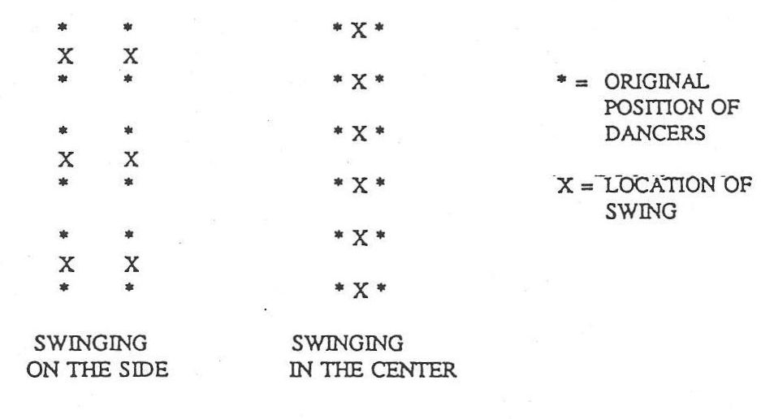
Figure 15. Swinging on the Sides and in the Center

In addition to the shift from the proper formation to the improper formation there are now dances composed in Becket formation, in which the dancers stand next to their partners, facing another couple across the set, a formation that is not found in the earlier dances. This formation was an innovation of Herbie Gaudreau's in his dance, "Becket Reel," an early composed dance named for the town of Becket, Massachusetts. There has been a small but steady output of dances in Becket formation from contemporary contra dance composers, and this formation continues to be a frontier for choreographers looking for new areas in which to work.
Another change during the last several decades has been the shift away from triple formation dances. In these dances every third couple is active, and consequently the minor set within the dance includes three couples instead of two. Almost one-third of the dances in Rickey Holden's book are in the triple formation. Today, however, it is rare to dance a triple formation dance, and many of the newer dancers are unacquainted with them.
The reason that the triple formation dances have fallen out of favor appears to be two-fold. First, the triples are a little bit trickier to teach and to dance. This is because as the active couple works its way down the set, the other couples alternate between the number two role and the number three role. A single couple will be number two one time through the dance and number three the next. This is confusing to dancers who are accustomed to maintaining the same role all the way up the set:

I don't know too many people writing triples, I think partly because they are harder to get across. . . . That "two" to "three" to "two" to "three" is tricky. . . . You really have to pay attention! (Hendrickson 1990)

With larger groups to teach, callers prefer to avoid dance forms that make the teaching job more difficult and more time consuming.
Another reason for the triples going out of fashion is that in a triple dance there are two inactive couples for every active couple, which means even more standing around than in the duple proper dances. This is unacceptable to most of today's dancers, who want continual activity in their dancing:

In a triple minor two couples are inactive for every active couple. Lots and lots of waiting. (Zakon 1990)

SYMMETRICAL ROLES

Another way in which contemporary choreography differs from that of the older dances is that in a large proportion of the new dances the roles of the active and inactive couples are symmetrical—meaning that their moves are identical, although they may be moving in opposite directions along the set. Of the ninety contra dances described in Rickey Holden's book, there are three that are symmetrical in the sense of giving everyone the same moves ("Dud's Reel," "Oregon Trail," and "Polka Contra"), which is about three percent of the total. If we look at the dances on my chart, and in particular at the "top twenty" group plus the twenty composed in the last decade, thirty-one of forty, or seventy-eight percent, are completely symmetrical. This is a significant change.
The choreographing of symmetrical moves is in part a response to the preference of the dancers for an equal activity level for everyone and is therefore related to the rise of the improper formation and the decline of the triple formation dances. Symmetrical choreography is also a response to the growing number of dancers at the dance events; the resulting long lines make the traditional active-inactive role division problematic. In a long line the inactive couples remain inactive for a long time before reaching the head of the set and becoming active; and the active couples stay active long enough to become tired out. Symmetrical dances avoid these problems by allowing everyone to be equally active regardless of their location in the line. Larry Edelman elaborates on this point:

Proper dances . . . are very unequal dances. . . . That's often not appropriate today . . . because some dance communities are so large that the dance would have to be so long for everyone to get a good shot at being active, that people don't like the inactive dances. So that choreography doesn't meet the needs of a large dance hall. An example would be Glen Echo [in Washington, D.C.] . . . fifty yards, you know, from end to end. (Edelman 1990)

The use of symmetrical dances has led to some changes in the terminology employed by callers in teaching the dances. It no longer makes sense to speak of "active" and "inactive" couples, when in fact everyone is equally active throughout the dance. Some callers refer to these couples as the "number ones" and the "number twos" instead:

There are dances where . . . nobody's inactive, especially a lot of the newer dances that the people write. Everybody goes all the time. But how do you distinguish to a new person who comes in? "I don't understand! I've been spinning around for five minutes! Who's active?" When you say, you're a "one" and you're a "two" and you change numbers at the top and the bottom, that makes more sense. (Hendrickson 1990)

Another approach is to use the terms "partners" and "neighbors" and do away with the distinction between the couples moving down the set and the couples moving up the set. Modified terminology also helps callers move away from addressing the calls only to the active couples, a practice that was standard in calling the older traditional dances. For example, consider the common call, "balance and swing below." For the active couple the person one swings is "below" (meaning down the set and away from the music). But for the inactive couple that person is "above." With the symmetrical dances it is no longer appropriate to direct the calls to the active couples, since everyone is doing the same thing. When "swing your neighbor" is used instead of "swing below," the call applies equally to everyone.

FIGURES

Another way to view the changes in contra dance choreography is to look at the kinds of figures that are being used today, to see how these differ from the figures used in the older dances. New figures have been added to the repertoire in recent years, and the popularity of the traditional figures has increased in some cases and decreased in others.
Although the "swing" was a part of contra dancing long before the current revival, it has taken on a greatly increased importance for today's dancers. Hardly a dance is called today that does not include a "swing," and most of the new dances include two "swings"—one with one's neighbor and one with one's partner. If there is no "swing" in a dance, many of the dancers will grumble. Tom Hinds has experienced this problem from the points of view of both caller and dancer:

I don't like the attitude of people that if you don't swing your partner then they get all mad. But I guess if I'm dancing with a partner I would really want to swing, I get mad too. (Hinds 1990)

The graph below shows the number of dances on my chart that include a "neighbor swing" and the number of dances that include a "partner swing" for each of the time periods represented:

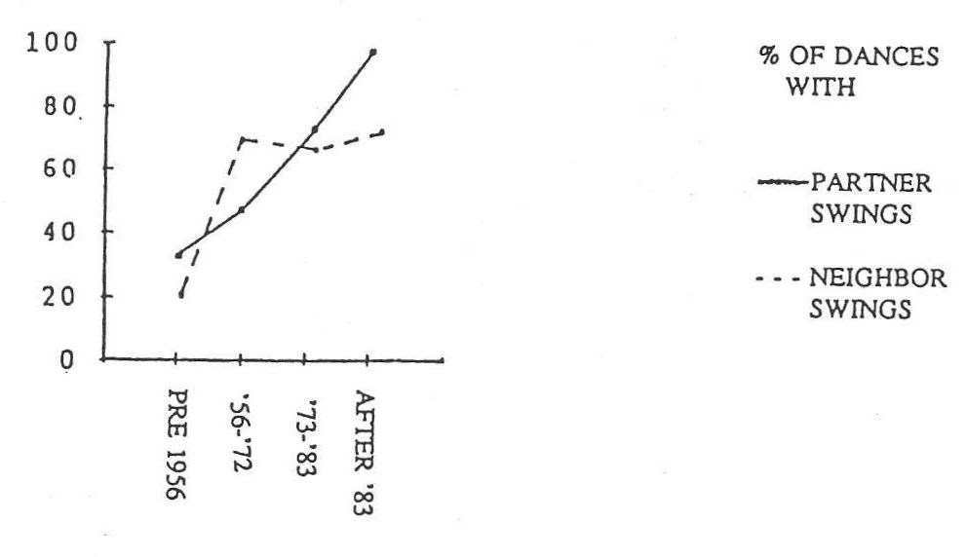
Figure 16. Swing Frequency Over Time

The graph indicates that there was first an increase in the number of "neighbor swings," and then the number of "partner swings" increased to equal and eventually surpass the number of "neighbor swings." This may reflect a gradual shift in emphasis from community interaction to partner interaction, a trend discussed in Chapter 7.
Another kind of figure that has gained prominence over the last twenty years is what I have called the "fractional figure." In the traditional dances one finds "circle to the left and back to the right," "ladies chain over and back," and other figures that include a return to place. In the contemporary dances one almost never does a "chain" over and back. The "ladies chain," "right and left through," "star," and "circle" are almost always done in one direction only, and some other means is used to return to the starting position, if indeed one does return. So these kinds of figures have been essentially broken in half. In addition to breaking figures in half, choreographers have begun to use fractional figures such as "circle three-quarters," "allemande once and a quarter," and the like. There is a very good reason for this. We have seen that in a symmetrical dance "partner swings" usually take place on the sides of the set, since it is too crowded for everyone to swing in the middle. From the starting position of the improper formation it is necessary to turn the minor set of four people either three-quarters, or once-and-a-quarter in order to position the dancers next to their partners on the sides of the sets. Consequently fractional circle turns have become common to facilitate this. As dancers have become more and more accustomed to fractional turns, the concept has spread to other figures that are not related to swinging on the sides of the set, and one finds, for example, a three-quarters "hey" in some contemporary dances. Today fractional figures have become an expected and understood part of the figure repertoire.
Another new way of using old figures is to dance them on the diagonal; that is, instead of doing a "right and left through" with the couple directly across the set, one faces left (or right) with one's partner and does the figure with the next couple down in that direction:

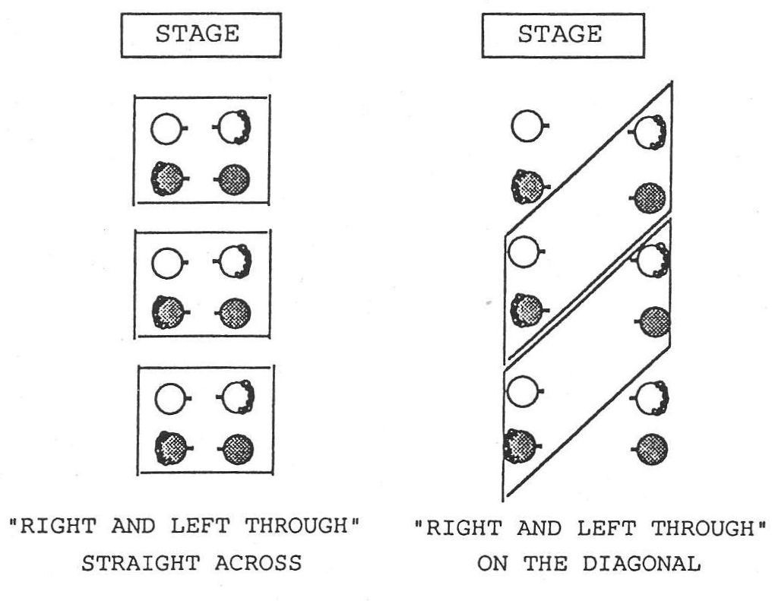
Figure 17. Diagonal "Right and Left Through"

One of the first dances that used this kind of movement is Herbie Gaudreau's "Becket Reel," to which we have already referred with regard to the Becket formation. A diagonal "right and left through" followed by a "right and left through" straight across the set leaves the dancers in their progressed position in Becket formation, and this sequence is still commonly used. Other figures may also be danced on the diagonal. "Dancing Sailors," by Ed Shaw and Al Olson, includes, for example, a "hey for four" on the diagonal.
Dancing figures on the diagonal involves dancers with others who are outside their minor set of two couples. These figures also contribute to the "surprise" element in some dances, an element regarded as desirable by many people, because a diagonal figure may separate partners who can then be reunited.
Many of the figures being used in contemporary contra dance have been purposefully or inadvertently borrowed from other traditions—in particular from the Western square dance, Appalachian square dance, New England square dance, and English country dance traditions.

The borrowing of . . . things from other dance styles is, you know, a way that you can create something new, but still stay within a tradition anyway, whether or not it's the tradition. (Breunig 1990)

An early example of this is Fred Feild's dance "Symmetrical Force," which includes a "four-leaf clover," a figure from Appalachian square dance. (This particular borrowing may have been unintentional. See footnote Error: Reference source not found at the end of page 62.) Dan Pearl's dance "The Rendezvous" includes a sequence in which each couple circles left with the other couple in their minor set, and then moves on to circle left with the next couple down the line, a move which is identical to the way couples progress around the circle in Appalachian square dance. Ted Sannella, in his dance "Salute to Larry Jennings," uses a "grand right and left" around the outside of the whole set, and in his dance "CDS Reel" he has the whole set circle left as a unit. These figures are borrowed from the square dance traditions. The "hey for four" and the "gypsy," which are quite commonly used in today's contra dances, are borrowed from English country dance.
In addition to borrowed figures there are also newly invented figures that are used in the composing of contra dances. The example given by Larry Edelman in the discussion of uniqueness in Chapter 5 is repeated here as a good illustration of such a figure:

Steve Zakon has really pioneered a sequence of figures that he uses in several dances in different ways in each one, an example being "Southern Swing," where the women . . . "right allemande" in the middle, then give left to their partners, pull their partners in the center, and the gents "chain" across and give left to their opposite and turn once and a little bit more. And it's just a nice sequence that no one's really [used before], that kind of sequence of "allemandes" and pulling across the set. (Edelman 1990)

Several choreographers observed a trend toward the use of more figures in which the dancers don't touch one another: figures like "heys" and "gypsies." Both of these figures are borrowed figures that are not found in the older contra dances, and both, particularly the "hey for four," have become quite popular in contemporary contra dance:

There's less body contact, but there's more opportunities for kind of individual stylizing. Your individual body can move more freely, because you aren't arm in arm, shoulder to shoulder, hip to hip with someone else. (Kaynor 1990b)

These "no hands" figures are more challenging to dance, particularly for beginning dancers, because one does not benefit from the security of holding onto other dancers; but they provide more opportunities for improvisation.
There has been a parallel rise in figures that provide strong physical connections between dancers, connections which facilitate smooth flow and greater speed in a dance. We have already noted the increased use of the "swing." "Allemandes" provide a smooth way to change direction quickly, and their use has also been on the increase in recent years. "Circle left" is being used more frequently in contemporary contra dances, while "circle right" is being used less, and I would speculate that this is a result of the attempt to conserve momentum in the transitions between figures. A "circle left" meshes nicely with the "swing," while a "circle right" does not. These figures provide the strong physical connection needed to perform today's faster, more complex dances.
A dance sequence that seems to have fallen out of favor is "down the center (or the outside) and back" followed by "cast off." This sequence is found only in dances with clearly differentiated active and inactive roles, and there is no place for it in the contemporary symmetrical dance. This is an important change, since the "cast off" was the primary means of accomplishing the progression in the older dances, and in the contemporary dances it is almost never used.
According to my chart, another figure which has declined in use is the "right and left through." My guess is that this figure is less frequently used today because it does not provide strong connections between the dancers, and consequently is not as effective in producing smooth flow and speed in the dancing.

TRANSITIONS

Contemporary contra dance composers have been increasingly interested in how the dance figures fit together—how one figure flows into the next:

We've gotten into kind of exploring how figures can transition into each other. A lot of the old dances are really straight-forward, you know? The "ones" did something, and then everybody did something, and then the "ones" did something else . . . and then you all ended up with a "right and left" over and back or something like that. And nowadays there's the delight of . . . one figure flowing into another. (Kaynor 1990b)

Smooth and effective transitions allow for faster and more complex dancing, since neither speed nor complexity works very well if one has to pause or stop between figures.
In making the transition chart, I listed separately the different directions in which a figure can be accomplished (e.g. "allemande left" and "allemande right" are listed separately), and the completed chart is consequently forty figures long and forty figures high, including a total of 1600 possible transitions. Of these 1600 transitions, only 280 were actually used in the one hundred dances I entered on the chart. Let me remind the reader here that I included twenty dances from each of five categories: pre-1950s dances; early modern composed dances (prior to 1973); dances composed between 1973 and 1983; dances composed after 1983; and the twenty most named dances in the interviews. Because each era is represented by only twenty dances, there are some statistical limitations to this analysis; but I believe it is possible to infer some general trends from these data.
The number of transitions used in each of the four time periods is as follows:

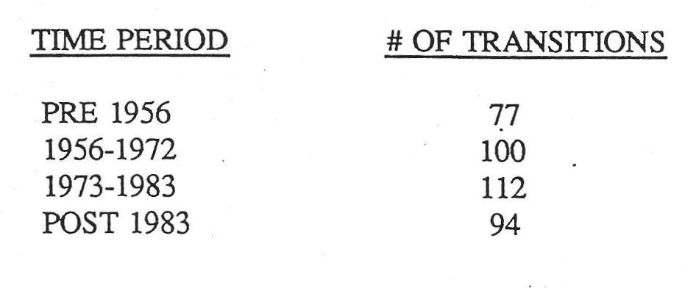
Figure 18. Transition Use through Time

These numbers are interesting because they suggest that the number of transitions used began to increase as the composing of new dances got underway, reaching a peak in the late 1970s and early 1980s, during which time the older transitions were still being used and newer ones were being added. Then as the older ones began to fall away, the most popular transitions became a somewhat different set from that of the earlier dances.
Below is an ordered list of the most popular transitions used in each of the four time periods noted above:

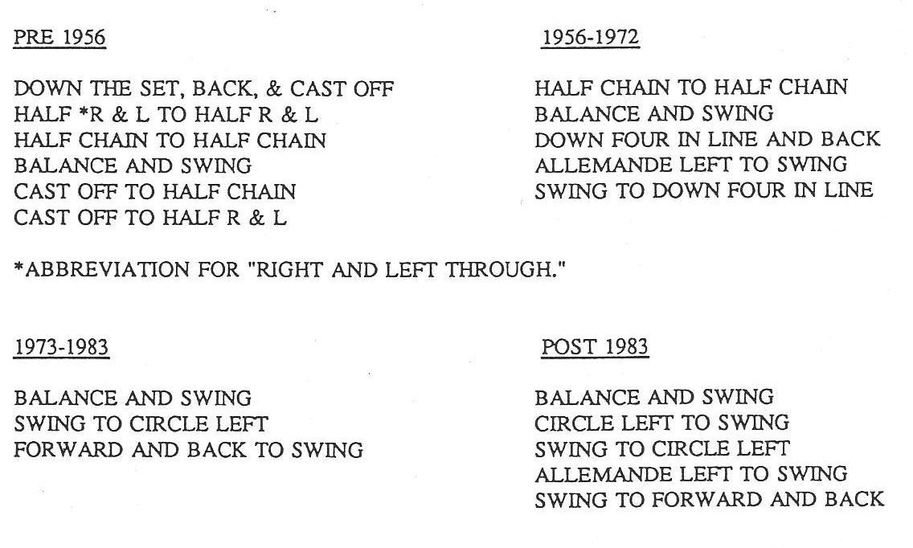
Figure 19. Changing Popularity of Transitions

Each list includes only the transitions that clearly separated themselves from the others in popularity. There are only three transitions listed for the 1973 to 1983 era because although many more transitions were used during that period, few stood out as being more popular than others. It seems to have been a period of choreographic experimentation, corresponding to the rise in popularity of contra dancing as the current dance revival got underway.
The transitions that have decreased over time include the sequence "down the hall and back" and "cast off;" the "chain" and the "right and left through" over and back; and the transitions from a "cast off" to either a "chain" or a "right and left through." These have fallen away, in part, because of the decrease in popularity of the dances with unequal roles. We have seen that the "cast off" is a figure that is used primarily in unequal dances, and consequently it is not in vogue today. The use of the whole "chain" and the whole "right and left through" has probably decreased because of the interest of choreographers in building more variety into their dances, by having the dancers return across the set in some other way after doing half of one of these figures.
The transitions that have increased over time include the "balance" followed by a "swing," the "swing" to a "circle left," the "circle left" to a "swing," and the "swing" to a "lines forward and back." These transitions reflect both the increasing popularity of the "swing" and the interest in good flow. The "circle left" and the "swing," as we have seen, work very well together since they are both revolving figures and they both revolve clockwise. The transition from one of these figures to the other was not used at all in the older dances, as far as I know, and it is very popular in contemporary dances. I suspect that the popularity of the transition from the "swing" to "lines forward and back" is related to the need to stop the revolution of the "swing" with a non-revolving figure so that the dancers don't get dizzy.
The changes in the transitions over time are consistent with the changes in the figures, showing the same trends toward fewer dances with unequal roles and more dances that are vigorous, complex, and smooth flowing.

COMPLEXITY

Today's dances are more complex than the traditional dances. They use more intricate combinations of moves, they use more moves of shorter duration within a single dance, and they are often danced somewhat faster than the older ones were. One reason for the increasing complexity of the dances seems to be the continuing development of new choreographic ideas and the efforts of the choreographers to implement them:

Sometimes just in order to get one interesting transition in a dance, half the problem is that you've got to get [the dancers] rearranged in a way that you need . . . in order to use that transition. And so you've done a bunch of things to shuffle the dancers around, and then you've done the gimmick you want to do, and then you've got to get them back where they started. And so you end up spending a lot of time in your choreography doing all this rearranging and then dearranging. And the dances get more and more complex. (Diggle 1990)

Some of my informants speculated that the desire to create complicated choreography is related to the choreographer's fascination with numbers and with spatial relationships:

I think a lot of people that are turned on to dancing, or calling for dances, or making up dances, also have some part of their mind . . . that's also highly mathematical, and they need to play with numbers. And playing with dance figures is just like playing with numbers. I think a lot of people enjoy doing that. I know a lot of callers do that. I know it, because they've said so. (Sutherland 1990)

In the same vein, others suggested that the fact that many dancers work with computers contributes to their enjoyment of complex sequences:

I would say that [many] of the people that go contra dancing today in the Boston area these days are computer oriented. They work in the computer industry or high tech of some sort. And so they bring all that right in. And if you look at Zesty Contras . . . those are very busy dances. Plus a lot of mathematics involved in there, when you turn one-and-three-quarters around. (Laufman 1990)

More complex dances are created, in part, because there is a demand for them. Dancers are interested in fast and vigorous dancing, an interest stemming not so much from the social aspect of the dance as from a desire for physical challenge. They work on developing their physical skill in the performing of contra dance and derive some of their enjoyment from this physical skill:

[When you] get good at something, there's a different level of enjoyment that you undergo than you did initially when you were worrying about a lot of other things than just doing the dance, or getting through the dance alive without having mortally embarrassed yourself. (Marshall 1990)

The increasing complexity of today's contra dances shows itself in the choreography in a number of ways. We have seen that new figures, fractional figures, and diagonal figures are being incorporated into the dances. It is also true that the new dances contain more and shorter figures than the older traditional dances, which consist of fewer and longer figures:

Traditional dances have very few parts. And these days more of the dances have more parts: four-count figures as opposed to eight-count figures, or in eight counts you do a couple of things rather than just one thing. In the older dances you had sixteen-count figures. (Kopp 1990)

The new dances often include moves in which dancers dance with those outside their own minor set, which was virtually unknown in the older dances. This means that dancers occupy a greater number of different positions and see more new faces in the course of a single repetition of a dance. As we have seen, partners may be separated from one another during a figure, to be reunited at some point later in the dance.
The transitions, as they have become smoother, have also become more precise, often requiring closer timing. Many of my informants feel not only that the timing has become closer, but that the dance movements have actually become faster in recent years. A number of reasons were suggested for this phenomenon. We noted earlier that there are an increasing number of dancers who are looking at the dance primarily as exercise, and these dancers enjoy faster dancing for its aerobic value. Bob Dalsemer speculated that the increased speed of the dance movements is also related to the crowded conditions on the dance floor. Because there is not room to execute expansive figures, the dancers add speed to the figures to compensate for the smaller space. If there is not room to perform a wide, elegant "allemande left" once around in eight counts, one can get a different sort of satisfaction from performing that "allemande left" twice around in a more confined space:

When space is at a premium, and you don't have room to spread out, faster tempos give you kind of a substitute for that lack of expansiveness. (Dalsemer 1990)

Faster movements within the dance may be encouraged by tempo changes in the music. Some figures, the "swing," for example, are actually easier to dance at a faster tempo. Bob Dalsemer suggested that the failure of many callers to control the tempo of the band contributes to the increasing speed of the dances:

Bands tend to feel that if you're going to be popular with the dancers, the easiest way to do that is to have a lot of energy. . . . And the energy musically is often, and I think erroneously, created by faster tempos. (Dalsemer 1990)

The willingness of dancers to dance more quickly has in turn created new choreographic opportunities in the use of timings that would have been unacceptably fast a few decades ago:

The fact that the dancers are willing to move a little faster means you can do things like "allemande" twice around in eight counts. That would have been unheard of thirty years ago. . . . You couldn't get the dancers to go that fast even if you wanted to. (Diggle 1990)

In sum, today's dances are more complex than the traditional dances, and this complexity is reflected in the figures and transitions being used, in the construction of the "gimmick" and the way it is set into the dance, in the use of more figures of shorter length in a single dance, in the inclusion of sequences that reach outside the minor set, and in the increased speed at which the dances are being performed.

MULTIPLE PROGRESSION DANCES

Another innovation of the last few decades has been the multiple progression dance, a dance in which the number one couples move more than one place down the set in the course of a single repetition of a dance. Most such dances are double progression dances, but there do exist some triple progression dances and at least one quadruple progression dance ("Contra Madness" by Gene Hubert). Steve Hickman recalls the beginnings of the use of double progression dances:

I can't remember the name of the first double progression dance. What an astounding idea! To progress two places! And then the inactives would get to be active twice as fast! (Hickman 1990)

His comment suggests one reason for the creation of these dances—the attempt to move the dancers more quickly through the ever lengthening lines so that in the unequal dances everyone gets a chance to be active without requiring the dance to continue for an inordinate amount of time.
Multiple progression dances usually include figures that involve dancers outside the initial minor set, since the dancers change minor sets as the second progression begins:

Most of the traditional dances keep you pretty strictly in your group of four all the way through. [Today] you get into multiple progression, or dances where you do things outside your minor set, sometimes significant amounts of stuff outside your minor set before you get reconnected with your partner maybe. Those are all pretty much modern innovations. (Diggle 1990)

One result of these innovations has been the creation of complex "end effects" in the dance. End effects are the peculiar things that happen at the end of a set when a couple has reached the bottom (or top) and is waiting to come back into the dance going the other way. In the traditional proper dances these couples simply stand out one time through the dance and then reenter from the same position. In the traditional improper dances the end couples need to change places with their partners before reentering. Today's dances, however, include at least two other kinds of complications that occur at the ends of the sets.
First, a multiple progression dance requires that the couples at the ends must make the necessary adjustments much more quickly in order to be ready to reenter the dance in half the time normally allotted (if it is a double progression dance) and even faster if it is a triple progression dance. This means that the common practice of taking a little break at the ends of the set doesn't work, and a couple needs to be ready to reenter the dance almost immediately.
Second, in a dance in which there are figures that reach beyond the minor set, the couples on the ends will find themselves out of the dance some of the time, but required to reenter temporarily in order to do an "allemande" with someone, or to be a part of a diagonal "hey" or some other move that reaches outside the minor set in their direction. In a Becket formation dance it sometimes happens that the couple at the end must refrain from entering the dance at particular intervals. For example in a left diagonal "right and left through" when there is no couple to their left, they must simply stand there and wait until there is a couple in the proper location for them to accomplish the figure.
Today couples at the ends need to be aware of when to cross over, when to be ready to reenter the dance more quickly, when to reenter temporarily, and when to absent themselves temporarily. Despite these complications, most dancers seem to deal readily with end effects, and a set rarely falls apart because of them. Often a couple will simply be whirled back into the dance by the next approaching couple, even if they have no idea what is going on.

INCREASING NUMBERS OF DANCES

One of the most obvious changes from the older dance scene to the contemporary one is in the sheer numbers of dances being composed and danced today. In the 1950s the repertoire was smaller. Many of the same dances were danced from week to week, and the dancers knew and requested these dances by name. Ted Sannella recalls:

Before . . . we just did the same ones all the time, and we never even thought about changing them or making up new ones. . . . We did have some new ones. But then it would be like one dance a year that would be new. . . . You didn't have the situation where every caller had half a dozen of his own that he had just written that he wanted to try out, like you do now. . . . It wasn't deemed necessary, I guess. People were satisfied. It's only in more recent years that the dancers I think are becoming more demanding. They like new things. (Sannella 1990a)

Today's dancers try so many new dances that they rarely remember their names. Favorites come and go:

The constant need for new material is one of the aspects of the new breed of dancer. . . . And if they get a good one, they'll dance it to death. And when it's been danced a lot and people thoroughly know it, the caller assumes . . . the people are tired of this. Or I'm tired of this. And so I'm going to delete it and add something new to my program. This need for constantly finding something new is not bad. It's just significant of this new era of contra dance. (Park 1990)

The need for new material may also be related to the faster pace of today's world, and the faster turnover and change in other aspects of life. Improved communications is one area in which we see this. Because it is increasingly easy to travel, the members of a dance community no longer depend on their local caller for all of their material. They can learn new dances from callers all over the country, either through dance camps or through the hiring of traveling callers and bands:

A lot of it is because of the smaller world that we live in. Callers are traveling now all over the country, and before you had the local caller calling for the local dancers. And he was the only caller they got to see. (Sannella 1990a)

Whatever the reasons, where there used to be a smaller and more stable number of contra dances in the common repertoire, there are now hundreds of dances circulating throughout the country, with new ones being composed every day. Only a small percentage of them remain in circulation long enough for the dancers to know them well or to ask for them by name.
The following table summarizes the primary changes in contra dance choreography over the past several decades.

Table 2. Changes in Contra Dance Choreography

FORMATIONS:

1. The triple formation and the proper formation are used less frequently.
2. The improper formation and the Becket formation are most commonly used.

SYMMETRICAL ROLES:

1. There is less distinction between the roles of the active and inactive couples.
2. Terminology has been altered to reflect this change.

FIGURES:

1. The use of the "swing" has increased.
2. Fractional figures are common.
3. Figures danced on the diagonal are being used.
4. Borrowed and invented figures have been added to the repertoire.
5. "No hands" figures have become more popular.
6. Strongly connected figures are used to facilitate good flow.
7. The use of figures requiring unequal roles has declined.

TRANSITIONS:

1. The sequence "down the center and back" and "cast off" has declined in use.
2. Figures that cross the set and return are now used more often in their half form.
3. Transitions are designed to build momentum for vigorous dancing.

COMPLEXITY:

1. Sequences are more complex.
2. Figures of shorter duration are common.
3. Dance movements are faster and use closer timing.

MULTIPLE PROGRESSIONS AND END EFFECTS:

1. Dances have been composed that progress the dancers more than one place in a single round of the dance.
2. Both single and multiple progression dances may require dancers to dance outside their minor set of two couples.
3. More complicated choreography has resulted in more complex adjustments that must be made at the ends of the set.

NUMBERS OF DANCES:

There are many more dances in circulation now.

ACCOMPANYING TRENDS

In the course of this chapter we have noted some general trends that accompany the choreographic changes in contra dance. Let us recapitulate these trends as we draw this chapter to a close.
Contra dance choreography has reached a stage of development in which there is an interest in trying out all the possibilities inherent in the form. This desire is reflected in the use of the more flexible improper formation and the newer Becket formation; in the use of fractional and diagonal figures; in the borrowing and inventing of figures that were not formerly included in contra dances; and in the composing of multiple progression dances, which move the dancers up and down the set more quickly.
We have seen that dances with equal activity for everyone have come to be preferred, both to avoid problems with long dance lines, and to provide more physical activity for the dancers. In response to this trend, dance figures have been changed, added, or dropped in order to make symmetrical choreography work. Figures that are only for the active couples have lost favor, and fractional circles that place couples on the sides of the set have been added. This trend has contributed to the popularity of the improper formation and the dwindling use of the proper formation and the triple formation.
A third trend has been the preference of today's dancers for dances that are physically challenging. This preference has led to dances that are faster and more complex, and that have the smooth flow necessary to support this greater speed and complexity: "Swings" are more popular now because they are vigorous; the "circle left" flows easily both into and out of a "swing"; and "allemandes" make rapid changes of direction possible. Consequently these figures are used more frequently, while the less connected figures such as the "right and left through" are used less often, because they tend to slow down the action. As choreographers seek the smooth flow required for physically challenging dances, there has been a change of emphasis from the figures themselves to how these figures are put together—the transitions between the figures.
Finally, there seems to be a greater need today for the stimulation of new material, which provides a market for a constant flow of new choreography and experimentation on the dance floor. New contra dances continue to spread across the country, carried by traveling callers or traded at dance camps, and as a result there is a continual turnover of the repertoire at many community dances.

Choreography and Community

The population of the contra dance communities has altered since the early 1970s, and this change in social makeup has been accompanied by changes in the social dynamics of the dance event. One major difference is in the sheer numbers of people that are involved in this kind of dancing today. Bob Dalsemer suggests that this has been a mixed blessing:

I think one of the biggest changes over the last fifteen years . . . has been the growth in numbers of people. And I think that's had a large, large impact. I think there's a danger that we may and do suffer from our success. (Dalsemer 1990)

Today's dancers represent a wider cross-section of the population than was true earlier in the revival, when many of the people interested in contra dancing were those who were seeking alternatives to modern life, by going back to the land and by exploring their roots in tradition. Now there is less of an interest in "tradition" per se. Bob Dalsemer surmises that most dancers today view contra dance primarily as a contemporary form of social dance, rather than as an activity rooted in the past:

There's not much concern about whether it's quote unquote "traditional" or not. . . . That definitely counted for something in the good old seventies, you know, part of the back to the land and back to the earth, and Mother Earth and Mother Nature and all that. . . . That was an important catch word. This is something that people before us did. This is something which we are linked to, some past reality, even if it's a reality that we and our families never shared. . . . But not any more. People are coming into it purely for social reasons. Hey, this is a good place to meet people. . . . People don't even know what to call it in Baltimore. . . . They call it, "oh I go folk dancing." (Dalsemer 1990)

Many of the dancers in the 1970s were involved in the folk music revival and consequently were familiar with traditional tunes, and they came to contra dancing with this familiarity. Some of today's new dancers are not only unfamiliar with the dance, but they are unfamiliar with traditional music as well:

[In the 1970s] I would say that about, easily three-quarters of the people that would come to dances were people who were already involved in the folk music revival and were familiar with traditional music of some kind and had that in their ear. And they found out, hey, I can dance to this music that I really like! But nowadays we have people coming in to the dances who have no background at all in dance or music, either one. (Dalsemer 1990)

Another important change in the dance population has been the increase in the number of dancers involved in technology. This is most likely a reflection of a change in our country's population as a whole, as technology has become more important in our society. Susan Elberger observed:

There're more techies, and it's a reflection of demographics. The high tech industry built up over the last ten years, and it's perfectly appropriate for a dance community, or a subsection of a community, to reflect the larger community. (Elberger 1990)

This change in demographics may also contribute to the popularity of the more complex "high tech" dances that are being composed today.
As the core of the dance community gets older, the dancers that come into the activity are aging as well, since people tend to join groups that reflect their own age and interests. Younger people are being brought into contra dancing primarily in areas where there is an active effort to recruit new dancers. Many of the people who began dancing in the 1970s are home with their kids now, and the dance remains largely a singles scene:

As a singles scene it tends to work that, you know, the singles come, and then they meet somebody, and then they get married, and then you don't see them again—unless they get divorced, you know, and come back. (Dalsemer 1990)

The average level of dancing skill in the dance population has increased. In the 1970s, when I started contra dancing, a larger proportion of the dancers were learning the tradition and consequently there was more teaching going on at the dances. The same people tended to come every week, and the group made progress together. Now beginners comprise a smaller proportion of the dancers and are given proportionately less attention. Mobility has also increased, and in many places participants change from week to week, making long-term teaching less practical.
The increased size and diversity of the dance community has led to changes in the dance events themselves. In urban areas there is more choice in dance events now, because there are more of them, and therefore there is less of a need and sometimes less of an attempt to build community feeling within a particular dance group. Susan Elberger describes this change as she has experienced it:

Where I started, there was the one dance a week, and if you wanted to dance, you went to that dance. . . . And also since it was a smaller community, you knew people who lived farther away. . . . When newcomers started to attend the dances, there was a much more concerted effort at bringing them in and integrating them into the community. (Elberger 1990)

With dance events larger and the participants less consistent, there can be less attention paid to beginners and to the community as an entity.
Bigger crowds have necessitated sound amplification in some dance halls, and in other halls the use of a sound system has become habitual whether it is needed or not. Dudley Laufman has been a part of the New England dance scene for a long time and has seen this change:

People are used to having a loud sound. They're used to the amplification and the thumping guitar and the bass and the piano and an accordion. . . . And they're used to having it amplified. And they're used to having it amplified well and loud . . . even if it's not needed. . . . And they're used to being able to make noise. (Laufman 1990)

Amplification of the caller's voice means that the dancers are less likely to quiet down during the teaching, because the caller can be heard despite the noise on the floor. Amplification of the music means that the band can be farther away from the dancers and still be heard. Even with amplification the music may lose its immediacy in a large hall:

You go to a big dance like Glen Echo on Friday night, if I was a new dancer going in there, I couldn't tell you what the music was on the stage. You can't hear it. You kind of hear something going on up there, but you can't hear what the music is. You can't really appreciate the music. (Dalsemer 1990)

The presence of larger crowds has also affected the genres of dance available at a given event. Because the caller is forced to cater to a wide range of skill levels with a group too large for the giving of significant help to individuals, that caller finds it easier to focus on a single genre of the social dance traditions. Consequently there are dance events at which there are only contra dances (or some other genre) included in the program. Bob Dalsemer saw this happening at his own dances:

Because you're dealing with large groups of people and quite a wide range of abilities . . . the types of dances that are being called is narrowed down. I mean this happened to me. . . . When we were twenty, thirty, forty people at the most, we did this broad range of stuff, you know: English and Playford and traditional English and American. . . . You had plenty of time to teach. You didn't feel rushed. . . . And then as the group got larger, I decided that it would be much easier to leave the English as a separate thing. . . . And so as the group got bigger, I narrowed my focus. (Dalsemer 1990)

These changes in the dance events have resulted in new concerns socially as well as new concerns choreographically. This chapter will examine seven areas of concern that were voiced by my informants: dance as sport, elitism on the dance floor, the difficulty of integrating beginners, leadership concerns, gender issues, changes in dance style, and the increasing focus on the individual at the expense of the community.
I would like to clarify at the outset that these concerns apply predominately to the larger dance communities in urban areas. There are many local dance communities in which the dance remains primarily a social occasion, where beginners are welcomed and the community as an entity is of great importance to its members. The dance community in Bloomington, Indiana, where I have danced regularly, is one of these.

DANCE AS SPORT

Most of my informants voiced the concern that the contra dance event has become less an occasion for socializing, and more an occasion for physical exercise. As soon as one dance is finished, the dancers line up for the next one, with very little pause for socializing in between. We have noted that the dances have become faster, more vigorous, and more complex, and that there is an ongoing demand for new and more challenging material. The increasing physical challenge of the dances seems in part to be a reflection of the fact that many people get little exercise during their working day, coupled with the general concern today for health and fitness:

There's a trend in the country to celebrate the physique. . . . Sex in advertising is a huge idea these days . . . the idea [of] aerobics as an enterprise, sports equipment as a product. . . . We have a society here in America that celebrates a trim figure, that celebrates things that you can do to lose weight, or to stay fit, to keep your heart up. . . . So people are coming to dance communities for that reason. (Park 1990)

This trend can also be discerned from the clothing worn by the dancers. When I started dancing, participants tended to dress for a dance party, wearing nice looking dresses and shirts and shoes. There is a growing trend today to wear sports clothing—shorts, tank tops, sweat bands, tennis shoes—and even to bring a small towel with which to dry off once in a while, and a change of T-shirt:

I think a lot of people come to the dance wanting it to be physically demanding. . . . They've got their T-shirt and their shorts, . . . often got a towel with them, or a head band, a sweat band of some kind, and they look like they're, you know, going out to run or play tennis or something when they come to the dance. (Dalsemer 1990)

Beth Parkes described an instance where someone showed up at a wedding dressed for aerobics, because there was to be a dance as a part of the wedding reception:

The ultimate in that image to me was the guy who showed up at a wedding reception in shorts and a T-shirt because he thought it was a dance. You know, it was a wedding party. And somehow he didn't connect "wedding," he thought "dance," and that's what he wears to a dance. (B. Parkes 1990)

There is a concern among many dance leaders that this interest in dance as exercise, as sport, is replacing the dance as a social occasion in today's dance communities. In the choreography we can see this tendency through the increased number of dances that are challenging physically, and the decrease in socializing time at the dance event:

I kind of miss that myself, going to a dance and not ever being able to talk to the person you're dancing with. Or a duple minor double progressive dance where you never even see them! You never even see your partner . . . some of the time. (Hickman 1990)

The degree of physical and mental challenge inherent in some of the new dances actually works against the ability of the dancers to relate to each other in ways above and beyond the dancing itself. Dancing together becomes a substitute for talk:

[Ed Shaw's] theory was that many New Englanders, as well as dancers from other places, were by nature taciturn folk who seek out an environment where it's not necessary to communicate verbally—that dancing was a good substitute. (Dalsemer 1990)

I've been aware of going to dances where I realized that . . . the challenging contras and everybody active, moving all the time, was working against my ability to socialize. . . . There's definitely no time to talk during the dance. There's literally no time. And that makes me uncomfortable. (Sutherland 1990)

This problem is nicely illustrated by an item in the Folklore Society of Greater Washington Newsletter which advertises a gathering called "Conversations with Contra Dancers," its purpose being "to give dancers a chance to talk to each other without interference from dancing" (FSGW Newsletter 27 [1990]:10).
The focus at the contra dance events has turned more toward the dances themselves. Experienced dancers become caught up in the thrill of new material and new challenges in the choreography, while the beginning dancers are completely preoccupied just trying to keep up:

People were satisfied with less change before, because they went to the dances mostly for the social activity, and to visit [with] people. And now there's more going to a dance for the dancing, rather than for the people. It seems that dancing now is not so much a means to an end, as an end in itself. (Sannella 1990a)

ELITISM

Another issue which is of concern to today's dance leaders is the cliquish behavior of some experienced dancers, particularly at the larger dance events. My informants singled out two behaviors in particular. The first is referred to as "center set syndrome," the tendency of experienced dancers to locate themselves at the top of the center set before the dance begins. The second is the growing practice of booking partners ahead of time for a dance. Gene Hubert describes the problem as he sees it:

This whole business of everybody cramming into the middle set is a real serious problem. And the other thing . . . which goes hand in hand with it, is everybody booking up dances ahead of time. And it's getting really . . . cutthroat. So many people are lining up dances ahead of time that if you don't play the game, you're just really left out. (Hubert 1990b)

These behaviors are completely baffling to newcomers, who end up without a partner or end up off in the far corner of the room where they can't hear the caller very well and can't see what's going on. It feels like elitism to them, although the experienced dancers usually don't intend it as such.
On a dance floor of moderate size there will usually be at least three sets formed for a contra dance—one in the center of the room with the top of the set in front of the caller, and the other two on either side of that set. In a larger dance hall there may be even more lines, depending on the size of the dance crowd. There are a number of reasons why experienced dancers like to be in the center set. Dancers feel that it is more fun to begin a dance at the head of the set. This is an attitude left over from the unequal traditional dances in which it is desirable to be in the active role, and by starting at the head of the set a couple is in the active role for a maximum length of time. In most of the contemporary dances it does not, in fact, matter where in the set one begins, because the dancing is the same from any position.
Another reason for lining up at the head of the center set is that it places dancers right in front of the caller and the band. This is desirable because it is easy to hear the teaching (although many experienced dancers don't listen very well), and it is exciting to be up where one can see the caller and the musicians and have a sense of being where the action is. The problem with this behavior is that it is, in fact, the beginning dancers who need to be up where they can hear and see the instruction, and they are usually not the ones who end up in this position, not being privy to the center set rush when people are lining up for a dance.
A third motivation for hurrying to the center set is that that is where all the best dancers are going to be, and it is considered more fun to dance with good dancers than to dance with beginners. The good dancers could congregate just as well in one of the side sets, but the center set habit has been firmly established.
The "center set syndrome" creates a number of problems at a dance event. First of all, the center set forms a physical barrier down the middle of the room, leaving the people who are still searching for partners cut off from those on the other side:

People who are milling around looking for partners . . . can't penetrate to each other and find that other dancer. There's a man over here and a woman over here and this wall in the center, and they can't find each other. (Jennings 1990b)

Another problem is that it not only leaves the beginners at a distance from the action, but it also tends to segregate experienced dancers into one line, resulting in a higher proportion of beginners in the other lines. A dance that will work fine with the dancers in the center set will completely fall apart in the other lines, because there are not enough experienced dancers mixed in to make the dance a success. Becky Hill describes the problem from the caller's point of view:

I don't think people [realize] how destructive racing to the center line is. For a caller it's a pain. . . . I've had to throw out dances I was going to do, because all the experienced people were in the center line. And I look at the two side lines and . . . throw the dance out, you know, and we do something easier. (Hill 1990)

Related to center set syndrome is the practice of prebooking dance partners. This virtually never happened when I started dancing in the 1970s. But now that the dances have become larger, the only way to ensure getting a dance with a special person is to set it up beforehand, often as one passes that person in the set during the preceding dance:

You're done with one dance, they grab the next partner and they run into the next set, and . . . I mean you're lucky if you get a thank you to your partner when you're done. . . . And there's no way they're milling around saying, "oh, I haven't danced with you tonight. Would you like to dance?" They've prearranged, you know, as they worked their way down the set, "hey, how about the next dance? I'll meet you at the top." (Zakon 1990)

Alice Markham, in an article entitled "To Book or Not to Book," suggests three reasons for the proliferation of booking partners:

Booking occurs for several reasons. One, people want to be sure they dance with their friends; and in a large, crowded hall, this may be the only sure way; two, if there are extra men or women, the gender in oversupply books in order to avoid being left without a partner; three, many people are driven to do it in self defense, because "everyone else" is doing it. (Markham 1990:6)

When groups were smaller, the problem of the oversupply of one gender or the other was solved simply by an awareness on the part of the dancers that they needed to take turns, and the consequent stepping aside of some so that others could enter the dance. In a large hall, however, it is harder to be aware of who was sitting out last time, and it is also harder to maintain a concern for the welfare of the group as a whole when the group is so large.
When everyone is booking ahead a dancer feels compelled to join in the process, or risk getting left out of the dance. It is sometimes actually easier to get a partner from the dance floor in the course of the dance, than it is to find a partner on the sidelines. Once one is left out, it may be hard to get back in again. Some dancers try to counteract these problems by refusing to book dances ahead.
All of the callers with whom I talked were aware of the difficulties posed by these practices, and most had made some attempts to deal with them. Some callers try to control the mixing of dancers on the floor through their choice of dances. Gene Hubert says he likes to include dances in which there are a lot of neighbor interactions, so that the beginners get to dance with lots of other people regardless of the lineup. David Kaynor programs a mixer occasionally, because it gives new people a chance to dance with experienced people. George Marshall makes a point of speaking directly to the beginning dancers and encouraging them to find experienced partners who will help them learn. Tony Parkes says he will not cater to the experienced dancers even though they line up together and want challenging dances. He is concerned with calling for the dancers of middle skill level, while staying aware of the beginners who might be at the event. Larry Jennings told me how he and Tod Whittemore, a caller from the Boston area, concocted a scheme involving a large cactus that they had placed at one side of the dance hall. Their plan was to ask the dancers who had prebooked (and who are generally the same ones that rush to the center set) to meet their partners by the cactus and form a line with all their friends in the side set instead of the center set. This would leave room for beginners up near the caller and would avoid the problem of the barrier in the middle of the room when people are trying to find partners, and yet it would also let the experienced dancers dance with each other if they so chose. In fact this ploy was never tried, since the problem did not materialize that evening.
The growing elitism and the new choreography have both developed at least partially in response to the increase in the number of dancers on the floor. Long lines and crowded dancing have led to more symmetrical choreography and to faster and closer moves; and these conditions have also resulted in a situation in which dancers feel a need to be closer to the stage and to make arrangements ahead of time in order to dance with particular people.
Another way in which the new choreography relates to the attitudes of the experienced dancers is that the emphasis on the dance as sport, and the interest in challenging and complex dancing—the focus, in short, on the dance movements themselves rather than on the event as a social occasion—means that partners are chosen as often for their skill level as for their social attributes. This leads to a widening gap between the "good" dancers and the new dancers, and contributes to the elitism of the experienced dancers and the lack of support for the newcomers.

INTEGRATING NEWCOMERS

Almost every contra dance event will have new dancers attending—dancers who have never come before, or dancers who have come only a few times and are still trying to learn the basics of contra dancing. Although there are exceptions, as a general rule it is harder for newcomers to break into the contra dance crowd now than it was when I started dancing in the 1970s. This is true for a number of reasons. First, the dances are more difficult, the choreography more complex and less forgiving. Second, the experienced dancers often are not very welcoming to beginners, as we have seen, leaving to them the initiative of finding a partner and learning the dance. Third, there has been a shift away from teaching the basic figures of contra dance, as more and more callers learn to call to an experienced dance crowd and neglect to work on the teaching aspect of calling. Let us examine these reasons in more detail:
When a newcomer walked into a contra dance event in the 1970s, he or she found the dances fairly simple to learn. A typical dance might include a "circle left" and a "circle right," a "star right" and a "star left," "down the center and back" and "cast off," and a "right and left through" and back, figures that are relatively easy to pick up, especially when the figures simply reverse direction. Today's dances are more difficult. They typically include a large number of "swings" using the buzz step, which is not easy to learn and seldom taught at a dance event. They include some relatively difficult figures in which no hands are used such as the "hey for four," and the lack of physical contact with other dancers makes it difficult for the newcomer to be "led" through these figures. The emphasis on flow, speed, and physical skills has resulted in sequences that are less forgiving, and that are made up of shorter and more numerous parts. In addition there are new complexities in the dances such as diagonal figures, sequences that take dancers out of the minor set, and multiple progression dances, with the accompanying end effects. All of these elements taken together make the contra dance a rather daunting experience for a beginner.
In addition to the increased complexity of the dances, the new dancer is at a disadvantage because there is no opportunity to watch the figures before getting swept into them. In a traditional dance new dancers could start the dance inactive and watch the active couples do the figures many times over before reaching the head of the set and becoming active themselves. Now they are whirled into a storm of activity on the dance floor with probably only a single walk-through as introduction, and are expected to cope.
Dance leaders are concerned that the increasingly difficult choreography of today's dances will scare away new dancers, and that without new blood the dance events will eventually die out. Tony Parkes expresses his concern:

One big mistake that the modern western square dance people have made, and that I think the folk revival contra dance world is making . . . is that the callers and some of the experienced dancers who've been doing it for years get dissatisfied with the same old stuff over and over. So they start doing newer and trickier stuff. And they forget that they've got this constant influx of new people, . . . that they need a constant influx of new people if the activity's going to stay healthy. (T. Parkes 1990)

The perceived elitism on the part of the experienced dancers results in a number of difficulties for newcomers. Many experienced dancers do not take the trouble to ask a newcomer to dance. A new arrival may end up standing on the sidelines all evening if he or she does not take the initiative to find a partner. Because of the frequency of booking ahead, however, when the newcomer has worked up the nerve to ask someone to dance, he or she may be refused. The newcomer may be refused not once, but several times, because other dancers already have partners lined up.
When a new dancer does get into the dance, it is often with another new dancer as a partner. Two new dancers together have much more trouble learning the dances than they would were they paired with experienced dancers. They also tend to end up, as we have seen, at the far end of the room, because everyone else rushes to the front center. As a result they cannot hear or see what is going on as well as they need to, nor can the caller see them to know that they need help. Consequently new dancers often feel unwelcome, and they often have unnecessary difficulties in learning the dances:

For people who are strangers or beginners it creates a real feeling of unfriendliness, and you feel like these people are cliquish and don't want to dance with you. And I think if I had walked into that kind of a dance when I first started dancing, I don't know if I would have stayed around. (Hubert 1990b)

It takes courage to get out there on the floor and try something new, under the gaze of dozens of people who are already good at it. If those other people are supportive and encouraging it can make the difference in whether that newcomer will come back:

The reaction of the other dancers around them, the experienced dancers, is real important. I hate it when I hear, you know, "people made me feel stupid." Or "people just made me feel as though I was interfering with their dancing," you know. (Zakon 1990)

There are communities in which these attitude problems either have not developed, or have been dealt with successfully by sensitive leaders. One such community is the Cleveland dance community, where a great deal of discussion and effort has led to a very welcoming dance community. Carol Kopp told me how their community tackled its problems:

[We] decided to have a meeting here with people who had become experienced dancers. And we were feeling that there was this running, dashing to the middle line, and not dancing too much with beginners, and kind of an elite feeling occurring in the dance community. And we thought it was important that we talk about this. And so we had a potluck dinner here and invited people. . . . Anybody who wanted to come could come, but we wanted certain people to be sure to come, so we could discuss what was happening in the community. And I think there was a real pulling together at that point and a deeper understanding of what we were striving toward. (Kopp 1990)

When I started dancing in the 1970s there were a lot of beginning dancers, and the caller would take a few minutes to teach the common figures. We would all hunker down and watch a demonstration of the "ladies chain." The whole community together learned to dance, and there was some continuity from one week to the next. Steve Zakon recalls:

Dudley [Laufman] would come to town, and he would teach dancing to a community. . . . And Dudley would come back the next month, and he knew just what they knew, because he had taught them the month before. And he could increase their own dancing roughly as a group. (Zakon 1990)

Today many local callers dispense with the teaching of basics, assuming that everyone either knows the language of contra dance already, or will pick it up by watching the other dancers. The problem with this assumption is that it is often hard to tell how the basic figures should be done from watching other dancers, because experienced dancers throw in twirls and other variations that look quite intimidating to a new dancer:

I think that it's a real dangerous thing that a lot of new dancers are walking in and learning from dancers who are into their own thing. People are walking in and thinking, "oh yeh, you've got to twirl twice on a 'ladies chain,' . . . and you've got to kick up real high when you balance, or jump up real high and come crashing down on two feet." Because they're not ready. They don't know the basics yet. (Zakon 1990)

A lot of beginners don't know that a basic "courtesy turn," or a basic "dosido," does not involve a twirl. Beth Parkes tells a story that illustrates this:

I was calling a dance where . . . the women did a once and a half "dosido" into a "swing your opposite." And if the women twirl all the way around the "dosido" they will be about four beats late for the "swing." . . . So I recommended to the women that they think seriously about doing a normal "dosido" so that they could get a full eight-count "swing" with their neighbor. . . . And there was this one woman out on that floor who was just twirling all the way around. . . . Every single time she was a good four to six beats late. . . . And she got up to the end of the set, and I came down off the stage and said, "I think it would be more fun if you tried to do the regular 'dosido' so that you'd get a longer 'swing.'" And she said, "I've been trying to!" And she really really didn't know what a normal "dosido" was. (B. Parkes 1990)

At many of today's contra dance events, the dancing has become more language-centered and less repertoire-centered. By this I mean that the caller assumes that most dancers are familiar with the figures of contra dancing and the progressive movement up or down the set, and consequently he or she feels free to call any dance whatsoever, regardless of whether the dancers have done it before. Any sequence using the language of contra dance is fair game. It used to be more common for the dancers to learn a specific repertoire of dances and to recall these dances by name. Because the same dances were done every week or every month, the dancers knew these dances as entities, recognizing them as familiar and complete sequences. Certainly there are some dances that today's dancers recognize as entities, but on the whole, the focus has changed from the learning of dances to the learning of dancing. This trend is problematic for beginners, since for them participation is not just a matter of learning one dance sequence, but a matter of learning all the basic building blocks of contra dance, before they can feel comfortable on the dance floor.
One aspect of the problem is that many new callers have learned to call primarily to experienced dancers and have not acquired the teaching skills necessary for calling to beginners. Roger Diggle expressed to me his concern about this lack of skilled teaching:

Figure teaching is an important part of calling, and . . . if you're calling to an experienced crowd you just don't need to [do it]. . . . An awful lot of the callers who've come along these days have come along calling to experienced dancers. And I think that's one of the reasons that figure teaching and style teaching doesn't get done as much. . . . They've been getting away with murder for years, because all they've got to do is name the figures. (Diggle 1990)

Many new callers have never called to a beginning group, and it requires even more skill to call to a dance crowd with mixed skill levels. The teaching of the beginners must be quick and effective, or the experienced dancers will get bored and restless:

The kind of hyper attitude at dances is making it more and more difficult for callers to be able to teach basics. The intermediate dancers for the most part yell out, they're really impolite. They yell at callers if callers try to teach. And if I try to do anything for beginners, I'll get one or two intermediate dancers come up and criticize me personally, you know, to my face. (Krumm 1990)

Some dance leaders try to solve this problem by setting aside a special time to work with beginners, such as during a break, or during the hour preceding the dance. Tony Parkes told me about his efforts to do this:

If I have two hundred people in the hall and six of them are beginners, I can't just speak to those six without losing the other hundred odd, you know. . . . Some dance series have had good luck with teaching sessions at the beginning. I find typically the people who need it most don't come on time. . . . One thing that we've done with some success is that Beth or I . . . will take people during the break. (T. Parkes 1990)

Others object to segregating the beginners in this way, and feel that contra dancing needs to remain accessible to newcomers without any special training sessions:

Some people think that having a beginner session is a good thing to do. But I think it's counter-productive. . . . Somebody at the festival session that I told you about said that it gives the beginners one more hoop to have to go through. And putting people through hoops is not what life is about. And I happen to subscribe to that opinion. (Jennings 1990b)

Another approach to the problem is to have occasional dances that are dubbed "for experienced dancers only." These may be single dances programmed into an evening of dance, or they may be entire dance events advertised for advanced dancers:

If you do have a whole evening of advanced dances, it's got to be listed as advanced dances. . . . It creates some segregation. . . . But to keep some people interested in dancing, they've got to have an evening where they can come in and do difficult dances, or do a medley, or do something that's going to challenge them. And then . . . they can go to the regular dances . . . and enjoy it. (Theyken 1990)

The most agreed upon solution to the problem of integrating beginners seems to be to develop leaders who are trained to be teachers and not just prompters of figures, and who have the skills to handle a mixed crowd successfully:

I feel that there needs to be better teaching and more conscientious teaching, more skillful teaching. And kind of my byword is that a walk-through is not teaching. And I think unfortunately all too many callers think that teaching means a walk-through. And if they don't get it, you walk them through it again. . . . There's a real need for callers who are there to help the dancers and to be advocates for the dancers. (Dalsemer 1990)

Workshops for callers are offered at most dance camps and dance weekends, giving more people an opportunity to acquire these teaching skills.
We see, then, that the integration of beginners into the contra dance events has been a problem in recent years. The dance choreography is more difficult for beginners to pick up without special training, and the symmetrical roles of the new dances take away the opportunity to watch before becoming active. The growing perception of dance as sport rather than as community socializing has led to intolerant and unwelcoming attitudes on the part of experienced dancers, who see beginners as interfering with their fun. And many of today's callers do not have skill in teaching the basics, since they have learned to call primarily to experienced dancers for whom prompting is enough. Consequently the basic moves are not taught, and new dancers must learn by watching and must try without guidance to sort the basic moves from the variations.

LEADERSHIP

Another area of concern that emerged from my talks with dance leaders was the uneven quality of the leadership. We have seen that the way in which a caller handles newcomers is important. Callers who are skillful teachers will attract beginners to their dances, and the community will grow. Callers who are poor teachers will drive beginners away, because these new dancers get discouraged and don't come back. In addition, the caller has control over the programming and consequently can influence the choice of dance genres that a community will dance. If the caller can call contras, but cannot call squares, then that community will dance contras. If the caller can call squares, but not very well, then that community may develop a dislike for squares. My informants were also concerned that the increasing professionalization of the dance leadership in some areas has made it hard for new leaders to get the practice and training that they need to do an effective job.
In many communities there is a marked preference for contra dances as compared to other dance forms such as square dances and circle dances. When one dance is over, the dancers automatically line up in contra lines for the next dance, and if another form is announced, there may be protests. This preference stems in part from the fact that many callers prefer contras to other formations, or do not feel competent to call dances in other formations.
I asked leaders and dancers about this preference for contras, and found that not only do many callers prefer to teach contra dances, but dancers also prefer contras for a number of reasons inherent in the form: the progression is exciting because one dances with many other people; a contra dance conforms to the musical phrase, which increases the dancers' appreciation of the music; and the repetitive structure of the contra dance provides a background conducive to improvisation.
It is generally agreed that contra dances are easier to call than square dances. The contra dance is repetitive, while the square dance requires a degree of instant choreography on the part of the caller. In the contra dance the basic unit is a group of four dancers, while in the square dance there are eight people to keep track of. Dancers can join in at the end of a contra dance line at any time, whereas the recruitment of couples for the forming of a new square can hold up the teaching. For these reasons it is easier, especially for a new caller, to establish a repertoire of contra dances and not develop the harder skill of calling squares.
Often when callers do call squares, they use old material that does not conform to today's aesthetics, with the result that the dances are not particularly well received:

They call the older dances, and it's just like the old contra dances. A lot of the dances aren't palatable to today's modern agogo society. . . . It isn't that they don't like squares, it's that they don't like yesterday's squares, or more often they don't like a square dance caller who isn't very skilled at helping them have fun by connecting the movement that they do to the music. (Edelman 1990)

Many dancers also have particular associations with square dance from their past experience, and have not been given new experiences to replace these old associations:

People remember doing "Virginia Reel" in grade school or they think of square dancing . . . and they think of something really hokey with bandannas and all that sort of thing. . . . But contras they associate with kind of this—I hate to say—in-crowd. . . . "All my friends are at the contra dance," you know, "and they shop at the same co-op as me, and believe in the same politics as me. And this is what is happening." (Sutherland 1990)

Callers can expose their dance communities to different genres of social dance, or they can encourage the dancing of one form more than another. It is this power to determine the propagation of particular genres that was at the heart of the concern voiced by some of the people I interviewed:

If one form is more popular than another, it is my attitude that it's because some caller really likes the specific form. And that caller maybe doesn't like some other form. . . . Maybe they learned that other form in the hands of some task master who . . . [was] inept in breathing life into [it]. . . . and consequently made it a dull and boring experience. . . . So they say, "well, I learned contra dance from this person, and so I'm going to do it, because they made it right. . . . But when I learned square dance it was from a jerk, and so I look at square dance as tough stuff." . . . [But] it's all one dance. It's all one dance. (Park 1990)

Because of the relatively simple structure of a contra dance, a dancer who understands how the figures are matched to the music can get up on the stage and call a dance. If a new caller does it poorly, or calls the figures on the wrong beat, the experienced dancers are usually sufficiently competent that they can compensate for the caller's mistakes. Beginners, however, will have a miserable experience. What was simply confusing becomes incomprehensible.
Some dancers want to become callers because they love the dance, and there is need in their community for leadership. Dudley Laufman speculates that others may want to call to try their hand at being in the limelight:

There's a whole generation out there that was raised on rock and roll and Beatles and seeing people stand up there, . . . or they see it on telly with the guitar and the performance and the microphone. . . . And here's an opportunity for them to do that without having to invest too much time and money, and it's an easy business to get into. (Laufman 1990)

Some new callers make an effort to attend a callers' workshop at a dance camp and get some pointers on calling techniques, but many others either do not or cannot do this, and they must rely on their innate talent for calling, which may be large or small. Because a caller can influence both the repertoire and the social success of a dance event, amateurs can do as much harm as good:

The fact that anybody can assume that they can be a caller and literally do it, that is one of the most important effects on the changes in dance in the whole country. . . . If they're not a musician, if they're not a teacher, then you have placed a tradition in the hands of somebody who is not prepared to deal with the tradition and is consequently going to have an effect on the tradition that is truly random. (Park 1990)

The other side of the coin is that in some areas of the country, particularly the urban areas of which wider Boston is a prime example, the dance callers and musicians have become professionals who are extremely good at what they do. These leaders will typically start their own dance series of weekly dances, and attract a following. A person in one of these areas who would like to learn to call or to play music for dancing will find the competition daunting. Dancers can pick and choose from dance events on most of the nights of the week, and from an array of excellent talent, and they are less likely to attend a dance led by an amateur:

It's [getting] competitive. I'd hate to be in Boston. I mean we're just starting to see it here, where all the Saturdays are full. Ann Arbor has every Saturday full. Lansing has two dances a month. And Detroit has one. Plus we're now starting to get dancing during the week. (Theyken 1990)

In addition to professional activity on the local scene, there are traveling professionals who are hired all across the country to call or to play music. Dances featuring guest callers and musicians are usually heavily advertised, and a larger fee may be charged at the door to cover expenses. These professionals inject new life into the communities they visit, and they also set a high standard for new leadership to emulate. Tony Parkes emphasized the importance of a balance between using local talent and hiring traveling talent:

I think that a local caller and a local band . . . should be the backbone of the activity. But I think there should be a place for people who have chosen to spend all or most of their time getting good, and that there's nothing wrong with having traveling talent. But . . . not every community should be expected to hire traveling talent. It's not a logical next step that your dance has to take in order to get better. (T. Parkes 1990)

One approach to the training of new talent is the open mike dance. At this kind of an event anyone who would like to call a dance can do so, and those who are interested take turns:

Seattle has an open mike dance where . . . anybody can call, anybody can play. . . . If you want to play you just get on stage and play. If you want to call you sign up with the host caller, who then tries to make a program out of what everybody's going to do. (T. Parkes 1990)

In Bloomington, Indiana, the first dance of each month is an open mike dance. This works well because the same dancers who come every week also come to the open mike event, and the beginning callers and musicians have community support for their efforts. We noted that in the Boston area it is more difficult to get dancers to come to a dance led by amateurs when they have access most nights of the week to professionally run dances. The Seattle dance community has an open mike dance that works because

there aren't that many other dances in town. It works because they get the hall for nothing. It's a bar, and if people drink enough the bar's willing to provide the dance floor free of charge, and they've laid in a whole supply of fruit juices and soda waters . . . so you don't have to get alcohol. Admission is free, which keeps people coming in, even though the talent is variable. (T. Parkes 1990)

Some communities have organized groups in which new talent can participate while they hone their skills. Sometimes there is an amateur band that will practice regularly and then provide the music for a special dance at some point in the year:

They have . . . in New Jersey a once-a-year Halloween party, with an afternoon and an evening that you do in costume, with a band called Rum and Onions. The way that band works is it only exists for Halloween. They practice for that [for] two months. Anybody, anybody who wants to play and who will come to all the rehearsals, regardless of level of expertise, is welcome. . . . You couldn't do it here [Boston] because the professional musicians will not sit down with the amateurs for that intensive kind of thing. (Elberger 1990)

In the Cleveland area there is a similar band called Mud in Your Eye, and a group for beginning callers as well:

It's another way that people grow, and this community provides the avenue if you want to do it. There's the Callers' Collective, which is a place for new callers, and there's Mud in Your Eye, which is a place for new musicians. (Hill 1990)

Another approach to integrating new musicians into the dance leadership is to let them "sit in" with a more professional band and play along, but without microphones:

Some bands will allow no sitting in whatsoever. Some bands allow it to a fault, to the point where the performance of the band is dictated by the sit-ins, both the quality of the performance, the tune choices, the repertoire, everything. . . . As a general rule I think that my ideal is that the hired band be able to hear itself and perform as a band, letting the sit-ins be encouraged to participate in that musical experience as much as possible, without pre-empting it. (Kaynor 1990b)

Assertive new callers can, in like manner, persuade the hired caller to let them call a dance or two in the course of the evening. There is a dynamic tension between the need to give new leadership a chance to develop, thus assuring a future for the activity, and the desire of the dancers to have high quality calling and music, which is best attained from professional callers and musicians.
These concerns about leadership, and the concerns discussed earlier about integrating new dancers, are really concerns about the future of the activity. There are local dance communities which are still relatively untouched by these issues, but in the areas with a higher density of dances, the combination of the more difficult choreography, the less successful integration of beginners, and the lack of a comfortable training ground for new leaders all combine to make the future of the contra dance activity uncertain.

GENDER

The new contra dance choreography reflects the movement toward gender equality in our society today. Gender issues appear in the choreography itself, in the sexual politics on the dance floor, and in the distribution of men and women in leadership roles in the dance communities.
Many of the early composed contra dances had parts of the sequence that were more awkward for the women to perform than for the men. This was because the male composers of the dances worked out the choreography from their own perspective, usually as the active man, and were not aware of how the dances flowed or felt for the women. This is occasionally the case even with new dances today, but there is now an increased awareness of this phenomenon on the part of dance composers, and there are also more women involved in the composing process itself. My informants stressed the necessity, when composing a dance, of considering every dancer—the active man, the active woman, the inactive man, and the inactive woman—to be sure that the dance works well for everyone:

It's a natural thing when you're writing a dance, you put yourself in, visually, in your mind, you create an image of yourself dancing that dance. . . . If you're not careful you tend to disregard the fact that the woman is also involved. And you write the dance from the man's point of view. And I find this in some of the earlier contras that have been written in the recent revival, that there're sequences, transitions, which have been very smooth for the man to make, but awkward for the woman. And I know that dance was written by a man. (Sannella 1990a)

Several examples were given to me of moves that are easier for one gender to execute. For example, to go into an "allemande left" after a "swing" is very difficult for a woman, because the woman's left hand is behind her partner's upper arm during the "swing" and must be disentangled before it is free for an "allemande left." The man's left hand, however, is pointing directly at the other man, and it is quite easy for the men to follow the "swing" with an "allemande left":

I try to avoid any time where someone's going to have a natural momentum one way, and you're asking them to do something that goes against that. For example, . . . finish a "swing," and say "ladies allemande left." They can't. You have the men allemande left. It's perfect. They're going into the center, they have a free left hand. But it doesn't work for the ladies. (Zakon 1990)

Other examples are more subtle. The transition from a "pass through" up or down the set to a "circle right" works somewhat better for the women than for the men. During the "pass through," the two couples are offset from one another, moving up or down the set, with the women to the right of their partners. At any given time during the dancing of a circle, some parts of the circle are moving up or down the set, while other parts are moving across the set. As these dancers enter the "circle right," the women, being on the right, move into the part of the circle that is moving up or down the set, and consequently do not have to change direction very much initially. The men, on the other hand, enter the part of the circle moving across the set, requiring them to move at right angles to their previous direction:

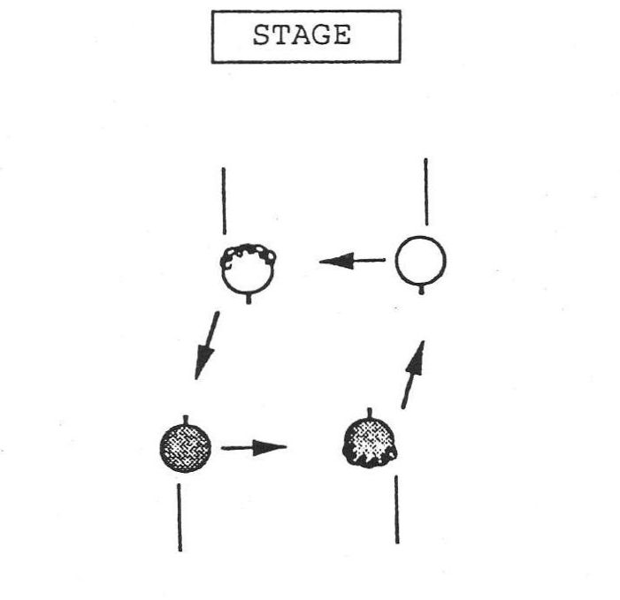
Figure 20. Paths of Men and Women Moving from a "Pass Through" to a "Circle Right"

[In] "The Reunion," the ending of this is interesting . . . because the "pass through" and "circle right" is a much better transition for the women. It's the men who don't get it together on that. . . . [The women] pass through and just keep going. And the guys have to really change direction there after that "pass through." (Hubert 1990b)

The "ladies chain" is the only traditional figure where the action seems to be primarily for the women. Susan Elberger speculates on why this might be the case:

In more traditional times, why would you have women doing more work? Aren't women supposed to be the dainty ones, the ones who "don't"? That's the way you show your woman off. That's where you put her out on display. So there's that aspect that men never have. They never get to be shown. (Elberger 1990)

Today callers rarely say, "men chain the ladies," and more often say, "do a ladies chain" (or even a "right hand chain") which does not imply the displaying of the women by the men, but rather allows dancers to conceive of the action as being equal:

Really everybody's working together fairly equally when you do [the "ladies chain"]. Whoever is the one who is turning the person on the outside is responsible for turning that person. Whoever is being turned is responsible for being turned. And there're certain ways of giving weight that make that stuff work really well and feel very good for both people. (Marshall 1990)

There are dances today composed with men's "chains" in them, a figure which feels awkward to both the men and the women because of their lack of familiarity with the opposite role.
Another example of a traditional move that has had gender implications is the "circle." Some of my informants speculated that the reason that dancers generally circle left first instead of right is that the man, who is usually standing to the left of the woman at the start of a circle, leads the woman into the circle, instead of vice versa:

[Circling left after a "swing"] the men are doing something a little more than the women do, because the men have to initiate the circle, and they have to use a little muscle control and sort of pull the women into the right direction. Whereas the woman is kind of being led. When we turn the tables around and have dances, the rare dance where the women initiate the circle, it does definitely feel different. It's not the flip side. It's different. (Pearl 1990)

Larry Jennings composed a dance in which the women pull the men into the circle:

I composed a dance a year or two ago that's designed to give the women the leadership part. You know, after a "swing," what do you do? You circle left. Why do you do that? Because the man's on the left. . . . The man leads the woman and she follows. And that's the traditional way. And why shouldn't you circle right? Because . . . the males stumble into [the women]. . . . No one has ever . . . said, let's practice it. For four or five dances now you'll have trouble, and then . . . you'll see that you've gotten the experience and you can have fun taking the lead and pulling the man into the circle instead. (Jennings 1990b)

The examples above demonstrate that dances can be more awkward for one gender or the other. They can also be more fun for one gender or the other, by giving that gender more of the action or a special figure of some sort. David Kaynor's dance, "Mary Cay's Reel," includes a sequence in which the women allemande right three-quarters in the center and then allemande left with the next woman down the line, while the men simply step slightly to the left. This little turning sequence is fun for the women, and Kaynor composed it that way on purpose so that Mary Cay would have fun doing her dance. There are always going to be dances that are better for one gender or the other, but there is now an attempt to balance dances that are more fun for the men with dances that are more fun for the women:

As far as I'm concerned it's OK to have a dance that's better for a man sometimes, and other times to have a dance that is . . . better for the women. And I find that if I'm using a dance that is one way or the other, I tend to balance it out with another dance that's better for the other gender. So I don't think having one like that is bad, but I do think you have to balance your choices out. (Kopp 1990)

Gender also enters into the social interactions within the choreography. In many dances there is very little same-sex contact, and another way that composers are dealing with gender issues is to include in their dances more sequences in which same-sex contact occurs. There are dances, some of which are perhaps still on the edge of what is acceptable to most dancers, that include "swings" between two women or between two men. There are dances, such as "Mary Cay's Reel," in which the women (or the men) have a sequence of moves primarily with each other instead of with the opposite sex:

I often will put those dances in . . . as a relief to having always interacted with just the opposite sex. . . . It's like, well is it time now for the men to realize there's another man on the other side of that woman? Or, you know, for the women too. (Marshall 1990, quote repeated from Chapter 5)

So today's choreography reflects a growing awareness of gender equality, and a growing concern for giving both sexes a chance to lead figures, to have a good piece of the action, and to interact with members of the same gender in the dance.
Gender issues show up not only in the choreography, but also on the dance floor in the course of a dance event. One kind of problem that arises is what David Kaynor refers to as the "pre-empting of the experience" of one person by another:

[It is important] to have every person feel that he or she is determining what the experience is going to feel like; and when you say a "ladies chain" and a "courtesy turn," that no one person says to the other, we are going to do this "courtesy turn" with, you know, just complete lugubrious lascivious body contact, as opposed to we're going to do a very kind of formal "courtesy turn" where we hold hands and the hand is on the waist, you know. . . . When one person decides that, that person's kind of pre-empting the experience for the two. (Kaynor 1990b)

This happens particularly with regard to a popular variation on the "courtesy turn," the turn which normally follows a half "ladies chain" or a half "right and left through." Instead of turning around as a couple, many dancers execute the turn by the man twirling the woman under his arm. This has become a bone of contention for some dancers, because they feel that they are forced into this variation against their will:

I find that I'm irritated by the degree to which people force twirling on each other. And there are women who will force it on men, although I think that most of the real harm generally comes when men force it on women. . . . A lot of gents just yank women's hands up. They just yank their arms up and force them into an egg-beater-like experience. (Kaynor 1990b)

This kind of aggressive dancing can occur in other figures too, such as the "allemande," where the stronger dancer may bend the arm of the other into an uncomfortable position during the turn.
Sometimes dancers engage in inappropriate behavior on the dance floor:

There're some particular dance figures that promote that, . . . that make it possible or easier to do that. You know, the "courtesy turn," "cast off," where the man gets to sneak a cheap quick feel, or something like that. . . . I mean everybody bumps into each other, and winds up . . . at various times grasping someone in some way that done purposefully would be considered inappropriate. But done in the context of just, you know, lurching and staggering and careening around the floor, is just sort of funny, you know, and no one worries about it. But it is a gender issue. (Kaynor 1990b)

This kind of problem seems more often to be the inappropriate behavior of men toward women, rather than the other way around:

Maybe it happens, and the men wouldn't complain about it. You know, maybe they would think, oh this is great, I got this unexpected experience, and I'm really glad I had it. Whereas a woman would say, well that was totally inappropriate and I'm upset about it. (Kaynor 1990b)

Same-sex interaction occurs in the choreography, as we have seen, and it also occurs at another level in the forming up of partners. Whenever there is an imbalance in the number of men and women at a dance, women will dance with women, and occasionally men will dance with men. Many people, particularly men, are uncomfortable dancing with a member of the same sex, but it is becoming increasingly accepted. It is confusing for beginners, however, for whom it may be disorienting to see someone of the wrong sex approaching for a "swing" or an "allemande." Many dancers enjoy trying the other gender's part, and a number of choreographers told me that they learn a great deal about the dance by dancing the other part:

I'm just really having a blast with it, because you can play around with it and you can explore both sides of it. And I've learned a lot about getting twirled out of "swings" and spinning around, and just generally playing around with the dances. (Hubert 1990b)

At least two of the callers with whom I talked had had the experience of being hired to call for gay dances. The challenge there was to use figures and terminology that resulted in dancing by position rather than dancing by gender roles. George Marshall gave an example where the "ladies chain" was rendered as a "right hand chain," in which the person on the right crossed the set, and the person on the left turned them around, regardless of gender
The terminology used in the calling of dances has changed in response to gender politics. The calls are no longer directed toward the men, just as the calls are less often directed toward the active couples. The term "woman" is used instead of "girl." "Neighbor" is used instead of "the one below," applying equally not only to both the actives and the inactives, but also to the men and the women. These changes are coming about gradually, and some callers are more sensitive to these issues than others. But if a caller today uses sexist language, he is very likely to hear about it:

At NEFFA [New England Folk Festival Association] we have an older caller who was traditional, and we had a lot of strong comments on the evaluation forms this year about his calling, because he used some of the more traditional calls, some of which are very sexist and quite rude. (B. Parkes 1990)

One of the questions that began to intrigue me as I looked for choreographers to interview was that virtually all the names I received were those of men. I did eventually find some women choreographers, and there are in fact a lot of them, but most of the nationally known choreographers of contra dance are men. I wondered why this should be so.
Part of the reason seems to be that traditionally most callers have been men, and dance composers tend to get involved in choreographic work through calling:

For generations of dancers, callers have been men. . . . When I started calling in 1945, and for quite a while after that, there were very few women callers. . . . The ones that I came in contact with were mostly connected with the Country Dance and Song Society. . . . They mostly got into calling through English dancing. (Sannella 1990a)

The callers have also tended to be the organizers in the dance communities, and men have taken these leadership roles in dance, just as they have in other sectors of our society. Women are still not taken as seriously in the role of authority figure:

When Ann and I are doing a swing dance workshop, if I book the hall and organize things, there's no problem in talking to people and having people . . . be willing to talk to me and take it seriously. Where if Ann calls up, she just feels like she's getting constantly hassled. (Marshall 1990)

There seem to be more men than women who are interested in becoming callers, if the enrollment at callers' workshops is any indication:

Any time I go to callers' workshops, there's a lot more men in the room than there are women, I can say that. (Zakon 1990)

Women more often choose to give their families priority over the demands of the life of a traveling caller:

When men callers get married and have children, they have their wives to stay home and take care of home and hearth and children. And they can continue their [calling] careers. (Elberger 1990)

Several of my informants speculated that one reason that women callers are less dominant is that their voices are not handled well by the sound systems used at dances:

I personally think some of that has to do with the voice quality, and especially the way sound systems treat voices. I do not know a lot of women that sound that good on a sound system. . . . Some of the big cavernous halls you end up calling in don't treat the high end very well, so a woman's voice gets kind of lost. (Zakon 1990)

Others suggested that a great many people are uncomfortable getting up in front of a large group, and that perhaps women are less inclined and less accustomed to doing this than men.
Women are unquestionably holding their own as dance musicians. Some of the best dance fiddlers today are women, and there are a number of all-women bands playing for contra dance:

I think it's generally acknowledged that some of the, maybe the majority of the really premiere dance fiddlers right now are women. . . . I'm not aware of real political issues vis a vis who gets hired to play in the band. (Kaynor 1990b)

There are many women involved in dance leadership, but they are working more on the local level than the national level, so they are less visible. Most of the callers in the Cleveland area are women, for example, and a high proportion of the musicians as well. I think that the tendency to work on the local level is also true of women choreographers. Their work does not disseminate as quickly, because they do not travel and bring their dances to other communities.
One may still ask why there is not a female Al Olson or Gene Hubert, choreographers whose work has spread far and wide despite their limited (in Hubert's case) and nonexistent (in Olson's case) calling careers. Some suggest that men simply have more aptitude for this kind of creativity:

I think maybe it's the same kind of thing that tends to make men and women different. I do believe that they're different in terms of aptitude for certain things, like spatial relationships, or math, or language . . . whatever it takes to make a good contra dance composer. Or maybe just the motivation, who knows? We're different, and that's it. Men may be better dance composers, but women are better dancers. (Pearl 1990)

Whatever the reason, men constitute the majority of the callers and the choreographers that are well known in the contra dance circuit. Women in these roles are less visible on the national scene. Susan Elberger is one among many women who are seeking to redress the balance by looking for dances composed by women, and by setting up dance events run by women:

I . . . organized dances one night where all the callers and all the musicians [were] women. And we had three women callers and a band going. . . . I would also try to encourage the other women I was working with to call dances written by women. (Elberger 1990)

In summary, gender issues are manifested in the contra dance revival, just as they are in the society at large, and these issues are apparent in the choreography of the dances themselves, as well as at the dance events and in the dance leadership.

STYLE

Another area of concern raised by my informants is the changing of the dancing style in recent years. The style of contra dancing is becoming more standardized, the attention to display has been weakening, and new elements of style are developing to match the faster pace of the new dances and the interest in aerobic dancing.
One aspect of the change in dance style has been the merging of local traditions into a more standard style. This is a result of cultural borrowing from one dance tradition to another, coupled with the increasing standardization of dance events as communications improve and the use of traveling talent increases:

Dance events are very very similar to each other across the country. And when you hear about somebody on one end of the country trying something really unique, it's not long before everybody wants to . . . use that pattern. . . . The bandwagon often is manifest in terms of hiring the same exact context, the same combination of caller and band. (Park 1990)

There are, of course, many smaller communities that still exhibit distinct dancing styles, but standardization is creeping into the larger dance camps and dance weekends.
The new choreography tends to give equal activity to all the dancers, as we have seen, with the result that most dancers are moving all of the time. One consequence of this change is that the dancers are not watching one another dance to the same extent. In the traditional dances the active couples would go down the center and back, and the inactive couples would be an audience for them; and it was fun to go down the center with skill and to show off one's dance steps or a unique way of turning around to come back. Now no one is watching. Dancers still try fancy variations with their partners, but it is predominantly for the enjoyment of those two people, and not a display in front of an audience. The traditional dance, "Petronella," has a series of four "balances" in it, and Tony Parkes observed:

"Petronella" . . . has been modified in my dancing lifetime from an actives and inactives to an everybody-move dance. . . . Ralph Page wrote that it used to be a point of pride for an experienced dancer to be able to balance a different way each time on "Petronella." Nobody's doing that any more, because nobody's watching them. (T. Parkes 1990)

There is more of a concentration on individual styling with one's partner, and less of a concern with communal movements. In the "lines forward and back" figure, for example, there tends to be more interest in relating to one's partner across the set than in making a straight line as a group. The inactives served a function by holding their stationary positions and keeping the set properly structured while the actives were dancing, and now the sets do not benefit from this structuring:

[There are] lots of chances to do your own thing, as opposed to playing the role as an inactive standing still for the good of the hall in a sense, for the good of everyone dancing. (Zakon 1990)

In the traditional dances the inactives both gave the set structure and also provided the actives with an audience, and these elements have weakened in the symmetrical dances. There is less point in a display if no one is watching.
The new dances are more complex, faster, and likely to be danced in a tighter space, as we have seen. These changes have also affected the dance style. There is less concern with grace and elegance, values that accompany the slower dance forms:

There's this whole new movement of people who don't really understand about the intrinsics of body movement and the relationship in the dance. . . . Some of the new folks who go to the dances now, . . . they're floppy, they're sloppy when they dance, and don't, in many instances, dance to the beat of the music. (Chalk 1990)

It's the same thing in western dancing. That's what happened to western dancing, the whole style of dancing degenerated as a dance form and became a track form. (Hendrickson 1990)

Callers are less concerned with teaching good dance style today. Some have not developed the skill to do so, just as they have not developed the skill to teach the basic figures to beginners; and when a caller attempts to give style pointers the dancers often become impatient:

In some cases when people try to do style teaching they kind of go overboard and the dancers start to look at the ceiling a lot and wonder why they can't just dance. . . . But in an evening of dancing I think it's nice to subversively sneak in a couple of style points in each walk-through. (Diggle 1990)

The lack of finesse in the dancing styles of many contemporary dancers leads to dancing that is unnecessarily rough, and sometimes to accidents on the dance floor:

They get into this rough twirling. . . . Men don't twirl ladies. Men hold their hand up, the lady puts her hand on it, and she twirls, if she wants to. But beginners can't see that. . . . So [a beginner] takes a hundred and ten pound thing, and he's two hundred and twenty, and he goes pew! We've had dislocated shoulders. (Hendrickson 1990)

Another element in the changing dance style is the addition of twirls to decorate the "dosido," the "courtesy turn," and sometimes other figures such as the "hey" or even the "slide" in one direction or the other. John Krumm summarized some of the reasons for the popularity of these kinds of variations:

One [reason is] that they can't dance slowly well enough. And the second is that they haven't ever learned the basic move. . . . Beginners that come to contra dances meet the flashy dancers, and that's who they have to imitate. That's all they can see. (Krumm 1990)

He goes on to suggest that because the new choreography uses faster and less forgiving moves, a slow move such as the "courtesy turn" feels out of place. Putting in a twirl keeps the pace of the dance more consistent:

Some dancers might be throwing in the twirls to make it a consistent pace through the dance, because changing the pace doesn't feel right to them. Better dancers . . . dance at the same pace. . . . Their pacing is controlled because they have better dance skills. (Krumm 1990)

So the dancing style has altered gradually in response to the different motivations of the dancers and in response to the changes in the choreography of the dances: Stylistic elements are becoming more homogeneous as the dance community grows; display elements are falling away for lack of an audience; grace and elegance are disappearing for lack of teaching and because of the increasing speed and aerobic nature of the dance moves; and twirls and other variations are being inserted into the dance figures to add vigor to the dance and to make the pacing of the dance more consistent.

THE INDIVIDUAL AND THE COMMUNITY

According to my informants, the average dancer today has a diminished awareness of the community aspect of the dance events, focusing instead on individual relationships. Part of this change stems from the fact that prior to the current revival the dances were first and foremost community dances, where an already existing community included dancing as one of many activities that its members shared:

A traditional community . . . is a group of people who have bonded together before, during, and including the life of their dance. . . . The people who come are always the same people. Somebody new is born into one of the families. Before they know it they're being whisked away to go to the little dance hall, because that's where the community goes, just like they meet in church. . . . Those people have truly bound themselves together, because they are a community first, and the dance is a secondary aspect of the community. (Park 1990)

Community dances still exist, of course, but there also exist many large dances, particularly in the urban areas, where there is not a pre-existing community of people who come together to dance; the dance is the community, and people congregate at the dance event as part of their search for a community with which to identify:

Type B is a bunch of people, often in a city, who have never met each other before, who are looking for a community, who somewhere in this sea of humanity, with plenty of people that they know but don't socialize with, they want to find a group to socialize with. So they come as individuals to a contra dance, and they form their community when they get there. (Zakon 1990)

This latter kind of dance event is based more on the needs of individuals, while the former kind is based primarily on community needs. This is a significant difference in perspective.
The focus on individual needs is part of what is behind the refusal of many dancers to put up with the teaching of beginners, the teaching of style, and the other methods that a caller may use to advance the skills of the group, sometimes at the expense of the interests of particular individuals:

A lot of it boils down to . . . the dancing master mentality versus the nobody's-going-to-tell-me-what-to-do mentality. . . . And one philosophy isn't necessarily all right and the other one all wrong. . . . But I also think that dancers need to be aware that there are good reasons for some of the guidelines that have been set down over the years—primarily that you're dancing with a whole lot of other people, and not just with yourself or your partner, and that it's a group activity, and in any group activity you need to have rules. (T. Parkes 1990)

The change in the clothing worn by some dancers is also indicative of a focus on the individual rather than on the community. Coming to a dance for exercise and aerobics is an individual purpose, whereas coming for a social occasion, for a party, is a community purpose. Beth Parkes speaks about the implications of the clothing worn at dances:

I think that's indicative of . . . a broader attitude issue, that I'm in this for me, as opposed to I'm in this for a social thing. I'm going to dress the way that's comfortable for me, not the way that looks good. I mean how you look is basically responding to other people. How you feel is basically responding to you. (B. Parkes 1990)

In these ways, the motivations for dancing are different than they used to be, and less community based.
Another factor in this change of focus is simply the increased size of the dance communities. It is easier to feel a sense of community with twenty other people than it is with one hundred and fifty:

When the dances were small . . . I think you had more of this sense of everybody as a group. And you did get to dance with everybody. . . . This is still true of the English country dance group on Monday nights. It's maybe only thirty people. And you dance with everybody pretty much in the course of the evening and you just don't think anything of it, because you're not really just dancing with that person, you're dancing with this whole group of people. So if you happen to choose one partner that you don't like so much, big deal. . . . And in contra dancing that's sort of gone by the wayside. (Dalsemer 1990)

The choreography, too, reflects this change of focus from the community to the individual. There are fewer moves such as "down the hall four in line," in which the whole room appears to move as a unit. This is partly in response to crowded conditions on the dance floor, and it is partly a response to the desire for individual challenge in the dances. Walking down the hall and back is not particularly challenging for today's dancers:

In the older dances you really had a sense that everyone was doing the same thing on the floor. And that was the joy. It didn't matter if you were swinging your partner. It was just so neat that you were all going down the center, and really everybody was, and you were all turning at the same time. And even if you were being inactive and standing still, well half of the room was doing just what you were doing. And you were doing the right role so the actives could do their thing. And it wouldn't work if you weren't doing your role. (Zakon 1990)

The division of roles between the actives and the inactives also fostered the taking of turns, which is a community value, whereas in today's choreography the dancers don't have to wait for their turn, but are continuously active:

I feel like more people want to be basically continuously amused, whereas in a lot of traditional dances I think there's that built-in concept of taking turns being amused. . . . While the ones are swinging, the twos watch. And the twos will get their turn as ones, and then the ones will be twos, and they'll watch. (Kaynor 1990b)

In the contemporary dances, as we have seen, there is not much opportunity to watch other people dance, and this too takes away from the perception of the dance as a community. In addition we have noted that the increasing difficulty of the new choreography also leads to sharper skill differences between the experienced dancers and the beginners, which is divisive and interferes with communal feeling.
Dance leaders are concerned about these trends and are trying to deal with them. The reader will recall the Cleveland community's attempts to raise the awareness of dancers there:

Ted Sannella talked about the growth of dancers. First you worry about yourself and getting yourself there, and then you worry about your partner, and then you worry about your little set. Then you worry about the line. And then you worry about the community! . . . And I think there are enough people [in Cleveland] in that community phase that will go pull people off the sides and make sure to ask them to dance. (Hill 1990)

David Kaynor voiced the hope that not only can we deal with these issues within the dance communities, but that through contra dance people can relearn some of the community values that we have lost in other aspects of our lives:

You don't have to surrender the need to take care of yourself, in order to help take care of somebody else's needs. . . . I think that the trick is to . . . explore the ways in which [the me-first need] can be satisfied in a group benefit context . . . that people will experience that synthesis of the bottom-line need of the self being completely compatible with neighborliness. . . . Our society doesn't tell people that. . . . A lot of our society tells people that in order to satisfy the me-first, you've got to get something before somebody else gets it, or at least get more than the other person gets. And I think contra dancing can teach people that that isn't so. (Kaynor 1990b)

Conclusion

Traditional art forms such as folk dance are not usually considered to have much relevance to an understanding of social change. This case study of one particular American social dance form, the contra dance, shows that changes in the interpretation of "dancing" and changes in the relationships between participants at a dance event can result in transformations of the dance form itself. Choreographic alterations can in turn affect the social environment in which the dances are performed. The contra dance form is not simply a reminder of our traditional heritage; on the contrary, it has been extremely responsive to change, both reflecting social change and contributing to it.
The origin of specific items of folk culture, notably the traditional ballads and folk songs, has been a source of debate among folklorists. Some scholars have considered them to be products of communal invention, while others have seen them as the inventions of creative individuals. The communal origins theory has been largely discredited today. Still folk dance, being a group activity, is often popularly conceived as having its origins in communal spontaneity and creativity, rather than in individual composition. We have seen that the contemporary contra dance exhibits a process of change that includes both individual innovation and community evaluation.
A variety of concerns lead to the injection of new material into the contra dance tradition, as we learned from the choreographers themselves. The composition of new dances may emerge from practical problems, such as a caller's need for a dance with particular features for teaching or for a special group of dancers. Other dances result from a composer's desire to mark special occasions or to honor particular people with a new dance that has not yet taken on the associations of other times and places, that is a fresh gift to the celebration. On yet a more abstract level, dances may emerge from a composer's struggle with a structural or aesthetic problem that teases the mind of the composer until a solution is found.
We traced the path by which a new dance is constructed, tested, and named by its creator, paying special attention to the "gimmick" and to the techniques used by the composer to set the gimmick into an effective sequence of figures. After the sequence is finished to the satisfaction of the composer, it enters a period of evaluation in which dancers, callers, and musicians inject life into the new dance, evaluating its potential as a vehicle for physical challenge and pleasure, for movement with the music, and for enjoyable social interaction. A dance that meets these criteria may be rapidly disseminated across the country, and one that does not will die on some local dance floor.
Underlying the evaluation of these new dances is a system of aesthetic values that is also evolving and that helps to set the bounds that determine which of the new dances will be embraced by the tradition and which will fall away. A wide variety of elements come into play in the evaluation of a choreographic sequence: those that relate to the movement of the body, such as direction, speed, and momentum; those that relate to the workings of the mind, such as the dancers' ability to memorize a sequence or the expectations they have developed through previous dancing experience; those that involve relationships between people, such as the social interactions that occur within a sequence; and those that facilitate the wedding of movement to music. This system of aesthetics is complicated and enriched by contextual factors that exert their effects when the choreography—the blueprint of a dance—is actually danced at a dance event. The emergent form of the dance performance derives not only from the choreography, but also from the quality of the music, the ability of the caller, the skill level of the dancers, and the physical environment in which the dance is performed.
The entire process by which the tradition evolves can be conceptualized in the following way: Imagine a "tradition boundary" that encloses all the dance sequences that are accepted as "contra dances." A choreographer may compose a new dance that lies entirely within this boundary, or he or she may push it out a bit with an innovation of some sort. As long as the choreographer does not push the boundary too far, the dance will be accepted as something new that is still a contra dance. As the tradition continues to develop through the innovations of individuals, this boundary moves, gradually encompassing new figures and new kinds of sequences as they become acceptable to the contra dance communities. At the same time that it stretches to accept new material, it will leave old material behind, and choreographic elements that were once part of the tradition will become obsolete. This is of necessity a gradual process, since a radical innovation will be too far outside of the traditional form to be accepted.
This model of change is illustrated by the recent developments in contra dance. For example, in 1950 the tradition boundary of contra dance did not include Becket formation dances, multiple progression dances, or the "hey for four." When these elements began to enter the tradition they were first marginal, and then gradually became incorporated into the bounds accepted by most dancers. Triple formation dances, on the other hand, have been for the most part left behind, abandoned because of their low level of activity, which no longer conforms to the aesthetic preferences of today's dancers.
The move from the proper formation to the improper formation is an example of a major shift in the tradition boundary of contra dance. In the early 1970s callers used to take time to explain the improper formation and to remind dancers to switch places at the ends of the set. Now callers must explain the proper formation, and remind dancers not to switch places at the ends of the set. Where once the proper formation was central to the tradition, it has now become more peripheral, the improper formation taking its place.
Men's "chains" and same-sex "swings" are marginal innovations that are out at the edges of the tradition boundary today. Had they been introduced in 1950 they would have been too far out for acceptance. Now they have a chance, as the boundary moves in directions that encourage gender equality.
This model is complicated by the fact that choreographic elements enter and leave the tradition at different rates. Some elements, such as the improper formation, have been around a long time and show no signs of going out of fashion. Other elements, such as the "four-leaf clover," came as an innovation, but did not take hold to the same degree, remaining relatively marginal. By contrast, the "hey for four" moved rapidly from the margins to the center of the field, and is now included in virtually every evening of contra dance, having established itself solidly within the contemporary contra dance tradition.
This case study gives us a picture of the process through which one traditional art form evolves. As new choreographic sequences enter the community repertoires, we experience not only transformations of specific dance sequences, but also a transformation of our conception of what constitutes a contra dance.
We have examined a number of concerns that have emerged to a greater or lesser extent in contra dance communities across the nation—concerns that include the elitism of experienced dancers, the nurturing of new dancers and new leaders, changes in gender relationships, alterations in the dance style, and the tension between the needs of the community and those of the individual. Most contra dance communities struggle with these social issues, but the ones that stand out as important may vary from one community to another. The size of a dance group is one variable that affects which issues come to the front. Small groups are usually more successful at paying attention to individual needs—making sure everyone who wants to dance is included, extending a welcome and some assistance to beginners, and giving community members the opportunity to develop their skills as callers and musicians. Large groups require more planning and better organization; leaders have a bigger job to do, and it is much more difficult to monitor the needs of individuals. Newcomers can be overlooked, and aspiring callers and musicians may have a harder time making their mark in competition with professional leadership. In determining what problems a dance community is likely to have, the size and the extent of isolation of the wider community also come into play. A small town in a rural setting will give birth to a dance group in which there are fewer outsiders and more members who are acquainted with one another through other sectors of their lives. In a large urban area, on the other hand, the makeup of the dance group may change from week to week as professionally run dance events ebb and flow in popularity, and many dancers will see one another only at the dance.
A third factor that distinguishes one local group from another has to do with the availability of talented leadership. One dynamic and sensitive leader can make a great difference in shaping the attitudes and habits that develop as a dance community grows. An insensitive leader can lead a group directly into some of the problems that we have discussed. These factors—the size and degree of isolation of the group and the quality of the leadership—make a difference in the extent to which problems such as center set syndrome, prebooking, and elitism emerge in a group, and they make a difference in the extent to which new dancers and leaders develop within the community. Every local dance group has its own strengths and weaknesses, and the issues that we have discussed are not equally applicable to them all.
The local differences discussed above exhibit elements of the distinction between "community dance" and "dance community" to which we alluded earlier. Recall that the term "community dance" refers to a dance event enjoyed by a group of people for whom the dance is but one of many shared activities; the term "dance community" refers to a group of people whose primary association with one another is at the dance. The distinction is not clear cut, but is rather a continuum with the two kinds of dance communities as its poles. This difference may be viewed against a cross section of contemporary dance events, or it may be viewed as a change through time.
Historically there has been a trend away from the "community dance" and toward the "dance community." Prior to the current dance revival, the typical dancer probably danced in a small New England village where dance events were but one activity among many shared by that group of people. Newcomers were infrequent, and were welcomed with interest and hospitality. The occasion was primarily social, and participants came to the dance event dressed for a party. They were familiar with the dances, both the sequences of figures and the tunes, and enjoyed a similar modest repertoire at every dance event, a selection of dances that served as a backdrop for socializing. Dance events similar to these still exist in localities that are outside the mainstream of the dance revival.
In recent years, particularly in the larger urban areas, the dance has become the community, and participants cultivate dancing friends who do not share other parts of their lives. They come dressed for a high level of activity, in cool, comfortable clothes and shoes with support. Socializing is not the only priority at the event. Many contemporary dancers thrive on the physical challenge of the dances and the thrill of learning new patterns that move them from one figure to another without pausing or turning back. They do not like to stand still and watch, but prefer dances that keep them in continuous motion, that flow. They value dancing skill, both in themselves and others, and try to arrange their dances to include the company of others who are equally skilled. Many contemporary dancers do not remember the individual dance sequences from one week to the next, but dance from a knowledge of the language of contra dancing.
The dancers at the poles of this continuum have a good many things in common, but their worlds differ in significant ways, and this is reflected in their dance events. What once was an activity of an existing community is now an activity that creates a community. What once was a localized activity has become a widespread activity, with increased sharing of regional styles and standardization of repertoires. Many callers have become professionals who tour the country for pay, bringing new dances into the repertoire to supplement (and supplant) the older ones. An activity in which social skills were paramount has become an activity in which physical skills may be equally important. These changes have evolved in conjunction with the development of the contemporary contra dance choreography.
It is interesting to speculate upon the degree to which the age of technology has made an impact on the contra dance tradition. Almost a third of the choreographers interviewed for this book work either in computer science or in science and engineering. Although this may simply reflect a changing demographic balance in the population as a whole, it may also suggest that dance choreography has an appeal for people who work with patterns and technical relationships. The fact that choreographers with these kinds of backgrounds are producing some of the new dances may in part explain the trend toward trying out all the choreographic possibilities, and the construction of complex as well as elegant solutions to choreographic problems.
Having a general population that is more familiar with technology may help to account for the language-centered approach to dancing that is replacing the repertoire-centered approach in some dance communities. Technology teaches us to learn a technical language and apply it to specific problems; perhaps this skill translates into learning the language of contra dance and applying it to specific dances. I wonder if another factor in this change may be the increased mobility of dancers and the need to have the dancing accessible to whoever may come in the door. Because the dances are always taught, and because their movements are drawn from a predictable pool of figures, a dancer who is familiar with the tradition can participate in the dancing nearly anywhere on the same basis as a local. The flip side of this, of course, is that a newcomer who is not conversant with the language of contra dance will have more trouble joining in.
The concern with attracting new blood to the contra dance events is of great importance, since the survival of the activity will ultimately depend upon it. Two decades ago the dances were easier, the groups were smaller, and the callers incorporated a great deal of basic figure teaching into an evening of dancing. We have explored the problems of today's beginners who, at a large dance event, may be met with more complex dance choreography, elitist behavior on the part of a number of the experienced dancers, and a new language for which there may not be a translator. In addition there is the problem of the dance communities getting older, and the reluctance of younger people to join in an activity that does not include many of their peers. More attention will need to be given to the recruitment of new dancers, if the activity is to thrive.
We noted another interesting pattern found in today's contra dance events—the shift towards dance as sport. The desire on the part of many experienced dancers for aerobic contra dances and for the company of others who have well-developed dancing skills is reminiscent of competitive sports. It is possible that the physical skills that were necessary for survival in the old traditional way of life have been transferred in contemporary society to our recreational life, and the need to excel has to some degree taken over the need to have fun—or perhaps has become a part of the concept of having fun. Readers have commented upon this pattern as being applicable to other forms of recreation as well—to bicycle clubs and hiking clubs, for example.
Patterns of change with regard to gender roles are also evident at the contra dance event, as we have seen. It is particularly interesting to see shifts in gender relationships within a tradition that derives much of its purpose and enjoyment from the relating of men and women to one another. In contra dancing, the movement toward gender equality is evident in the leadership, in the terminology used for calling dances, in interactions on the dance floor, and in the choreographic moves as well. Same-gender contact has become more common as partners of the same sex become more acceptable and as contra dancing is taken up by the gay community.

This examination of social issues and choreographic developments related to the contra dance tradition indicates that social change is mirrored both in the dance event and in the dance form itself. The contra dance is not a mere vestige of the past, nor is it simply a passive form upon which societal transformation makes its mark. The dance itself both responds to and plays a part in the construction of the social processes and relationships that develop among those who participate in this tradition.

Appendix

A. CONTRA DANCE FORMATIONS

Types of Contra Dance Formations

Contra dance formations can be divided into duple formations, in which every second couple moves down the set (away from the music) while alternating couples move up the set (toward the music), and triple formations, in which every third couple moves down the set and the remaining couples move up the set. The couples moving down the set are called the active couples and the couples moving up the set are called the inactive couples, because in the traditional dances the couples moving down the set have the more active role in the dance figures.

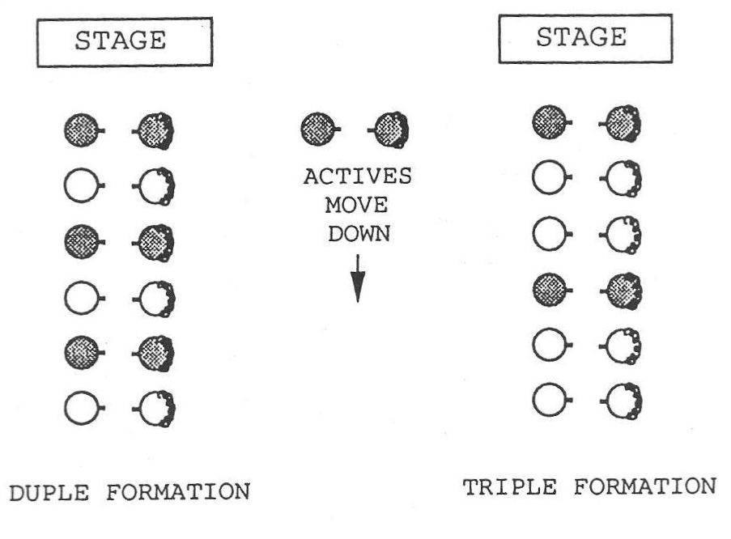
Figure 21. The Duple and Triple Formations

In the duple formation the figures are performed within subgroups of four dancers, and in the triple formation the figures are performed within subgroups of six dancers. These subgroups are called minor sets. After the dancers line up the caller will ask them to take "hands four" or "hands six" starting from the top of each set to determine these subgroups.

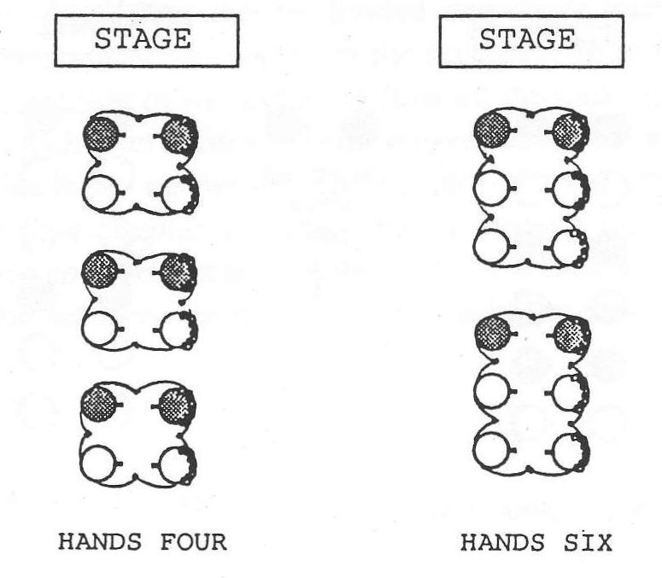
Figure 22. Minor Sets in Duple and Triple Formations

There are three linear duple formations. A duple proper contra dance is one in which the men are in one line and the women are in the other line standing across from their partners. A duple improper contra dance is one in which the active couples change places with their partners, resulting in alternating genders in each line. A Becket formation contra dance is one in which partners stand next to each other on one side or the other of the contra dance set. This formation is named after the dance, "Becket Reel," an early composed dance by Herbie Gaudreau, which was, to the best of my knowledge, the first contra dance to use this formation. There are no active or inactive couples in Becket formation; each couple progresses one place around the outside of the set with every repetition of the dance:

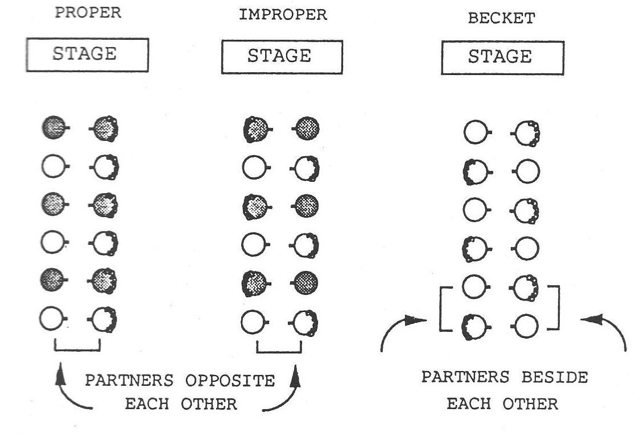
Figure 23. Duple Formations

Triple formation contra dances, like the duple ones, may be either proper or improper, depending on whether the men (or women) are all on one side of the set or whether the active couples change places with their partners instead:

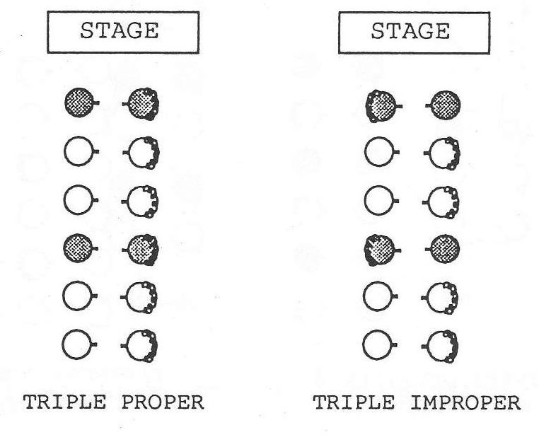
Figure 24. Triple Formations

Two other formations sometimes used for the contra dance are the Sicilian circle formation and the double contra formation. The Sicilian circle is a contra line that has been curved around the room into a circle so that the ends of the set meet. Instead of moving down the set and back up, each couple moves either clockwise or counterclockwise around the circle as long as the dance continues, never needing to turn around:

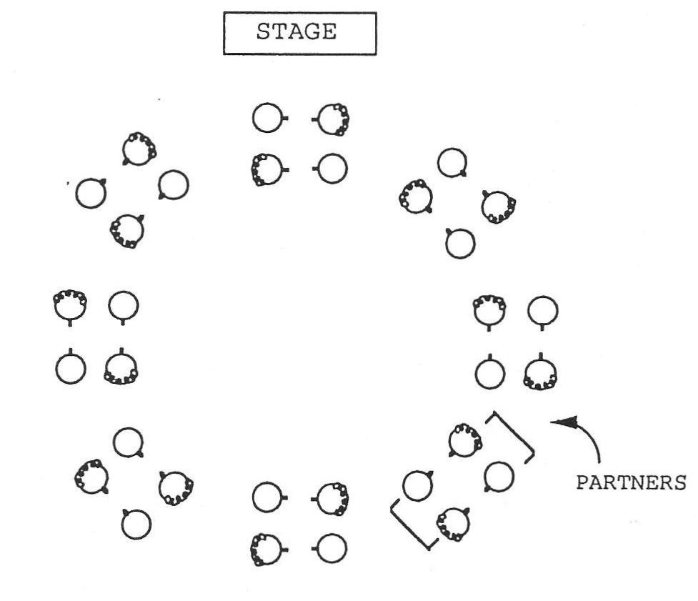
Figure 25. Sicilian Circle Formation

The double contra formation, also called "Portland Fancy" formation after the dance of that name, is simply two contra lines put together at the sides, resulting in groups of four dancers moving up and down the set instead of two. The subgroup dancing the figures becomes a group of eight dancers:

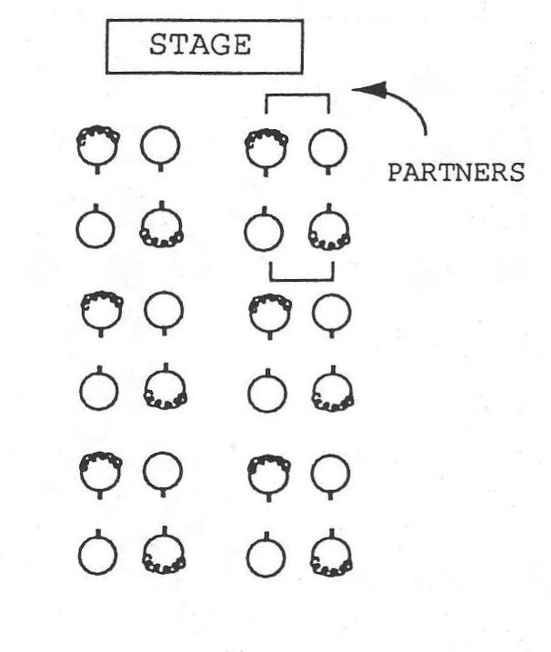
Figure 26. Double Contra Formation

The Progression

It is the progression that gives the contra dance its distinctive character. Because each couple progresses to a new position for each round of the dance, they meet and dance with every other couple in the set in turn. In the duple proper and improper formations the odd numbered couples, or active couples, move one position down the set (away from the music) and the even numbered couples, or inactive couples, move one position up the set (toward the music) for each repetition of the dance. At either end of the set, a couple must wait out one time through the dance before re-entering the set moving in the other direction. During the wait couples will commonly rest, talk, or dance with one another:

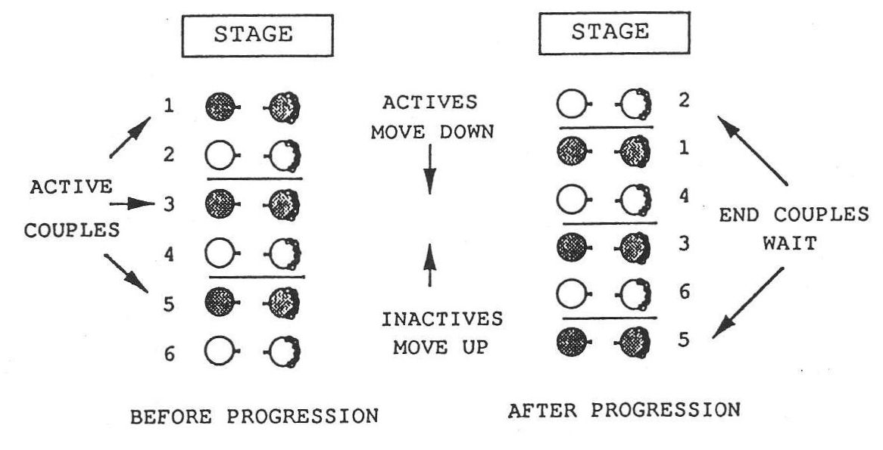
Figure 27. The Progression

In a Becket formation dance the progression goes down the set on one side and up the other, either clockwise or counter-clockwise around the set. Sometimes couples do not need to wait out at the ends in this formation; other times a couple at the end of one side of the set must wait out all or part of a particular figure if no other dancers are in the position to do it with them:

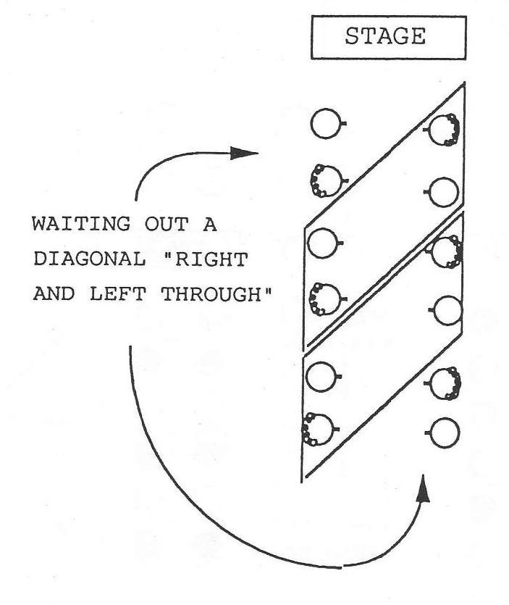
Figure 28. Waiting Out in Becket Formation

The progression in a triple formation contra dance, either proper or improper, occurs as every third couple moves one place down the set, while the other two couples in each minor set move up. The inactive couples alternate being couple two and couple three as they move up the set. At the top of the set a couple must wait out two times through the dance to acquire two more couples with whom to begin the dance again. At the bottom of the set two couples must dance with a ghost third couple in order to progress (see "End Effects" below).
Multiple progression dances are contra dances in which the dancers progress more than one place during a single repetition of the dance. Theoretically they may be in any of the above formations, but they are usually in the duple proper or improper formations. Double progressions are the most common kind of multiple progression dance, in which the active couples progress two places down the set during each repetition of the dance. Triple and quadruple progressions are possible, but rare. The multiple progression dances move the dancers through the various positions faster, but leave less time for social interaction with other couples along the way. Dancers must be ready to re-enter the dance more quickly at the ends of the sets.

End Effects

When a contra dance is done in a line, rather than in a circle, the dancers must change roles at each end and re-enter the dance going the other way. This change of direction may result in end effects, things the dancers must do or be aware of as they change roles.
In a duple contra dance there are two invariable end effects. One is that a couple must wait out one time through the dance at each end of the set before re-entering, as described above. The second is that in an improper formation dance the man and the woman dancing together must switch places before re-entering the dance, since in the improper formation men and women alternate along the sides of the set. Other end effects occur in particular situations. If a dance is a double progression dance, it is usually the case that a couple at the end need only wait out for half the length of the dance and must cross over quickly if the dance is improper, because they are most commonly pulled back into the dance after only sixteen measures of music instead of the usual thirty-two. If a dance contains figures that go out of the minor set (the subgroup of four dancers) and involve dancers in neighboring subgroups, then this will affect the couple waiting out at the end, who may be temporarily needed for an "allemande," a "swing," or some other dance move.
In Becket formation, the last couple on one or the other side of the set may need to modify some figures of the dance. For example, if couples are to slide left, the end couples must slide around the end of the set. If a diagonal figure is called for, such as a "right and left through" diagonally to the left, then one couple at the end will have no other couple with whom to dance. In this case they must wait out that particular move, and continue with the dance as soon as they are able (see Figure 28).
In triple formation dances, the end effects are different at the two ends, as described above. At the top of the set a couple must wait out two times through the dance in order to gather two more couples with whom to dance. At the bottom of the set an active couple must dance with the one remaining inactive couple plus a ghost third couple in order to assure a progression, and must then wait out one time alone at the end before re-entering as an inactive couple. Because the triple formation is less used in modern choreography, there are few, if any, instances in the triple formation of either multiple progression or figures that use dancers outside the minor set.

B. CONTRA DANCE FIGURES

Allemande left (right): Two dancers take left (right) hands and walk around one another, pulling slightly on one another's arms to facilitate the turn. The grip is not the one we use to shake hands, but is a grip with the thumb pointing upward, with which it is possible to exert tension more effectively. "Once around" means that the dancers walk completely around one another and back to where they started. Fractional turns are measured in relation to this. A handy hand allemande means that as one couple goes between the other, they allemande with the nearest hand, the dancers on one side of the set using the opposite hand from the dancers on the other side of the set:

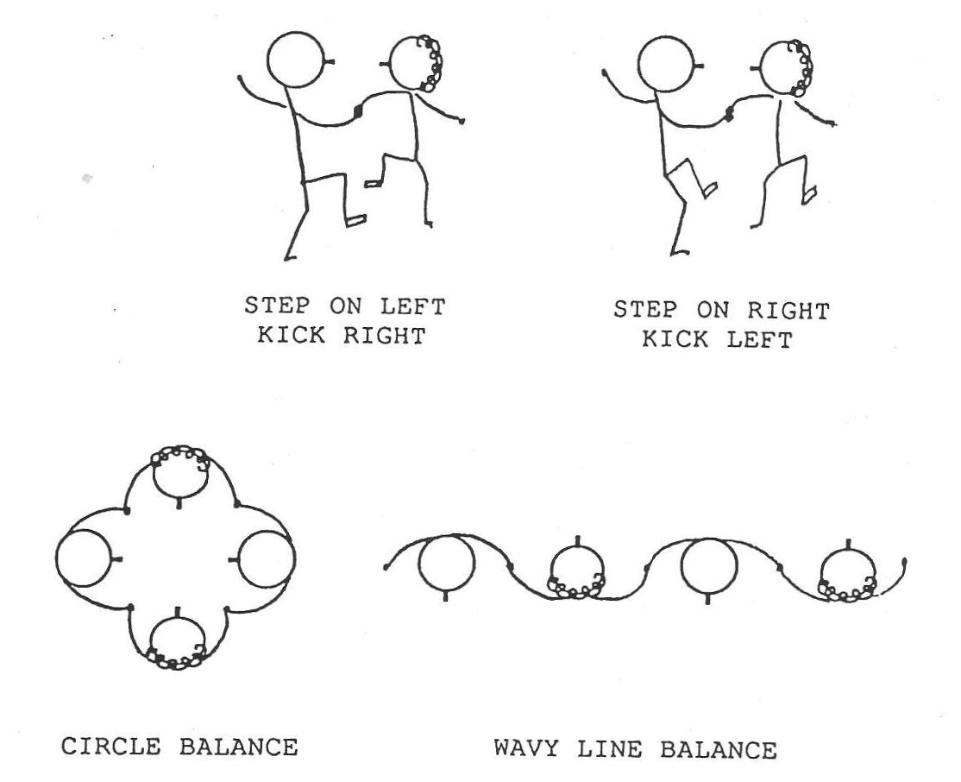
Figure 29. The Allemande

Balance: The balance has many variations, but the most common one is a move performed by stepping on the left foot and kicking up the right (or vice versa), and then stepping on the right foot and kicking up the left (or vice versa), in a four count sequence. The balance is found in three settings in contra dance: two dancers may take one hand or both and balance facing one another, usually preceding a swing; four dancers may take hands in a circle and balance together; or four dancers may take hands in a wavy line (adjacent dancers facing opposite ways) and balance together:

Figure 30. The Balance

Box the gnat: This is a figure borrowed from western square dance, and is a means by which two dancers change places. The two dancers face one another and take right hands; the woman turns and backs under the man's right arm while the man crosses to her place, turning to face back the way he came; the dancers end the move each occupying the original place of the other:

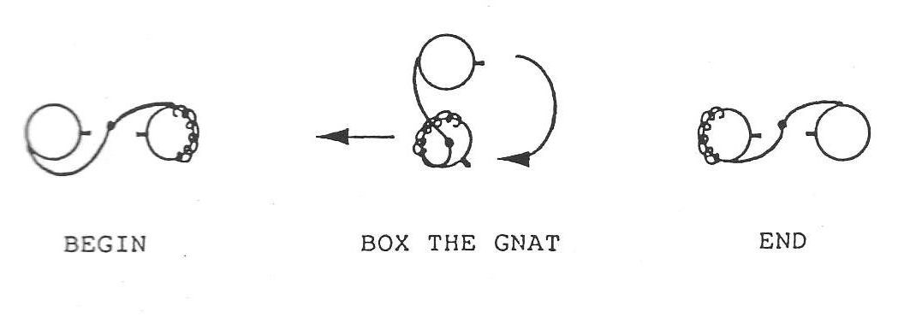
Figure 31. Box the Gnat

California twirl: This figure is similar to "box the gnat" in that two dancers use it to change places. But it is different in that the dancers begin and end the move standing side by side instead of facing one another, and the man takes the woman's left hand in his right. The woman walks under the arch made by their joined hands, while the man walks around her to his right to change places, with the end result that the dancers are still side by side, but facing the opposite way (Country Dance and Song Society Newsletter 95 [1990]:8):

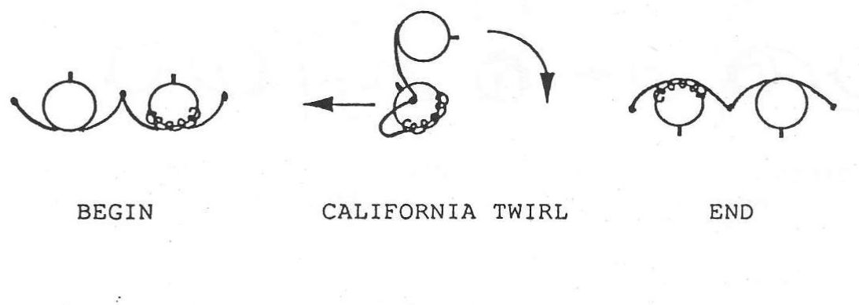
Figure 32. California Twirl

Cast off (or around): The cast off is a figure commonly used to accomplish the progression in a contra dance, especially in the more traditional dances. Actives couples stand between the inactives and either take inside hands or put their nearest arms around these inactives, and turn with them, ending up below the inactives in the set. Casting around another couple generally means that the actives turn to the outside of the set and walk out and around the inactives:

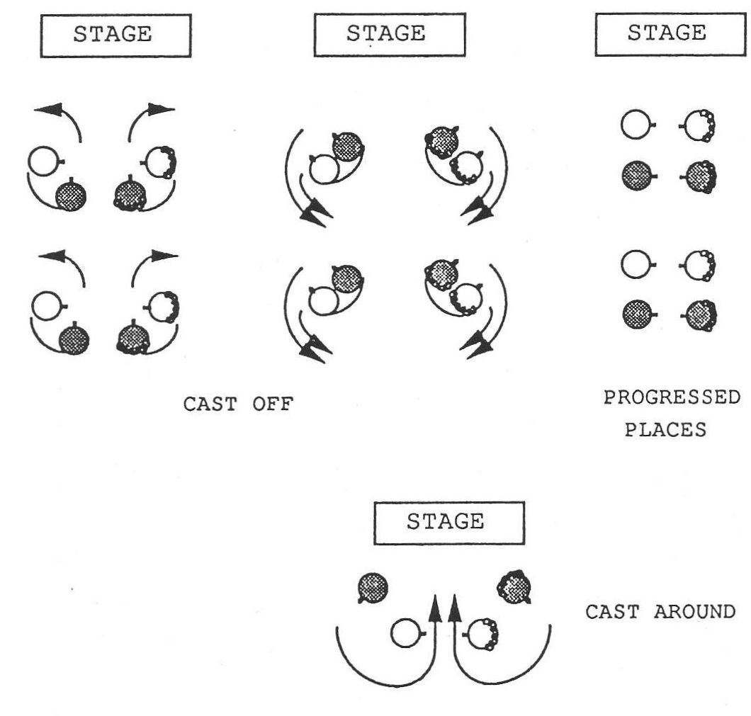
Figure 33. Cast Off and Cast Around

Circle left (right): Four dancers (or six in triple formation) take hands in a circle and walk to the left (right) one full turn and back to place. Fractional circles involve turns of more or less than one full turn:

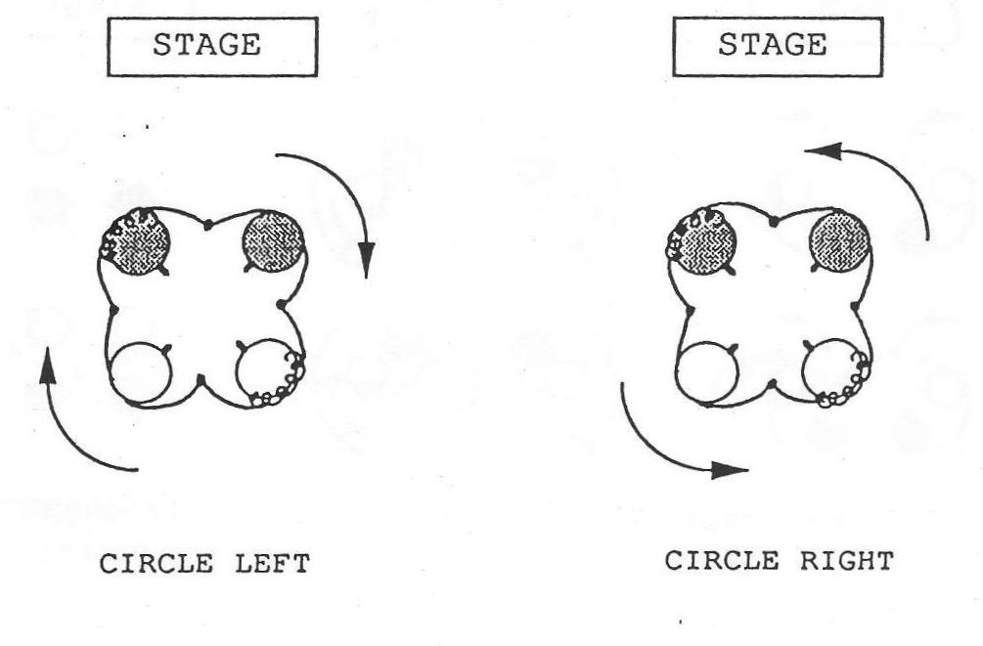
Figure 34. The Circle

Contra corners: Contra corners is a traditional figure in which the active couple performs a series of allemandes with the couples on either side of them, and with each other. To begin contra corners the active couple allemandes right with each other in the center of the set, and then each of them allemandes left with the person across the set to their right diagonal; the actives then return to the center and allemande right with each other again, and then allemande left with the person across the set and to their left diagonal. (Note that each inactive person is turned by two different active dancers, one from each side.) This completes the contra corners, and the active couple will usually come together again in some fashion as they finish the figure:

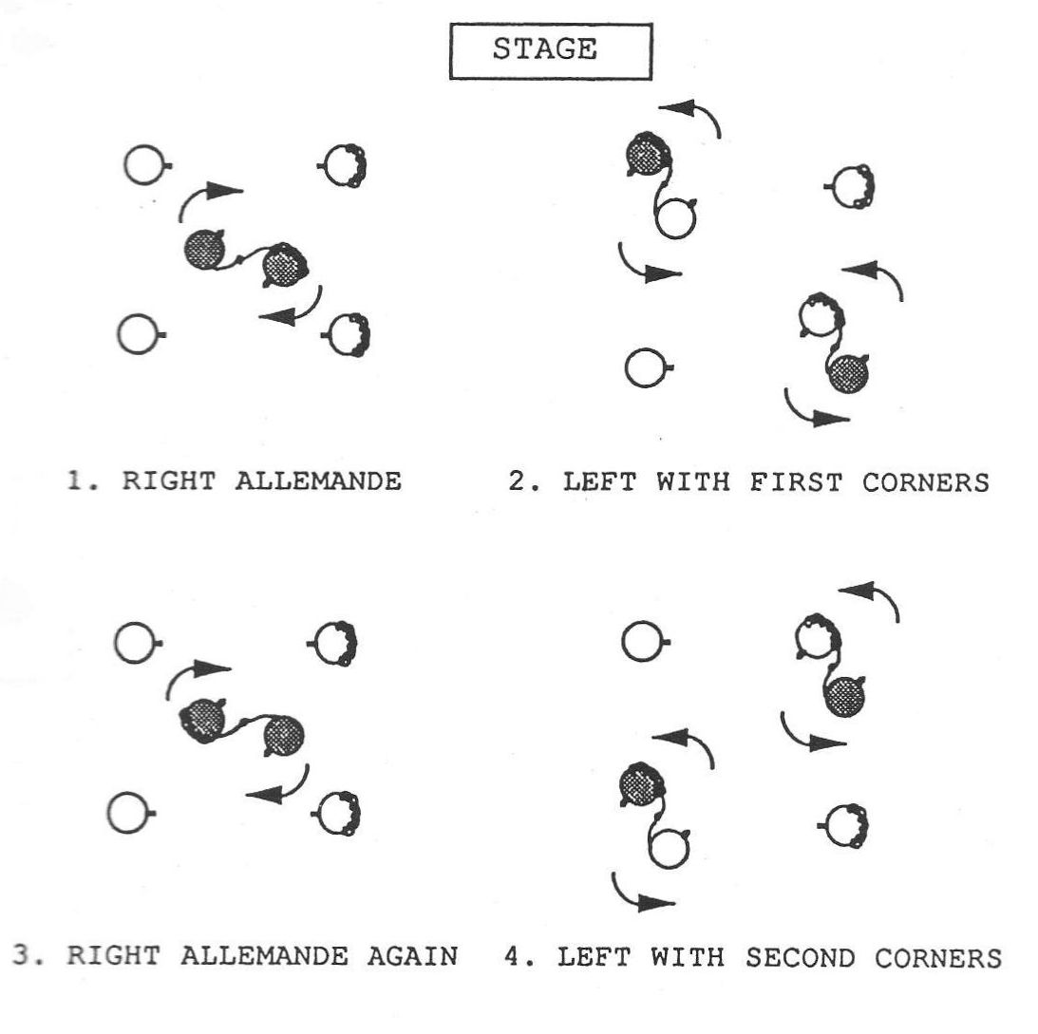
Figure 35. Contra Corners

Courtesy turn: The courtesy turn is a way in which a couple turns around halfway, usually following a half ladies chain or a half right and left through. The man takes the woman's left hand in his own left hand and places his right arm around her waist, taking her right hand at the right side of her waist. In this position the couple turns together one hundred and eighty degrees. Today's contra dancers often dispense with the courtesy turn and accomplish the turn with a twirl instead (see "twirl"):

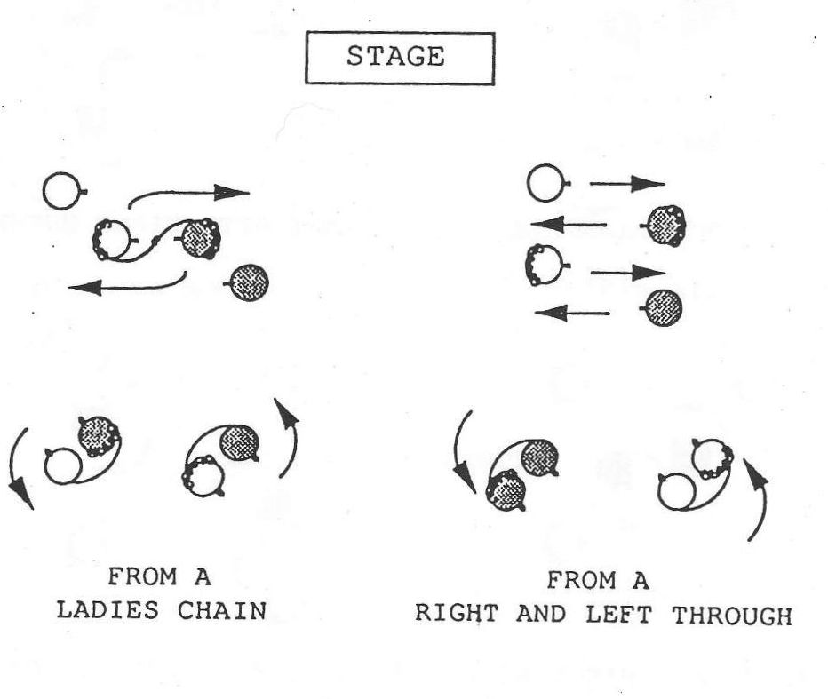
Figure 36. The Courtesy Turn

Dosido: The basic dosido figure is executed by two dancers who pass right shoulders with one another, pass back to back, and back up passing left shoulders and returning to place. A mirror dosido is one in which the dancers on one side of the set begin the dosido passing right shoulders, and the dancers on the other side of the set begin the dosido passing left shoulders. In modern contra dance choreography it is common to do a "dosido once and a half," which means that the dancers complete the basic dosido figure and then pass right shoulders again, moving past one another, often to swing someone else. Many of today's contra dancers like to twirl themselves around as they do the dosido:

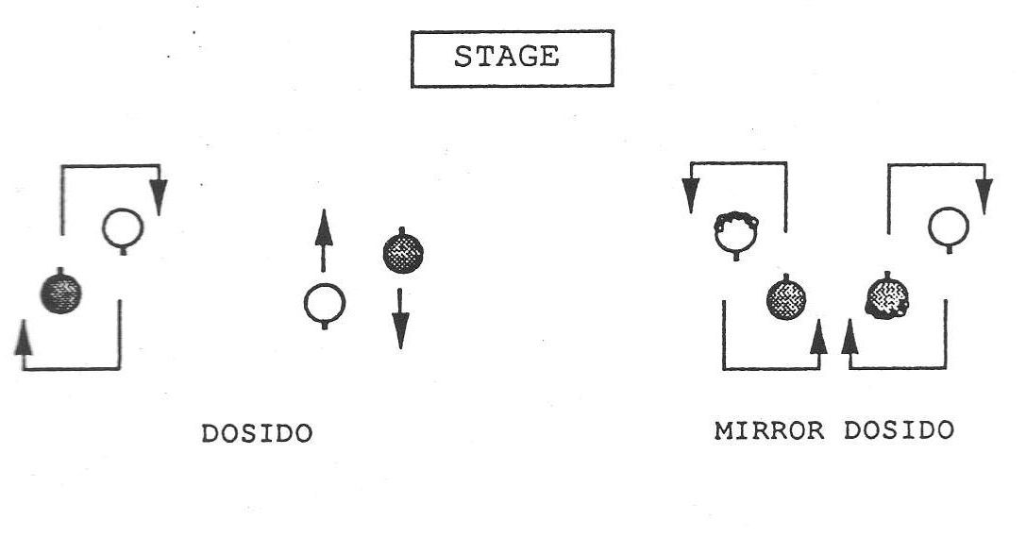
Figure 37. The Dosido

Down the center and back: Active couples go down the center and back while the other dancers watch. The dancers may turn individually before returning up the hall, or they may turn as a couple. The caller will usually specify which way to turn, since the method of turning affects the dancers' positions for the next figure:

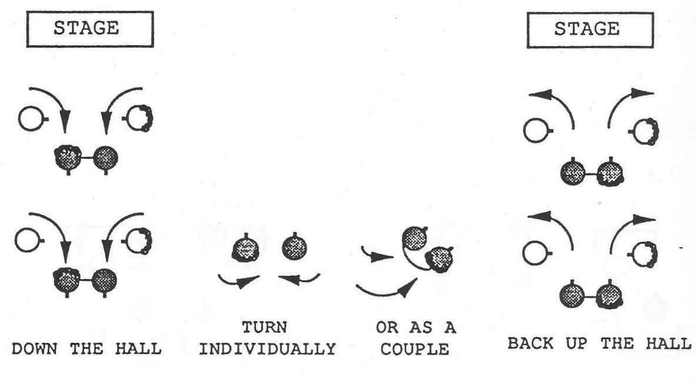
Figure 38. Down the Center and Back

Down the outside and back: This figure is traditionally performed by the active couples, who turn away from the center of the set and walk down the outside of the set, and then turn and come back to place:

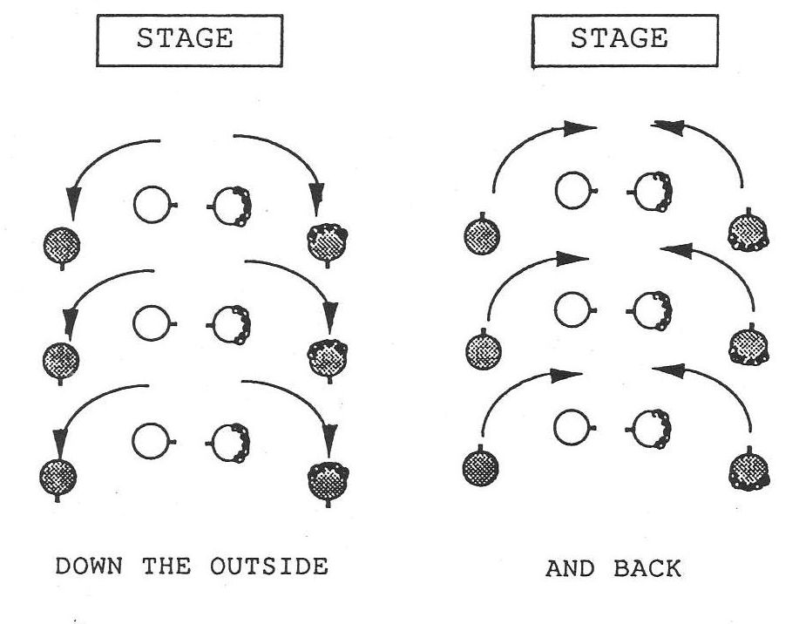
Figure 39. Down the Outside and Back

Down the hall four in line: The four dancers in a minor set all walk down the hall together in a line of four. Usually the active couple is in the middle, but not necessarily. The caller will specify whether the four dancers should turn individually or as couples before coming back up the hall, since the method of turning affects their positions for the next figure:

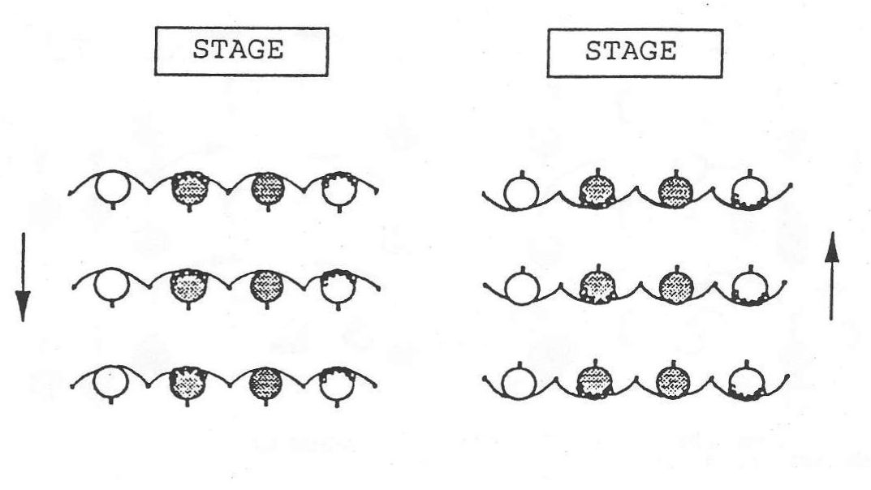
Figure 40. Down the Hall Four in Line and Back

Figure eight: This figure is usually executed by the active couples around the inactive couples. While the inactives stand still, the actives walk around them in a figure eight pattern. Both a whole figure eight and a half figure eight are common in contra dances. Often the inactives will move slightly to facilitate the movement of the actives:

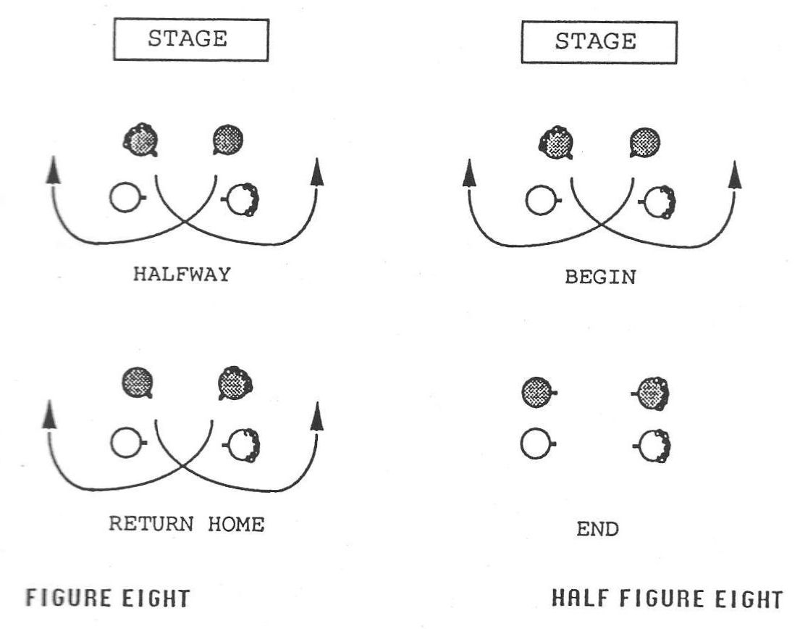
Figure 41. The Figure Eight

Four-leaf clover: This figure is from square dancing, and is performed by four dancers. It begins with dancers taking hands in a circle. Two dancers walk under the arch made by the joined hands of the other two, and then turn back to back bringing their own joined hands over their heads and into the center of the circle:

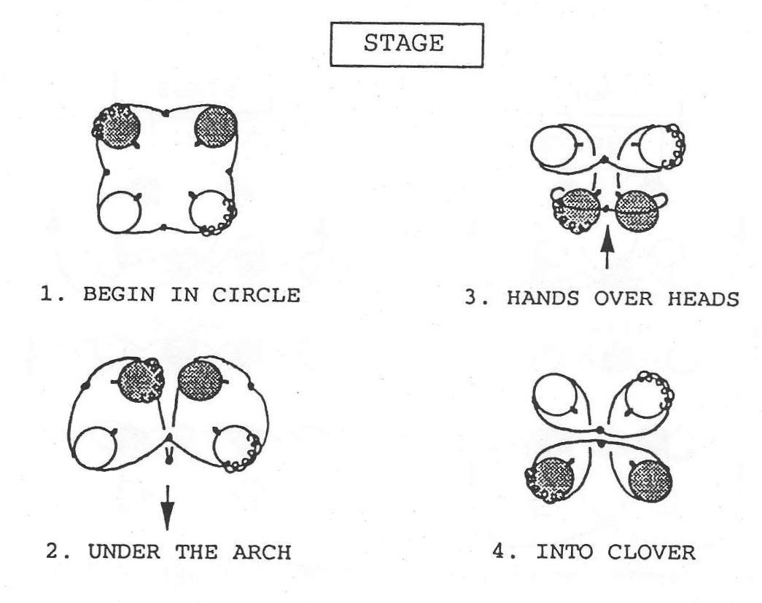
Figure 42. The Four-Leaf Clover

Grand right and left: This figure is used only rarely in contra dance, and is from the square dance tradition. In a contra dance it is usually executed around the large circle formed by the two sides of the set, joined at each end. Dancers walk around the circle taking right hands and then left hands alternately with successive dancers as they pass:

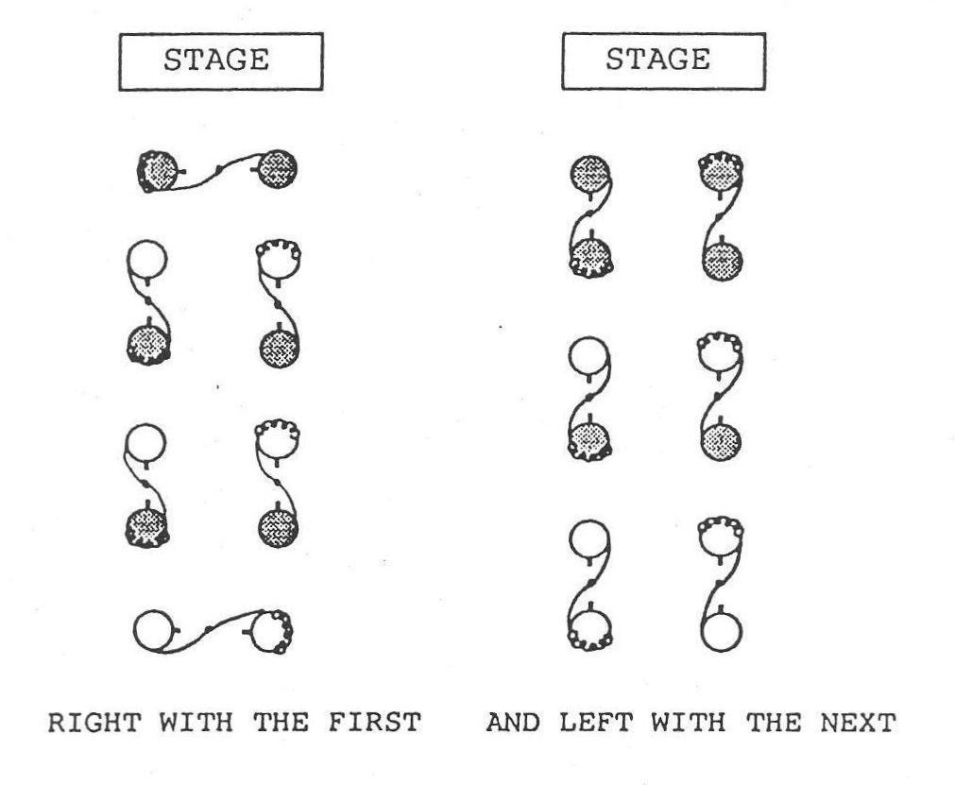
Figure 43. The Grand Right and Left

Gypsy: The gypsy is a figure borrowed from English country dance. It is done by two dancers, and may be done either to the right or to the left. The two dancers circle, facing one another and without touching one another, and eye contact is maintained continuously:

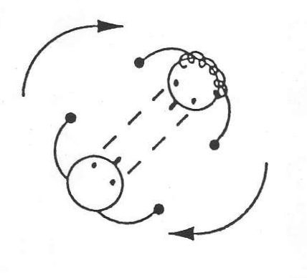
Figure 44. The Gypsy

Hey for four: This weaving figure has been borrowed from English country dance and is now quite popular in contra dances. Four dancers weave around one another without touching. Two dancers begin the figure by passing right (or sometimes left) shoulders, and the dancers continue to pass right shoulders in the center of the set and left shoulders at the sides (or vice versa) until they have returned to place. Some new dances include fractions of heys, and also heys on the diagonal. The contra dance hey differs from the English country dance hey in that it is done in a smaller space and does not have the expansive elegance given to it in the English country dance tradition:

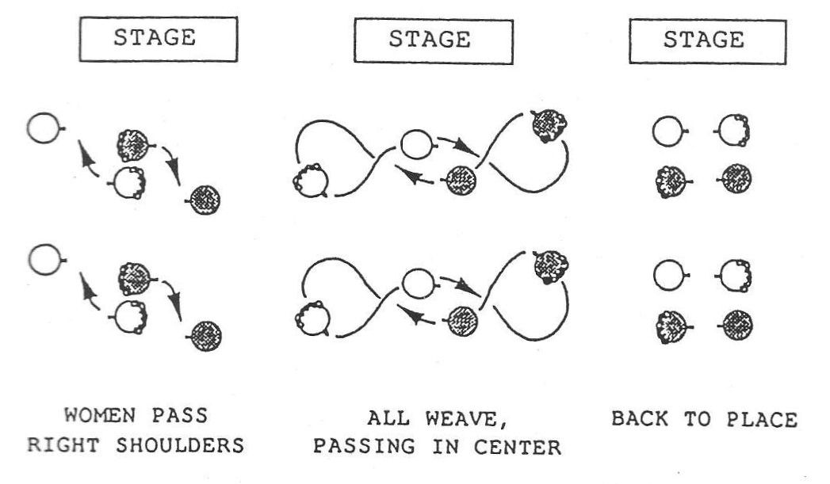
Figure 45. The Hey for Four

Ladies chain: The two women take right hands and cross the set, where they are turned with a courtesy turn by the man on the opposite side. The women then take right hands again and cross back to place, where they are once again turned, this time by the man on their original side. This figure is often performed only half way (across the set) without the return. Many of today's dancers like to use twirls in place of the courtesy turns. There are newly composed dances that include chains for the men instead of the women:

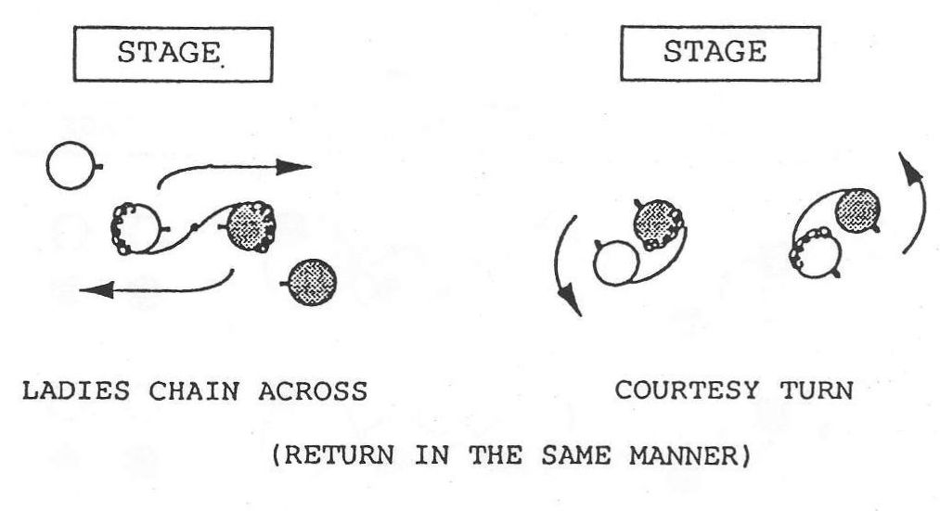
Figure 46. The Ladies Chain

Long lines forward and back: Dancers take hands along the sides of the sets, and the two long lines walk four steps toward each other, and then four steps backwards to place:

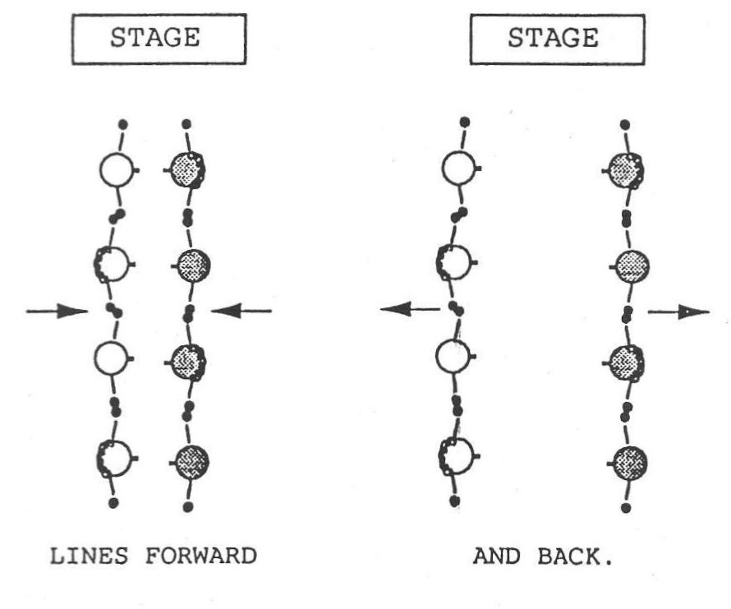
Figure 47. Long Lines Forward and Back

Pass through: This figure is performed by two couples who pass by one another as they walk in opposite directions. The dancers on the right (usually the women) walk in between the dancers approaching. This figure may be done up or down the set or it may be done across the set:

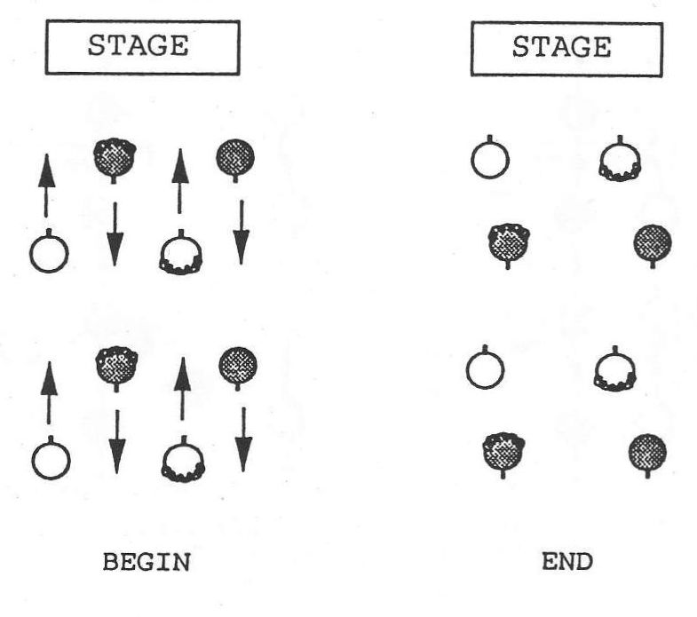
Figure 48. The Pass Through

Promenade: The two couples in the minor set walk across the set in promenade position passing one another, and then turn into the place vacated by the other couple. The promenade hold varies regionally:

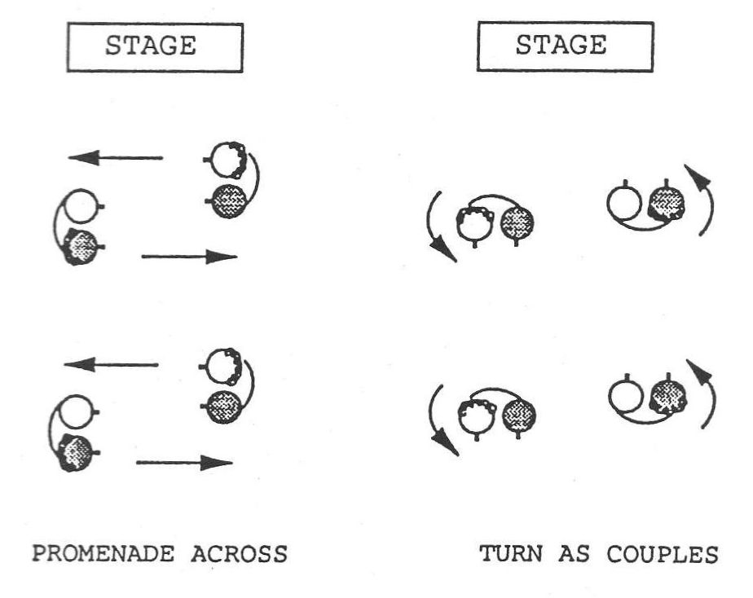
Figure 49. The Promenade Across

Pull by: Two dancers take hands and pull by one another going opposite directions. This figure may use the right hand or the left hand depending on its context, and it may occur along the set or across the set:

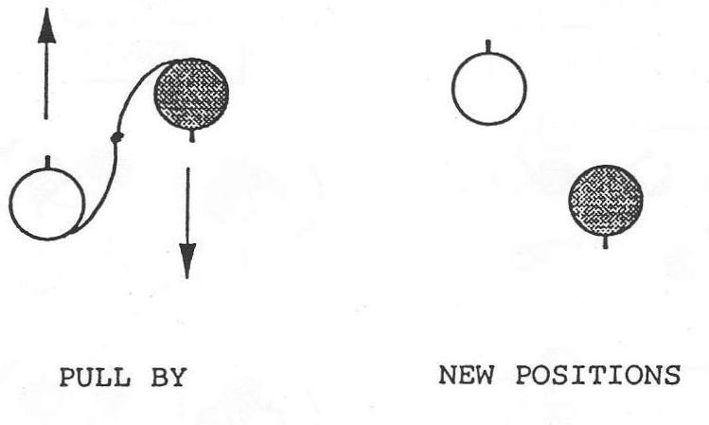
Figure 50. The Pull By

Right and left through: Two dancers on one side of the set change places with two dancers on the other side of the set by passing through (passing right shoulders with the dancer directly opposite) to the other side, and doing a courtesy turn; then in like manner the two dancers pass through again and return home to another courtesy turn. The "right and left through" is often done only halfway, without the return:

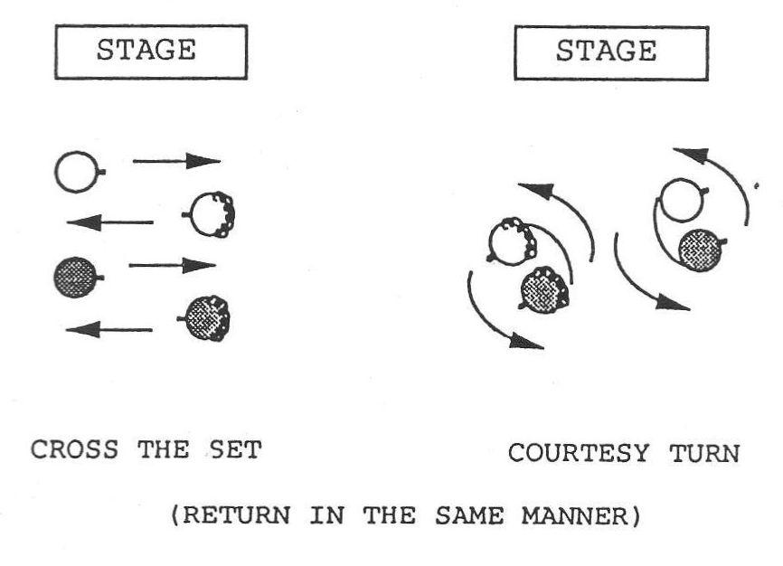
Figure 51. The Right and Left Through

Slide: This term simply refers to a movement to the right or left, usually no more than one or two steps. One common use of the slide is in the balance in a wavy line, when after one balance the dancers slide one place further down the line and balance again. Another common use is when a couple moves together down the side of the set to circle with a new couple:

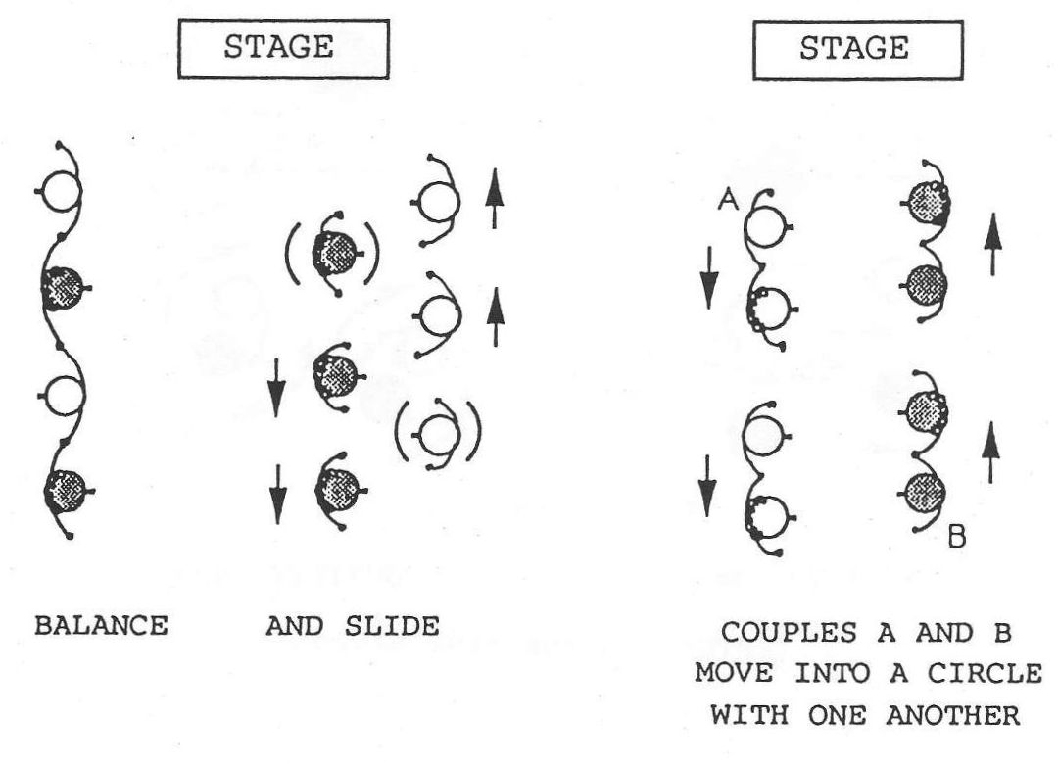
Figure 52. Two Kinds of Slides

Star: The star left (right) is performed by four dancers, who place their left (right) hands together in the center of their little circle and walk around counter-clockwise (clockwise). The hand hold used will vary regionally, the most common holds being the handshake hold with the person opposite in the star, and the wrist hold in which every dancer takes the wrist of the dancer ahead. To star once around brings one back to where one started. Fractional stars are also used in contra dance:

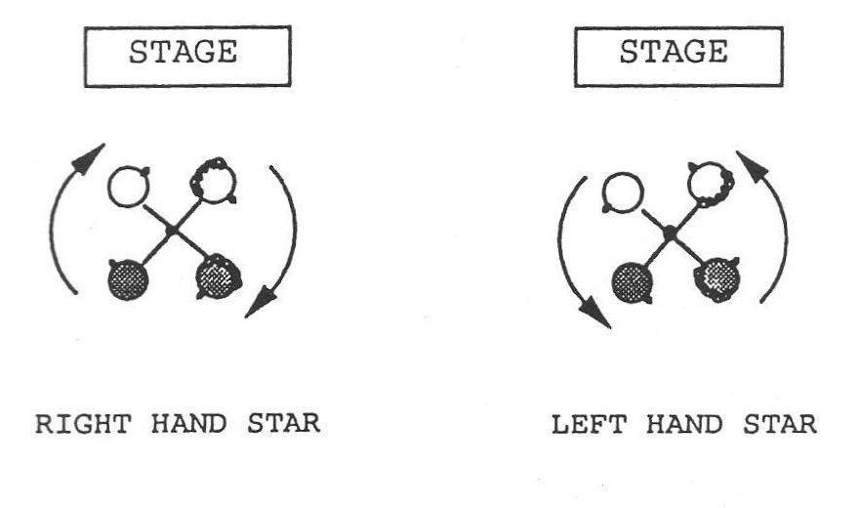
Figure 53. The Star

Swing: The swing is performed by two dancers, who most commonly hold one another in ballroom position (the woman's left hand behind the man's upper right arm, and his right hand on her lower back, their other hands joined), and turn clockwise together. A walking step may be used with the swing, but the buzz step is more popular in modern contra dance. The buzz step is a scooting motion in which the dancers' right feet stay close to their center of gravity, while their left feet scoot them around in a tight circle. Dancers lean back slightly as they swing, "giving weight" (see Dancing Style below). There are alternate holds for the swing, particularly for same-gender swings. When a man and a woman swing, the swing ends with the woman standing to the right of the man:

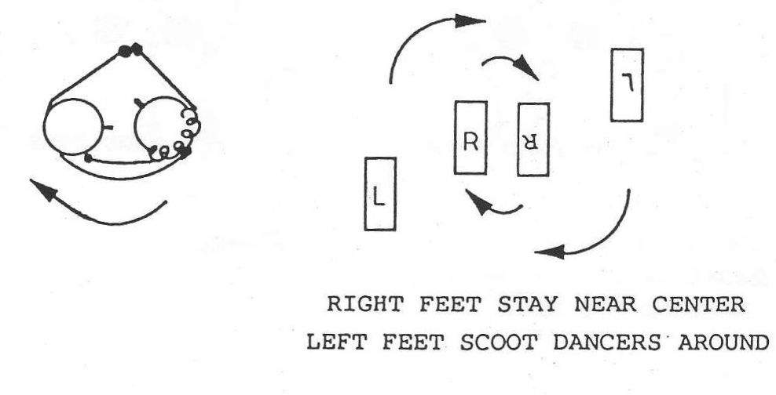
Figure 54. The Buzz Step Swing

Twirl: The twirl is not a contra dance figure, but it is a popular variation used in place of the courtesy turn in the ladies chain figure. Instead of the man putting his right arm around the woman and turning around with her, he takes her left hand in his and she turns clockwise under his raised left arm, revolving one or more times, while he turns counter-clockwise in place, guiding her all the way around him and facing her as she goes. Another kind of "twirl" happens when dancers turn themselves around solo as they execute a dosido or a hey for four:

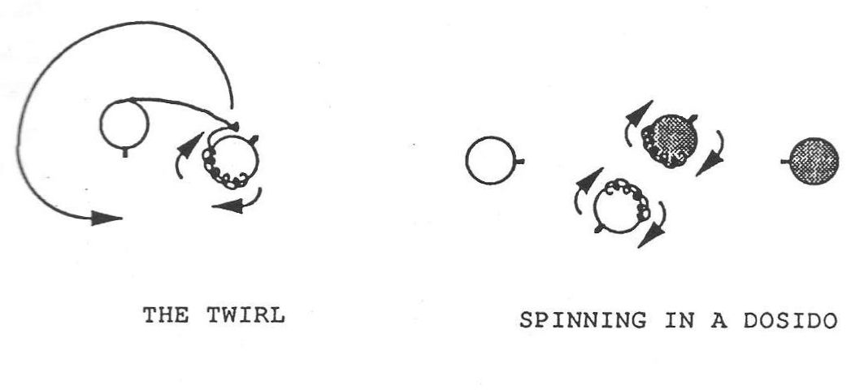
Figure 55. The Twirl

C. DANCING STYLE

It will be useful to describe a few of the basic elements that go into the dancing style used for contra dance. First, there is a minimum of complicated footwork, most figures being performed with a simple walking step. Exceptions are the "balance," the buzz step "swing," and individual flourishes which are not integral to the dance figures. Most contra dance figures are basically floor patterns and are walked.
In contra dance it is important to fit the figures to the music. This is an element of the dance style which must be learned by beginning dancers. A "circle" to the left must fit a four-bar musical phrase, and a "circle" back to the right must fit the next four-bar musical phrase. Changes of direction are usually made at the end of the preceding figure in order to start the new figure on the beat. Dancers try to dance each figure in such a way that it exactly uses up the music allotted for it, finishing the figure neither too late nor too early, but exactly at the end of the musical phrase.
"Giving weight" is another important element of the contra dance style. Dancers create a tension between them by pulling slightly as they take hands with one another, and this tension helps the dancers move quickly and efficiently through the figures. Giving weight is in fact necessary in order to finish the figures on time, especially in some of the faster moving modern contra dances. If the arms are held limp it is not possible to go around another dancer as quickly, nor is it as much fun.
Connecting strongly to other dancers is considered important in contra dancing. One should make every effort to feel the physical presence of the other dancers in any figures in which dancers touch one another. In a circle, for example, one should have a sense of the weight of each dancer, including the dancer across the circle from oneself.
Eye contact is used in the contra dance style to establish contact with another dancer with whom one dances a figure. This element of the contra dance style often makes beginning dancers uncomfortable initially, because they are unsure how to interpret this direct look.
It is important in contra dancing to keep the spacing on the floor orderly and predictable. Ideally lines should be straight, circles should be round, and dancers should time their moves so that they reach the appropriate positions with the musical phrase. In walking down the hall, care should be taken not to go too far, so that the return can be accomplished without rushing. Attention to these matters makes the dancing more pleasurable to do and more beautiful to watch.

D. BIOGRAPHIES OF INFORMANTS

Peter Bixby, a dancer in his thirties, is a graduate student in comparative literature at Indiana University. He was active in dance in New England for nine years, prior to moving to Indiana. Bixby is a beginning caller and choreographer of contra dance, and a devotee of morris dance.
Fred Breunig, a caller and musician in his forties, lives in Putney, Vermont. He works as a printer when he is not engaged in music and dance. Breunig has been dancing, playing music, calling, and composing dances for over twenty years. He is regularly active in dance in Vermont and New Hampshire, and has also shared his talents in twenty-eight states, three Canadian provinces, and in England and Scotland.
Bernard Chalk, a caller in his fifties, lives in England. He is retired from working for the Thames Water Company in London. Chalk has been dancing and calling for over thirty years, and at the time of our interview had been composing dances for ten years. In addition to being active in all the major festivals and dance groups in England, he has toured more than thirty states in the United States. He also served as the resident manager for the Berea Folk Center in Kentucky for a couple of years.
Bob Dalsemer, a caller and musician in his forties, lives in Brasstown, North Carolina. He makes his living working with music and dance. Dalsemer has been dancing, calling, and playing music for dancing for over twenty years, and at the time of our interview had been composing dances for fifteen years. He is regularly active in dance in the Baltimore and Washington D.C. area, and has also called and played music in more than twenty-five states, in Canada, England, Denmark, and the U.S.S.R.
Roger Diggle, a caller and musician in his forties, lives in Madison, Wisconsin. He makes his living as a refrigeration and heating service engineer. At the time of our interview, Diggle had been dancing and playing music for about ten years, and calling and composing dances for over six years. He has been active in dance primarily in the Midwest, but also in the South and in the mid-Atlantic region of the United States. He is currently working on a book of his own dances and has written several articles for dance newsletters. In addition, he has given workshops on the intricacies of choreography, calling, dancing, dance music, and P.A. equipment.
Larry Edelman, a caller and musician in his thirties, lives in Baltimore, Maryland. He works both as a square dance caller (squares and contras) and as an adult education specialist. At the time of our interview, Edelman had been dancing and playing music for eighteen years, calling for fifteen, and composing dance for twelve years. He has called in twenty-five states from Florida to Alaska, and he has also called in four European countries. Edelman is the author of the book Square Dance Callers Workshop and each year he teaches a week long intensive callers' workshop. He is known for his ability to write square dances that appeal to today's dancers.
Susan Elberger, a caller in her forties, lives in Lexington, Massachusetts. She has worked as a manager and administrator in human services and health care and is currently a parent and homemaker. At the time of our interview, Elberger had been dancing for fifteen years, calling for thirteen, and composing for twelve. She is active in dance primarily in New England and the mid-Atlantic states, but she has also called in Michigan, California, and England. Elberger was President of the New England Folk Festival Association for four years. She is particularly interested in the social context of dance as opposed to its value as aerobic exercise, and she is also collecting dances written by women.
Chip Hendrickson, a caller in his fifties, lives in Sandy Hook, Connecticut. He works primarily with English social country dancing (Playford) and historical English and Early American country dancing and square dancing of the 1950s. He works with eighteenth century presentations, and has held a position as the supervisor of dance at Colonial Williamsburg. At the time of our interview, Hendrickson had been calling for over forty years, and dancing longer than that. He is regularly active in the New England area and has called in over thirty states and in Canada. He has also made approximately twenty modern square dance records on the TOP Caller label.
Steve Hickman, a dance musician in his forties, lives in King George, Virginia. He makes his living as a musician, both playing for dances and giving music lessons. At the time of our interview Hickman had been dancing and playing music for twenty-one years, had called a little, and had co-authored one dance. He is regularly active in the Washington D.C. area and the east coast in general, and in addition has worked all across the United States, and in Canada and Europe.
Becky Hill, a caller and musician in her thirties, lives in Cleveland Heights, Ohio. She works half time in special education and half time with the folk arts, story telling and dance calling. At the time of our interview, Hill had been dancing for seven years, calling and composing for five, and playing music for four years. She has been active in dance primarily in Ohio, but also in Pennsylvania, West Virginia, Washington D.C., and New York.
Tom Hinds, a dance caller and musician in his thirties, lives in Silver Spring, Maryland. He makes his living as a dance teacher. At the time of our interview, Hinds had been dancing for ten years, calling for six, and playing music and composing dances for four years. He calls regularly in Maryland, Virginia, Pennsylvania, New Jersey, New York, Connecticut, Massachusetts, and North Carolina, and he has also called on the west coast. He has published two books of his own dances.
Gene Hubert, a dance caller in his thirties, currently lives in Bethesda, Maryland. He makes his living as a computer programmer. At the time of our interview, he had been dancing eleven years, and calling and composing nine years. Hubert has been active in dance primarily in the Midwest and the Southeast, but he has also called in the Washington D.C. to Boston corridor. Hubert's dances are very well know nationally among contra dancers, and he has published three books of them, Dizzy Dances I, II, and III.
Larry Jennings, a contra dance facilitator in his sixties, lives in Belmont, Massachusetts. He is a retired scientist and works now to facilitate the growth of the dance communities in the Boston area. At the time of our interview, Jennings had been dancing for forty-one years, and calling and composing for seventeen years. He edited a collection of dances, Zesty Contras, that has been an invaluable source book for dance callers since it was published in 1983. He also contributes to the "Contra Connection" column in the Country Dance and Song Society Newsletter.
David Kaynor, a dance caller and musician in his forties, lives in Montague, Massachusetts. He makes his living leading dance events and giving music lessons. Kaynor has been dancing since he was a child, and at the time of our interview had been playing music for eighteen years, calling for fifteen, and composing dances for about ten years. He calls regularly in the New England area and has also traveled throughout the United States and in Scandinavia.
Carol Kopp, a dance caller in her forties, lives in Streetsboro, Ohio. She makes her living as a programmer-analyst. At the time of our interview, she had been dancing twenty-six years and calling thirteen years, and had composed dances sporadically for eleven years. Kopp is active in dance primarily in the Cleveland-Akron area, but has also called in Massachusetts, West Virginia, Pennsylvania, and Michigan.
John Krumm, a dance caller in his thirties, lives in Audubon, Pennsylvania. He makes his living as a teacher working with children at an alternative school and is known for his prolific composing of rounds for singing. He is regularly active in dance in the Philadelphia area, and has also traveled as a caller and run workshops at dance camps. He has composed a number of popular contra dances.
Dudley Laufman, a dance caller and musician of sixty, lives in Canterbury, New Hampshire. He makes his living as an itinerant fiddler and dancing master. He has been dancing, calling, playing music, and composing dances for over forty years. He is active in dance throughout New England, and in New Hampshire in particular. Laufman has traveled as a caller and musician on the eastern seaboard, in the South, in the Midwest, on the west coast, and in Alaska and Hawaii. His work as a dance caller and musician has been a primary influence in the resurgence of traditional dance forms in this country. Many of today's callers and musicians learned to dance at Laufman's dances in the earlier years of the revival.
George Marshall, a musician and caller in his thirties, lives in Belchertown, Massachusetts. At the time of our interview, he had been dancing eighteen years, and calling, playing music, and occasionally composing dances for over fifteen years. Marshall plays and calls with the dance bands, Wild Asparagus, and Swallowtail. He is most active in the Northeast, but has called and played all over the United States and in Canada.
Al Olson is a dancer and dance composer who learned his dancing in Boston but now lives in Chicago. He was completely uninvolved in any kind of dancing until a very smart woman trapped him into his first square dance in 1962, but he's been dancing enthusiastically ever since. By 1976 he began to realize that the awkward moments he sensed in some contras resulted from the dance patterns themselves rather than from his lack of skill, and he began altering dances to remove awkward spots. This eventually led him into composing original dances, and he still composes compulsively whenever a "new" idea comes to him. [Olson] is retired now, but his training in physics may have helped to shape the way he thinks about dance patterns (quoted verbatim from Olson 1992:1-2).
Fred Park, a caller and musician in his forties, lives in Asheville, North Carolina. He makes his living leading and performing music and dance, and performing as a story teller. Park has been dancing, calling, and playing music since the early seventies, and he has composed a few dances along the way. In his work he has traveled all over the United States and in France.
Beth Parkes, a dance caller in her thirties, lives in Billerica, Massachusetts. She makes her living teaching people how to use computers and calls dances as a secondary occupation. She also works with Hands Four Productions, an organization that arranges dance weekends and publishes material related to dance. Parkes has traveled as a dance caller and has composed dances as well.
Tony Parkes, a dance caller in his forties, lives in Billerica, Massachusetts. He makes his living as a dance caller, and supplements it by working as a proofreader and by working with Hands Four Productions (described above). At the time of our interview, Parkes had been calling for about twenty-seven years and composing contra dances for twenty years. His dances have been widely disseminated, in part through his books, Shadrack's Delight and Other Dances (1988) and Son of Shadrack (1992). He is also the author of a recently published book, Contra Dance Calling: A Basic Text. Parkes is regularly active in dance in the Boston area and has called all over the United States and in Europe.
Dan Pearl, a dance caller in his thirties, lives in Ashland, Massachusetts. He makes his living as a computer programmer. At the time of our interview, he had been dancing for twelve years, and calling and composing for eleven. Pearl is active in dance primarily in the Greater Boston area, but he has also traveled extensively in New England, the mid-Atlantic, the South, the Midwest, and the West. He contributes to the "Contra Connection" column in the Country Dance and Song Society Newsletter.
Ted Sannella, a dance caller in his sixties, lived for many years in the Boston area and has recently moved to Wiscasset, Maine. He is a retired pharmacist and finds that in his retirement he is doing more calling and traveling to dance camps than ever before. At the time of our interview, he had been dancing forty-seven years, calling forty-six, and composing dances for thirty-seven years. His dance collection Balance and Swing is widely used by callers across the country. He also contributes to the "Contra Connection" column in the Country Dance and Song Society Newsletter. Sannella is regularly active in dance in New England, and in addition has traveled throughout the continental United States and Alaska, and in Canada, England, Denmark, and Belgium. His work as a dance caller and composer has had tremendous influence on the growth of the dance revival in New England.
Pete Sutherland, a caller and musician in his forties, lives in Monkton, Vermont. He makes his living as a musician and an educator. At the time of our interview, he had been dancing and playing music for twenty years, and calling for fifteen. Sutherland has been most active in New England and the Midwest, but has traveled widely all over the country as a dance musician. He has composed many songs and dance tunes, and has been a member of the performing group Metamora and several dance bands, including Arm and Hammer String Band, Def Leprekon, and his current band, the Clayfoot Strutters.
Don Theyken, a dance caller in his fifties, lives in Ann Arbor, Michigan. He makes his living as an electron microscope service engineer. At the time of our interview, he had been dancing eleven years, calling for eight, and composing dances for seven years. Theyken is active primarily in the Great Lakes area, mostly in Michigan. He was a dance leader on a folk dance exchange to Denmark in 1989.
Steve Zakon, a dance caller and musician in his thirties, lives in East Sullivan, New Hampshire. He makes his living as a chef and as a dance caller. At the time of our interview, he had been dancing eleven years, calling and playing music for seven, and composing dances for six years. Zakon is primarily active in the Monadnock region of southwestern New Hampshire, but he has also traveled widely on both coasts, and in Alaska, Texas, and Minnesota.

E. TWENTY CONTEMPORARY CONTRA DANCES

The following twenty dances were mentioned as active in the repertoires of my informants. Larry Jennings, compiler of Zesty Contras, has put these dances into a consistent notation for me. He explains his notation as follows:

The notation complies with [the] usual practice for contemporary dances: unless otherwise specified, instructions to partners apply to all partners, not just to the actives; "right and left through" and "ladies chain" are eight-count "half" figures, not the 16-count full figures assumed in some notation. A "shadow" is a dancer, other than your partner, with whom you interact in the same way, change after change. In general, for the dances given, the apportionment of the action into eight-count and four-count subphrases should be obvious and is not explicitly indicated. (Jennings 1992)

"Brimmer and May Reel" by Dan Pearl
Duple and improper

A1 Swing neighbor. Right and left through.
A2 Actives balance and swing.
B1 Go down four in line, actives in the center. Actives California twirl and give free (handy) hand to neighbor. Mirror allemande neighbor twice around.
B2 Go up as couples, actives leading, inactives improper; actives cast around the inactives, who continue well up and turn in, changing hands to face down. Circle left one-half and pass through along the set.

Pearl now prefers the following alternate version:

A1 Swing neighbor.
A2 Right and left through. Actives swing.

(Jennings 1983:38)

"Centrifugal Hey" by Gene Hubert
Duple and improper

A1 Allemande right neighbor once-and-three-quarters. Men allemande left once-and-one-half.
A2 Hey, starting with partners passing right shoulders.
B1 Swing partner.
B2 Right and left through. Circle left three-quarters and pass through along the set.

(Hubert 1986:1)

"The First Fling of Fall" by Al Olson
Duple and improper

A1 Ladies chain along the set. Dosido partner (along).
A2 As a couple with your neighbor: dosido around the pair containing your partner,going once-and-one-half around. Turn to face partner.
B1 Balance and swing partner.
B2 Circle left once around. Allemande right partner three-quarters; women allemande left one-half and all face up and down, adjusting for the unusual extra separation from partner compared to the usual separation at the start of a ladies chain.

(Olson 1992:8)

"Jed's Reel" by Penn Fix
Duple and improper

A1 Dosido neighbor. Women dosido.
A2 Men: balance; dosido; allemande right once-and-one-half.
B1 Balance and swing partner.
B2 Half promenade. Circle left three-quarters and pass through along the set.

(Jennings 1983:51)

"Mary Cay's Reel" by David Kaynor
Becket formation

A1 Circle left three-quarters. Pass neighbor right shoulder (i.e., pass through along the set). Allemande left the next neighbor once around.
A2 Balance and swing the original neighbor.
B1 In long lines go forward and back. Women allemande right three-quarters to a new woman. Those new women allemande left three-quarters while the men slide left two short steps.
B2 Balance and swing partner.

(Word of mouth from David Kaynor)

"More for Your Neighbor" by Al Olson
Duple and improper

A1 Circle left once around. Allemande right neighbor once-and-one-half to long waves.
A2 Balance (to right and to left); slide right past neighbor. Balance in new wave (to left and to right); slide left past neighbor.
B1 Allemande right neighbor once around; three-quarter hey, starting with the men passing left shoulders.
B2 Swing partner. Ladies chain.

(Jennings 1983:56)

Olson now prefers a Becket formation alternate of Roger Diggle's:

A1 Shift left one position along the set to new couple. Circle left three-quarters. Allemande right that new neighbor once-and-one-half to long waves.
A2 As above.
B1 As above.
B2 Swing partner and face across.

"The Rendezvous" by Dan Pearl
Duple and improper

A1 Swing (same) neighbor.
A2 In long lines go forward and back. Women dosido once-and-one-half.
B1 Balance and swing partner.
B2 Circle left once around. Dropping handhold with those neighbors, couples shift left one position along the set; circle left three-quarters with new neighbors.

(Jennings 1983:61)

"The Reunion" by Gene Hubert
Becket formation; Double progression

A1 Ladies chain on the left diagonal. Ladies chain straight across to shadow.
A2 Hey with shadow and the pair across, starting with the women passing right shoulders. (Your partner is in another hey.)
B1 Balance and swing partner.
B2 With the couple now across (originally on the left diagonal), circle left three-quarters and pass through along the set. Circle right three-quarters with new couple.

(Hubert 1986:8)

"Roll in the Hey" by Roger Diggle
Duple and improper

A1 Circle left once around. Swing neighbor.
A2 Circle left three-quarters. Swing partner.
B1 In long lines go forward and back. Ladies chain.
B2 Hey, starting with women passing right shoulders.

(Word of mouth)

"Scout House Reel" by Ted Sannella
Duple and improper

A1 Go down four in line, actives in the center. Turn individually. Return and form a circle.
A2 Circle left once around. Ladies chain.
B1 Women dosido once-and-one-half. Swing neighbor.
B2 In long lines go forward and back. Actives swing and face down.

(Sannella 1982:108)

"Shades of Shadrack" by Gene Hubert
Duple and improper

A1 Balance and swing neighbor.
A2 Circle left once around. Dosido neighbor once-and-one-quarter to a wave across, men in the center, actives facing up.
B1 Balance. Men allemande left one-half. Swing partner.
B2 Right and left through. Ladies chain.

(Hubert 1986:18)

"Shadrack's Delight" by Tony Parkes
Duple and improper

A1 Dosido neighbor once-and-one-quarter to a wave across, women in the center, actives facing down. Balance. Allemande right neighbor one-half.
A2 Balance. Men allemande left one-half. Swing partner and face down.
B1 Go down four in line. Turn as couples. Return. Hand cast off.
B2 Right and left through. Ladies chain.

(Parkes 1988:36)

"Southern Swing" by Steve Zakon
Duple and improper

A1 Balance and swing neighbor.
A2 Ladies chain. Half hey, starting with the women passing right shoulders.
B1 Balance and swing partner.
B2 Women allemande right once around. Allemande left partner one-half. Men allemande right one-half. Allemande left neighbor once-and-three-quarters.

(Word of mouth)

"Summer of '84" by Gene Hubert and Steve Schnur
Duple and improper

A1 In long lines go forward and back. Men pass by right hands. Allemande left partner almost once around to a wave across, men in center, actives facing up.
A2 Balance. Advance to take a similar position in a different wave (with shadow and previous neighbor). Balance. Allemande left shadow.
B1 Balance and swing partner.
B2 Right and left through. Ladies chain.

(Hubert 1986:22)

Schnur now prefers this variation:

B2 Men turn halfway by the left, give right hand to neighbor, and balance and swing neighbor.

"Symmetrical Force" by Fred Feild
Duple and improper

A1 Mirror dosido neighbor, starting with actives moving to center. Allemande neighbor with handy hand, twice around.
A2 Actives swing.
B1 Go down four in line. Never letting go of hands, the actives back under their joined hands while the ends turn in to face up. As the foursome goes up in that cozy line, the inactives join their free hands behind the actives, make an arch, and pull that arch over the actives to form a four-leaf clover.
B2 Maintaining the four-leaf clover, "circle" left once around. Inactives again lift the arch and pull the actives through; actives unwind; inactives send the actives under the arch to next couple.

(Jennings 1983:66)

"The Third Time's the Charm" by Roger Diggle
Becket formation

A1 Star right once around. Allemande left shadow twice around.
A2 Right-hand balance partner; pull by partner; pull by neighbor across the set with left hand. Repeat that.
B1 Balance and swing partner.
B2 Circle left once around. Dosido neighbor (across the set) and shift left one position along the set to the next couple.

(Word of mouth)

"Triskaidekaphobia" by Kirston Koths
Duple and improper

A1 Balance and swing neighbor.
A2 Men allemande left once-and-one-half. Swing partner.
B1 Go down four in line. Never letting go of hands, the center pair back under their joined hands while the ends turn in to face up. As that cozy line goes up, the ends join free hands, make an arch, and pull it over the center pair.
B2 Maintaining that four-leaf clover, "circle" left once-and-one-quarter. Partners, using their already joined hands, California twirl and face in their direction of progression; pass through along.

(Word of mouth)

"Winter Wedding" by Steve Zakon
Duple and improper

A1 Allemande left neighbor once-and-one-half. Ladies chain.
A2 Women cross passing right shoulders; counterclockwise gypsy neighbor. Women allemande right once-and-one-half.
B1 Balance and swing partner.
B2 Circle left three-quarters. Swing neighbor.

(Word of mouth)

"With Thanks to the Dean" by Steve Zakon
Duple and improper; Double progression

A1 Allemande left neighbor once-and-one-half. Ladies chain.
A2 Women allemande right once around. Swing partner.
B1 Circle left once around. Dropping handhold with neighbors, shift left one position; circle left three-quarters with new neighbors.
B2 Dosido that new neighbor. Allemande right same neighbor once-and-one-half.

(Word of mouth)

"The Women's Wall" by Al Olson
Duple and proper

A1 Actives go down the outside, below two couples and meet in the center. Actives go up the center and cast off.
A2 Actives turn contra corners.
B1 Balance and swing the first contra corner turned in A2 and face the women's wall (the side of the hall faced by the men's line).
B2 Allemande left second contra corner three-quarters; actives balance partner. Actives swing and face up.

(Jennings 1983:72)

Selected Bibliography

Armstrong, Don. The Caller/Teacher Manual for Contras. Beverly Hills, CA: American Square Dance Society, 1973.
Barrand, Anthony G. Six Fools and a Dancer. Plainfield, Vermont: Northern Harmony Publishing Co., 1991.
Bayard, Samuel P. "Decline and `Revival' of Anglo-American Folk Music." Midwest Folklore 5(1955):69-77.
Bealle, John. "American Folklore Revival: A Study of an Old-Time Music and Dance Community." Ph.D. Dissertation. Indiana University, 1988.
Ben-Amos, Dan. "The Seven Strands of Tradition: Varieties in Its Meaning in American Folklore Studies." Journal of Folklore Research 21(1984):97-131.
Berger, Peter L. and Thomas Luckmann. The Social Construction of Reality. Garden City, New York: Doubleday, 1966.
Best, David. Philosophy and Human Movement. London, Boston, Sydney: George Allen and Unwin, 1978.
Bixby, Peter. Personal Interview. Audiotape. Rec. 24 January 1991. Indiana University, Bloomington, Archives of Traditional Music. Accession #91-386-F, cass #4061.
Breunig, Fred. Personal Interview. Audiotape. Rec. 11 October 1990. Indiana University, Bloomington, Archives of Traditional Music. Accession #91-386-F, cass #4059.
Bronner, Simon. Chain Carvers: Old Men Crafting Meaning. University Press of Kentucky, 1985.
Burns, Thomas and Doris Mack. "Social Symbolism in a Rural Square Dance Event." Southern Folklore Quarterly 42(1978):295-327.
Butenhof, Ed. "Square Dancing in Lines." Country Dance and Song Society News 83(1988):3-4.
Chalk, Bernard. Personal Interview. Audiotape. Rec. 14 June 1990. Indiana University, Bloomington, Archives of Traditional Music. Accession #91-386-F, cass #4048.
______. Letter to author. 25 February 1992.
Country Dance and Song Society News. Northampton, Massachusetts: Country Dance and Song Society.
Cowan, Jane K. Dance and the Body Politic in Northern Greece. Princeton: Princeton University Press, 1990.
Dalsemer, Robert G., West Virginia Square Dances. New York: Country Dance and Song Society of America, 1982.
______. "Community Feelings: Center Set Syndrome." Country Dance and Song Society News 82(1988):10.
______. Personal Interview. Audiotape. Rec. 2 October 1990. Indiana University, Bloomington, Archives of Traditional Music. Accession #91-386-F, cass #4053.
______. Letter to author. 26 February 1992.
Damon, S. Foster. The History of Square Dancing. Barre, Massachusetts: Barre Gazette, 1957.
Denisoff, R. Serge and Jens Lund. "The Folk Music Revival and the Counter Culture: Contributions and Contradictions." Journal of American Folklore 84(1971):394-405.
Diggle, Roger. "Contradance Callers' Workshop." Cincinnati, Ohio, 1989.
______. Personal Interview. Audiotape. Rec. 25 August 1990. Indiana University, Bloomington, Archives of Traditional Music. Accession #91-386-F, cass #4051.
Du Fresne, Ann Sarah, collector and editor. Cleveland Dances! A Midwestern Expression of the New England Tradition. Self published, 1990.
Edelman, Larry. Personal Interview. Audiotape. Rec. 19 May 1990. Indiana University, Bloomington, Archives of Traditional Music. Accession #91-386-F, cass #4032.
Elberger, Susan. Personal Interview. Audiotape. Rec. 10 October 1990. Indiana University, Bloomington, Archives of Traditional Music. Accession #91-386-F, cass #4058.
Feintuch, Burt. "Dancing to the Music: Domestic Square Dances and Community in South-central Kentucky (1880-1940)." Journal of the Folklore Institute (1981):49-68.
Fix, Penn. Contradancing in the Northwest. Produced with the assistance of the May Gadd Endowment Fund of the Country Dance and Song Society, 1991.
The Folklore Society of Greater Washington Newsletter 27 (1990).
Ford, Mr. and Mrs. Henry. Good Morning. Dearborn, Michigan: The Dearborn Publishing Company, 1926.
Goldstein, Kenneth S. "Study of Repertory," in Americo Paredes and Richard Bauman, Toward New Perspectives in Folklore. Austin, London: University of Texas Press, 1972, pp. 62-67.
Green, Hank. Square and Folk Dancing. New York: Harper & Row, 1984.
Hall, Frank. "Improvisation and Fixed Composition in Clogging." Journal for the Anthropological Study of Human Movement 3(4) (1985):200-217.
Hamilton, Jack, ed. The Ralph Page Book of Contras. London: The English Folk Dance and Song Society, 1969.
Handler, Richard and Jocelyn Linnekin. "Tradition, Genuine or Spurious." Journal of American Folklore 97(1984): 273-290.
Hanna, Judith Lynne. To Dance is Human: A Theory of Nonverbal Communication. London, Austin: University of Texas Press, 1979.
______. Dance, Sex and Gender: Signs of Identity, Dominance, Defiance, and Desire. Chicago and London: University of Chicago Press, 1988.
Hendrickson, Chip. Personal Interview. Audiotape. Rec. 5 October 1990. Indiana University, Bloomington, Archives of Traditional Music. Accession #91-386-F, cass #4055.
Herring, J.L. Saturday Night Sketches: Stories of Old Wiregrass, Georgia. Tifton, Georgia: The Sunny South Press, 1978.
Hickman, Steve. Personal Interview. Audiotape. Rec. 1 October 1990. Indiana University, Bloomington, Archives of Traditional Music. Accession #91-386-F, cass #4052.
Hill, Becky. Personal Interview. Audiotape. Rec. 14 October 1990. Indiana University, Bloomington, Archives of Traditional Music. Accession #91-386-F, cass #4060.
Hinds, Tom. Personal Interview. Audiotape. Rec. 20 May 1990. Indiana University, Bloomington, Archives of Traditional Music. Accession #91-386-F, cass #4033.
Hobsbawm, Eric and Terence Ranger, eds. The Invention of Tradition. Cambridge: Cambridge University Press, 1983.
Holden, Rickey. The Contra Dance Book. Newark, New Jersey: American Squares, 1956.
Hubert, Gene. Dizzy Dances, Volume I. Published by the author, n.d.
______. Dizzy Dances, Volume II. Published by the author, 1986.
______. Dizzy Dances, Volume III. Published by the author, 1990a.
______. Personal Interview. Audiotape. Rec. 4 July 1990b. Indiana University, Bloomington, Archives of Traditional Music. Accession #91-386-F, cass #4049-4050.
______. Letter to author. 14 March 1992.
Ingarden, Roman. "Phenomenological Aesthetics: An Attempt at Defining its Range," in Critical Theory Since 1965, ed. by Hazard Adams and Leroy Seark. Tallahassee: Florida State University Press, 1986, pp. 185-197.
Ives, Edward D., Henry Glassie and John F. Szwed, Folksongs and Their Makers. Bowling Green, Ohio: Bowling Green University Popular Press, 1971.
Jamison, Phil. "Community Dances in the Eighties: Dare to Be Square!" The Old-Time Herald 6(1988-1989):21-24, 35.
Jennings, Larry, Ted Sannella, and Dan Pearl. "The Contra Connection: Confusion on the Floor." Country Dance and Song Society News 84(1988):5, 9-10.
Jennings, Larry. Zesty Contras: A Selection of 500 New England Style Dances with a Provocative Explanatory Text. Cambridge, Massachusetts: The New England Folk Festival Association, 1983.
______. "How Duple Minor Contras Work, with Applications to End Effects." Unpublished paper, June, 1990a.
______. Personal Interview. Audiotape. Rec. 5 June 1990b. Indiana University, Bloomington, Archives of Traditional Music. Accession #91-386-F, cass #4037-4038.
______. Letter to author. 28 March 1992.
Kaeppler, Adrienne L. "Folklore as Expressed in the Dance in Tonga." Journal of American Folklore 80(1967):160-168.
______. "Preservation and Evolution of Form and Function in Two Types of Tongan Dance," in Genevieve A. Highland et al., ed., Polynesian Culture History: Essays in Honor of Kenneth P. Emory. Honolulu, Hawaii: Bishop Museum Press, 1967, pp. 503-536.
______. "Tongan Dance: A Study in Cultural Change." Ethnomusicology 14(1970):266-277.
______. "Aesthetics of Tongan Dance." Ethnomusicology 15(1971):175-185.
______. "Method and Theory in Analyzing Dance Structure with an Analysis of Tongan Dance." Ethnomusicology 16(1972):173-217.
______. "American Approaches to the Study of Dance." International Council for Traditional Music, Yearbook, vol. 23 (1991), pp. 11-21.
Kaynor, David. "Calling Dances for Beginners by Beginners." Printed and distributed by the author, 1990a.
______. Personal Interview. Audiotape. Rec. 7 June 1990b. Indiana University, Bloomington, Archives of Traditional Music. Accession #91-386-F, cass #4042-4043.
Kealiinohomoku, Joann M.W. "Theory and Methods for an Anthropological Theory of Dance." Ph.D. Thesis. Indiana University, 1976.
Knox, Roger, ed. Contras: As Ralph Page Called Them. Ithaca, New York: Roger C. Knox, 702 North Tioga Street, 1990.
Kopp, Carol. Personal Interview. Audiotape. Rec. 14 October 1990. Indiana University, Bloomington, Archives of Traditional Music. Accession #91-386-F, cass #4060.
Krumm, John. Personal Interview. Audiotape. Rec. 3 October 1990. Indiana University, Bloomington, Archives of Traditional Music. Accession #91-386-F, cass #4054.
Kuhn, Thomas S. The Structure of Scientific Revolutions. Chicago: University of Chicago Press, 1962.
Laufman, Dudley. Personal Interview. Audiotape. Rec. 8 October 1990. Indiana University, Bloomington, Archives of Traditional Music. Accession #91-386-F, cass #4057.
Longstreet, A.B. "The Dance: A Personal Adventure of the Author." Taken from Georgia Scenes, 1835. Printed in Country Dance and Song 20(1990):42-48.
Markham, Alice. "To Book or Not to Book," in Country Dance and Song Society News 97(1990):6.
Marshall, George. Personal Interview. Audiotape. Rec. 11 June 1990. Indiana University, Bloomington, Archives of Traditional Music. Accession #91-386-F, cass #4046-4047.
Martin, Gyorgy and Erno Pesovar. "A Structural Analysis of the Hungarian Folk Dance." Acta Ethnographica 10 (1961):1-40.
McKenzie, Greg. Letter to the Editor. Bay Area Country Dancer 22(1989):23.
Millar, John Fitzhugh. Country Dances of Colonial America. Williamsburg, Virginia: Thirteen Colonies Press, 1990.
Morningstar, Glen. "Building a Contra and Square Dance Band." Printed and distributed by the author, 1982a.
______. "Sitting in with the Dance Band." Printed and distributed by the author, 1982b.
Ness, Sally Ann. Body, Movement, and Culture. Philadelphia, Pennsylvania: University of Pennsylvania Press, 1992.
Nevell, Richard. A Time to Dance: American Country Dancing from Hornpipes to Hot Hash. New York: Saint Martin's Press, 1977.
Olson, Al. "Notes on Composing Contras." Distributed by the author at a workshop at the Michigan Dance Heritage Weekend, 1988.
______. Letter to author. 11 March 1992.
Page, Ralph. "A History of Square Dancing." Square Dancing 24(1972)-26(1974).
______. Heritage Dances of Early America. Colorado: The Lloyd Shaw Foundation, Century One Press, 1976.
Page, Ralph, and Beth Tolman. The Country Dance Book. Brattleboro, Vermont: The Stephen Green Press, 1976 (1937).
Park, Fred. Callers' Workshop at Knoxville Dance Weekend, February, 1987. Taped and transcribed by author.
______. Personal Interview. Audiotape. Rec. 17, 21 May 1990. Indiana University, Bloomington, Archives of Traditional Music. Accession #91-386-F, cass #4030-4031.
Parkes, Tony. Shadrack's Delight and Other Dances. Bedford, Massachusetts: Hands Four Books, 1988.
______. Callers' Class Notes. Published by the author, February, 1989.
Parkes, Tony and Beth Parkes. Personal Interview. Audiotape. Rec. 9 June 1990. Indiana University, Bloomington, Archives of Traditional Music. Accession #91-386-F, cass #4044-4045.
Parkes, Tony. Contra Dance Calling: A Basic Text. Bedford, Massachusetts: Hands Four Books, 1992.
______. Son of Shadrack and Other Dances. Bedford, Massachusetts: Hands Four Books, 1992.
Pearl, Dan. "Outline for `Dance Composition and Decomposition'." Distributed by the author at Hudson Guild Farm, 9-10 May, 1987.
______. Personal Interview. Audiotape. Rec. 5 June 1990. Indiana University, Bloomington, Archives of Traditional Music. Accession #91-386-F, cass #4039.
Pitkin, Ronald. "A Brief Report, containing notes from a research project related to the cultural history and performance of the New England contra dance." Submitted in partial fulfillment of the requirements for the degree of Bachelor of Arts at Goddard College. June 15, 1952.
Powers, Richard. "Guidelines for Performing Traditional Social Dance," in Country Dance and Song 20(1990):16-26.
Ranger, T.O. Dance and Society in Eastern Africa, 1890-1970: The Beni Ngoma. Berkeley and Los Angeles: University of California Press, 1975.
Reed, Robert. "An Open Letter to Phil Jamison." Bay Area Country Dancer 22(1989):23-25.
Royce, Anya Peterson. The Anthropology of Dance. Bloomington, Indiana and London: Indiana University Press, 1977.
Sannella, Ted. Balance and Swing. New York: Country Dance Society, Inc., 1982.
______. Personal Interview. Audiotape. Rec. 6 June 1990a. Indiana University, Bloomington, Archives of Traditional Music. Accession #91-386-F, cass #4040-4041.
______. "Calling in Denmark and Belgium," in Country Dance and Song Society News 95(1990b):5, 16.
Schnatmeier, Vanessa. "Circling the Square: A Peek at Round Dancing." Bay Area Country Dancer 25(1990):17, 19.
Sharp, Cecil J. The Country Dance Book, Parts I and II. Yorkshire, England: E.P. Publishing Limited, 1975. (First edition 1909).
Sharp, Cecil J. and George Butterworth. The Country Dance Book, Parts III and IV. Yorkshire, England: E.P. Publishing Limited, 1975.
Sharp, Cecil J. and Maud Karpeles. The Country Dance Book, Parts V and VI. Yorkshire, England: E.P. Publishing Limited, 1976.
Shaw, Lloyd. Cowboy Dances. Caldwell, Idaho: The Caxton Printers, Ltd., 1952.
Spencer, Paul, ed. Society and the Dance: The Social Anthropology of Process and Performance. Cambridge: Cambridge University Press, 1985.
Spradley, James P. You Owe Yourself a Drunk: An Ethnography of Urban Nomads. Boston: Little, Brown and Company, 1970.
Stekert, Ellen Jane. "Two Voices of Tradition: The Influence of Personality and Collecting Environment upon the Songs of Two Traditional Folksingers." Ph.D. Thesis. University of Pennsylvania, 1965.
Sudnow, David. Ways of the Hand: The Organization of Improvised Conduct. New York: Bantam Books, 1978.
Sutherland, Pete. Personal Interview. Audiotape. Rec. 7 October 1990. Indiana University, Bloomington, Archives of Traditional Music. Accession #91-386-F, cass #4056.
Theyken, Don. Personal Interview. Audiotape. Rec. 1 June 1990. Indiana University, Bloomington, Archives of Traditional Music. Accession #91-386-F, cass #4034.
Ujvary, Zoltan. "The Role of Individuals in Folk Customs." Acta Ethnographica Academiae Scientiarum Hungaricae. Tomus 18(1969):133-151.
von Sydow, C.W. "On the Spread of Tradition," in Selected Papers on Folklore. Copenhagen: Rosenkilde and Bagger, 1948, pp. 11-43.
Williams, Drid. "Deep Structures of the Dance." Journal of Human Movement Studies 2:123-144.
______. "The Role of Movement in Selected Symbolic Systems." Ph.D. Dissertation. St. Hugh's College, Oxford, 1975.
______. "Introduction to Special Issue on Semasiology." Journal for the Anthropological Study of Human Movement 1(4) (1981):207-225.
______. Ten Lectures on Theories of the Dance. (Unpublished.)
Winslow, David John. The Rural Square Dance in the Northeastern United States: A Continuity of Tradition. Ph.D. dissertation, University of Pennsylvania, 1972.
Zakon, Steve. Personal Interview. Audiotape. Rec. 4 June 1990. Indiana University, Bloomington, Archives of Traditional Music. Accession #91-386-F, cass #4035-4036.
Zorn, Eric. "The 1983 Bad Contra Contest: A Report." Chicago Barn Dance Company, 1983.

Index

Activity level, 81, 99, 112, 114, 119
Aesthetics, 3, 6, 24, 47, 58, 60, 64, 71, 79, 84, 93, 95, 99, 101, 104, 107, 114, 115, 148, 166
Anniversary Reel, 83
Bad Contra Contest, 102
Balance Yourself, 103
Becket Reel, 118, 122, 173
Beneficial Tradition, 76, 102
Bixby, Peter, 25, 94, 95, 101, 112, 195
Bonnie Jean, 62
Boomerang, 66, 93
Breunig, Fred, 33, 60, 62, 67, 87, 122, 195
Brimmer and May, 97, 201
British Grenadier, 49
Byland Abbey, 67
Caller, 30
Callers' Collective, 151
CDS Reel, 123
Center Set Syndrome, 139, 140, 168
Centrifugal Hey, 202
Chalk, Bernard, 27, 73, 97, 160, 195
Chorus Jig, 16, 57
Cloudburst, 94
Community dance, 16, 21, 133, 161, 168
Complexity in choreography, 86
Composition techniques, 60
Contra Madness, 129
Dalsemer, Bob, 7, 39, 89, 90, 107, 128, 134, 135, 136, 137, 138, 146, 162, 195
Dance as sport, 137
Dancing Sailors, 122
Diagonal figures, 121, 127, 133, 142, 177
Diggle, Roger, 7, 61, 66, 68, 76, 88, 110, 114, 126, 128, 129, 145, 160, 195, 203, 206
Dissemination of contra dances, 68
Druid's Reel, 63
Dud's Reel, 119
Edelman, Larry, 28, 33, 77, 89, 101, 111, 119, 123, 148, 195
Elberger, Susan, 28, 35, 38, 101, 135, 150, 153, 157, 158, 196
Elitism, 136, 138, 141, 143, 167
End effects, 109, 129, 132, 142, 177
Expectations of dancers, 93
Eye contact, 46, 77, 188, 194
Fandango, 62
Fiddleheads, 102
Field, Fred, 62, 122, 206
First Fling of Fall, 202
Fix, Penn, 202
Flow, 6, 61, 77, 81, 88, 93, 94, 96, 100, 103, 105, 107, 123, 124, 126, 132, 133, 142, 151
Ford, Henry, 19
Forgettable sequence, 88
Forgiving sequence, 64, 98, 105, 142, 161
Fractional Figures, 56, 85, 121, 127, 132
Gaudreau, Herbie, 118, 122, 173
Gender, 151
Gimmick, 61, 62, 64, 66, 68, 76, 89, 93, 101, 114, 126, 128, 165
Giving weight, 94, 153, 193, 194
Halliehurst, 94
Hendrickson, Chip, 118, 119, 160, 196
Hickman, Steve, 40, 41, 44, 129, 138, 196
Hill, Becky, 26, 63, 76, 93, 140, 151, 163, 196
Hinds, Tom, 36, 64, 75, 95, 120, 196
Historical Background, 13
Holden, Rickey, 6, 19, 52, 116, 118, 119
Hubert, Gene, 7, 52, 64, 66, 67, 71, 73, 83, 85, 87, 89, 94, 95, 96, 97, 99, 100, 103, 104, 109, 129, 139, 141, 143, 153, 156, 158, 197, 202, 204, 205
Hull's Victory, 16, 17, 57
Individual and the Community, 161
Inflation Reel, 68
Jan and Dan, 61, 67
Jed's Reel, 202
Jennings, Larry, 7, 31, 49, 71, 72, 77, 82, 85, 87, 98, 108, 123, 140, 141, 146, 154, 197, 201, 202, 206, 207
Kaynor, Cammie, 91
Kaynor, David, 7, 25, 27, 28, 34, 36, 37, 38, 39, 41, 42, 44, 46, 61, 69, 76, 78, 85, 86, 93, 97, 101, 107, 113, 123, 124, 141, 151, 154, 155, 156, 158, 163, 164, 197, 203
Kopp, Carol, 26, 35, 67, 110, 127, 144, 154, 197
Koths, Kirston, 206
Krumm, John, 31, 84, 91, 107, 146, 161, 197
Lady of the Lake, 16, 17
Laufman, Dudley, 17, 20, 34, 42, 127, 136, 144, 149, 197
Leadership, 147
Lost in the Interstellar Haze, 68
Lovely Lane Chain, 39
Lovett, Benjamin, 19
Marian's Delight, 67
Marshall, George, 26, 29, 35, 43, 87, 111, 114, 127, 141, 153, 155, 156, 157, 198
Mary Cay's Reel, 69, 154, 203
Medleys, 41, 42, 45, 46, 146
Miller, Duke, 20
Money Musk, 16, 17
More for Your Neighbor, 203
Mud in Your Eye, 151
Music, 38, 56, 95
Naming Dances, 66
Newcomers, integrating, 13, 135, 139, 142, 167, 168
Newlywed's Reel, 77
Olson, Al, 7, 62, 68, 77, 122, 158, 198, 202, 203, 207
Oregon Trail, 119
Ownership of dances, 72
Page, Ralph, 18, 19, 20, 67, 159
Park, Fred, 27, 28, 29, 32, 35, 36, 37, 38, 39, 41, 42, 45, 47, 60, 63, 70, 74, 82, 91, 112, 130, 137, 148, 149, 159, 161, 198
Parkes, Beth, 69, 109, 137, 145, 156, 162, 198
Parkes, Tony, 7, 16, 35, 36, 38, 63, 65, 66, 67, 68, 69, 92, 93, 99, 108, 111, 113, 114, 141, 143, 146, 150, 159, 162, 198, 205
Pearl, Dan, 7, 27, 29, 33, 35, 61, 72, 74, 76, 83, 85, 89, 93, 94, 97, 100, 102, 108, 109, 122, 154, 158, 199, 201, 203
Pedal Pushers, 90
Petronella, 16
Phrasing, 39, 65, 77, 95
Physical Environment, 46
Piece count, 87
Playford, John, 14, 136, 196
Polka contra, 119
Prebooking, 139, 141, 168
Programming, 32, 107
Reconcilable Differences, 91
Reel in C#, 67
Reel Mud, 67
Rendevous, 61, 83, 122, 203
Reunion, 153, 204
Ritz, 52
Roll in the Hey, 61, 114, 204
Rory O'More, 16
Rum and Onions, 150
Salute to Larry Jennings, 123
Sannella, Ted, 7, 20, 26, 32, 33, 34, 38, 61, 62, 67, 68, 69, 70, 71, 77, 83, 84, 86, 89, 98, 100, 102, 112, 123, 130, 131, 138, 152, 157, 163, 199, 204
Schnur, Steve, 67, 205
Scout House Reel, 204
Shades of Shadrack, 204
Shadrack's Delight, 65, 205
Shaw, Ed, 122, 138
Shaw, Lloyd, 19
Snake River Reel, 76
Social interaction in choreography, 90
Southern Swing, 101, 123, 205
Story Line, 35, 59, 82, 88, 91, 92, 93
Style, changes in dancing, 159
Summer of '84, 67, 74, 205
Sutherland, Pete, 42, 43, 44, 45, 57, 88, 91, 98, 138, 148, 199
Sweet, Ralph, 67
Symmetrical Force, 62, 122, 206
Tempo, 30, 31, 39, 40, 42, 95, 97, 98, 99, 105, 115, 128
Theyken, Don, 26, 69, 78, 102, 112, 113, 146, 149, 199
Third Time's the Charm, 66, 206
Transitions, changes in, 124
Triplet, 32, 62, 68, 86
Triskaidekaphobia, 206
Unforgiving sequences, 96, 105, 109
Uniqueness, 101
Virginia Reel, 14, 17, 48, 148
Which Circle Is It?, 89
Whittemore, Tod, 141
Winter of '82, 67
Winter Wedding, 207
With Thanks to the Dean, 61, 67, 207
Women's Wall, 207
Ya Gotta Wanna, 62
Yankee Reel, 89
Zakon, Steve, 28, 29, 34, 36, 61, 64, 67, 71, 74, 75, 78, 82, 85, 86, 88, 89, 96, 101, 102, 110, 111, 113, 117, 118, 123, 140, 144, 152, 157, 160, 162, 163, 199, 205, 207
Zesty Dancing, 77, 85, 98

In her article, "Method and Theory in Analyzing Dance Structure with an Analysis of Tongan Dance" (1972), Kaeppler defines four structural levels of dance. "Kinemes" are defined to be the smallest elements of movement recognized as significant by the people who perform a dance tradition, and are comparable to phonemes in language. "Morphokines" are meaningful movements composed of one or more kinemes. A "motif" consists of a combination of morphokines that forms an entity. The fourth level is that of the "genre" itself.
An exception is Becket formation, a contra dance formation in which partners stand next to one another instead of across from one another.
This is a reference to the old joke about the prisoner who told his jokes so many times that eventually he only had to shout out the number and everyone would laugh.
Al Olson, a choreographer from Chicago, wrote me a letter giving more historical background on this dance: The "four-leaf clover" in "Symmetrical Force" came about from spontaneous improvisations in a dance including [the sequence] "down four in line, turn alone, come back"; it was not the result of deliberately borrowing from some other tradition. That's straight from Feild to me. (Olson 1992)
Al Olson recalls: Ted announced that the next dance would be "Ted's Triplet #18" (or whatever number). Some clown among the dancers . . . broke into enthusiastic clapping and cheering. It took the rest of us a moment to get the joke, and we joined in on the applause. The joke was that none of us had the faintest idea of which of Ted's Triplets this was, so it was delightfully ridiculous to applaud. (Olson 1992)
Here are the twenty figures used to estimate the number of possible contra dances that could be written: allemande, balance, cast off, circle, contra corners, dosido, down the hall four in line, down the inside of the set, down the outside of the set, figure eight, gypsy, hey, ladies chain, lines forward and back. pass through, promenade, pull by, right and left through, star, swing
Gene Hubert wrote me and pointed out that some figures can only be danced from selected positions (e.g. "right and left through" only happens with the woman on the right of the man), and suggests the following revision of my calculations: By making a few assumptions, a more believable but still impressive estimate can be made. Figure twelve possibilities for the first three figures, eight possibilities for the next three figures, and four possibilities for the last figure. The result is 12 x 12 x 12 x 8 x 8 x 8 x 4 = 3,538,944. This calculation reflects the fact that there are fewer figures that may be used near the end of the dance to still get the progression in. . . . And three and one half million contra dances is a lot more than exist now or ever will. (Hubert 1992)
In his book, Zesty Contras, Larry Jennings (Jennings 1983:4) defines "zesty dancing" as follows: —Dictionary definition: Characterized by keen enjoyment. —Broad application to dancing: A zesty dancer puts more than the minimum enthusiasm into a dance with the expectation of more than the minimum reward. A dance figure, sequence, program, or series which encourages such dancing is also referred to as zesty. . . . The fundamentals: *smooth, exhilarating swings, *powerful allemandes and other strong connections, *strict compliance with the phrasing, *elegance, with eye contact and without extra turns or twirls.
For the past eight years Dan Pearl has called an alternative version of "Brimmer and May Reel" that does not suffer from the short swing in the first phrase. See the Appendix for both versions.
Citations below the dance notations indicate my source for each dance. The specific wordings of the notations here are Larry Jennings', and may not correspond word for word with the source cited, although the dance sequences are identical.

